EVALUATION OF MAIZE GRAIN YIELD IN
DROUGHT-PRONE ENVIRONMENT

Felix Ogar Takim¹, Gbedabo Olaoye¹, Yakeen Abiola Abayomi¹, Samuel Olakojo², Matthew Isah³, Folusho Bankole¹, Mohammed Ishaq⁴ and Sulaiman Yussuf Abdulmaliq³

¹Department of Agronomy, University of Ilorin, Nigeria
²Institute of Agricultural Research and Training, Moor Plantation, Ibadan, Nigeria
³Ibrahim Babangida University, Lapai, Nigeria
⁴National Cereals Research Institute, Badeggi, Nigeria

Abstract: Multi-location trial data obtained between 2007 and 2014 involving open pollinated varieties (OPVs) and hybrid maize (Zea mays L.) were analyzed using GGE (Genotype and Genotype x Environment) and AMMI (Additive Main Effect and Multiplicative Interaction) models to assess their performance and suitability as cultivars, identify promising genotypes and sites for further evaluations in the different locations of the southern Guinea savanna of Nigeria. The experiments were set up as a randomized complete block design with three replications in all the locations. The plot size consisted of two rows, 5m long with inter and intra row spacing of 0.75m x 0.4m for the early maturing varieties and 0.75m x 0.5m for intermediate/late maturing varieties and hybrids. Two seeds were planted/hill to give a plant population of approximately 66,000 plants/ha (early) and 54,000 plants/ha (intermediate/late). Data were collected on agronomic and yield parameters. The environment accounted for 84.80% and 90.42% of the total variation in grain yield of OPVs and hybrids, respectively. TZE-Y-DT STR C₄ (early OPV) and white-DT-STR-SYN (intermediate/late OPV), TZE-W-Pop-DT STR-C₅ (early maturing hybrids) and TZEEI 3 x TZEEI 46 (extra early genotype) were the most stable and high yielding. The core test locations for evaluation of early OPVs, intermediate/late OPVs and hybrids are Ilorin/Ballah, Ejiba/Mokwa and Kishi/Badeggi, respectively. This study recommends that fewer but better locations that provide relevant information should be used for conducting multi-location trials and TZE-Y-DT STR C_{4,} white-DT-STR-SYN, TZE-W-Pop-DT STR-C₅ and TZEEI 3 x TZEEI 46 should be further evaluated on farmer fields.
Key words: genotype, grain yield, hybrids, maturity, maize, location.

Introduction

Maize (Zea mays L.) is the most important staple food for over 300 million people in the Sub-Saharan Africa (SSA) countries (Beyene et al., 2016), making it an essential food crop for global food security. However, recent changes in climatic factors which often manifest in form of irregular rainfall pattern, excessive temperatures and abrupt cessation of rains during the growth period, have militated against attainment of optimum maize productivity in drought-prone areas of the west and central Africa (WCA). Although maize productivity, especially in the Nigerian savannas, is affected by biotic (parasitic weed − striga, stem borer) and abiotic (drought, low nitrogen) stress factors, drought stress alone constitutes the greatest yield limiting factor in maize production in most of WCA including Nigeria. Empirical data show that maize yield loss due to moisture deficit can be as high as 80%, especially if it occurs during the flowering period (Bolanos and Edmeades, 1993; Cairns et al., 2013) while a range of 40−90% yield loss has also been reported for maize in studies conducted in WCA (Menkir and Akintunde, 2001; Olaoye, 2009). Consequently, a reduction in drought susceptibility through the cultivation of maize drought tolerant genotypes will provide added stability to rural economics and reduce the level of chronic food deficit in more marginal production areas (Edemeades et al., 1997). In other words, the development and deployment of maize genotypes with capacity to remain productive under moisture deficit conditions of drought-prone ecologies will likely boost maize production beyond its present level.
The initial strategy in combating drought in WCA focused on the deployment of extra-early and early maturing maize genotypes to the marginal rainfall areas. However, recent breeding efforts by maize scientists at the International Institute of Tropical Agriculture (IITA), Ibadan, Nigeria have resulted in the development of maize varieties (open pollinated varieties and hybrids) of different maturity with capacity to tolerate moisture deficit conditions. These varieties have demonstrated the superiority for grain yield over the existing genotypes especially under moisture deficit conditions. Furthermore and in order to ensure that resource-poor farmers benefit from growing these varieties, recently developed genotypes have been evaluated in multi-environments in the Nigerian savannas, including the southern Guinea savanna (SGS), through funds provided by Bill and Melinda Gates for the Drought Tolerant Maize for Africa (DTMA) project and facilitated by the Maize Improvement Programme of the IITA.
The contribution of DT maize varieties in averting crop failure or increasing crop productivity especially in semi-arid and low moisture areas of the world is well documented (Jensen, 1994; Ngure, 1994; Njoroge, 1994). The authors have attributed the gains either to the use of DT maize genotypes or the adoption of early and extra-early maize varieties for cultivation in marginal rainfall areas. However, varietal evaluation in multi-locations and/or years has heavy financial implication in terms of physical and human resources, identification of locations which correctly classifies the genotypes with respect to their yielding ability as well as those with the similarity of performance for grain yield will reduce the number of testing sites to manageable size without losing information on yield potential. The study reported here employed data collected on DT maize genotypes across several locations and years (2007−2014) in the Nigerian SGS with the objectives to (1) identify promising candidates for further evaluation in farmers’ fields, (2) classify the testing sites for their discriminating ability and (3) identify maize varieties that could serve as a replacement for the existing varieties.

Materials and Methods

Description of experimental materials and sites

The genetic materials used were comprised of DT maize germplasm obtained from the Maize Improvement Programme (MIP) of the IITA, Ibadan, Nigeria. This study was conducted in the drought−prone ecologies of Nigerian SGS which comprised many farming communities in four states: Kwara, Kogi, Niger and the northern fringes of Oyo state. The communities included Ilorin, Oke-Oyi and Ballah (Kwara State), Ejiba (Kogi State), Mokwa and Badeggi (Niger State) and Kishi (Oyo State), all in the SGS of Nigeria. The coordinates of locations ranged between latitude 8⁰26^{Ꞌ} − 9⁰30^{Ꞌ}N and longitude 3⁰50^{Ꞌ} − 6⁰56^{Ꞌ}E with an altitude between 143 and 430m asl. Ferruginous tropical soils on crystalline acid rocks are the soil types across the locations. Rainfall distribution at each location is bimodal with an annual rainfall of 1100−1400mm. However, the distribution is highly unpredictable, with an early false start around April, but which often ceases abruptly for few weeks and ends not later than mid-October of every year.

Crop establishment and maintenance

The experimental materials were evaluated during the 2007−2014 late cropping seasons. Each set was planted as a separate experiment, but adjacent to each other, as a randomized complete block design with three replications in all the locations. The plot size consisted of two rows, 5m long with inter and intra row spacing of 0.75m x 0.4m for the early maturing varieties and 0.75m x 0.5m for intermediate/late maturing varieties and hybrids. Three seeds were planted/hill but later thinned to 2/hill to give a plant population of approximately 66,000 plants/ha (early) and 54,000 plants/ha (intermediate/late). Crop management practices included weed control with a pre-emergence application of the herbicide (Primextra at 2.5kg ai/ha) and supplementary hoe weeding. The fertilizer application was carried out as split-dosage at the rate of 80kgN/ha, 60K₂O/ha and 60P₂O₅ at three weeks after planting (3WAP) and at anthesis (7WAP), using compound fertilizer (NPK 20:10:10).

Data collection

Data were collected on agronomic and yield parameters including days to mid-anthesis and silking, plant and ear heights (cm), stand count, ear aspect, cob weight and grain weight at harvest.

Data analysis

Using extrapolated grain yield data, genotypes (37 OPVs and 99 hybrids) common to a specific period were selected and subjected to individual as well as combined analysis of variance of the three-way mixed effects model where a genotype and locations were considered as fixed effect and year effect was considered as random. The statistical model used is Y_{ijkl}= μ + B_{i} + G_{j}+ E_{k}+ F_{l} + (GE)_{jk +} (GF)_{jl +} (EF)_{kl} + (GEF)_{jkl} + e_{ijkl}
where:
Y_{ijk =} performance of genotype j in the k^{th} environment;
μ ₌ grand mean;
B_{i =} block effect;
G_{j =} main effect of the j^{th} genotype;
E_{k =} main effect of the k^{th} year;
F_{l} = main effect of the l^{th} location;
(GE)_{jk}, (GF)_{jl}, (EF)_{kl}, (GEF)_{jkl} = interaction effects;
e_{ijkl} = random error term.

Genotype x Environment (GE) interaction for each trait was determined. Pertinent means were separated using least significant difference (LSD) at p≥0.05 while significant GE interactions were further analysed using the GGE biplot to identify superior genotypes, ideal genotypes, genotypes with a specific adaptation as well as an ideal location for future testing of the varieties using GGE biplot software (Version 7.0).

Results and Discussion

Results from the AMMI model for grain yield showed significant differences among the levels of all sources of variation except the genotypes. The environment accounted for the largest total mean squares followed by principal component (PC) axes 1 and 2 accounted for both OPVs and hybrids across the trial years (Table 1). The large mean squares contributed by the environment indicated that the SGS region of Nigeria was highly variable from location to location and a highly significant GE for grain yield justified the use of the GGE biplot to decompose the GE to determine the yield potential and stability of the genotypes. Table 1. Some physicochemical properties of soil.

Table 1. AMMI model for grain yield (t/ha) of selected DT maize genotypes evaluated between 2007 and 2014 in the SGS of Nigeria.

 | Early OPVs |  | Intermediate/late OPVs
 | 2007–2012 |  | 2007–2009 |  |  | 2010–2012
 | DF | MS | DF | MS |  | DF | MS
Genotypes | 13 | 992973 | 7 | 203103 |  | 14 | 296439
Environments | 5 | 13786592** | 6 | 9670266** |  | 5 | 26099623**
Interactions | 65 | 731092 | 42 | 268452 |  | 70 | 460989
IPC1 | 17 | 1539730** | 12 | 461174** |  | 18 | 915409**
IPC2 | 15 | 1014934** | 20 | 390917* |  | 16 | 490596*
Residuals | 33 | 185503 | 20 | 91586 |  | 36 | 220621
Early maturing hybrids |  |  | Extra early maturing hybrids
2009–2014 |  |  | 2009–2013
 | DF | MS | DF |  | MS
Genotypes | 21 | 433073 | 21 |  | 433073
Environments | 6 | 70578713** | 6 |  | 70578713**
Interactions | 126 | 679831 | 126 |  | 679831
IPC1 | 26 | 2367911** | 26 |  | 2367911**
IPC2 | 24 | 595193** | 24 |  | 595193**
Residuals | 76 | 129058 | 76 |  | 129058
DF=degree of freedom, MS=mean sum of square, **significant at p=0.001, * significant at p≤0.05.

This is in agreement with the findings of Badu-Apraku et al. (2011) who reported 83.4%, 1.5% and 11% contributions of environment, genotype and G x E to the total variation in grain yield of maize in West and Central Africa, respectively. The findings of this study are consistent with the reports of Yan et al. (2010), who identified essential test locations for oat breeding in Canada, Setimela et al. (2007), who evaluated early to medium open pollinated maize in southern African communities and Badu-Apraku et al. (2011), who targeted early maize cultivars in West Africa countries.
Mean location grain yield across years for the selected genotypes depicts similar performance among each group and trial year. The early OPVs had higher grain yield compared to the intermediate/late OPVs and similar performance in each cropping year (Table 2). A similar trend was observed for early and extra early hybrids (Table 3). This is a deviation from the norm because yield is usually sacrificed for earliness although the early OPVs selected are new generation of advanced lines that are being improved as opposed to the intermediate/late OPVs.
Table 2. Maize grain yield (kgha⁻¹) of selected drought tolerant OPVs’ in the
SGS of Nigeria.

Genotype | 2007 | 2008 | 2009 | 2010 | 2011 | 2012 | Sed
Early DT OPVs
TZE Comp 3 DT CO F3 | 6903.29 | 6526.52 | 7186.19 | 7541.14 | 6931.80 | 7197.76 | 460.60
TZE-Y DT STR C4 | 6998.44 | 6871.12 | 7853.23 | 6500.37 | 7294.55 | 7478.19 | 485.13
TZE Comp 3 DT CO F2 | 6602.32 | 6772.69 | 6392.81 | 6554.37 | 6613.07 | 6480.76 | 599.38
EVDT-Y 2000 STR CO | 6343.40 | 6156.45 | 6105.75 | 6603.83 | 6295.77 | 6360.21 | 418.57
TZE Comp 3 DT CO F5 | 6625.77 | 6135.54 | 6444.80 | 6433.99 | 6175.13 | 6092.28 | 612.64
TZE-W DT STR C4 | 5263.41 | 5370.96 | 6026.94 | 5632.39 | 5122.77 | 3407.53 | 715.90
TZE Comp 3 DT CO F4 | 6021.73 | 6197.69 | 6292.22 | 5531.34 | 6004.34 | 5379.29 | 666.55
Sed | 1290.49 | 1344.99 | 1372.19 | 1387.81 | 1280.29 | 1558.48
Intermediate/late DT OPVs
DT-SR-W CO F2 | 5337.27 | 6154.12 | 5523.26 | - | - | - | 558.21
DT-SYN-1-W | 5081.27 | 5018.44 | 5479.03 | - | - | - | 429.04
SUWAN-1-SR-SYN | 5032.29 | 4381.98 | 5093.78 | - | - | - | 256.41
TZB-SR | 4794.45 | 4937.62 | 4257.63 | - | - | - | 432.45
TZL Comp 1-W- C6 F2 | 4859.11 | 5442.28 | 5461.32 | - | - | - | 606.23
TZUTSY-W-STR-SYN | 5188.29 | 5082.76 | 5072.84 | - | - | - | 406.50
White DT STR SYN | 5900.21 | 5025.81 | 5628.41 | - | - | - | 401.82
DT-STR-Y-SYN 2 | - | - | - | 5064 | 4867 | 5158 | 438.30
IWD C3 SYN F2 | - | - | - | 4993 | 5160 | 5472 | 533.60
TZL COMP3 C3 DT | - | - | - | 5771 | 4846 | 5650 | 507.70
IWD C3 SYN/DT-SYN-1-W | - | - | - | 5489 | 5727 | 5179 | 549.00
(White DT STR SYN/IWD C3 SYN)F2 | - | - | - | 5738 | 5489 | 5176 | 525.30
DT-STR-W C2 | - | - | - | 5811 | 5306 | 5288 | 607.90
DT-STR-W SYN C2 | - | - | - | 5404 | 5519 | 5629 | 571.00
(White DT STR SYN/TZL Comp1-W)F2 | - | - | - | 4712 | 5604 | 6648 | 776.30
TZL Comp4 C3 DT | - | - | - | 6383 | 5725 | 6015 | 715.60
Sed | 481.53 | 676.88 | 696.39 | 942.63 | 590.51 | 838.57

Table 3. Maize grain yield (kgha⁻¹) of selected drought tolerant hybrids in the SGS of Nigeria.

Genotype | 2009 | 2010 | 2011 | 2012 | 2013 | 2014 | Sed
Early maturing DT hybrid
TZE-Y Pop DT STR C4 x TZEI 11 | 8118.64 | 8557.72 | 8887.17 | 8863.61 | 9250.60 | 8924.43 | 720.84
TZEI 24 x TZEI 17 | 8824.10 | 9094.45 | 8808.21 | 8390.31 | 9226.72 | 8884.67 | 427.68
TZEI 8 x TZEI 17 | 8964.43 | 7965.20 | 9164.89 | 8969.90 | 8015.25 | 7737.73 | 664.36
TZE-W Pop DT C4 STR C5 | 8968.49 | 10467.07 | 10349.65 | 9789.20 | 10088.46 | 9664.60 | 581.25
DT -W STR Synthetic | 8861.87 | 8910.48 | 8324.60 | 9716.30 | 10139.42 | 8855.42 | 686.91
DTE STR-Y Syn Pop C2 | 8910.42 | 8963.26 | 9355.23 | 9299.35 | 9563.91 | 9367.93 | 651.87
2012 TZE-Y DT C4 STR C5 | 9632.42 | 9865.03 | 9322.40 | 9754.20 | 8821.86 | 9182.60 | 612.25
DTE STR-W Syn Pop C2 | 9677.82 | 10098.13 | 9601.83 | 8624.57 | 8372.74 | 8633.66 | 554.45
Sed | 1689.29 | 1729.71 | 1757.48 | 1808.88 | 2012.04 | 1945.52
Extra early white DT hybrid
TZEE-W Pop STR C5 x TZEEI 14 | 11439 | 10498 | 9955 | 8787 | 11742 | - | 775.20
(TZEEI 29 x TZEEI 21) x (TZEEI 14 x TZEEI 37) | 10784 | 8920 | 10256 | 9661 | 9836 | - | 1775.20
(TZEEI 21 X TZEEI 14) X TZEEI 29 | 9576 | 8354 | 11183 | 9507 | 10428 | - | 925.20
TZEEI 3 x TZEEI 46 | 9899 | 9864 | 10557 | 9358 | 9316 | - | 1331.20
TZEEI 29 x TZEEI 21 | 9499 | 9062 | 10622 | 9451 | 9000 | - | 681.90
(TZEEI 29 x TZEEI 21) x TZEEI 55 | 10645 | 9096 | 10218 | 8267 | 8282 | - | 826.90
(TZEEI 29 x TZEEI 37) x TZEEI 13 | 9763 | 9850 | 9322 | 8588 | 8827 |  | 1109.00
TZEE-W Pop STR C5 x TZEEI 46 | 9208 | 9001 | 8609 | 9498 | 8986 | - | 965.60
(TZEEI 4 x TZEEI 14) x (TZEEI 29 X TZEEI 49), | 12605 | 12308 | 10616 | 11264 | 11986 | - | 1442.70
(TZEEI W Pop STR C5 x TZEEI 29 | 10552 | 9675 | 8993 | 9265 | 9761 | - | 993.00
TZEEI 4 x TZEEI 49) x TZEEI 29 | 9297 | 10363 | 9413 | 10512 | 8320 | - | 776.50
TZEEI 29 x TZEEI 21) x (TZEEI 4 x TZEEI 14) | 10047 | 10165 | 9457 | 8635 | 9239 | - | 1218.5
Sed | 2133.30 | 2016.70 | 1628.20 | 2013.60 | 1915.60 | -

The GGE biplot for the early OPVs explained 74.7% of genotype main effects and G x E interaction. The PC1 and PC2 components explained 51.9 and 22.8% of genotype main effects and G x E interaction, respectively (Figure 1) while 80.1% (Figure 2A) and 94.4% (Figure 2B) of the GGE biplot for the intermediate/late OPVs explained the genotype main effects and G x E interaction.
Based on the reports of Yan and Tinker (2006) and Setimela et al. (2007), the small circle is the average-environment axis (AEA), and the arrow pointing to it is used to indicate the direction of the AEA and the locations that have shorter vectors are less informative in contrast to those with longer vectors whereas the most representative locations are those locations with smaller angles with the AEA. Therefore, Ballah is the most discriminating location while Ilorin is the most representative location (Figure 1). The implication of the above is that a promising OPV selected in one of these locations will also be suitable for production in the other locations within the SGS of Nigeria.

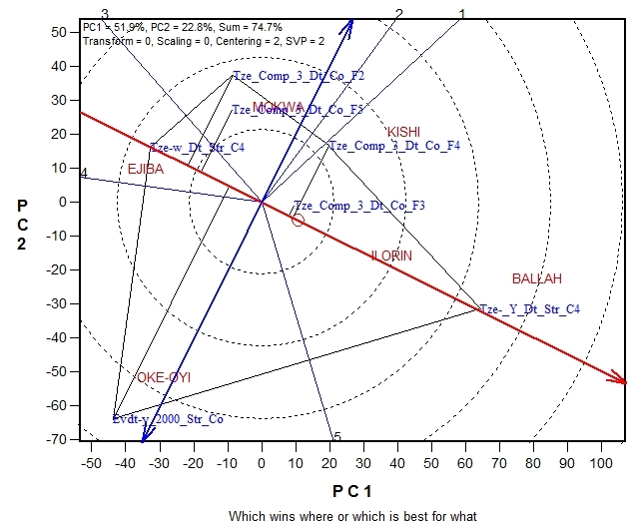

Figure 1. The polygon view of the GGE biplot showing which early OPVs maize won in which location.

Yan (2001) defined ideal genotype to have high projection towards the double-arrowed line and near zero projection to the line with the AEA. In Figure 1, the early OPV, TZE-Y-DT STR_C₄ had the highest but unstable grain yield performance across the environments, TZE-Comp-3-DT-Co F₃ was highly stable with low yielding as compared to the former while TZE-Comp-3-DT-Co F₄ was unstable and low yielding across the environments.
Stability across locations for intermediate/late OPVs in 2007−2009 seasons (Figure 2A) shows that TZL-Comp 1-W C₆-F 2 was high yielding but unstable genotype, DT-SR-W-Co_F₂ and White-DT-STR-SYN were the most stable and high yielding genotypes.

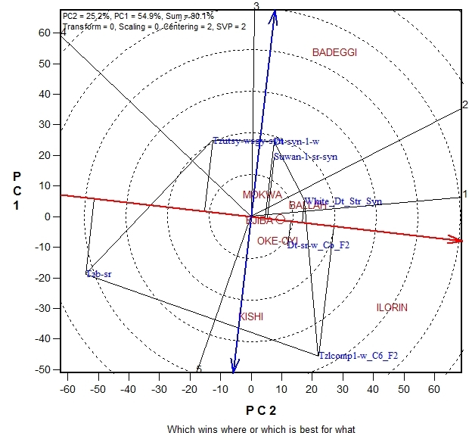A
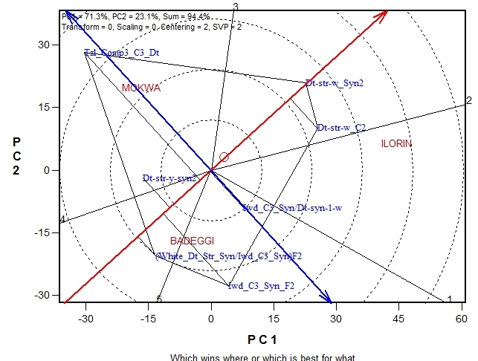B

Figure 2. The polygon view of the GGE biplot showing which OPVs won in
which location for intermediate/late DT OPVs maize between 2007 and
2009 (A) and between 2010 and 2012(B).
The 2010-2012 evaluation shows that DT-STR-W-SYN 2 and DT-SR-W-C₂ were high yielding but less stable. Genotype White-DT-STR-SYN/IWD-C₃-SYN F₂ was the most stable but the low yielding (Figure 2B. Yield performance consists of mean yield and stability concepts (Karimizadeh et al., 2013), therefore plant breeders should explore genotypes that indicate yield stability as well as high yield across environments. This study will projects TZE-Y-DT STR C₄ (early OPV) and White-DT-STR-SYN (intermediate/late OPV) with acceptable stability and good grain yields as the best OPVs.
The early hybrid genotypes in 2009–2011(Figure 3A) trials showed that the highest mean performance was obtained from TZE-Y-Pop-DT-STR-C₄ x TZEI 11 but relatively unstable while in 2012–2014 (Figure 3B), TZE-W-Pop-DT-C₄-STR-C₅, 2012 TZE-Y-DT-C₄ STR-C₅ and DTE-STR-Syn-Pop-C₂ were the high performed hybrids, while the most stable genotype was 2012 TZE-Y-DT-C₄ STR-C₅. Also, Figure 4A shows that hybrid TZEEI-W-Pop-STR-C₅ x TZEEI 14 was the highest yielding genotype but unstable compared to TZEEI-3 x TZEEI 46 while in 2011–2012 (TZEEI 4 x TZEEI 14) x (TZEEI 29 x TZEEI 49) was the only outstanding hybrid in terms of performance and stability (Figure. 4B).
The polygons are divided into several sectors and some of these sectors have locations within them suggesting the possibility of different mega-environments existing for the genotypes. The mega-environments for early OPVs were Ballah, Ilorin and Kishi (Figure 1) while Ilorin, Kishi, Oke-Oyi and Ejiba made up the first mega-environment; Badeggi and Mokwa constituted the second mega-environment for the intermediate/late maturing OPVs during 2007–2009 cropping periods (Figure 2A).
Figure 3A shows two mega-environments in 2009–2011 trials which included: Badeggi, Ejiba and Ilorin as a mega-environment with TZE-Y-Pop-DT-STR-C₄ x TZEI11 as the best performing hybrid and Mokwa as the second mega-environment and TZEI-24 x TZEI-17 as the best yielding hybrid. The 2012–2014 genotype evaluation was divided into five mega-environments and each with the best performing hybrid (Figure 3B). The extra early trial shows that, Kishi was the most discriminating and representative in both trials while Ballah was close to Kishi during the 2009–2010 growing seasons. Hybrid TZEEI-W-Pop-STR-C₅ x TZEEI 14 was the highest yielding genotype but unstable while TZEEI-3 x TZEEI 46 was the most stable and high yielding genotype (Figure 4A). Similarly, in 2011–2012, (TZEEI 4 x TZEEI 14) x (TZEEI 29 x TZEEI 49) was high yielding
hybrid but unstable. Three of the hybrids genotypes were stable but had low yield (Figure 4B).
However, this mega-environment pattern needs verification through other multi-environment trials for this target region. Regarding this pattern, genotypes TZE-Y-DT-STR-C₄ and White-DT-STR-SYN were the most favorable genotypes, having specific adaptability for these mega-environments. These inferences about polygon view patterns are mostly, but not totally, validated from the original data. However, the model outcome is worthwhile for recommendation purposes as demonstrated by several authors (Setimela et al., 2007; Badu-Apraku et al., 2008, 2011, 2013; Badu-Apraku and Lum, 2010).

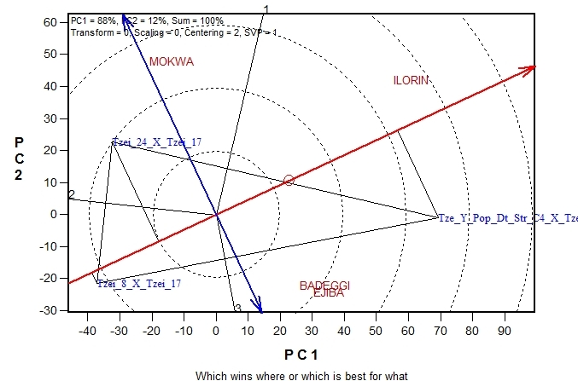A
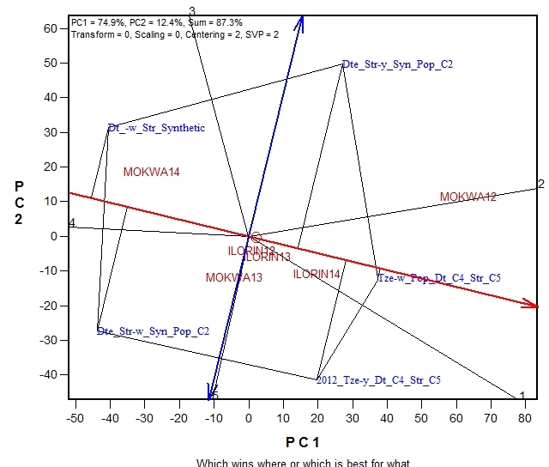B

Figure 3. The polygon view of the GGE biplot showing which OPVs won in which locations for early maturing DT hybrids between 2009 and
2011 (A) and between 2012 and 2014(B).
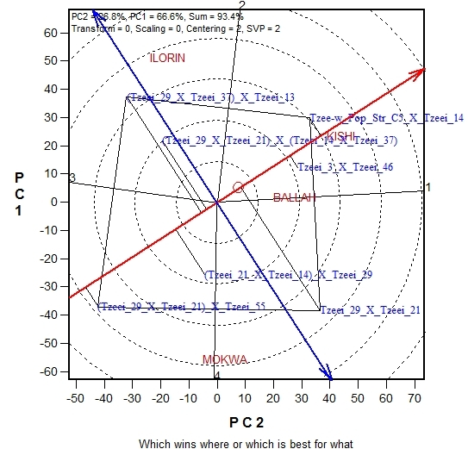A
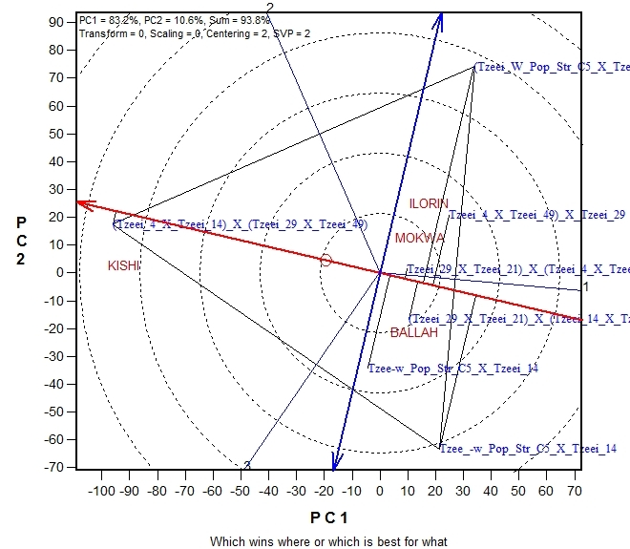B

Figure 4. The polygon view of the GGE biplot showing which OPVs won in which location for extra early white DT hybrid maize between 2009 and 2010 (A) and between 2011 and 2013 (B).

Conclusion

This study concludes that fewer but better locations that provide relevant information should be used for conducting multi-location trials. Thus, Ilorin/Ballah, Ejiba/Mokwa and Kishi/Badeggi are core test locations for evaluation of early OPVs, intermediate/late OPVs and hybrids, respectively although these patterns need verification through other multi-environment trials. The following promising genotypes are recommended for further evaluation on farmer’s fields: TZE-Y-DT-STR-C₄ (early OPV), White-DT-STR-SYN (intermediate/late maturing OPVs), TZE-W-Pop-DT STR-C₅ (early maturing hybrids) and TZEEI 3 x TZEEI 46 (extra early genotype) for the SGS agro-ecological region of Nigeria.

Acknowledgements

Financial support of the DTMA project for this study is gratefully acknowledged. The authors are also grateful to the United Nations University-Institute for Resources in Africa (UNU-INRA) for granting the first author financial support and the enabling environment during his Visiting Scholar Programme. This manuscript is culled from his working paper submitted to UNU-INRA.

References

Badu-Apraku, B., & Lum, A.F. (2010). The pattern of grain yield response of normal and quality protein maize cultivars in stressed and non-stressed environments. Agronomy Journal, 102, 381-394.
Badu-Apraku, B., Lum, A.F., Fakorede, M.A.B., Menkir, A., Chabi, Y. The, C., Abdulai, M., Jacob, S., & Agbaje, S. (2008). Performance of early maize cultivars derived from recurrent selection for grain yield and Striga resistance. Crop Science, 48, 99-112.
Badu-Apraku, B., Oyekunle, M., Obeng-Antwi, K., Osuman, A.S., Ado, S.G., Coulibaly, N., Yallou, C.G., Abdullai, M., Boakyewaa, G.A., & Didjeira, A. (2011). Performance of extra-early maize cutivars based on GGE biplot and AMMI analysis. Journal of Agricultural Sciences, 150, 473-483.
Badu-Apraku, B., Akinwale, R.O., Obeng-Antwi, K., Haruna, A., Usman, R.I., Ado, S.G., Coulibaly, N., Yallou G.C., & Oyekunle, M. (2013). Assessing the representativeness and repeatability of testing sites for drought-tolerant maize in West Africa. Canadian Journal of Plant Science, 93, 699-714.
Beyene, Y., Semagn, K., Crossa,J., Mugo, S., Altin,G., Tarekegne, A., Meisel, B., Sehabiague, P., Vivek, B.S., Oikeh, S., Alvarado, G., Machida, L., Olsen, M., Prasanna, B.M., & Bänziger, M. (2016). Improving maize grain yield under drought stress and non-stress environments in sub-Saharan Africa using marker assisted recurrent selection. Crop Science, 56, 344-353.
Bolanos, J., & Edmeades, G.O. (1993). Eight cycles of drought tolerance in lowland tropical maize: response in grain yield, biomass, and radiation utilization. Field Crops Research, 31, 233-252.
Cairns, J.E., Hellin, J., Sonder, K., Araus, J.L., MacRobert, J.F., Thierfelder, C., & Prasanna, B.M. (2013). Adapting maize production to climate change in sub-Saharan Africa. Food Security, 5, 345-360.
Edemeades, G.O, Bazinger, M., Chapman, S.C., Ribault, J.M., & Bolanos, J. (1997). Recent advances in breeding for drought tolerance in maize. In B. Badu-apraku, M.O. Akorfoda, M. Ouderago and F.M. Quin (eds). Contributing to food self-sufficiency: Maize Research and Development in West Africa. Proceedings of a regional maize workshop (pp. 22- 41). IITA, Cotouou, Benin Republic.
Jensen, S. (1994). Genetic improvement of maize for drought tolerance. In Jewel, D.C.et.al (eds). Maize research for stress environments. Proceedings of 4th Eastern and Southern Africa Regional Maize conference (pp. 67-75), Harare, Zimbabwe.
Karimizadeh, R., Mohammad, M., Sabaghni, N., Mahmoodi, A.A., Roustami, B., Seyyedi, F., & Akbari, F. (2013). GGE biplot analysis of yield stability in multi-environment trials of lentil genotypes under rainfed condition. Notulae Scientia Biologicae, 5 (2), 256-262.
Menkir, A., & Akintunde, A.O. (2001). Evaluation of the performance of maize hybrids, improved open pollinated and farmers’ local varieties under well watered and drought stress conditions. Maydica, 46, 227-238.
Ngure, M. (1994). Strategies for increasing maize production in moisture stress areas of eastern Kenya. In Jewel, D.C. et.al (eds). Maize research for stress environments. Proceedings of 4th Eastern and Southern Africa Regional Maize conference (pp. 76-80), Harare, Zimbabwe.
Njoroge, K. (1994). Seedling vigour as a selection criterium in breeding maize under water stress. In Jewel, D.C. et.al (eds). Maize research for stress environments. Proceedings of 4th Eastern and Southern Africa Regional Maize conference (pp. 86-91), Harare, Zimbabwe.
Olaoye, G. (2009). Screening for moisture deficit tolerance in four maize populations derived from drought tolerant inbred and adapted cultivar crosses. Journal of Tropical and Subtropical Agroecosystem Mexico, 10, 237-251.
Setimela, P.S., Vivek, B., Banziger, M., Crossa, J., & Maideni, F. (2007). Evaluation of early to medium maturing open pollinated maize varieties in SADC region using GGE biplot based on the SREG model. Field Crops Research, 103, 161-169.
Yan, W. (2001). GGE biplot- a windows application for graphi-cal analysis of multi-environment trial data and other types of two-way data. Agronomy Journal, 93, 1111-1118.
Yan, W., & Tinker, N.A. (2006). Biplot analysis of multi-environment trial data: principles and application. Canadian Journal of Plant Science, 86 (3), 623-645.
Yan, W., Pageau, D., Fregeau-Reid, J., & Durand, J. (2010). Assessing the representativeness and repeatability of test locations for genotype evaluation. Crop Science, 51, 1603-1610.

Received: August 1, 2016
Accepted: February 14, 2017

PROCENA PRINOSA ZRNA KUKURUZA U SREDINI SKLONOJ SUŠI

Felix Ogar Takim¹, Gbedabo Olaoye¹, Yakeen Abiola Abayomi¹, Samuel Olakojo², Matthew Isah³, Folusho Bankole¹, Mohammed Ishaq⁴ i Sulaiman Yussuf Abdulmaliq³*

¹Odsek za agronomiju, Univerzitet u Ilorinu, Nigerija
²Institut za poljoprivredna istraživanja i obuku, Plantaža Moor, Ibadan, Nigerija
³Univerzitet Ibrahim Babangida, Lapai, Nigerija
⁴Državni institut za istraživanje žita, Badegi, Nigerija

R e z i m e

Podaci višelokacijskih ogleda dobijeni između 2007. i 2014. godine uključujući slobodno oprašujuće populacije (engl. open pollinated varieties [OPVs]) i hibrid kukuruza (Zea mays L.) analizirani su korišćenjem modela GGE (engl. Genotype and Genotype x Environment) i AMMI (engl. Additive Main Effect and Multiplicative Interaction) kako bi se ocenio njihov učinak i pogodnost kao populacija, identifikovali obećavajući genotipovi i mesta za dalju evaluaciju na različitim lokacijama savane južne Gvineje u Nigeriji. Ogledi su postavljeni po metodi slučajnog blok sistema u tri ponavljanja na svim lokacijama. Veličina parcele se sastojala od dva reda, dužine 5m sa rastojanjem od 0,75m x 0,4m između i unutar redova za rane populacije i 0,75m x 0,5m za srednje i kasne populacije i hibride. Zasejana su dva semena po kućici, kako bi se dobila gustina populacije od oko 66.000 biljaka/ha (rane) i 54.000 biljaka/ha (srednje/kasne). Prikupljeni su podaci o agronomskim parametrima i parametrima prinosa. Uslovi spoljašnje sredine su činili 84,80% odnosno 90,42% ukupne varijacije u prinosu zrna slobodno oprašujućih populacija odnosno hibrida. TZE-Y-DT STR C₄ (rana OPV) i bela-DT-STR-SYN (srednja/kasna OPV), TZE-W-Pop-DT STR-C₅ (rani hibridi) i TZEEI 3 x TZEEI 46 (veoma rani genotip) bili su najstabilniji i dali su visok prinos. Glavne proučavane lokacije za evaluaciju ranih slobodno oprašujućih populacija, srednjih/kasnih slobodno oprašujućih populacija i hibrida su Ilorin/Balah, Ejiba/Mokva odnosno Kiši/Badegi. Ovo istraživanje preporučuje da, manji broj, ali boljih lokacija, koje obezbeđuju relevantne informacije, treba da budu korišćenje za sprovođenje višelokacijskih ogleda. Genotipove TZE-Y-DT STR C_{4,} bela-DT-STR-SYN, TZE-W-Pop-DT STR-C₅ i TZEEI 3 x TZEEI 46 treba dalje procenjivati na poljoprivrednim površinama.

Ključne reči: genotip, prinos zrna, hibridi, zrelost, kukuruz, lokacija.

Primljeno: 1. avgusta 2016.
Odobreno: 14. februara 2017.

Corresponding author: e-mail: felixtakim@yahoo.co.uk
*Autor za kontakt: e-mail: felixtakim@yahoo.co.uk

