INFLUENCE OF UV LIGHT EXPOSURE ON MINERAL COMPOSITION
AND BIOMASS PRODUCTION OF MYCOMEAT PRODUCED
FROM DIFFERENT AGRICULTURAL SUBSTRATES

Isaac Oluseun Adejumo, Charles Oluwaseun Adetunji and
Oluyomi S. Adeyemi

ADRESA

Abstract: The wild and mutant strain of Pleurotus sajor caju was cultured on different agricultural substrates. Treatment 1 contained agricultural substrates alone. Treatment 2 contained the mutant strain of the mushroom plus agricultural waste. Treatment 3 contained the wild strain of the mushroom plus agricultural waste. The mutant strain of Pleurotus sajor caju cultured on groundnut shell had the highest iron content while the mutant strain cultured on palm kernel meal had the highest biomass production, 10.5 g/L and 17.20 g/L after 7 and 14 days respectively. The proximate analyses of the feed variety (mycomeat) revealed the rich nutritional content which may be explored for feed ingredients in livestock production. The findings do not only support the bioremediation of agricultural waste to produce high-value bio-products but also provide evidence that improvement of microorganism strains represents a viable way to enhance the nutritional value of fermented products.
Key words: agricultural wastes, mutant, mycomeat, Pleurotus.

Introduction

Agricultural wastes are produced in large quantities during the processing of agricultural products or after harvest and their disposal in developing countries is currently a major economic and ecological challenge. They are usually allowed to accumulate in large quantities, allowed to decay or are burnt indiscriminately which could impact negatively on the environment as well as pose a serious threat to human health. Mushrooms refer to fruiting bodies of macrofungi (Das, 2000) and they are highly nutritious (Kumari et al., 2011; Aina et al., 2012). Chang and Miles (1989) coined mycomeat to refer to fungal protein obtained through the conversion of food processing biomass wastes; most times via solid state fermentation (SSF). Edible fungi, mainly mushrooms, can be cultured for their fruiting body, metabolites such as an enzyme, or mycomeat (containing both the growth substrate and the mycelia of the fermenting fungi). Chiu et al. (2000) have earlier noted that production of medicinal or edible mushrooms is a successful way of agro-waste recycling. Mushroom has been found to suppress breast cancer (Grube et al., 2001). Ultra violet radiation is one of the best physical methods of strain improvement for better performance (Oloke et al., 2012). The microbiological quality of feed is of great importance to its safety. Adetunji and Adejumo (2017) earlier studied the proximate and amino acid profile of mycomeat produced from different agricultural substrates. The present study evaluated the nutritional value of a feed variety, mycomeat, produced through solid state fermentation from various agricultural wastes using wild and mutant strains of P. sajor caju.

Materials and Methods

Pleurotus sajor caju LMU 0 was procured from NIHORT, Ibadan, Nigeria. The cultures were sub-cultured periodically after every 4 weeks and incubated at 25 ± 1°C for 10 days on potato dextrose agar (PDA) slants and stored at 4°C. A fresh PDA plate to grow the organisms was prepared. After the growth of the organisms, a cork borer was used to obtain several mycelia plugs from the culture into a sterile PDA plate. The sterile plate containing several mycelia plugs was placed under UV lamp at 300 nm wavelength at a distance of 30 cm to the plates. At time interval of 30 min, 5 mycelia plugs were withdrawn and used as inoculants for solid state fermentation studies. The mycelia plugs from the domesticated type culture served as the control (Adetunji and Oloke, 2013).
The basal medium for seed culture was made (w/v) of glucose 2.0%, malt extract 2.0% and peptone 0.1%. The pH was initially adjusted to 5 before sterilizing by autoclaving. P. sajor caju was transferred to the medium by punching out 0.7 mm diameter agar discs from a culture grown on PDA plates, and five discs were used to inoculate 100 mL of liquid media. The seed culture was grown in a 250 mL Erlenmeyer flask at 25 ◦C on a rotary shaker incubator at 100 rpm for 3 days. Agricultural wastes (wheat bran [WB], groundnut shell, Moringa oleifera seed shell, corn bran [CB], corn cob [CC], palm kernel meal [PKM], rice bran [RB] and cassava peel [CP] meal) which served as substrates were prepared according to the method of Akintunde and Akintunde (2002) with a little modification. The moisture content of the different agricultural wastes was maintained at 60% and apportioned into three sets each. Treatment 1 contained agricultural substrate waste alone. Treatment 2, in addition to agricultural waste, contained the mutant strain of the mushroom exposed to UV for 30 min. Treatment 3, in addition to agricultural waste, contained the wild strain of the mushroom. They were filled into the wide-mouthed transparent jars in triplicates, corked with cotton wool and sterilized in the autoclave at 121ºC for 15 min. The sterilized substrates were inoculated with 10% (v/v) seed cultures on different agricultural substrates. The set-up was incubated in the dark and monitored daily until full ramification was obtained.
The mycelia were obtained by boiling the cultures with boiling water for about 0.5 h to separate the mycelia from the fermented substrate, and filtered immediately with eight layers of gauze. The filter residue was washed three times with boiled water. Then the yield of biomass in SSF was determined gravimetrically after drying at 70ºC overnight to a constant weight.
The potassium (K) and sodium (Na) contents of the mycomeat were determined using a flame spectrophotometer (Jenway PFP7, UK). The phosphorus content was determined by a UV spectrophotometer (Jenway 6305, UK). The magnesium (Mg) and calcium (Ca) contents were determined by the EDTA titration method while the iron (Fe), manganese (Mn) and copper (Cu) contents were determined using an atomic absorption spectrophotometer (AA320N, PEC Medical, USA) according to the procedure of AOAC (2000). The values of the determined minerals were reported in mg/L. The design of the study was a 3x8 factorial arrangement in a completely randomized design. The mean values obtained for mineral composition and biomass production were subjected to an analysis of variance using SPSS (Version 21). Significant means were analyzed using Duncan’s multiple range tests at α = 0.05.

Results and Discussion

Using the mutant strain, mycomeat produced from groundnut shell (0.14 mg/L) had the highest iron content while rice bran wild (0.00 mg/L) and cassava peel (CP) control (0.00 mg/L) yielded the least value (Table 1). Conversely, the wild strain using groundnut shell as substrate produced the highest value of calcium content (108.24 mg/L), followed by the mutant strain produced from corn cob, CC (98.52 mg/L) while the wild strain produced from the palm kernel meal, PKM (36.49 mg/L), obtained the least value. The mutant strain produced from the wheat bran, WB (244.52 mg/L), obtained the highest value of magnesium while the wild strain produced from the CC (36.09 mg/L) obtained the lowest values.
The manganese content ranged from 0.04 to 0.23 mg/L. Similar values were obtained by the wild strain produced from the WB (0.04 mg/L), groundnut shell control (0.04 mg/L), the mutant strain produced from groundnut shell (0.03 mg/L), the wild strain produced from groundnut shell (0.04 mg/L), the mutant strain produced from M. oleifera (004 mg/L), the wild strain produced from M. oleifera (0.03 mg/L), the wild strain produced from corn bran, CB (0.03 mg/L), CC control (0.03 mg/L), the mutant strain produced from CC (0.04 mg/L), the wild strain produced from CC (0.03 mg/L), PKM control (0.03 mg/L), CP control (0.04 mg/L) and the mutant strain produced from CP (0.04 mg/L).
The mutant strain produced from CB (345.10 mg/L) obtained the highest value of phosphorus while the wild strain produced from CC (106.78 mg/L) obtained the least value. Potassium content was low for M. oleifera control (1.54 mg/L) and the wild strain produced from rice bran, RB (2.05 mg/L). The copper content was generally low across the treatments. Sodium was only observed in WB control (4.36 mg/L), the mutant strain produced from M. oleifera (4.38 mg/L), the wild strain produced from M. oleifera (4.38 mg/L), CC control (4.35 mg/L), the mutant strain produced from RB (4.38), the mutant strain produced from CP (4.36 mg/L) and the wild strain produced from CP (4.37 mg/L). The groundnut shell (0.094) and M. oleifera (0.087) obtained significant higher iron values. Significant lower values of calcium content were reported for PKM (44.60), RB (46.66) and WB (56.79).

Table 1. Interactive effect of agricultural substrates and strain improvement on mineral composition of mycomeat.

Substrates | Strain | Fe | Ca | Mg | Mn | P | K | Cu | Na
WB | Control | 0.05g | 68.18f | 216.45c | 0.23a | 263.84k | 3.88g | 0.006def | 4.36a
 | Mutant | 0.02l | 47.45q | 244.52a | 0.09ef | 265.79h | 3.35i | 0.004ef | 0.00b
 | Wild | 0.01m | 54.73m | 220.46b | 0.04h | 265.60i | 4.63e | 0.004ef | 0.00b
Groundnut shell | Control | 0.10d | 88.77c | 92.19q | 0.04h | 229.86p | 3.59h | 0.003g | 0.00b
 | Mutant | 0.14a | 47.42q | 98.19p | 0.03h | 237.97o | 4.36f | 0.003g | 0.00b
 | Wild | 0.04i | 108.24a | 166.37f | 0.04h | 141.25t | 3.08j | 0.02a | 0.00b
Moringa oleifera seed shell | Control | 0.02j | 52.29o | 138.28i | 0.07g | 240.96n | 1.54m | 0.002g | 0.00b
 | Mutant | 0.11c | 63.25i | 122.26l | 0.03h | 237.98o | 3.10j | 0.011b | 4.38a
 | Wild | 0.13b | 66.89g | 142.31h | 0.03h | 252.41l | 2.59k | 0.002g | 4.38a
CB | Control | 0.003op | 46.23r | 184.39e | 0.08f | 329.09b | 4.37f | 0.009bc | 0.00b
 | Mutant | 0.06f | 72.97e | 142.29h | 0.08f | 345.10a | 4.88d | 0.006def | 0.00b
 | Wild | 0.002pq | 58.37j | 136.27j | 0.03h | 277.19f | 5.13c | 0.002g | 0.00b
PKM | Control | 0.05gh | 41.34s | 210.42d | 0.03h | 302.69c | 4.87d | 0.02a | 0.00b
 | Mutant | 0.01m | 55.96l | 126.26k | 0.16c | 256.28k | 5.15c | 0.02a | 0.00b
 | Wild | 0.02j | 36.49u | 156.33g | 0.09ef | 267.53g | 4.64e | 0.02a | 0.00b
RB | Control | 0.00q | 38.91t | 118.24n | 0.12d | 294.59d | 3.85g | 0.002g | 0.00b
 | Mutant | 0.01n | 52.39n | 88.22s | 0.20b | 292.86e | 3.62h | 0.016a | 4.38a
 | Wild | 0.00q | 48.66p | 102.21o | 0.17c | 245.23m | 2.05l | 0.007fg | 0.00b
CP meal | Control | 0.00^{q} | 75.41^{d} | 70.18^{u} | 0.04^{h} | 206.68^{q} | 6.42ª | 0.002^{g} | 0.00^{b}
 | Mutant | 0.02^{kl} | 98.57^{b} | 90.22^{r} | 0.04^{h} | 182.11^{s} | 6.43ª | 0.003^{fg} | 4.36ª
 | Wild | 0.07e | 57.16^{k} | 120.24^{m} | 0.12^{d} | 191.56^{r} | 6.16^{b} | 0.003^{g} | 4.37ª
 | SEM | 0.01 | 3.91 | 11.08 | 0.01 | 12.81 | 0.26 | 0.001 | 0.41
Means with different superscripts within the same column are significantly different, P = 0.05, SEM = standard error of the mean; CB = corn bran; WB = wheat bran; RB = rice bran; CC = corn cob; PKM = palm kernel meal.
WB obtained the highest value of magnesium (227.14), followed by PKM (164.34). CC (53.45) obtained the least value. Manganese content ranged between 0.16 (RB) and 0.03(CC). Phosphorus content was higher for CB (317.13), RB (277.56) and PKM (275.50). Potassium content ranged between 6.34 (CP meal) and 3.17 (CC and RB). The copper content was generally low. PKM obtained the highest mean (0.022), while CP meal (0.003) obtained the least value. Groundnut seed husk meal, CB, and PKM obtained no values for sodium. M. oleifera (2.92) and CP meal (2.91) recorded the highest means, followed by RB (1.46), CC (1.45) and WB (1.45). Strain improvement enhanced mineral contents of the mycomeat produced except for magnesium and phosphorus.
The mutant strain of the mycomeat produced on PKM had the best biomass yield after 7 days (10.50 g/L) and 14 days (17.20 g/L). The main effects of agricultural substrates and strain types on biomass production are presented in Figure 2. The mycomeat produced on palm kernel meal obtained the biomass yield after 7 days (7.66 g/L) and 14 days (10.03 g/L) while CP obtained the least values. Strain improvement enhanced biomass production.

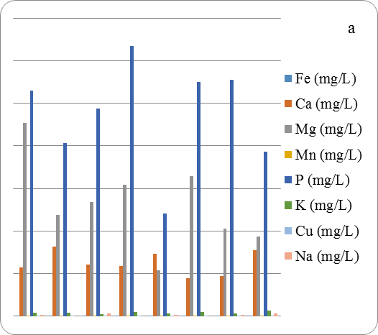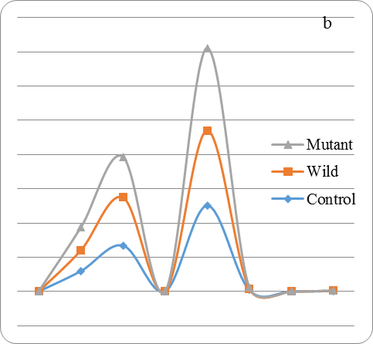

Figure 1. Effects of agricultural substrates and strain type of Pleurotus sajor caju on mineral composition of mycomeat A = effect of agricultural substrates;
B = effect of strain type of Pleurotus sajor caju.

The low yield by M. oleifera seed husk and cassava peel could be due to the inhibitory activities of antibacterial compounds and hydrocyanide acid of M. oleifera and cassava peel respectively against the fungi. M. oleifera had been previously reported to express anti-microbial properties while cassava is rich in hydrocyanide (Tewe 1994; Ola-Fadunsin and Ademola, 2014).
Table 2. Interactive effect of agricultural substrates and strain improvement on biomass production of mycomeat.

Substrates | Strain | 7 days (g/L) | 14 days (g/L)
WB | Control | 0.00^{j} | 0.00^{k}
 | Mutant | 4.20de | 9.60^{c}
 | Wild | 2.10^{g} | 4.30^{fg}
Groundnut shell | Control | 0.00^{j} | 0.00^{k}
 | Mutant | 7.20^{b} | 13.40^{b}
 | Wild | 3.20^{f} | 6.20e
Moringa oleifera seed shell | Control | 0.00^{j} | 0.00^{k}
 | Mutant | 0.03^{j} | 0.08^{k}
 | Wild | 0.00^{j} | 0.02^{k}
CB | Control | 0.00^{j} | 0.00^{k}
 | Mutant | 1.20^{ghi} | 4.30^{fg}
 | Wild | 0.90^{hij} | 2.10^{hi}
CC | Control | 0.00^{j} | 0.00^{k}
 | Mutant | 3.50^{ef} | 7.80^{d}
 | Wild | 1.60^{gh} | 4.30^{fg}
PKM | Control | 0.00^{j} | 0.00^{k}
 | Mutant | 10.50ª | 17.20ª
 | Wild | 8.30^{b} | 10.40^{c}
RB | Control | 0.00^{j} | 0.00^{k}
 | Mutant | 6.20^{c} | 10.40^{c}
 | Wild | 4.60^{d} | 7.80^{d}
CP meal | Control | 0.00^{j} | 0.00^{k}
 | Mutant | 0.02^{j} | 0.05^{jk}
 | Wild | 0.00^{j} | 0.01^{k}
 | SEM | 0.06 | 0.09
Means with different superscripts within the same column are significantly different, P = 0.05, SEM = standard error of the mean; WB = wheat bran; CB = corn bran; CC = corn cob; PKM = palm kernel meal; RB = rice bran; CP = cassava peel.

Strain improvement resulted in better biomass yield in the present study. Strain improvement in the field of microbiology is carried out to improve the microbial productivity, to change unused co-metabolites, to improve the use of carbon and nitrogen sources and to improve the morphology of cells in order to separate the cells and its products.
The values reported in this study for Fe, Ca, Mg, Mn, Na, and Cu are lower than the values reported by Bamigbose et al. (2013). The variation could be attributed to the substrates used. The substrate used in the previous study was richer in these minerals than the substrates used in the present study. Minerals perform structural, physiological, catalytic and regulatory functions in animals. Calcium, phosphorus, and magnesium form structural components of the body organs and tissues. Sodium, potassium, calcium and magnesium in the blood, cerebrospinal fluid, and gastric juice are known to provide maintenance of osmotic pressure, acid-base balance, transmission of nerve impulses and membrane permeability (Suttle, 2010).

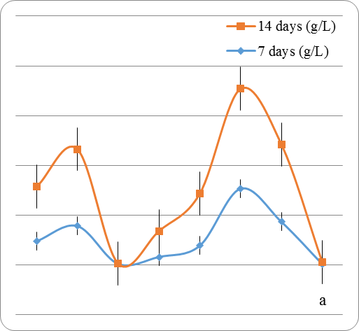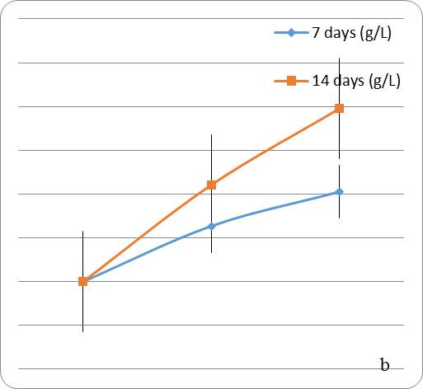

Figure 2. Effects of agricultural substrates and strain type of Pleurotus sajor caju on biomass yield of mycomeat A = effect of agricultural substrates;
B = effect of strain type of Pleurotus sajor caju.

The values of Mg in the present study are higher than the values reported in the MAFF (1990). The increase in the present study could be attributed to the fermentation and fungal growth. Lack of magnesium in the diet could result in hyperirritability and convulsions. Magnesium is largely protein-bound and functions as a catalyst of a wide array of enzymes. The formation of bone and its maintenance are the most important functions of phosphorus. It is a component of deoxy and ribonucleic acids, essential for cell growth and differentiation (Suttle, 2010).

Conclusion

Strain improvement enhanced iron, calcium, manganese, potassium, copper, and sodium content of mycomeat. PKM, groundnut seed husk meal and RB enhanced biomass production of mycomeat while M. oleifera seed husk meal and CP meal did not. This study supports the bioremediation of agricultural wastes to produce high-value bio-products. It provides evidence that improvement of microorganism strains represents an important means of enhancing nutritional values of fermented products.
References

Adetunji, C.O., & Adejumo, I.O. (2017). Nutritional assessment of mycomeat produced from different agricultural substrates using wild and mutant strains from Pleurotus sajor-caju during solid state fermentation. Animal Feed Science and Technology, 224, 14-19.
Adetunji, C.O., & Oloke, J.K. (2013). Efficacy of freshly prepared pesta granular formulations from the multi-combination of wild and mutant strain of Lasiodiplodia pseudotheobromae and Pseudomonas aeruginosa. Albanian Journal of Agricultural Science, 12, 555-563.
Aina, D.A., Oloke, J.K., Jonathan, S.G., & Olawumi, D.J. (2012). Comparative assessment of mycelial biomass and exo-polysaccharide production of wild type and mutant strains of Schiozophyllum commune grown in submerged liquid medium. Natural Science, 10, 82-89.
A.O.A.C. (2000). Official Methods of Analysis.17th Ed. Analytical Chemist s Inc. Arlington Virginia 22201 USA.
Chiu, S.W., Law, S.C., Ching, M.L., Cheung, K.W., & Chen, M.J. (2000). Themes for mushroom exploitation in the 21st century sustainability, waste management and conservation. Journal of General and Applied Microbiology, 46, 269-282.
Das, K. (2010). Diversity and conservation of wild mushrooms in Sikkim with special reference to Barsey rhododendron sanctuary. NeBio, 1, 1-13.
Akintunde, T.Y., Akintunde, B.O. (2002). Development of models for predicting the yield and quality of soymilk. Journal of Food Technology in Africa, 7, 55-58.
Bamigboye, C.O., Oloke, J.K., Adebayo, E.A., Majolagbe, O.N., Ayandiran, T.A., & Adegunlola, E.O. (2013). Mycomeat production through the solid state fermentation of soymilk waste by Lentinus subnudus. Journal of Natural Sciences Research, 3, 88-93.
Chang, S.T., & Miles, P.G. (1989). Edible mushrooms and their cultivation. CRC Press, Inc. Florida.
Grube, B.J., Eng, E.T., Yen-Chih, K., Kwon, A., & Shiuan, C. (2001). White button mushroom phytochemical inhibit aromatase activity and breast cancer and cell proliferation. Journal of Nutrition, 131, 3288-3293.
Kumari, D., Reddy, M.S., & Upadhyay, R.C. (2011). Nutritional composition and antioxidant activities of 18 different wild Cantharellus of Northwestern Himlayas. Food Science and Technology International, 17, 557-567.
MAFF (1990). UK Tables of the Nutritive Value and Chemical Composition of Feedstuffs. In: Givens D.I. (ed). Rowett Research Services, Aberdeen, UK.
Ola-Fadunsin, S.D., & Ademola, I.O. (2014). Anticoccidial effects of Morinda lucida acetone extracts on broiler chickens naturally infected with Eimeria species. Pharmaceutical Pharmaceutical Biology, 52, 330-334.
Oloke, J.K., Adebayo, E.A., Archana, Y., & Bora, T.C. (2012). Importance of Laccase production in Pleurotus pulmonarius LAU09 by mutation. Scientific and Academic Publishing.
Suttle, N.F. (2010). Mineral Nutrition of Livestock. 4th ed. CABI, UK.
Tewe, O.O. (1994). Indices of cassava safety for livestock feeding. Acta Horticulture, 373, 241-249.

Received: September 29, 2016
Accepted: February 9, 2017

UTICAJ IZLAGANJA SVETLOSTI ULTRALJUBIČASTOG ZRAČENJA NA MINERALNI SASTAV I PROIZVODNJU BIOMASE MIKOMESA PROIZVEDENOG OD RAZLIČITIH POLJOPRIVREDNIH PODLOGA

Isaac Oluseun Adejumo, Charles Oluwaseun Adetunji and
Oluyomi S. Adeyemi*

ADRESA

R e z i m e

Divlji i mutirani soj Pleurotus sajor caju bio je gajen na različitim poljoprivrednim podlogama. Tretman 1 je sadržao samo poljoprivredne podloge. Tretman 2 je sadržao mutirani soj pečurke i poljoprivredni otpad. Tretman 3 je sadržao divlji soj pečurke i poljoprivredni otpad. Mutirani soj Pleurotus sajor caju koji je uzgajan na ljuskama kikirikija imao je najviši sadržaj gvožđa, dok je mutirani soj uzgajan na sačmi od palminog jezgra imao najvišu proizvodnju biomase, 10,5 g/L odnosno 17,20 g/L posle 7 odnosno 14 dana. Standardne analize različitih varijanata mikomesa (engl. mycomeat) otkrile su bogati hranljivi sadržaj koji bi se mogao koristiti kao sastojak hraniva u stočarskoj proizvodnji. Rezultati ne podržavaju samo bioremedijaciju poljoprivrednog otpada za proizvodnju visoko vrednih bioproizvoda, već takođe pružaju dokaze da poboljšanje sojeva mikroorganizama predstavlja održiv način da se poboljša hranljiva vrednost fermentisanih proizvoda.
Ključne reči: poljoprivredni otpad, mutant, Pleurotus.

Primljeno: 29. septembra 2016.
Odobreno: 9. februara 2017.

Corresponding author: e-mail: XXXXXXXXXX
*Autor za kontakt: e-mail: xxxxxxxxxxxxxxxxxx

