ANTIFUNGAL ACTIVITY OF CHITOSAN AND ITS QUATERNIZED DERIVATIVE IN GEL FORM AND AS AN EDIBLE COATING ON
CUT CHERRY TOMATOES

Leandro P. da Silva¹, Tamires A. Bitencourt², Ana L. F. Saltoratto²,
Mirna H. R. Seleghim¹ and Odílio B. G. Assis³*

¹Federal University of São Carlos, PPG Biotechnology,
Rod Washington Luis, km 235, 13565-905 São Carlos, SP, Brazil
²University of Ribeirão Preto, Bioscience Laboratory,
Av Costábile Romano, 2201, 14096-900 Ribeirão Preto, SP, Brazil
³Embrapa Instrumentation, National Nanotechnology Laboratory for Agriculture (LNNA), Rua XV de Novembro, 1452, 13560-970 São Carlos, SP, Brazil

Abstract: The antifungal activities of medium molecular weight chitosan and its hydrosoluble derivative salt N,N,N-trimethylchitosan were examined as both gel and as a solid protective coating against three common food spoilage fungi (Penicillium sp., wild Aspergillus sp. and one standard strain of Aspergillus flavus). The salt derivative is characterized by having permanent positive charges and is expected to have a higher antimicrobial activity than commercial chitosan. In gel form, the minimum inhibitory concentration (MIC) resulted in the same value for both polymers against all tested fungi (> 2.0 gl⁻¹). The derivative presented a significant fungistatic action against the Penicillium strain within the concentration range of 0.2 to 0.6 gl⁻¹. When applied as protective coatings on freshly cut cherry tomatoes, the commercial chitosan appeared to be more effective in forming stable films and preventing fungal infestation than its derivative. Less than 20‒25% of samples were infected after one week of incubation when compared to control (uncoated) and chitosan treated samples.
Key words: chitosan, antifungal activity, edible coatings, minimally processed tomatoes.

Introduction

Tomato (Lycopersicum esculentum M.) is the second most consumed vegetable in the world after potato, being widely accepted in all cuisines and cultures. Despite the availability of industrially processed products, the worldwide consumption of fresh tomatoes continues to increase, accounting for about 74% of the total tomato market (FAOSAT, 2013).
Mature fresh tomatoes, however, have a short postharvest life. Due to its high water content and low mechanical resistance, the fruit is quite susceptible to diseases and damages, particularly contamination with spoilage microorganisms. Alternaria, Fusarium, Aspergillus, Mucor, Rhizopus and Penicillium are the most common fungi species that can occur in tomatoes after harvesting.
Several techniques can be applied in order to minimize fresh tomato degradation such as temperature and humidity control during storage, modified atmosphere packaging, ozone washing and applications of chemical, biocidal or sanitary irradiation. The use of protective edible coatings is a simple alternative, although a promising approach. A variety of natural materials including chitosan (El Ghaouth et al., 1992), corn zein proteins (Park et al., 1994), arabic gum (Ali et al., 2010) and carnauba wax (Avina et al., 2011) have been tested to form protective coatings on tomatoes. Amongst them, chitosan is one of the most studied due to its broad antimicrobial activity (Goy et al., 2009) and effective action in stimulating host-defense responses (Bautista-Baños et al., 2006).
Chitosan is a copolymer with the chemical structure composed of 2-acetamido-2-deoxy-D-glucose and 2-amino-2-deoxy-D-glucose (D-glucosamine) units linked by O-glycosidics β (1-4) bonds. It has been widely tested as an edible coating and its chemical transformation to a salt derivative (N,N,N-trimethylchitosan) is reported to enhance the polymer activity against several bacteria and fungi that often infect fruit and vegetables (Qin et al., 2006; Belalia et al., 2008).
This derivative is characterized by having permanent positive charges distributed along the polymeric backbone due to the quaternization of primary amino groups of the parent chitosan. This feature gives the polymer a cationic response independent of the solvent pH. Since the most acceptable mechanism of the antimicrobial activity of chitosan is based on its cationic nature (Goy et al., 2009), it is expected that the derivate resulted in an improved bioactivity. It is also worth highlighting that, unlike chitosan, the trimethylated salt is not a commercial product and its potential applications in food are still in the initial stages of investigation.
The aim of this study is to assess and compare the antifungal capacity of parent commercial chitosan and its derivative N,N,N-trimethylchitosan, in vitro in diluted form (gel) and in vivo as protective coatings on cut cherry tomatoes, against intentional inoculation of Penicillium and Aspergillus species.

Materials and Methods

Polymers

Chitosan (here identified as Chit) in powder (medium molecular weight with 80% deacetylated units) was purchased from Sigma Aldrich (St. Louis, USA) and used as a reference and to synthesize the quaternized derivative N,N,N-trimethylchitosan (TMC). The TMC was obtained by reaction at 70 °C, comprising a suspension of 1.0 g of chitosan (0.005 mol) in 4 mL of deionized water with additions of 16 mL of dimethylsulfate (Synth, R. Janeiro, Brazil) and 1.2 g of NaOH (0.015 mol) plus 0.88 g of NaCl (0.015 mol). The resulting derivative was dialyzed in a cellophane membrane (cut-off of 12000–14000 gmol⁻¹) and the final product obtained by precipitation, followed by washing with acetone. Details of the methylation process and TMC full characterization are available within the literature (Britto and Assis, 2007; Britto et al., 2011). Chitosan gel (used as a reference) was prepared by dissolution in 1.0% acetic acid aqueous solution (pH 4.3) and TMC gel was obtained by direct solubilization in distilled water (pH 6.6), both at a concentration of 2.0 gl⁻¹. Therefore, samples were homogenized for 2 hours under magnetic stirring.

Fungal strains and cultures

Three food spoilage fungi were used for testing: Penicillium sp. originally isolated from decayed apples; Aspergillus sp. originally isolated from coffee beans and one standard strain of Aspergillus flavus (ATCC 14108), which was used for comparison. The wild fungal cultures were provided by the Culture Collection of Federal University of São Carlos and previously identified at the genus level in accordance with Singh et al. (1991). The use of wild fungi was intended to evaluate the general action of the polymers and to compare the efficiency against a control strain. The chosen fungi release toxins, mainly the Aspergillus sp. which are considered the largest producers of aflatoxins, carcionogenic mycotoxins that commonly contaminate agricultural commodities.
The fungi were incubated in Petri dishes (potato dextrose agar medium) for seven days at 35°C before testing.

Minimum inhibitory concentration (MIC) determination

For the MIC determination of the gels, the average concentration of inoculum was standardized as follows: the fungi colonies grown were picked up and transferred into BHI (brain heart infusion) broth and again incubated at 35°C. After the mycelial growth was visually confirmed, the formed conidal mass was removed and transferred to 10 ml of saline solution at 90%. Each suspension was homogenized using a vortex and the inoculum separated by filtration through glass wool. The number of colonies in suspension was determined by UV spectroscopy (UV-vis Spectrum series SP-2000UV, Shanghai, China), correlating the absolute absorbance at 530 nm with a suspension corresponding to approximately 104 CFU.ml⁻¹ (EUCAST-AFTS, 2008). To achieve this concentration, several dilutions were necessary in an RPMI-160 medium.
The antifungal activity of the Chit and TMC was performed using 96-well cell microliter culture plates (Fisher Scientific, Atlanta, USA) by a standard dilution method. 100 μl of RPMI-160 medium was added to all wells, with exception of those in column 3 for which 3 wells (3A, 3B and 3C) were filled with Chit gel, then wells 3D and 3E were filled with acetic acid at 1.0% (Chit solvent), and 3F, 3G and 3H were filled with the TMC derivative gel.
The first row (1A‒1H) was marked as a negative control without any inocula. The second row (2A-2H) served as a positive control (no polymers). From the fourth column on, each well was filled with an additional 100 μg of polymer gels (Chit and TMC, separately) in serial two-fold dilutions (from 2.0gl⁻¹ to 7.8 μgml⁻¹). The inoculum was added (100 μl of fungal suspension) in these wells. The plates were stored for 7 days at 37 °C under aerobic conditions. The lowest concentrations without detectable change in turbidity were defined as MICs. All tests were run in triplicate.

Coatings

Cherry tomatoes (Solanum lycopersicum var. cerasiforme) were acquired at a local market. The fruits were picked from the same lot on the same day after harvest. The samples were sorted by similar size (average diameter of 2.8 cm), mass (approximately 20 grams) and appearance. The tomatoes were washed and sanitized by immersion in a 200 ppm sodium hypochlorite solution for 10 min, then rinsed, dried spontaneously and sliced along the equator into approximately 5 g pieces. Groups of 15 slices were separately dipped for 3 min in each coating solution (Chit, TMC and into acetic acid at 1.0%, Chi solvent) for comparison. Excess gel was allowed to drain off and samples were allowed to dry at room temperature. Fifteen slices of non-treated samples were considered as a control. All treatments were performed in triplicate. Table 1 summarizes the tested treatments.

Table 1. Treatments applied on tomatoes (Solanum lycopersicum).

Sample identification | Treatment | Number of surfaces analyzed*
T_{ctr} | Control (no coating) | 45
T_{chit} | Chit gel coating** | 45
T_{tmc} | TMC gel coating** | 45
*triplicate of 15 samples per treatment; ** concentration of 2gl⁻¹.
Antifungal activity of Chit and TMC on cut tomatoes

For in vivo evaluation, the samples were transferred to Petri dishes (9-cm diameter) and each surface was inoculated with a suspension of 10⁴ conidia ml⁻¹. All strains were assayed on coated and non-coated tomatoes. The samples were kept at 30 °C and evaluations of rot incidence were scored daily by visual observation over 7 days. Samples were considered infected when the development of fungal mycelia was clearly visualized on cut surfaces. The data was considered as a percentage of infected samples according to the relation: (%) of infection = (number of infected samples/total number of samples) X 100.

Statistical analyses

The experimental results were evaluated by one-way analysis of variance (ANOVA) and the means were compared by Tukey’s test considering a significance level of p ≤ 0.05, using the software Statistica 8.0 (StatSoft Inc, Tulsa, USA).

Results and Discussion

In vitro analyses

The antifungal activity of Chit and its derivatives is usually expressed by the ability to prevent spore germination and to temporarily inhibit fungi growth. As to whether chitosan possesses fungistatic or fungicidal properties, the literature reports it to be dependent on several physical-chemical factors (Qiu et al., 2014). There is evidence that Chit has fungistatic rather than fungicidal activity against most of the fungi species (Barka et al., 2004). Our results from an in vitro assay showed that, in gel form, concentrations lower than 2.0 gL⁻¹ were not effective in reducing the fungal growth, i.e., the tested strains were not sensitive to the medium with low contents of Chit and TMC. This would indicate that the presence of dissolved polymers, as higher than 2.0 gl⁻¹, is necessary to achieve a satisfactory response.
These results should be taken with some caution due to lack of previously reported literature. There is generally an absence of numerical data concerning determination of MIC for polyelectrolytes like Chit and its derivatives. Additionally, the analytical antifungal essays are largely randomized and do not follow a standardized procedure with regards to fungi strains, culture medium, pH, incubation temperature or polymer characteristics such as molar weight, purity or degree of acetylation. Experimental conditions are therefore difficult to verify or replicate (Llop et al., 2000; Balouiri et al., 2016).
Despite this uncertainty, it is possible to find some numerical values relating to the activity of different types of chitosans against certain fungi. For example, Tsai et al. (2002) reported the same value i.e. MIC’s > 2.0 gl⁻¹ when assaying commercial Chit against fungi from Aspergillus family. Similar values (1.0‒2.0 gl⁻¹) were also reported by Li et al. (2008) and Souza et al. (2013), who presented the MIC of 4.0 gl⁻¹ against A. flavus in similar analysis. Conversely, Santos et al. (2012) described the necessity of 10 gl⁻¹ of Chit to overcome one resistant strain of A. flavus and Lopes (2013) cited values as high as 13 gl⁻¹ for MIC of Chit on A. flavus.
The activity of quaternized Chit derivatives is much less reported than the activity of the mother polymer Chit, with little numerical information available. TMC, however, is generally described as more effective than Chit against various fungi strains (Sajomsang et al., 2012).
Generally, Aspergillus species are reported to present some resistance to the toxic effect of Chit-based polymers, attributed to two possible properties: i) the previous natural existence of glucosamines and chitosan as structural components in cell walls of some Aspergillus strains, which prevents and reduces the severity of wall damages (Bartnicki-Garcia, 1968), and ii) a defense response by producing chitosanase enzymes that degrade the Chit and reduce the intensity of activity over time (Cheng and Li, 2000). Besides the Aspergillus family, several other fungi may induce the production of chitosan which enhances the tolerance and intensifies the degenerative effect on Chit-based polymers.
Very little data has been published for Chit and its derivatives against Penicillium sp. Liu et al. (2007) suggested that Chit concentrations were superior to 1.0 gl⁻¹ for attaining an effective inhibition of spore’s germination, whilst Wang et al. (2014) indicate a MIC of 5.0 gl⁻¹ for a complete interruption of Penicillium sp. growth. No previous data could be found in the literature for TMC activities on Penicillium sp.
In the present study, the MIC values against Penicillium sp. were the same as those measured against A. flavus (> 2.0 gl⁻¹) for both tested materials (Chit and TMC). It is noteworthy that for Penicillium, in the medium amended with TMC, the analysis by UV spectroscopy showed a significant reduction in fungus colonies (though without a complete inhibition) for concentrations between 0.2 and 0.6 gl⁻¹, with a maximum activity at a concentration of 0.4 gl⁻¹ (Figure 1).
This can be interpreted as the fungistatic activity of TMC when dispersed in low concentrations. The activity of Chit-based polymers against fungi is relatively well reported where microscopic observations provide evidence of damage in the hyphal structure (Cota-Arriola et al., 2011). The exact mechanism behind this activity, however, remains uncertain, although it is generally accepted that charges present in Chit amino groups and in the N-quaternized moieties in the TMC backbone play an important role in the electrostatic interaction between positively charged polymers and oppositely charged functionalities presents in the cell walls of fungi (Goy et al., 2009).
Previous studies have reported that the derivative TMC is more likely to be able to penetrate through the cell walls, causing structural damages and fluid imbalances that would inhibit sporulation, conidial germination and mycelial growth (Tan et al., 2013).

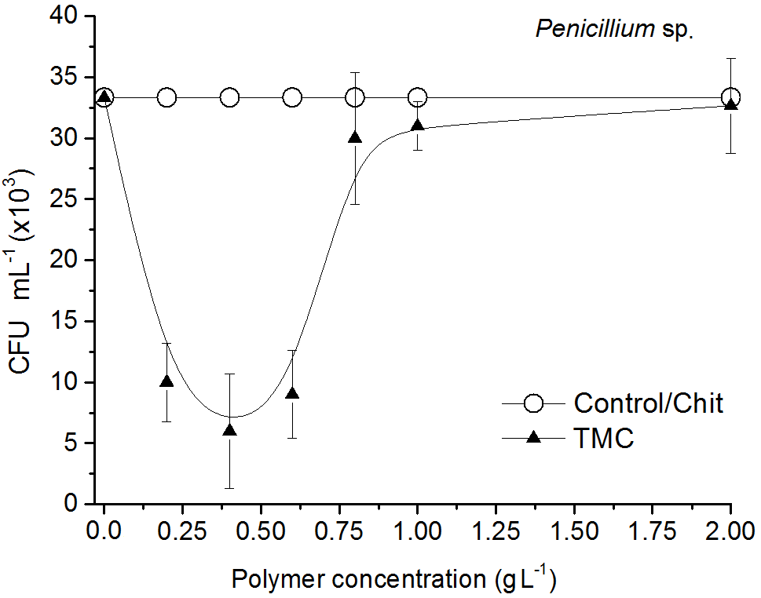

Figure 1. Colony forming units (CFUs) of fungi related to polymer concentration in the gel, as measured by UV spectroscopy. For other strains, no activity was observed in this range.

The reduction of the antifungal inhibition as TMC concentration increases in the medium, as observed against the Penicillium sp. (Figure 1), can be understood in terms of two interrelated processes:
i) The spatial arrangement of the polymer chains. TMC is a reactive polymer and at low diluted concentrations, a small number of primary inter-chain interactions are established, so the TMC charged sites available for external coupling are maximized. As the polymeric concentration increases, there is an increase in the hydrodynamic volume per unit of molecular weight. Such an increase of mass favors interactions between ionic groups located in the same or in different chains leading to the formation of coils densely overlapped (Freitas et al., 2010). The extensive chain entanglement causes the polymer to collapse in a smaller configuration (Wyatt et al., 2011), reducing the overall interaction to fungal surface. This effect was also observed when assaying TMC against bacteria (Goy and Assis, 2014);
ii) The gradual weakening as the concentration increases has also been interpreted as a consequence of the elution of chitonolytic enzymes that hydrolyze Chit-based polymers into reduced sugars and D-glucosamine unities (Wang et al., 2008). Such fractions can be further utilized as nutriments accelerating microorganism growth. Li et al. (2008) report such behavior in assaying Chit against Aspergillus niger, whose maximum activity was at a concentration of 1.0 to 2.0 gl⁻¹ followed by a gradual fungal growth as the polymer concentration increases. Further investigation is needed to better understand this behavior.
No significant reduction in fungal growth was observed when using only acetic acid, indicating that the solvent had little or no effect on the measured antimicrobial activity.

In vivo analyses

In solid form, as edible coatings on cut cherry tomatoes, both polymers exerted inhibitory activity against the inoculated fungi (at 2.0 gl⁻¹). In Table 2, the mean values of proportional infected samples are listed as recorded every day, in each group, for one week.
The chitosan coating (Chit) acted more effectively than TMC with a proportionally reduced number of infected samples for the inoculated fungus.

Table 2. Fractions of infected samples, as recorded each day for one week, in function of the coating material and inoculated fungus.

Aspergillus flavus ATCC 14108
Infected samples (%)
Day | Control* |  | TMC | Chit
1 | 2 ± 1.47ª |  | 0ª | 0ª
2 | 91 ± 4.72ª |  | 37.67 ± 4.04^{b} | 8.34 ± 4.04^{c}
3 | 95.34 ± 5.16ª |  | 57.67 ± 4.04^{b} | 15.34 ± 5.14^{c}
4 | 97.67 ± 4.12ª |  | 75.34 ± 5.14^{b} | 17.67 ± 8.08^{c}
5 | 97.67 ± 4.04ª |  | 84.34 ± 7.50^{b} | 24.34 ± 7.33^{c}
6 | 100ª |  | 95.35 ± 3.74ª | 24.33 ± 7.50^{b}
7 | 100ª |  | 95.34 ± 3.97ª | 35.34 ± 4.04^{b}
Aspergillus flavus (wild strain)
 | Control | TMC |  |  | Chit
1 | 2 ± 2.00^{d} | 0^{d} |  |  | 0^{d}
2 | 91 ± 3.47^{d} | 29.00 ± 3.72e |  |  | 4.00 ± 3.46^{f}
3 | 95.34 ± 5.16^{d} | 51.00 ± 3.47e |  |  | 8.34 ± 4.04^{f}
4 | 97.67 ± 4.14^{d} | 89.34 ± 4.02e |  |  | 10.67 ± 4.08^{f}
5 | 97.67 ± 3.93^{d} | 93.34 ± 6.50^{d} |  |  | 17.67 ± 4.74e
6 | 100^{d} | 95.33 ± 3.04^{d} |  |  | 17.67 ± 3.98e
7 | 100^{d} | 97.67 ± 4.74^{d} |  |  | 24.67 ± 4.12e
Table 2. Continued.

Penicillium sp (wild strain)
 | Control | TMC | Chit
1 | 2 ± 1.64^{g} | 4 ± 3.47^{g} | 2 ± 1.64^{g}
2 | 91 ± 3.07^{g} | 57.67 ± 8.08^{h} | 8.33 ± 4.02^{i}
3 | 95.67 ± 4.04^{g} | 71.34 ± 7.54^{h} | 17.67 ±4.24^{i}
4 | 97.67 ± 4.14^{g} | 71.34 ± 7.08^{h} | 17.67 ± 4.02^{i}
5 | 97.67 ± 3.93^{g} | 82.34 ± 4.74^{h} | 24.67 ± 4.50^{i}
6 | 100^{g} | 82.34 ± 3.98^{h} | 26.67 ± 6.50^{i}
7 | 100^{g} | 87 ± 3.46^{h} | 31 ± 3.46^{i}
*non-coated samples. Means in the same line with different letters are statistically different at p<0.05.

The daily evolution in the number of infected samples is best visualized in graphical form, as shown in Figure 2, on control and on coated surfaces inoculated with Aspergillus (standard (a) and wild strain (b)). The fungal inhibition was similar against both strains, indicating the same mechanism of action, and changes in the kinetic models promoted by the coatings can be clearly observed in all tested samples. Control (non-coated) tomatoes resulted in an exponential growth with almost all samples infected by the second to third day after inoculation. The TMC coating promoted a reduction, following a quasi-exponential mode with an inferior number of samples infected over time. Finally, the Chit-coating resulted in a linear relationship with a significant reduction in the number of samples infected (more than 60% at the end of seven days). In short, the TMC coating provided a measurable reduction in fungal spreading, mainly in the first four to five days, though the Chi coatings were more efficient in limiting overall contamination.

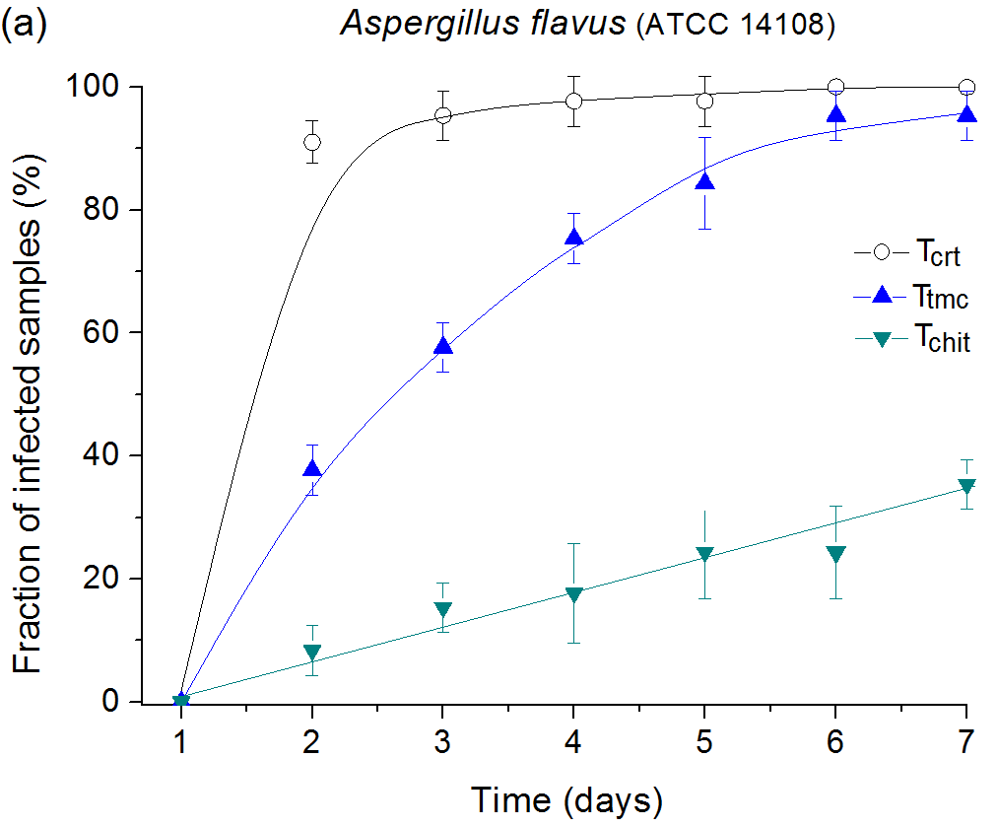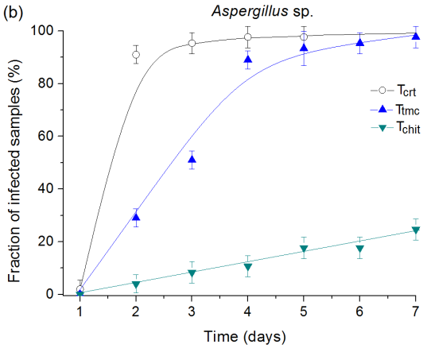

Figure 2. Fractions of infected samples by Aspergillus flavus (a) and Aspergillus sp. (b) as measured on cut tomato surfaces uncoated and coated with Chi and
TMC (2.0 gl⁻¹) as a function of the storage time at 30°C
(identification of samples as in Table 1).
Similar behavior was observed in samples inoculated with Penicillium sp., as shown in Figure 3. For this strain, the TMC coating reduced approximately 20% of the total of infected samples by the end of one week when compared to uncoated samples.
The Chit, however, was highly effective. Figure 4 illustrates the aspects of some samples with TMC and Chit after seven days of Penicillium inoculation, confirming the better antifungal properties of Chi gel as a coating.
This higher protection of Chit when compared to the TMC coating could not have been predicted by the in vitro analyses. Several factors, however, can be identified that directly or indirectly must be considered in interpreting this result. Firstly, the degree of quaternization of TMC derivative deeply alters the polymeric water affinity. As the degree of quaternization increases, the water retention will be higher in the matrix, and thus surface hydrophilicity and gas permeability.

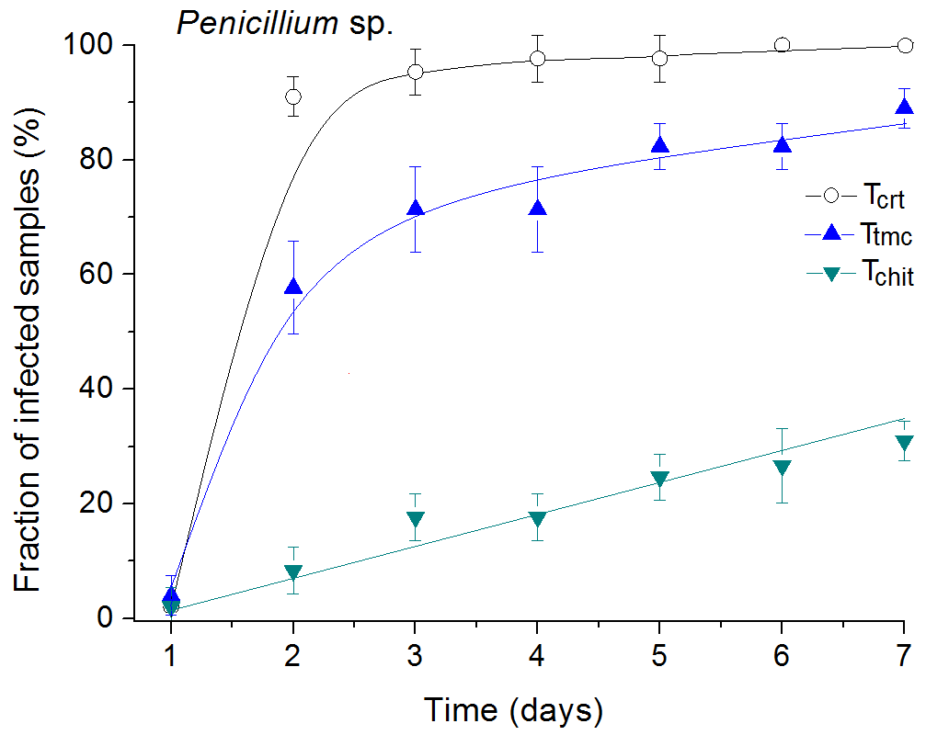

Figure 3. Fraction of infected samples by Penicillium sp., as measured on cut tomato surfaces uncoated and coated with Chi and TMC (2.0 gl⁻¹) as a function of the storage time at 30°C (identification of samples as in Table 1).

In the synthesis conducted in this work, the average degree of quaternization was around 35% (Britto and Assis, 2007), i.e. at least 35% of the primary amino groups of the precursor Chit polymer were converted to quaternary amines. Such an increase of charges favors the electrostatic repulsions between chains, contributing to the formation of a less compact network (Huei and Hwa, 1996). Less dense films lead to matrix instability by facilitating water uptake, causing swelling, and consequently increase the diffusion of water molecules through the coating network (Uragami et al., 2002).
Secondly, the quaternization reaction occurs by electrophilic substitution of nitrogen, liberating H⁺ as a byproduct. An excess of H⁺ causes breaking of the glycosic bonds resulting in a derivative with low molecular weight. Commercial chitosan has a molecular weight of 400,000 g mol⁻¹, while for the TMC the average weight is around 55,000 g mol⁻¹ (Britto et al., 2011). As characterized by Bof et al. (2015), regarding Chit films, the higher the molecular weight, the lower will be the water vapor permeability, since higher molecular weight leads to a more effective polymer chain arrangement with fewer interstitial spaces.

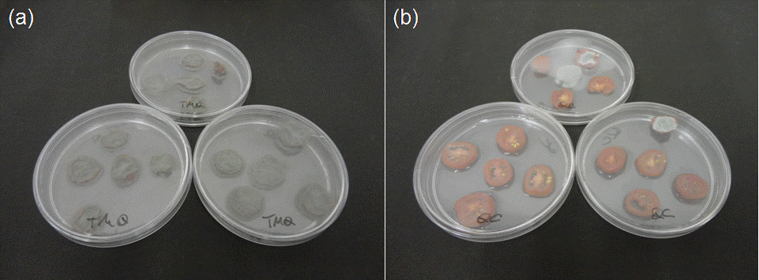

Figure 4. Visual aspect of samples coated with TMC (a) and Chit (b) after seven days of Penicillium incubation at 30 °C. It is possible to observe the
effectiveness of the Chit coating in reducing fungal infestation.
By this time, all control samples were also infected.

TMC films are also characterized by having a high degree of wetting (elevated surface hydrophilicity) than chitosan films (Britto and Assis, 2010). This also contributes to maintaining the relative physiological conditions, i.e., water in surface is favorable for spore germination and fungi growth. It should be observed that there is a direct relationship between the amount of available water in one surface and the average growth rate of Aspergillus and Penicillium species (Ayerst, 1969).
Such features, which are only detectable in solid state (coating format), differ from the properties initially assessed in gel form, in which Chit and TMC present similar antifungal activities. TMC coatings have been reported to be successfully used in the protection of vitamins (Britto et al., 2012), as a carrier system of vaccines (Nnamani et al., 2011) and for general drug delivery (Mourya and Inamdar, 2009). However, for an effective application on food products, the association of TMC with other less hydrophilic polymers, such as PLA or even non-quaternized chitosan, can be an alternative to overcome the negative effects caused by its high solubility.
Conclusion

The antifungal tests (under the present experimental conditions) did not identify a clear difference between commercial chitosan (Chit) and its quaternized derivative N,N,N-trimethylchitosan (TMC), when in gel form, in inhibiting the germination of Aspergillus and Penicillium species. The MIC stipulated for both polymers in BHI culture medium was greater than 2.0 gl⁻¹. Of interest is that the diluted TMC (in concentrations between 0.2 and 0.6 g.l⁻¹) demonstrated fungistatic activity against Penicillium sp., although with no activity outside this range. When gels at a concentration of 2.0 gl⁻¹ were applied to form edible coatings on cut cherry tomatoes, both polymers demonstrated activity against inoculated Aspergillus and Penicillium. The derivative TMC slowed the kinetics of growth, mainly in the first four days of storage, but with steady growth on subsequent days. Chit coatings performed better by reducing significantly the number of infested samples (to 20% for the tested microorganisms in the same period assessed). This is understood to be due to terms of polymer physical-chemical interaction in film forming.
In conclusion, commercial chitosan with medium molar weight, despite its low solubility and low number of charged sites, was effective in controlling fungal infections on cut cherry tomatoes. The feasibility of using Chit in forming protective coatings is confirmed for commercial application in processed tomatoes during storage and/or marketing.

Acknowledgments

This research was supported by CNPq, Embrapa Rede AgroNano and MCTI/SisNANO (National System of Laboratories in Nanotechnology).

References

Ali, A., Maqbool, M., Ramachandran, S., & Alderson, P. G. (2010). Gum arabic as a novel edible coating for enhancing shelf-life and improving postharvest quality of tomato (Solanum lycopersicum L.) fruit. Postharvest Biology and Technology, 58, 42-47.
Avina, J.E.J.D., Rodriguez, J.V., Valenzuela, R.C., Armenta, M. R., Diaz, M.E., Zavala, J.F.A., Orozco, G.I.O., Heredia, B., & Aguilar, G.G. (2011). Effect of edible coatings, storage time and maturity stage on overall quality of tomato fruits. American Journal of Agricultural and Biological Science, 6, 162-171.
Ayerst, G. (1969). The effects of moisture and temperature on growth and spore germination in some fungi. Journal of Stored Products Research, 5, 127-141.
Balouiri, M., Sadiki, M., & Ibnsouda, S.K. (2016). Methods for in vitro evaluating antimicrobial activity: A review. Journal of Pharmaceutical Analysis, 6, 71-76.
Bautista-Baños, S., Hernández-Lauzardo, A. N., Velázquez-del Valle, M.G., Hernández-López, M., Ait Barka, E., Bosquez-Molina, E., & Wilson, C.L. (2006). Chitosan as a potential natural compound to control pre and postharvest diseases of horticultural commodities. Crop Protection, 25, 108-118.
Barka, E. A., Eullaffroy, P., Clément, C., & Vernet, G. (2004). Chitosan improves development, and protects Vitis vinifera L. against Botrytis cinerea. Plant Cell Reports, 22, 608-614.
Bartnicki-Garcia, S. (1968). Cell wall chemistry, morphogenesis, and taxonomy of fungi. Annual Reviews Microbiology, 22, 87-108.
Belalia, R., Grelier, S., Benaissa, M., & Coma, V. (2008). New bioactive biomaterials based on quaternized chitosan. Journal of Agricultural and Food Chemistry, 56, 1582-1588.
Bof, M.J., Bordagaray, V.C., Locaso, D.E., & García, M.A. (2015). Chitosan molecular weight effect on starch-composite film properties. Food Hydrocolloids, 51, 281-294.
Britto, D., & Assis, O.B.G. (2007). A novel method for obtaining quaternary salt of chitosan. Carbohydrate Polymers, 69, 305-310.
Britto, D., & Assis, O.B.G. (2010). Hydrophilic and morphological aspects of films based on quaternary salts of chitosan for edible applications. Packaging Technology and Science, 23, 111-119.
Britto, D., Frederico, F.R., & Assis, O.B.G. (2011). Optimization of N,N,N-trimethylchitosan synthesis by factorial design. Polymer International, 60, 910-915.
Britto, D., Moura, M. R., Aouda, F. A., Mattoso, L. H. C., & Assis O. B. G. (2012). N,N,N-trimethyl chitosan nanoparticles as a vitamin carrier system. Food Hydrocolloids, 27, 487-493.
Cheng, C.Y., & Li, Y-K. (2000). An Aspergillus chitosanase with potential for large-scale preparation of chitosan oligosaccharides. Biotechnology and Applied Biochemistry, 32, 197–203.
Cota-Arriola, O., Cortez-Rocha, M.O., Rosas-Burgos, E.C., Burgos-Hernández, A., López-Franco, Y. L., & Plascencia-Jatomea, M. (2011). Antifungal effect of chitosan on the growth of Aspergillus parasiticus and production of aflatoxin B1. Polymer International, 60, 937-944.
El Ghaouth, A., Ponnampalam. R., Castaigne. F., & Arul, J. (1992). Chitosan coating to extend the storage life of tomatoes. HortScience, 27, 1016-1018.
EUCAST-AFST. (2008). European Committee for Antimicrobial Susceptibility Testing. EUCAST Definitive Document EDef 7.1: Method for the determination of broth dilution MICs of antifungal agents for fermentative yeasts: Subcommittee on antifungal susceptibility testing (AFST) of the ESCMID European Committee for Antimicrobial Susceptibility Testing (EUCAST). Clinical Microbiology and Infection, 14, 398-405.
FAOSTAT. Food and Agriculture Organization of the United Nations. (2013). Retrieved April, 4, 2016 from http://faostat.fao.org
Freitas, R.A., Drenski, M.F., Alb, A.M., & Reed, W.F. (2010). Characterization of stability, aggregation, and equilibrium properties of modified natural products; The case of carboxymethylated chitosans. Materials Science and Engineering: C, 30, 34-41.
Goy, R.C., Britto, D., & Assis, O.B.G. (2009). A review of the antimicrobial activity of chitosan. Polímeros: Ciência e Tecnologia, 19, 241-247.
Goy, R.C., & Assis, O.B.G. (2014). Antimicrobial analysis of films processed from chitosan and N,N,N-trimethylchitosan. Brazilian Journal of Chemistry Engineering, 31, 643-648.
Huei, C.R., & Hwa, H-D. (1996). Effect of molecular weight of chitosan with the same degree of deacetylation on the thermal, mechanical, and permeability properties of the prepared membrane. Carbohydrate Polymers, 29, 353-358.
Li, X-F., Feng, X-Q., Yang, S., Wang, T-P., & Su, Z-X. (2008). Effects of molecular weight and concentration of chitosan on antifungal activity against Aspergillus niger. Iranian Polymer Journal, 17, 843-852.
Liu, J., Tian, S., Meng, X., & Xu, Y. (2007). Effects of chitosan on control of postharvest diseases and physiological responses of tomato fruit. Postharvest Biology and Technology, 44, 300-306.
Llop, C., Pujol, I., Aguilar, C., Sala, J., Riba, D., & Guarro, J. (2000). Comparison of three methods of determining MICs for filamentous fungi using different end point criteria and incubation periods. Antimicrobial Agents and Chemotherapy, 44, 239-242.
Lopes, A.I.R. (2013). Application of chitosan in the control of fungal infections by dermatophytes. (M.Sc. Thesis). Porto, Portugal: Catholic University of Portugal.
Nnamani, P. O., Scoles, G., & Kröl, S. (2011). Preliminary characterization of N-trimethylchitosan as a nanocarrier for malaria vaccine. Journal of Vector Borne Diseases, 48, 224-230.
Mourya, V. K., & Inamdar, N.N. (year??). Trimethyl chitosan and its applications in drug delivery. Journal of Materials Science: Materials in Medicine, 20, 1057-1079.
Park, H.J., Chinnan, M.S., & Shewfelt, R.L. (1994). Edible coating effects on storage life and quality of tomatoes. Journal of Food Science, 59, 568-570.
Qin, C., Li, H., Xiao, Q., Liu, Y., Zhu, J., & Du, Y. (2006). Water-solubility of chitosan and its antimicrobial activity. Carbohydrate Polymers, 63, 367-374.
Qiu, M., Wu, C., Ren, G., Liang, X., Wang, X., & Huang, J. (2014). Effect of chitosan and its derivatives as antifungal and preservative agents on postharvest green asparagus. Food Chemistry, 155, 105-111.
Sajomsang, W., Gonil, P., Saesoo, S., & Ovatlarnporn, C. (2012). Antifungal property of quaternized chitosan and its derivatives. International Journal of Biological Macromolecules, 50, 263-269.
Santos, N.S.T., Aguiar, A.A.J.A., Oliveira, C.E.V., Sales, C.V., Melo e Silva, S., Silva, R.S., Stamford, T.C.M., & Souza, E.L. (2012). Efficacy of the application of a coating composed of chitosan and Origanum vulgare L. essential oil to control Rhizopus stolonifer and Aspergillus niger in grapes (Vitis labrusca L.). Food Microbiology, 32, 345-353.
Singh, K., Frisvad, J.C., Thrane, U., & Mathur, S.B. (1991). An illustrated manual on identification of some seed-borne Aspergilli, Fusaria, Penicillia and their mycotoxins. Danish Government Institute of Seed Pathology for Developing Countries, Technical Bulletin, 133p.
Souza, R.H.F.V., Takaki, M., Pedro, R.O., Gabriel, J.S., Tiera, M.J., & Tiera, V.A.O. (2013). Hydrophobic effect of amphiphilic derivatives of chitosan on the antifungal activity against Aspergillus flavus and Aspergillus parasiticus. Molecules, 18, 4437-4450.
Tan, H., Ma, R., Lin, C., Liu, Z., & Tang, T. (2013). Quaternized chitosan as an antimicrobial agent: Antimicrobial activity, mechanism of action and biomedical applications in orthopedics. International Journal of Molecular Sciences, 14, 1854-1869.
Tsai, G-J., Su, W-H., Chen, H-C., & Pan, C-L. (2002). Antimicrobial activity of shrimp chitin and chitosan from different treatments and applications of fish preservation. Fisheries Science, 68, 170-177.
Uragami, T., Takuno, M., & Miyata, T. (2002). Evapomeation characteristics of cross-linked quaternized chitosan membranes for the separation of an ethanol/water azeotrope. Macromolecular Chemistry and Physics, 203, 1162-1170.
Wang, L., Wu, H., Qin, G., & Meng, X. (2014). Chitosan disrupts Penicillium expansum and controls postharvest blue mold of jujube fruit. Food Control, 41, 56-62.
Wang, J., Zhou, W., Yuan, H., & Wang, Y. (2008). Characterization of a novel fungal chitosanase Csn2 from Gongronella sp. JG. Carbohydrate Research, 343, 2583-2588.
Wyatt, N.B., Gunther, C.M., & Liberatore, M.W. (2011). Increasing viscosity in entangled polyelectrolyte solutions by the addition of salt. Polymer, 52, 2437-2444.

Received: July 19, 2017
Accepted: May 11, 2018

ANTIGLJIVIČNO DEJSTVO HITOZANA I NJEGOVOG KVATERNIZOVANOG DERIVATA U OBLIKU GELA I KAO JESTIVE PREVLAKE NA ISEČENOM PARADAJZU

Leandro P. da Silva¹, Tamires A. Bitencourt², Ana L. F. Saltoratto²,
Mirna H. R. Seleghim¹ i Odílio B. G. Assis³*

¹Federalni univerzitet São Carlos, Biotehnologija PPG,
Rod Washington Luis, km 235, 13565-905 São Carlos, SP, Brazil
²Univerzitet Ribeirão Preto, Laboratorija za bionauke,
Av Costábile Romano, 2201, 14096-900 Ribeirão Preto, SP, Brazil
³Embrapa Instrumentation, Nacionalna nanotehnološka laboratorija za poljoprivredu (LNNA), Rua XV de Novembro, 1452, 13560-970 São Carlos, SP, Brazil

R e z i m e

Antigljivična dejstva hitozana srednje molekulske mase i njegovog derivata soli rastvorljivog u vodi N,N,N-trimetilhitozan ispitivana su kao gel i kao čvrsta zaštitna prevlaka u odnosu na tri uobičajene gljive koje izazivaju kvarenje hrane (Penicillium sp., Aspergillus sp. i jedan standardni soj Aspergillus flavus). Derivat soli poseduje stalno pozitivno naelektrisanje kao i očekivano veće antimikrobno dejstvo nego kod komercijalnog hitozana. U obliku gela, minimalna inhibitorna koncentracija (engl. minimum inhibitory concentration ‒ MIC) rezultirala je istom vrednošču za oba polimera u odnosu na testirane gljive (> 2,0 gl⁻¹). Derivat je pokazao značajno fungistatičko dejstvo u odnosu na soj Penicillium u okviru opsega koncentracije od 0,2 do 0,6 gl⁻¹. Kada se upotrebi kao zaštitna prevlaka na sveže isečenom paradajzu, komercijalni hitozan se pokazao efikasnijim u stvaranju stabilnih filmova i sprečavanju gljivične infekcije od svog derivata. Manje od 20‒25% uzoraka bili su zaraženi posle jednonedeljne inkubacije u poređenju sa kontrolom (neobloženi uzorci) i uzorcima koji su tretirani hitozanom.
Ključne reči: hitozan, antigljivično dejstvo, jestive prevlake, minimalno obrađen paradajz.

Primljeno: 19. jula 2017.
Odobreno: 11. maja 2018.

*Corresponding author: e-mail: odilio.assis@embrapa.br
*Autor za kontakt: e-mail: odilio.assis@embrapa.br

