SOIL MOISTURE INDUCED GENOTYPE-BY-ENVIRONMENT INTERACTION FOR ROOT VOLUME OF UPLAND RICE

Adesola L. Nassir, Kayode M. Adewusi and Solomon O. Olagunju

Department of Crop Production, Faculty of Agricultural Production and Renewable Resources, College of Agricultural Sciences, Olabisi Onabanjo University,
Yewa Campus, Ayetoro, Ogun State, Nigeria

Abstract: Sixteen rice genotypes comprising established cultivars, recent releases and breeding lines were established in the greenhouse under different moisture levels, obtained from a combination of the amount and number of times of moisture application to study genotype-by-environment interaction (GEI) for root volume (RV), and also probe into the level of moisture imposition, that would be adequate for screening of genotypes for response to moisture stress. Across the simulated environments, WAB 880-9-32-1-1-12-HB had the largest root volume of 8.71 cm³, whereas ITA 257 had the lowest (4.89 cm³). Genotype (G) accounted for significant (P < 0.001) 10.6%, environment (E) (P < 0.001) captured 79.0%, and GEI (P < 0.001) 10.4% of the total sum of squares. The GGE biplot captured 82% of the G+GE and clustered the environments into two groups, with OS 6 being the best for RV in the rainfed environment (E10). WAB 880-9-32-1-1-12-HB recorded the best RV under environments with adequate to limited moisture, but was less stable, and recorded grain production (13.5 g/plant) close to the best mean of 16.0g/plant by ITA 150 and 14.1 g/plant by IRAT 170. Environments were generally positively correlated with vegetative and yield traits, but E2 (100% moisture requirement applied once in two weeks) was more representative of the screening condition while E10 (rainfed) was highly discriminating, and would be appropriate for discarding genotypes with poor RV. Overall, E1, E2, E4 and E7 were identified as moisture conditions that are appropriate for selection of genotypes for general adaptation for RV within the overall goal of developing drought tolerant rice.
Key words: GGE, drought tolerance, grain yield, Oryza sativa, Oryza glaberrima, stability.

Introduction

Rooting and related traits in rice have received some amount of attention in the development of drought tolerant genotypes of rice. The importance of root traits for drought adaptation is premised on the ability to scout for soil moisture-based nutrient solution under drought conditions which occur at different stages of growth (Kamoshita et al., 2008). Water stress can reduce grain filling to zero, and can significantly reduce harvest index (Boonjung and Fukai, 1996; Bouman et al., 2006; Kato et al., 2006). Fukai and Cooper (1995) had discussed the importance of deep roots to improved water uptake under drought conditions. Wang et al. (2009) observed a marked reduction in root length (nodal and lateral) as a consequence of drought. Conversely, a progressive increase in root length and depth with the onset of drought leads to root modifications: shoot biomass partitioning as reported by Price et al. (2002) and Asch et al. (2005). Improvement of a large and deep root system of rice in order to capture more soil solution, especially under drought, would stabilise grain yield (Kondo et al., 2003).
Differences in genotypes for root density and ability to surmount soil resistance were reported by Cairns et al. (2009) although a significant interaction of site and root density was not observed. Price et al. (2002) observed a significant interaction of the type of drought and influence of year on root length and root thickness in the F₆ population, but not consequently on the two established lines, exposed to different drought simulations. Kondo et al. (2003) also reported a significant genotype-environment interaction for root dry weight under different soil conditions, and in addition, differences in the structure of genotype-environment interaction for root traits. The difference in root architecture which translated to the differential ability of genotypes to utilise soil moisture, and hence exhibited drought tolerance, was reported by Wang et al. (2009). Nassir and Adewusi (2015) reported differences in the pattern of response of root traits of rice to drought across upland soil moisture conditions. Whilst genotype responses in terms of root volume and root fresh weight appeared to be similar in their reaction to moisture limitation, the reaction and classification of genotypes were markedly different for root thickness and branching. Root volume is undoubtedly described by the number of roots (itself a function of branching), root length and root thickness, as conditional for both large root system and weight.
Genetic differences in root trait biology and its implication for drought response were extensively reviewed by Gowda et al. (2011). Extensive variation in rice root anatomical and morphological traits, and in their heritability, as reported, underscores the potential for further exploration of rice populations and traits in breeding efforts for rice tolerant cultivars. Further efforts to improve available drought tolerant rice cultivars have led to the expansion of the interspecific hybrid populations from Oryza sativa and O. glaberrima cross (Africa Rice Center [WARDA]/FAO/SAA, 2008). Selections that vary in a number of agronomic traits have been made, some of which have been released for cultivation in the upland ecology. The upland ecology is, however, characterised by variation in soil water within the growing season and this is occasioned by inconsistency in rainfall, both magnitude and spread. Some of the traits specific to the upland ecology include earliness, tallness to compete favourably with weeds, resistance to blast, insects and lodging, good tillering erect leaf angle, compact and well exserted panicles. Obviously, rice populations are in a constant flux in terms of their genetic traits and their adaptations, especially to water-limited environments.
An assessment of genotype and cultivation (test) environment is one of the features of genotype-by-environment analysis of root traits using the biplot method (Gauch, 2006; Yan et al., 2000; 2007). The method has proved useful in grouping environments and eliminating redundant ones. The range of moisture stress encountered on the field and the cumulative effect of the adequate-inadequate moisture flux on root volume, as a function of the plant ability to survive drought, require investigation by using variable genotypes. The moisture difference is, however, a major contributor to the location effect on crop performance in the tropics. Kato et al. (2006) have affirmed that yield stability under variable soil moisture regimes represents a putative plant attribute for developing superior upland varieties. The aims of this research were to: 1) use disparity in water availability to rice genotypes to create different water-based ‘environments’ and examine the response of rice genotypes in terms of root volume differences under variable moisture conditions; 2) assess the stability of rice genotypes for root volume in ten moisture-based environments; 3) show the adaptability and heritability of rice genotypes in terms of root volume under ten moisture-based environments, and 4) select environments with the best discriminatory ability and representativeness for root volume of rice.

Materials and Methods

Sixteen rice genotypes developed for upland cultivation were obtained from the New Africa Rice Centre at the International Institute for Tropical Agriculture (IITA), Ibadan, Nigeria. The genotypes include NERICA releases (from interspecific Oryza sativa × Oryza glaberrima crosses) and other Oryza sativa selections. NERICAs 1‒5 are selections from WAB 56-104 × CG 14 cross. WAB 880 series are selections from WAB 56-50 × CG 14. WAB 56-50 is from IDSA6 (Columbia) × IAC 164 (Liberia). WAB 181 and other WAB parentage are not clear but are breeding line selections from IDSA 6 and IAC 164 (Africa Rice Centre [WARDA]/FAO/SAA, 2008). The genotypes with their designation, origin and status are presented in Table 1.
The study was conducted in the greenhouse of the College of Agricultural Sciences, Olabisi Onabanjo University, Ayetoro, which is located in a derived savannah ecology of South Western Nigeria (7°14'17''N 3°2'42''E). The location had a total rainfall of 654.8 mm, mean relative humidity of 78.7% and average temperature of 29.2 ⁰C over the four-month study duration (May–August, 2014). Three-week-old rice seedlings of the studied genotypes were transplanted in replicates onto black polythene bags, measuring 28 cm in diameter and 28 cm in depth, previously filled with 5 kg of loam top soil, obtained from the upland paddy. All plants had adequate moisture up to two weeks after transplanting.

Table 1. Genotypes used in the study with their designation, origin and status.

Genotype | Designation | Origin | Status
WAB 880-9-32-1-1-12-HB | G1 | Cote D’Ivoire | Breeding line
NERICA 1 (WAB 450-1-B-38-HB) | G2 | Cote D’Ivoire | Recent release
ITA 150 | G3 | Nigeria | Established line
WAB 56-50 | G4 | Cote D’Ivoire | Breeding line
NERICA 2 (WAB 450-11-1-P31-1-HB) | G5 | Cote D’Ivoire | Recent release
NERICA 3 (WAB 450-1-B-P-28-HB) | G6 | Cote D’Ivoire | Recent release
WAB 224-8-HB | G7 | Cote D’Ivoire | Breeding line
NERICA 4 (WAB 450-1-B-P-91-HB) | G8 | Cote D’Ivoire | Recent release
ITA 321 | G9 | Nigeria | Established line
NERICA 5 (WAB 450-11-1-P31-HB) | G10 | Cote D’Ivoire | Recent release
WAB 189-B-B-B-HB | G11 | Cote D’Ivoire | Breeding line
OS6 | G12 | Zaire | Established line
ITA 257 | G13 | Nigeria | Established line
WAB 337-B-B-20-1-129 | G14 | Cote D’Ivoire | Breeding line
IRAT 170 | G15 | Nigeria | Established line
WAB 181-18 | G16 | Cote D’Ivoire | Breeding line

The moisture treatments were thereafter imposed following a factorial arrangement of three water regimes and three times of application, between maximum tillering and maturity, to generate moisture mediated ‘environments’ (E). The previous pilot study at the location over the similar period had revealed moisture requirements to average 1.6 l per plant per week between tillering and maximum tillering stage; 2.4 l per plant per week at panicle initiation stage, and 3.2 l per plant per week at grain filling stage. Moisture-based environments E1, E2, and E3 received the full amount of moisture for each stage, applied twice weekly, once weekly, and once in two weeks, respectively. Moisture-based environments E4, E5, and E6 received 75% moisture twice weekly, once weekly, and once in two weeks, respectively. E7, E8, and E9 received 50% moisture applied twice weekly, once weekly, and once in two weeks, respectively. A set of each genotype was exposed entirely to rainfall at the E10 making a total of ten treatments. The imposition of drought for the purpose of investigation of drought tolerance, with the differential amount of moisture, is consistent with the study by Kamoshita et al. (2008). The pots were arranged following the randomised complete block design with three replications.
Data collection and analysis

Data collection on the vegetative traits and yield characters (grain weight per plant) was made as described by Anon (1988). After harvesting, the remaining plant parts were recovered by carefully washing off the soil from the roots. The shoot and the roots were separated, and used to obtain root volume, measured as the volume of displaced water when soil-free root was inserted in distilled water. The mean values of root volume were subjected to a combined analysis of variance. Genotype-by-environment analysis was done with the SAS software (Version 9.2). The additive main effect and multiplicative interaction (AMMI) and genotype and genotype-by-environment (GGE) analyses were done with the GGE biplot software following the models described by Zobel et al. (1988) and Yan et al. (2000; 2007).

Results and Discussion

Table 2 showed descriptive statistics for root volume of rice for ten environments.

Table 2. Descriptive statistics for root volume of rice for ten environments.

Environment | Label | Mean (cm³) | Min (cm³) | Max (cm³) | CV (%) | Heritability
1 | E1 | 8.1 | 5.1 | 13.0 | 8.41 | 0.938
2 | E2 | 8.7 | 5.4 | 12.8 | 8.18 | 0.956
3 | E3 | 3.5 | 1.5 | 5.6 | 15.90 | 0.794
4 | E4 | 6.6 | 3.8 | 11.0 | 11.07 | 0.918
5 | E5 | 6.9 | 4.3 | 10.9 | 7.17 | 0.959
6 | E6 | 3.0 | 1.8 | 4.7 | 13.31 | 0.894
7 | E7 | 4.8 | 2.6 | 10.4 | 13.36 | 0.938
8 | E8 | 4.2 | 2.6 | 7.7 | 11.89 | 0.917
9 | E9 | 1.9 | 0.3 | 6.1 | 23.76 | 0.951
10 | E10 | 12.1 | 7.9 | 18.4 | 6.40 | 0.977

Environment E10, which had superfluous rainfall over the study months, recorded the largest mean root volume of 12.1 cm³, with a range of 7.9 cm³ to 18.4 cm³. The lowest mean root volume of 1.9 cm³ (with a range of 0.3–6.1 cm³) was recorded in environment E9. Generally, a decline in root volume followed the gradient of a reduction in the volume of water and the times of application. This observation further confirms the injurious effect of within-season variation in moisture availability to rice plants, and necessitates the importance of developing varieties that can make the required adjustment such as to minimise the effect of such drought on grain yield. The decline also gives an indication of the large linear response of root volume to increasing or decreasing drought.
The coefficient of variation was generally low ranging from 6.4 for E10 to 23.76 for E9. The heritability estimates were high to very high in all environments, with the lowest of 0.794 for E3, and the highest of 0.977 for E10. By implication, the genotypes exhibited low variability in root volume within each of the environments, but the range of CV of 6.4 to 23.76 indicated large differences in root volume between environments, implying that differences in soil moisture conditions would influence genotypic selection for root volume. The minimal inconsistency in the heritability estimates along moisture gradients is an indication of genotype-environment and soil-moisture interactions in root volume expression.
Table 3 shows the genotype means and coefficient of variation (CV) for root volume (RV) and grain weight per plant (GWPP) across all test environments. The root volume for genotypes ranged from 4.89 cm³ for ITA 257 (G13) to 8.71 cm³ for WAB-9-32-1-1-12-HB (G1). The genotype coefficient of variability for root volume was high to very high. Grain weight per plant (GWPP), however, had exceptionally high CV in the range from 63 for ITA 150 (G3) to 130 for ITA 321 (G9). ITA 150 also recorded the largest GWPP of 15.99 g followed by IRAT 170 (G15) with 14.09 g. The lowest GWPP (7.37 g) was obtained for WAB 224-8-HB (G7). Root volume and grain weight per plant were significantly (P <0.01) correlated (r = 0.789), showing the opportunity for increasing both simultaneously. The relatively higher CV for GWPP by genotypes across environments points to the possibility of further selection for root volume and grain output. The significant positive correlation of the two traits would be an added advantage. Although the ability to produce deeper and thicker roots for the extraction of soil solution is a desirable feature (Fukai and Cooper, 1995; Kondo et al., 2003), the ability to scout for moisture with more soil-root contact, as mediated by higher root volume under challenging moisture conditions, would be quite important. Obviously, the genotype ability to scout for water is based on different root sizes and architectures (Wang et al., 2009), expressed here with the differences in root volume.
Table 4 presents AMMI analysis of variance for root volume of upland rice genotypes under different moisture-based environments. Genotype (G), environment (E) and G × E components were highly significant (P < 0.001), each accounting for 10.6%, 79%, and 10.4%, respectively, of the total sum of squares. The IPCA1 captured more than 50% of the G × E, with the first three axes jointly harbouring 81.3% of the interaction. The genotype and genotype-by-environment interaction (GGE) was responsible for 21% of the differential root volume observed.
The response to the environment was expectedly large, and normally would mitigate an equally large linear response of genotypes. The differences in genotypic and environmental proportion of G × E interaction for root traits have been reported by Kondo et al. (2003). The G × E was, however, considerable enough to necessitate a further analysis in order to identify genotypes that were both high performers and stable for root volume under different soil moisture conditions. The significant proportion of IPCA1 and IPCA2 to G × E interaction further alludes to the presence of both crossover and non-crossover interactions (Yan et al., 2007), and suggests the need for growing rice genotypes in multiple environments, in order to provide adequate conditions for genotype selection for root volume.

Table 3. Genotype means and coefficient of variation (CV) for root volume and grain weight per plant across all test environments.

Genotype | Label | Root volume (cm³) | CV (%) | Grain weight per plant (g) | CV (%)
WAB 880-9-32-1-1-12-HB | G1 | 8.71ª | 38 | 13.53^{b} | 85
NERICA 1 (WAB 450-1-B-38-HB) | G2 | 7.02^{c} | 63 | 12.21^{c} | 70
ITA 150 | G3 | 5.12^{fg} | 54 | 15.99ª | 63
WAB 56-50 | G4 | 4.91^{g} | 53 | 8.02^{gh} | 100
NERICA 2 (WAB 450-11-1-P31-1-HB) | G5 | 4.95^{g} | 45 | 7.80^{gh} | 106
NERICA 3 (WAB 450-1-B-P-28-HB) | G6 | 7.47^{b} | 58 | 9.02^{efg} | 75
WAB 224-8-HB | G7 | 5.64e | 47 | 7.37^{h} | 93
NERICA 4 (WAB 450-1-B-P-91-HB) | G8 | 5.55e | 57 | 8.93^{efg} | 66
ITA 321 | G9 | 7.54^{b} | 53 | 8.50^{fgh} | 130
NERICA 5 (WAB 450-11-1-P31-HB) | G10 | 5.33^{ef} | 44 | 10.46^{d} | 67
WAB 189-B-B-B-HB | G11 | 5.38^{ef} | 53 | 8.32^{fgh} | 90
OS6 | G12 | 6.06^{d} | 73 | 9.94de | 103
ITA 257 | G13 | 4.89^{g} | 66 | 9.66^{def} | 65
WAB 337-B-B-20-1-129 | G14 | 5.52e | 52 | 11.95^{c} | 87
IRAT 170 | G15 | 5.58e | 55 | 14.09^{b} | 103
WAB 181-18 | G16 | 6.18^{d} | 58 | 12.20^{c} | 101
a,b,c…are Duncan’s multiple range test (DMRT) values. Means marked with the similar alphabets are not significantly different from one another.

Table 4. AMMI analysis of variance for root volume of upland rice genotypes under different moisture-based environments.

Source | df | SS | MS | SS (%) | GE (%)
Total | 479 | 5433.391
Genotype | 15 | 564.8018 | 37.653*** | 10.6
Environments | 9 | 4195.079 | 466.120*** | 79.0
G x E | 135 | 550.67 | 4.079*** | 10.4
IPCA1 | 23 | 291 | 12.65*** |  | 52.8
IPCA2 | 21 | 101 | 4.79*** |  | 18.3
IPCA3 | 19 | 56 | 2.94*** |  | 10.2
IPCA4 | 17 | 48 | 2.81*** |  | 8.7
IPCA5 | 15 | 33 | 2.19*** |  | 6.0
IPCA6 | 13 | 12 | 0.93*** |  | 2.2
Residual | 27 | 10 | 0.38*** |  | 1.8
BLK(ENV) | 20 | 11.95292 | 0.597
Error | 300 | 110.887 | 0.37
***, significant at P < 0.001.
The additive main effect and multiplicative interaction (AMMI) biplot is shown in Figure 1. WAB 880-9-32-1-1-12-HB (G1) had the largest root volume and also showed positive interaction with E1, E4 and E5. G8, G13 and G15 had the below-average mean values for root volume and the positive interaction of these genotypes with any environment was absent. E10 recorded the highest root volume across all genotypes, and shared positive main effects and negative IPC1 with E2, interacting with G2, G6, G9, G12, G16 as the specifically adapted genotypes.
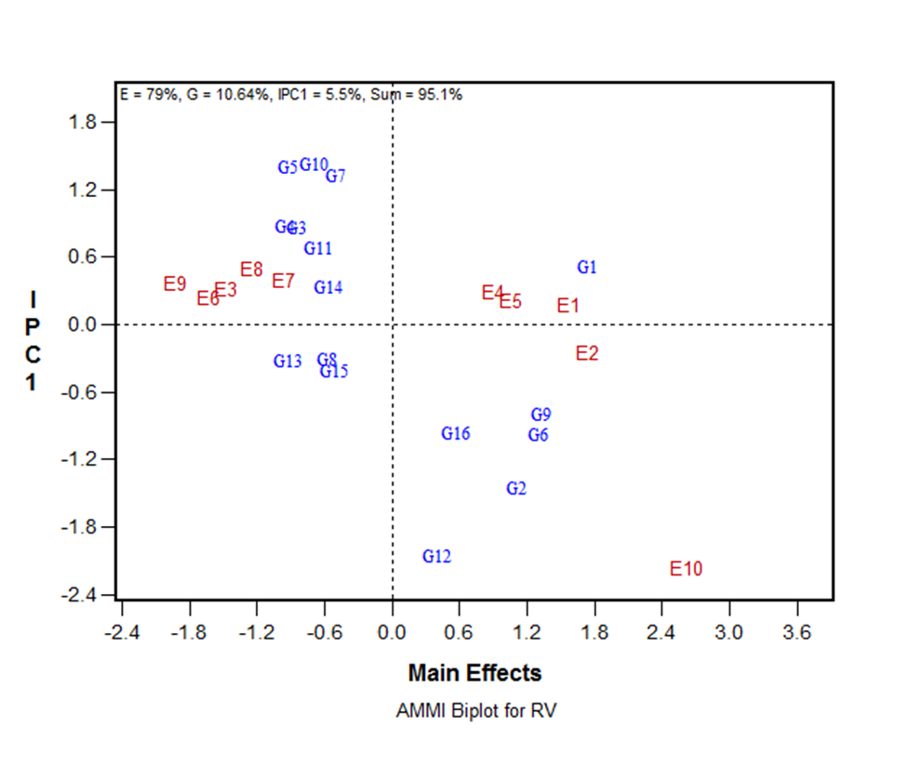
Figure 1. AMMI1 biplot of root volume of sixteen rice genotypes in ten moisture-based environments.
The other genotypes had the below-average mean root volume, but positive IPC1 scores, and were favourites in poor moisture environments represented by E3, E6, E7, E8 and E9.

The AMMI biplot separated genotypes based on mean root volume and interaction with environment. Genotypes with positive IPCA1 are expected to improve as the cultivation environment becomes better, whilst those with negative IPCA1 would do otherwise (Zobel et al., 1988; Samonte et al., 2005). Obviously, none of the genotypes had a good combination of larger and stable root volume, even though G1 appeared more acceptable, especially when the drought was not extreme, as depicted in environments E1, E5 and E4. The underlying necessity for a combination of good mean performance and stability for root volume is further made obvious.
The genotype and genotype × environment (GGE) biplot for root volume of sixteen rice genotypes in ten moisture-based environments captured 82% of the GGE (Figure 2), and classified the environments into two groups. An attempt to separate groups for analysis did not provide any meaningful gain in the genotype and environment classification; hence all environments were included in the analysis. In the group comprising all environments except E10, G1 was the superior genotype, whereas G6 and G9 were also in the sector. In environment E10, G12 was the best genotype regarding root volume, but with G8, G15 and G16 sharing this polygon sector. The genotypes in the sector, however, had low root volume, but G15, which had the lowest root volume, produced the second best grains after G1.
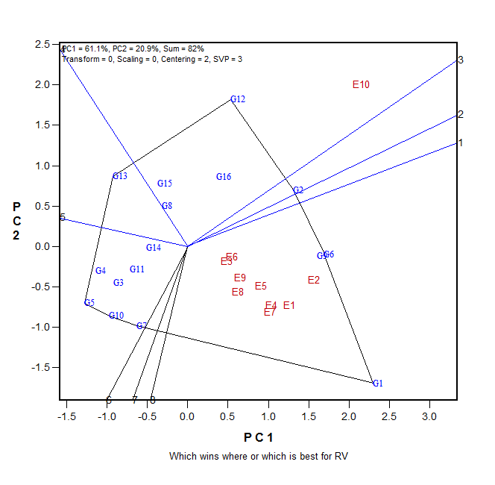
Figure 2. The genotype and genotype × environment (GGE) biplot for root volume of sixteen rice genotypes in ten moisture-based environments.

The G1 sector comprised environments with the highest to lowest amount of moisture, and those with the adequate to moderate amount of moisture (and by extension, moderate drought). Going by the underlying principle of the which-wins-where attribute of the GGE biplot (Yan et al., 2001; 2007), G1 appeared to be capable of above-average rooting under these moisture conditions. The PC1 of the GGE correlated significantly (P < 0.01, data not shown) with fresh root weight (0.972), fresh shoot weight (0.629), total fresh weight (0.774), indicating that the root volume performance also translated to higher values for other rice plant traits. In addition, root volume was significantly positively correlated (P < 0.01) with all vegetative and yield traits, with the highest correlation of 0.990 observed with grain weight per plant, while the lowest correlation of 0.775 was found with spikelet fertility. Genotypes G1 and G6 produced fewer grains on the average, compared to G3, and would probably benefit from introgression of gene from G3 for higher grain output. G12, G16, G15 and G8 would give higher root volume under higher moisture conditions typical of E10.
The mean versus stability view of GGE for root volume is displayed in Figure 3. Expectedly, G1 was identified as having the best root volume and was also less stable though better in this regard than most of the genotypes. G14 was the most stable but with below-average mean root volume compared to G1.
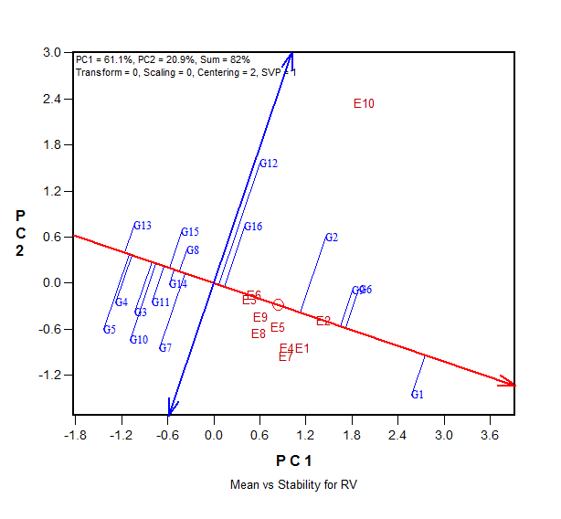
Figure 3. Genotype mean and stability for root volume of sixteen upland rice genotypes in ten moisture-based environments.
The ranking of genotypes relative to G3, an established upland cultivar with a record of good grain yield (Figure 4), and also an ideal genotype with both high mean performance and high stability across environments, confirms the above order of the genotypes in terms of mean performance. Only G14 was more stable than G1. Conversely, G12 was the most unstable, and thereby confirmed its inclusion in the E10 sector of the which-wins-where biplot. G1 had better stability compared to G3 and also better root volume. With introgression of traits for improved grain production, it may replace G3 in the ecology.
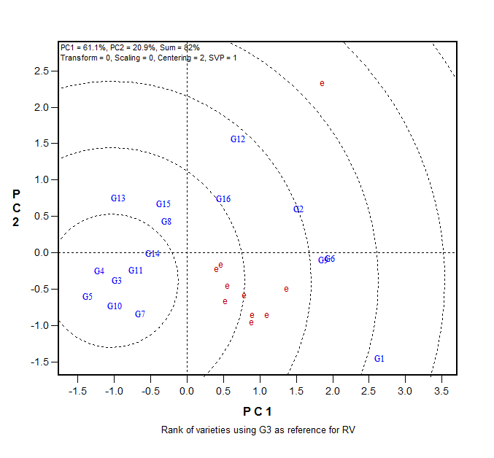
Figure 4. The genotypic relationship and ranking with ITA 150 (G3) as a reference.

Representativeness in that order. E2, however, appeared to be the best of the three by virtue of having the longest vector while E3 and E6 with short vectors may not elicit distinct differences between the genotypes.

By these observations, questions may be raised as to the possibility of some compensatory relationship between root volume and grain yield (Nassir and Ariyo, 2006). Although there was a significant positive relationship between root volume and grain yield indices in this study, the increased concentration of genes that consolidated the traits would further narrow the possible counteracting expression of the traits. Nonetheless, G1 and G14 merit further studies specifically for its use in developing varieties with a good combination of larger and stable root volume, on the one hand, and grain productivity on the other.
The discriminating ability vs. representativeness for root volume of rice is exhibited in Figure 5. The view allows the classification of the environments by their discriminating power, eliminating redundant test environments, and categorising their representativeness in evaluating genotypes based on the underlying objective (Yan et al., 2007). Environment subgroup 1 comprised all environments except E10 which is the only entry in subgroup 2. E10 had a combination of the long vector and large angle with the average environment coordinate (AEC) axis and was on the opposite side of the AEC line compared to subgroup 1. Subgroup 1 caused genotypes to have some of the poorest root volume in contrast to subgroup 2. The environments in subgroup 1 had short- to medium-length vectors, but relatively smaller angles with AEC, with E6, E2 and E3, thereby having the best
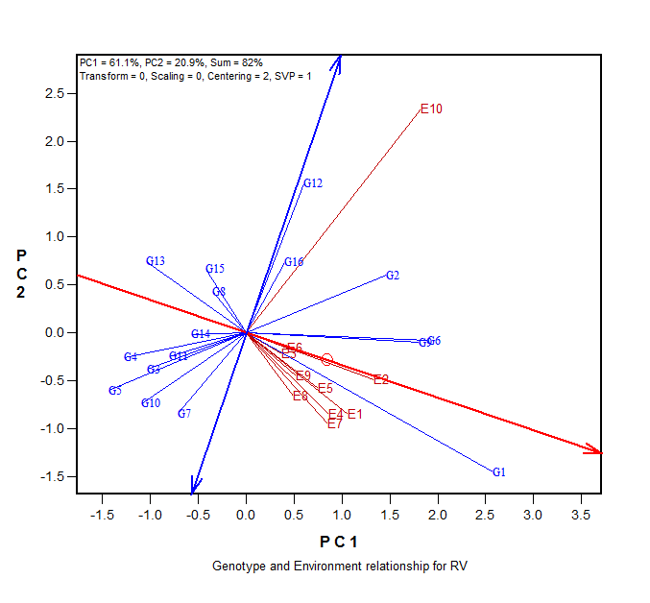
Figure 5. The discriminating ability vs. representativeness of the moisture environment for root volume of rice.

Environment 10 was obviously the most discriminating of the genotypes for root volume, whilst E2 was more representative of moisture-based environment for screening of rice genotypes for root volume. Clearly, there were duplications which necessitate dropping of some of the environments to save cost, and make the experiment more efficient and analysis more concise. For instance, E1 (full moisture, applied twice weekly), E2 (full moisture applied once weekly), E4 (75% moisture applied twice weekly) and E7 (50% moisture applied twice weekly) can be used while others (E3, E5, E6, E8 and E9) can be discarded without any loss in interpretation and decision making.

Conclusion

Variable soil moisture regimes/conditions created by a combination of the amount and times of water application to rice genotypes created different moisture environments that elicited both proportional and disproportional differences in root volume, hence the significant genotype-by-environment interaction. Studied genotypes expressed differences in root volume under the different moisture conditions, and offered insight into their use for development of genotypes with a stable response to root formation, and eventual plant performance under poor soil moisture conditions. The largest root volume was recorded in the rainfed environment and declined with reducing moisture. WAB 880-9-32-1-1-12-HB (G1) had the largest root volume of 8.71 cm³, recorded the third best grain production, but was less stable compared to WAB 337-B-B-20-1-129 (G14) which had low root volume. AMMI analysis captured 95.1% of the total variation but did not identify any genotype as having a combination of large and stable root volume. The GGE biplot summarised 82% of the G+GE and identified WAB 880-9-32-1-1-12-HB (G1) as the best genotype for root volume in environments with adequate to limited moisture. E10 (rainfed) was very discriminatory and would be appropriate for identifying unstable genotypes while E1 (full amount of moisture for each stage, applied twice weekly), E2 (full amount of moisture for each stage, applied once weekly), E4 (75% moisture applied twice weekly) and E7 (50% moisture applied twice weekly) (all with adequate to limited moisture) were more representative of screening environments for rice root volume.

References

Acuna, T.L.B., & Wade, L.J. (2012), Genotype × environment interactions for root depth of wheat. Field Crops Research, 137, 117-125.
Africa Rice Center (WARDA)/FAO/SAA (2008). NERICA: the New Rice for Africa – a Compedium. E. A. Somado, R. G. Guei and S. O. Keya (eds). Cotonou, Benin: Africa Rice Center (WARDA); Rome, Italy: FAO; Tokyo, Japan: Sasakawa Africa Association. 210 pp.
Anonymous (1988). Standard Evaluation System for Rice. 3rd Ed., IRRI, Philippine, pp: 54.
Asch, F., Dingkuhn, M., Sow, A., & Audebert, A. (2005), Drought-induced changes in rooting patterns and assimilate partitioning between root and shoot in upland rice. Field Crops Research, 93, 223-236.
Boonjung, H., & Fukai, S. (1996), Effects of soil water deficit at different growth stages on rice growth and yield under upland conditions: 2. Phenology, biomass production and yield. Field Crops Research, 48, 47-55.
Bose, L.K., Nagaraju, M., & Singh, O.N. (2012). Genotype x environment interaction and stability analysis of lowland rice genotypes. Journal of Agricultural Sciences, 57, (1), 1-8.
Bouman, B.A.M., Xiaoguang, Y., Huaqi, W., Zhimin, W., & Junfang, Z. (2006). Performance of aerobic rice varieties under irrigated conditions in North China. Field Crops Research, 97, 53-63.
Cairns, J.E, Acuña B.T.L., Simborio, F.A., Dimayuga, G., Lakshmi, Praba, M., Leung, H., Torres, R., & Lafitte, H.R. (2009), Identification of deletion mutants with improved performance under water-limited environments in rice (Oryza sativa L.). Field Crops Research, 114, 159-168.
Fukai, S., & Cooper, M. (1995), Development of drought - resistance cultivars using physiomorphological traits in rice. Field Crops Research, 40, 67-86.
Gauch, H.G. (Jnr) (2006). Statistical Analysis of Yield Trials by AMMI and GGE. Crop Science, 46, 1488-1500.
Gowda, V.R.P., Henry, A., Yamauchi, A., Shashidar, H.E., & Serraj, R. (2011), Root biology and genetic improvement for drought avoidance in rice. Field Crops Research, 122, 1-13.
Kamoshita, A., Babu, R.C., Boophati, M.N., & Fukai, S. (2008). Phenotypic and genotypic analysis of drought-resistance traits for development of rice cultivars adapted to rainfed environments. Field Crops Research, 109, 1-23.
Kato, Y., Kamoshita, A., Yamagishi, J., & Abe, J. (2006). Growth of three rice (Oryza sativa L.) cultivars under upland conditions with different levels of water supply: 2. Grain yield. Plant Production Science, 9, 435-445.
Kondo, M., Pablico, P.P., Aragones, D.V., Agbisit, R., Abe, J., Morita, S., & Courtois, B. (2003), Genotypic and environmental variations in root morphology in rice genotypes under upland field conditions. Plant and Soil, 255, 189-200.
Nassir, A.L., & Adewusi, K.M. (2015). Genotype x Environment analysis of root traits of upland rice (Oryza sativa) in a drought prone tropical rainfed ecology. Tropical Agriculture, Trinidad, 92 (1), 16-26.
Nassir, A.L., & Ariyo, O.J. (2006). Plant character correlations and path analysis of grain yield in rice (Oryza sativa). Journal of Genetics and Breeding, 60, 161-172.
Price, A.H., Steele, K.A., Moore, B.J., & Jones, R.G. W. (2002). Upland rice grown in soil-filled chambers and exposed to contrasting water deficit regimes II. Mapping quantitative trait loci for root morphology and distribution. Field Crops Research, 76, 25-43.
Samonte, S.O.P.B., Wilson, L.T., McClung, A.M., & Medley, J.C. (2005). Targeting cultivars onto rice growing environments using AMMI and SREG GGE biplot analyses. Crop Science, 45, 2414-2424.
Wang, H., Siopongcob, J., Wade, L.J., & Yamauchi, A. (2009). Fractal analysis on root systems of rice plants in response to drought stress. Environmental and Experimental Botany, 65, 338-344.
Yan W., Hunt, L.A., Sheng, Q., & Szlavnics, Z. (2000). Cultivar evaluation and mega-environment investigation based on the GGE Biplot. Crop Science, 40, 597-605.
Yan, W., Kang, M.S., Ma, B., Woods, S., & Cornelius, P.S. (2007). GGE biplot vs. AMMI analysis of Genotype-by-Environment data. Crop Science, 47, 643-655.
Zobel, R.W., Wright, M.J., & Gauch, (Jr.) H.G. (1988). Statistical analysis of a yield trial. Agronomy Journal, 80, 388-393.

Received: July 31, 2017
Accepted: March 28, 2018
INTERAKCIJA GENOTIPA I SPOLJNE SREDINE INDUKOVANA VLAGOM ZEMLJIŠTA ZA ZAPREMINU KORENA PLANINSKOG PIRINČA

Adesola L. Nassir*, Kayode M. Adewusi i Solomon O. Olagunju

Odsek za ratarsku proizvodnju, Fakultet za poljoprivrednu proizvodnju i obnovljive resurse, Koledž za poljoprivedne nauke, Univerzitet Olabisi Onabanjo, Kampus Yewa, Ajetoro, Država Ogun, Nigerija

R e z i m e

Šesnaest genotipova pirinča koji su obuhvatali zasnovane sorte, nedavno priznate sorte i linije za uzgajanje uspostavljene su u stakleniku pri različitim nivoima vlage, dobijenih kombinacijom količine i broja vremena primene vlage kako bi se ispitala interakcija genotipa i spoljne sredine (engl. genotype-by-environment interaction ‒ GEI) za zapreminu korena (engl. root volume ‒ RV), i kako bi se istražio nivo nametanja vlage, koji bi bio adekvatan za isptivanje genotipova za odgovor na stres izazvan vlagom. U simuliranim spoljnim sredinama, WAB 880-9-32-1-1-12-HB je imao najveću zapreminu korena ‒ 8,71 cm³, dok je ITA 257 imao najnižu (4,89 cm³). Genotip (G) je predstavljao značajnih (P < 0,001) 10,6%, spoljna sredina (E) (P < 0,001) zauzela je 79,0%, a GEI (P < 0,001) 10,4% ukupne sume kvadrata. Dvoparcela GGE zauzela je 82% od G+GE i grupisala spoljne sredine u dve grupe, sa OS 6 kao najboljim za RV u spoljnoj sredini sa kišom (E10). WAB 880-9-32-1-1-12-HB je zabeležio najbolji RV u sredinama sa adekvatnom do ograničenom vlagom, ali manje stabilnom, i zabeležio je proizvodnju zrna (13,5 g/biljci) blizu najboljeg proseka ‒ 16,0 g/biljci (ITA 150) i 14,1 g/biljci (IRAT 170). Spoljne sredine su generalno pozitivno korelirale sa vegetativnim i osobinama prinosa, ali E2 (zahtev za 100% vlagom primenjenom jednom u dve nedelje) bila je reprezentativnija za uslov ispitivanja dok je E10 (kišna sredina) bila veoma diskriminativna, te bi bila odgovarajuća za odbacivanje genotipova sa lošim RV. Generalno, E1, E2, E4 i E7 prepoznati su kao uslovi vlage koji su prikladni za odabir genotipova za opštu adaptaciju za RV u okviru sveukupnog cilja razvijanja pirinča tolerantnog na sušu.
Ključne reči: GGE, tolerantnost na sušu, prinos zrna, Oryza sativa, Oryza glaberrima, stabilnost.

Primljeno: 31. jula 2017.
Odobreno: 28. marta 2018.

Corresponding author: e-mail: adesola.nassir@oouagoiwoye.edu.ng
*Autor za kontakt: e-mail: adesola.nassir@oouagoiwoye.edu.ng

