GENETIC POLYMORPHISM OF β-LACTOGLOBULIN GENE IN INDIGENOUS NIGERIAN GOAT BREEDS

Anthony E. Ezewud, Rukayyat G. Abubakar,
Acheneje S.S. Egena and John O. Alabi

Department of Animal Production, Federal University of Technology,
P.M.B 65, Minna, Niger State, Nigeria

Abstract: Polymorphism at the β-Lactoglobulin (β-LG) gene of three Nigerian goat breeds, namely: the West African Dwarf, Sahel and Red Sokoto goats, was investigated using the Polymerase Chain Reaction-Random Fragment Length Polymorphism (PCR-RFLP) method. The restriction endonucleases used in the study were Rsal and Mspl, respectively. The results revealed the existence of only one polymorphic variant (allele A) with a gene frequency of 1.0 in all the three goat breeds studied. The amplified products were observed at 120 bp and the restriction digestion with Rsal revealed just one genotype at the β-LG locus. It was concluded that there was the absence of polymorphism at the β-LG locus of the goats investigated.
Key words: polymorphism, goats, gene locus, PCR-RFLP, β-Lactoglobulin.

Introduction

Domestic goats are kept extensively at a global scale majorly in the developing world and serve as a good source of milk, meat, fibre and pelts (MacHugh and Bradley, 2001; Qureshi et al., 2014). Variability in economic traits has been recorded among different goat breeds and within breeds as well. Researchers have established that gene polymorphism can affect the yield of milk and coding for whey proteins (Kumar et al., 2006; El-Hanafy et al., 2010). Genetic polymorphism is the incidence in a population of several alleles at one locus, each with considerable frequency, where the least occurrence is usually taken as 1% (Philip, 2011). It comes about as a result of chance processes or may have been induced by external agents such as viruses, chemicals or radiation. The main factors that can lead to phenotypic variation in an organism are basically its genotype and environmental factors acting on it.
Variations in the DNA sequences can be studied by protein polymorphism. β-Lactoglobulin (β-LG) is the dominant non-casein whey protein present in the milk of goats. It has widely been accepted to be absent in humans, although there are indications of minor presence (Hambraeus and Lonnerdal, 2003). Studies have revealed β-LG-pectin complexes as molecular nano-vehicles for delivering hydrophobic nutraceuticals such as fatty acids and vitamin D (Kontopidis et al., 2004; Zimet and Livney, 2009; Ron et al., 2010; Cui et al., 2012). Studies exploring β-LG polymorphism in goats have found two allelic variants: A and B (Kumar et al., 2006; El-Hanafy et al., 2010). El-Hanafy et al. (2010), in their study of goats in Egypt, observed three genotypes (AA, AB, BB) of β-LG gene with genotype frequency of 0.1, 0.8, 0.1; 0.85, 0.1, 0.05 and 0.41, 0.51, 0.08 in Barki, Damascus and Damascus x Barki crossbred, respectively. El-Hanafy et al. (2014) reported the presence of three genotypes (AA, AB, BB) in three Saudi goats with genotype frequencies of 0.08, 0.4, 0.52 (Ardi), 0.23, 0.41, 0.36 (Habsi) and, 0.09, 0.34, 0.57 (Harri) goats, respectively. The authors reported allele frequency for the A and B polymorphic forms of the gene in the goats as 0.28 and 0.72 (Ardi), 0.43 and 0.57 (Habsi) and, 0.26 and 0.74 (Harri), respectively. The β-LG locus in Spanish and French goats was characterized at the DNA level revealing two new genetic variants (Pena et al., 2000). Chianese et al. (2000) also observed differences in the β-LG content of Italian Girgentana goats ranging from 43 to 63% of the major whey protein in the milk. A polymorphism in the promoter region of each Italian Girgentana goat with reduced β-LG content was identified (Graziano et al., 2003) even though it has not been correlated with β-LG content of the milk. The forms of β-LG gene and frequency at the locus have not been studied in indigenous Nigerian goats. Therefore, the aim of this research was to investigate the genetic polymorphism of the β-lactoglobulin locus in indigenous Nigerian goat breeds using PCR-RFLP methods.

Materials and Methods

Blood samples used for DNA isolation were collected from 60 goats belonging to three indigenous Nigerian goat breeds: Red Sokoto (20), Sahel (20) and West African Dwarf (20). The blood samples were collected from goats kept by the National Animal Production Research Institute (NAPRI), Shika, Zaria, Kaduna State and from Ibadan metropolis. Total DNA was isolated from whole blood samples using a ZymoBeadTM Genomic DNA Kit using the protocol recommended by the manufacturer (Zymo Research Corporation). The Zymo Research (ZR) kit was used in the present study for the isolation and extraction procedure of genomic DNA from the blood samples collected from the goats because the procedure has been reported to yield more DNA than was observed when using other methods in reef corals (Santos et al., 2012); it was also reported to be more time-saving and cost-effective than other extraction methods for forensic samples (Yunjie and Oluseyi, 2013). Gel monitoring was used to determine DNA quality.

PCR and RFLP procedure

β-Lactoglobulin genotypes were identified as described by Feligini et al. (1998). The β-lactoglobulin genotypes were identified in two steps: in the first step, the 120 bp (base pair) fragment of the goat β-lactoglobulin gene was amplified using forward primer 5-CAACTCAAGGTCCCTCTCCA-3 and reverse primer 5-CTTCAGCTCC TCCAGGTACA-3. PCR amplifications were performed in reaction mixtures of 25μL containing 12.5μL of 2×PCR master mix (ZymoBiomics™ PCR PreMix), 0.5μM of each primer, and 25-75ng genomic DNA. Amplification was performed in a Biologix Thermal Cycler (TC1000-G), programmed for an initial denaturation at 95◦C for 10 minutes, followed by 35 cycles each with denaturing at 93◦C for 15 seconds, annealing at 60 C for 30 seconds, extension at 72◦C for 30 seconds, and a final extension at 72◦C for 10 minutes.
In the second step, the 105 bp fragment of the goat β-lactoglobulin gene was amplified using forward primer 5-TCAGGACCCCGGAGGTGGACAAC-3 and reverse primer 5-CCTCCAGCTGGGTCGGGTTGAAG-3. The cycling program began with an initial denaturation step (1 min at 94◦C), followed by 30 cycles consisting of 15 seconds at 94◦C, 1 minute at 60◦C, 10 seconds at 72◦C, and a final elongation for 10 minutes at 72◦C. The same PCR reaction mixtures used in the first step were used for amplification. In both cases, PCR products (12 μL) were digested with 8 U of Rasa and 10 U of Mspl restriction enzyme in a 20μL total reaction volume for 2 hours at 37◦C. Mspl is a restriction endonuclease obtained from the organism Moxarella spp. The restriction fragments were directly analyzed by electrophoresis in 3% agarose gel in 1×TAE buffer stained with ethidium bromide and visualized under Ultra Violet (UV) light. The genotypes of the analyzed individuals at the β-lactoglobulin locus were recognized using the restriction fragments observed in the gel.

Statistical analysis

Direct counting was used to estimate phenotypic and allele frequencies of β-lactoglobulin genetic variants. The chi-square test (χ2) was used to check for whether the populations were in Hardy-Weinberg equilibrium. All calculations and the χ2 analyses were carried out using GenAIEx software v. 6.502 (Peakall and Smouse, 2012).

Results and Discussion

Isolation of genomic DNA of β-lactoglobulin gene of indigenous Nigerian goat breeds

Figure 1 shows the agarose gel electrophoresis results of DNA of β-lactoglobulin gene extracted from Sahel, Red Sokoto and West African Dwarf goats. The isolated DNA was of high quality, high molecular weight and appeared as single bands without sheared fragments. There are many molecular techniques available for the extraction and purification of genomic DNA from blood and other animal tissues. Different biotechnological laboratories derive different techniques, depending on the facilities available to obtain results.

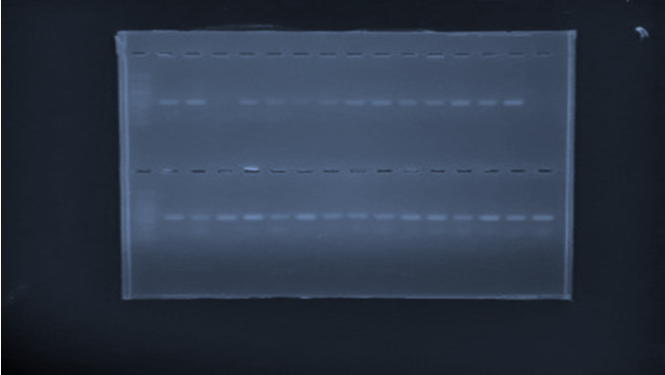

Figure 1. Agarose gel electrophoresis of genomic DNA extracted from Nigerian indigenous goat breeds.

The high quality, high molecular weight and single banded and sheared-less DNA fragments obtained in the present study agree with the reports of Santos et al. (2012). It is, however, in disagreement with the findings of Yunjie and Oluseyi (2013), who reported that the highest yield of DNA was obtained when using the Qiagen kit followed by the Bioneer kit and Zymo kit in that order. The Zymo research kit was adopted in this study because its protocol was found to be simple and unambiguous. This is supported by Yunjie and Oluseyi (2013); the authors recommended the use of the Zymo genomic DNA kit in laboratories where the speed of sample processing is paramount.

PCR amplification of the β-lactoglobulin gene of indigenous Nigerian goat breeds

The agarose gel electrophoresis results of the PCR amplified β-lactoglobulin gene are presented in Figures 2 and 3, respectively. In all the samples tested, the amplified product size was approximately 120 and 105 bp, respectively, with no variation in size between the animals studied.
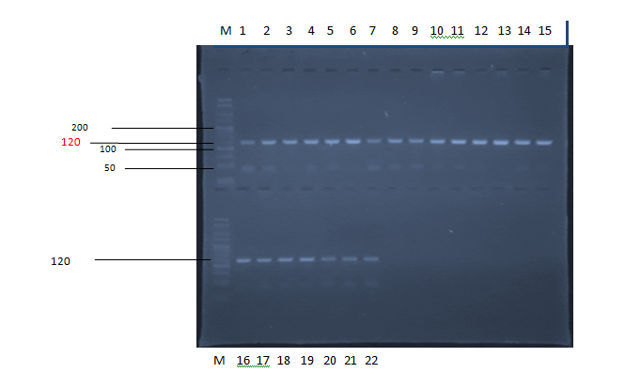

Figure 2. Agarose gel electrophoresis of PCR amplified product of exon II from position 1563 of intron I to position 1779 of intron II of the β-lactoglobulin gene of indigenous Nigerian goat breeds Lane M = 25 bp DNA ladder; Lane 1-22 = PCR amplicons.

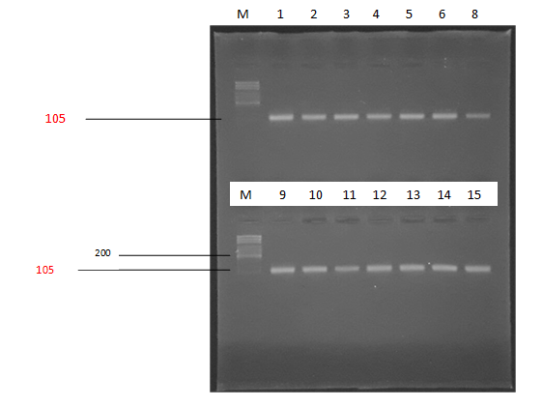

Figure 3. Agarose gel electrophoresis of PCR amplified products of exon V from position 4551-4655 of the β- lactoglobulin gene of indigenous Nigerian goat breeds PCR-RFLP analysis of the β-lactoglobulin gene of indigenous Nigerian goat breeds.

The 120 bp fragments of the exon II from position 1563 of intron I to position 1779 of intron II were observed to be similar for all the animals to the 105 bp fragments of exon V from position 4551-4655 of the β-lactoglobulin gene of the indigenous breed of goats amplified by PCR using oligonucleotide primers for both steps. This result confirms the repeatability of the method of identification of the β-lactoglobulin genotype described by Feligini et al. (1998) indicating that the β-lactoglobulin gene locus is conserved in the goat breeds studied.
The PCR-RFLP analysis of the β-lactoglobulin gene extracted from indigenous Nigerian goat breeds is presented in Figures 4 and 5, respectively.

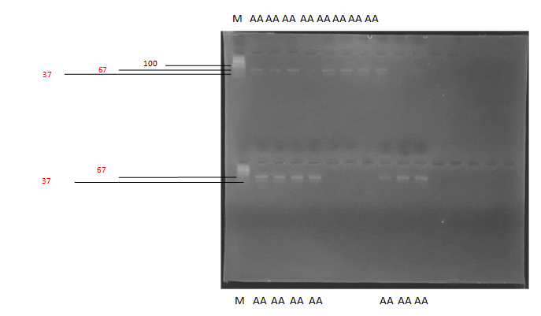

Figure 4. Agarose gel electrophoresis of 120 bp β- lactoglobulin genotyping by PCR-RFLP with Rsal enzyme of native Nigerian goats Lane M = DNA ladder; Lane 1-12 = AA genotype; Lane 15-18 = AA genotype.
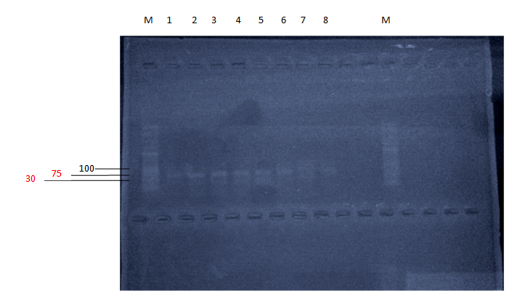

Figure 5. Agarose gel electrophoresis of 105 bp β-lactoglobulin genotyping by PCR-RFLP with Mspl enzyme of Nigerian indigenous breed of goats.

The first step which involved the use of Rsal restriction enzyme revealed the presence of only A genetic variant at the β-lactoglobulin gene locus in the amplified 120 bp PCR products (Figure 4). The second step using Mspl showed that it digested the PCR fragments into two fragments of size 75 and 30 bp (Figure 5). No other RFLP pattern was observed from the agarose gel. The presence of only one allele A at the β-lactoglobulin gene locus at the amplified 120 bp PCR product is in agreement with earlier reports (Yahyaoui et al., 2000). The authors also recorded the presence of only one genetic variant at the β-lactoglobulin gene locus of a Lithuanian goat (Canaria). The Rsal-RFLPs allelic pattern observed contradicts earlier reports (El-Hanafy et al., 2010). The authors recorded the presence of two genetic variants; A and B using Barki, Damascus and, Damascus x Barki crossbred in Egypt.
These differences observed in the results could be because different restriction enzymes were used in the studies. Elyasi et al. (2010), however, reported the presence of variants A, B and AB in Iranian goats using the Rsal restriction enzyme. Other authors who have reported on the presence of the AB variant in goats are El Hanafy et al. (2010, 2014). The presence of a single allele at the β-lactoglobulin gene locus can be attributed to mating (inbreeding). Inbreeding reduces heterozygosity at the same time as it is escalating the percentage of homozygotes relative to random expectations (Janna et al., 2015). Genetic variation is usually revealed by increasing heterozygosity and allelic diversity. Woodworth et al. (2002) reported that genetic diversity can be reduced as a result of genome-wide activities like inbreeding and genetic drift, and even the effect of practices like the artificial selection on individual genes. The 75 and 30 bp fragments observed with the use of the Mspl restriction enzyme to check for the β-lactoglobulin gene C variant conformed to the reports of Elmaci et al. (2007). Elmaci et al. (2007) have reported that the β-lactoglobulin gene C allele is characterized by only a 105 bp fragment. No other Mspl-RFLP allelic pattern was observed from the agarose gel, thus indicating the absence of C variant at the β-lactoglobulin gene locus of the Nigerian indigenous goat breeds sampled. The rare variant (β-lactoglobulin gene C) has, however, been detected in few goat breeds such as the Jamunapari and Jakhrana Indian goats (Jain et al., 2012) where it was detected in exons 3, 6 and 7 of the DNA. A, B and C alleles are generally found more in indigenous goat breeds (Barłowska et al., 2007; Torres-Vázquez et al., 2008) than in typical dairy breeds. The appearance of only A allele of β-LG contradicts the result above and those of Kumar et al. (2006) and El Hanafy et al. (2010, 2014).

Allelic and genotypic frequencies of β-lactoglobulin polymorphism of indigenous Nigerian goat breeds

Table 1 shows the allelic pattern of the β-lactoglobulin gene digested with the Rsal restriction enzyme in the indigenous Nigerian breed of goats while Table 2 shows the gene and genotype frequencies of β-lactoglobulin/Rsal polymorphism in the indigenous Nigerian breed of goats. Only the A allele was found in the entire goat sample with fragment sizes of 66, 37 and 17, respectively (Table 1). The gene frequencies for the A and B alleles in Sahelian goats were 1.00 and 0.00, respectively. The same results were also observed in the Red Sokoto and West African Dwarf goats. The genotypic frequencies of β-lactoglobulin polymorphism for AA, AB and BB were observed as 1.00, 0.00 and 0.00, respectively for all goat breeds examined. These genotype frequencies were found not to be in Hardy-Weinberg equilibrium as the breeds were monomorphic at the β-lactoglobulin gene locus (Table 2). The monomorphic allelic pattern and genotype frequencies obtained in this study are in disagreement with the findings of El-Hanafy et al. (2010). The monomorphic allelic pattern, however, conforms with the report of Baltrėnaitė and Miceikienė (2007) who have reported that, in goat species, β-lactoglobulin gene protein is considered to be monomorphic due to the high frequency of β-lactoglobulin A genetic variant (ranging from 0.73 to 1.00). This was observed in Spanish, Hungarian and Lithuanian native goats. Considering the preponderance of the β-lactoglobulin A allele over the B allele, the A allele may well be taken as the inherited variant of the gene in Nigerian goats.

Table 1. The allelic pattern of the β-lactoglobulin gene digested with Rsal restriction enzyme in indigenous Nigerian breeds of goats.

S/No. | Allele type | Fragment size (bp) | Number of animals (n=60)
1 | AA | 66, 37, 17 | 60
2 | BB | 103, 17 | 0
3 | AB | Both A and B fragments | 0

Table 2. Genotype and allelic frequencies of the β-lactoglobulin gene locus in three indigenous Nigerian goat breeds

 |  | β-lactoglobulin genotype |  |  | Gene frequency
Breed | Number | AA | AB | BB | A | B | (χ²)^{b}
Sahelian | 20 | 20 (1.00) | 0(0.00) | 0(0.00) | 1.00 | 0.00 | Monomorphic
Red Sokoto | 20 | 20 (1.00) | 0(0.00) | 0(0.00) | 1.00 | 0.00 | Monomorphic
WAD | 20 | 20 (1.00) | 0(0.00) | 0(0.00) | 1.00 | 0.00 | Monomorphic
Total | 60 | 60 (1.00) | 0(0.00) | 0(0.00) | 1.00 | 0.00 | Monomorphic
WAD = West African Dwarf, AA = β-LG AA, AB = β-LG AB, BB = β-LG BB, b = test of Hardy-Weinberg equilibrium.

The populations were found not to be in Hardy-Weinberg equilibrium which might be due to non-random mating (inbreeding) with its attendant increase in homozygosity of the gene leading to heterozygote deficiency. Elyasi et al. (2010) also reported similar findings in their study of polymorphism of β-lactoglobulin in Iranian goats using PCR-RFLP.
Conclusion

This research provides evidence that the β-LG locus of West African Dwarf, Red Sokoto and Sahelian goats is monomorphic. The singular nature of the β-LG locus points to a decrease in genetic diversity. This may have a negative effect on the population structure of the indigenous goats due to inbreeding depression. Its attendant consequences, especially on dairying ability of the studied goats, may lead to reduced productivity. Sometimes, results from different investigations are not comparable with each other for many reasons such as population size, breed, kind of primers used and restriction enzymes used.

References

Baltrėnaitė, L., & Miceikienė, I. (2007). Investigation of beta lactoglobulin gene polymorphism in Goats bred in Lithuania Proceedings of the 13th Baltic Animal Breeding Conference, Pärnu, Estonia.
Barłowska, J., Litwińczuk, Z., Florek, M., & Kędzierska-Matysek, M. (2007). Milk yield and its
composition of 4 Polish goat breeds with different genotypes of αs1-casein (in Polish). Vet. Med., 63 (12), 1600-1603.
Chianese, L., Portolano, B., Pizzolongo, F., Ferranti, P., Addeo, F., Alicata, M.L., Pilla, F., & Calcagna, G. (2000). The quality of Girgentata goat milk. In: Gruner, L. and Chabert, Y. (eds.). Proceedings of the 7th International Conference on Goat. (pp. 946-949). Tours, France Institut de L’Elevage, Paris and INRA, Nouzilly, France.
Cui, U., Cao, Y., Ma, Y., Qu, X., & Dong, A. (2012). Genetic variation in the B-lactoglobulin of Chinese yak (Bos grunniens). Journal of Genetics, 91, 44-48.
El-Hanafy, A.A., El-Saadani, M.A., Eissa, M., Maharem, G.M., & Khalifa, Z.A. (2010). Polymorphism of β-lactoglobulin gene in Barki and Damascus and their cross bred goats in
relation to milk yield. Biotechnology in Animal Husbandry, 26 (1-2), 1-12.
El-Hanafy, A.A., Qureshi, M., Sabir, J., Mutawakil, M., Ahmed, M.M., El-Ashmaoui, H., Ramadan, H., Abou-Alsoud, M., & Sadek, M.A. (2014). DNA polymorphism study of β lactoglobulin gene in Saudi goats. International Journal of Agriculture and Biosystems Engineering, 8, 1390-1393.
Elmaci, C., Oner, Y., & Balcioglu, M.S. (2007). B-lactoglobulin gene types in Karacabey sheep breeds using PCR-RFLP Merino sheep. Journal of Applied Animal Research, 32 (2), 145-148.
Elyasi, G., Shodja, J., Nassiry, M.R., Tahmasebi, A., Pirahary, O., & Javanmard, A. (2010). Polymorphism of β-lactoglobulin gene in Iranian sheep breeds using PCR-RFLP. Journal of Molecular Genetics, 2 (1), 6-9.
Feligini, M., Parma, P., Aleandri, R., Greppi, G.F., & Enne, G. (1998). PCR-RFLP test for direct determination of β-lactoglobulin genotype in sheep. Animal Genetics, 29, 473.
Graziano, M., D’Andrea, M., Angiolillo, A., Lagonigro, R., & Pilla, F. (2003). A new polymorphism in goat β-lactoglobulin promoter region. Italian Journal of Animal Sciences, 1, 65-68.
Hambraeus, L., & Lonnerdal, B. (2003). Nutritional aspects of milk proteins. In: Fox, P.F. and McSweeney, P.L.H.M. (Eds). Advanced dairy chemistry (I. Proteins 3rd Ed. Part B). (pp.??-??). New York, USA: Kluwer.
Jain, A., Gour, D.S., Bisen , P.S., Dubey, P.P., Sharma , D. K., Tiwari, R.P., Gupta, N., & Kumar, D. (2012). Allele mining in β-lactoglobulin gene of Capra hircus. African Journal of Biotechnology, 11 (50), 11057-11064.
Janna, R.W., Nadia, B.F., Maureen, C.L., Jamie, A.I., Robert, C.L., & Andrew, D.J. (2015). The impacts of inbreeding, drift and selection on genetic diversity in captive breeding populations. Molecular Ecology, 24, 98-110.
Kontopidis, G., Holt, C., & Sawyer, L. (2004). Invited review: beta-lactoglobulin: binding properties, structure, and function. Journal of Dairy Science, 87, 785-796.
Kumar, A., Rout, P.K., & Roy, R. (2006). Polymorphism of beta-lactoglobulin gene in Indian goats and its effect on milk yield. Journal of Applied Genetics, 47, 49-53.
MacGugh, D.E., & Bradley, D.G. (2001). Livestock genetic origins: goats buck the trend. Proceedings of the National Academy of Sciences USA, 98, 5382-5384.
Peakall, R., & Smouse, P. E. (2012). GenAIEx 6.5: genetic analysis in Excel. Population genetic software for teaching and research-an update. Bioinformatics, 28(19): 2537-2539.
Pena, R.N., Sanchez, A., & Folch, J.M. (2000). Characterization of genetic polymorphism in the goat beta lactoglobulin gene. Journal of Dairy Research, 67, 217-224.
Philip, W.H. (2011). Genetics of populations. Sudbury, MA: Jones and Bartlett Learning.
Qureshi, M.I., Sabir, J.S.M., Mutawakil, M.H.Z., El-Hanafy, A.A., Ashmaoui, H.E. Ramadan, H., Anwar, Y., Sadek, A.M., Alsoud, M.A., Saini, K.S., & Ahmed, M.M. (2014). Review of modern strategies to enhance livestock genetic performance: form molecular markers to next generation sequencing technologies in goats. Journal of Food, Agriculture and Environment, 12, 752-761.
Ron, N., Zimet, P., Bargarum, J., & Livney, Y.D. (2010). Beta-lactoglobulin-polysaacharide complexes as nano vehicles for hydrophobic nutraceuticals in non fat foods and clear beverages. International Dairy Journal, 20, 686-693.
Santos, H.F., Carmo, F.L., Leite, D.C.A., Jesus, H.E., De Carvalho Maalouf, P., Almeida, C., Soriano, A.U., Altomari, D., Suhett, L., Vólaro, V., Valoni, E., Francisco, M., Vieira, J., Rocha, R., Sardinha, B.L., Mendes, L.B., João, R.R., Lacava, B., Jesus, R. F., Sebastian, G.V., Pessoa, A., van Elsas, J.D., Rezende, R. P., Pires, D.O., Duarte, G., Castro, C.B., Rosado, A.S., & Peixoto, R. S. (2012). Comparison of different protocols for the extraction of microbial DNA from reef corals. Brazilian Journal of Microbiology, 43 (2), 819-826.
Torres-Vázquez, J.A., Vázquez Flores, F., Montaldo, H.H., Ulloa-Arvizu, R., Posadas, M.V., Vázquez, A.G., & Morales, R.A.A. (2008). Genetic polymorphism of the αs1-casein locus in five populations of goats from Mexico. Electronic Journal of Biotechnology, 1 (3), 2-11.
Woodworth, L.M., Montgomery, M.E., Briscoe, D.A., & Frankham, R. (2002). Rapid genetic deterioration in captive populations: causes and conservation implications. Conservation Genetics, 3, 277-288.
Yahyaoui, M., Pena, R., Sanchez, A., & Folch, J. (2000). Rapid communication: polymorphism in the goat beta lactoglobulin proximal promoter region. Journal of Animal Science, 78, 1100-1101.
Yunjie, M., & Oluseyi, V. (2013). Comparison of different DNA extraction methods for forensic samples. Journal of Natural Sciences Research, 3 (11), 32-38.
Zimet, P., & Livney, Y.D. (2009). Beta-lactoglobulin and its nano-complexes with pectin as vehicle for omega-3 polyunsaturated fatty acids. Food Hydrocolloids, 23, 1120-1126.

Received: September 19, 2017
Accepted: December 9, 2019

GENETIČKI POLIMORFIZAM β-LAKTOGLOBULINSKOG GENA KOD DOMAĆIH NIGERIJSKIH RASA KOZA

Anthony E. Ezewudo, Rukayyat G. Abubakar,
Acheneje S.S. Egena* i John O. Alabi

Odsek za animalnu proizvodnju, Federalni tehnološki univerzitet,
P.M.B 65, Mina, Država Niger, Nigerija

R e z i m e

Ispitivan je polimorfizam β-Laktoglobulinskog (β-LG) gena tri nigerijske rase koza, naime: zapadnoafričkе patuljastе, Sahel i crvenе Sokoto kozе, korišćenjem metoda reakcije lančanog umnožavanja-polimorfizma dužine slučajnih delova (engl. Random Fragment Length Polymorphism – PCR-RFLP). Restrikcione endonukleaze korišćene u istraživanju uključivale su Rsal odnosno Mspl. Rezultati su otkrili postojanje samo jedne polimorfne varijante (alel A) sa frekvencijom gena od 1,0 kod sve tri rase koza koje su proučavane. Pojačani proizvodi uočeni su kod 120 bp i restrikciona digestija sa endonukleazom Rsal otkrila je samo jedan genotip kod lokusa β-LG. Zaključeno je da postoji odsustvo polimorfizma kod lokusa β-LG koza koje su ispitivane.
Ključne reči: polimorfizam, koze, lokus gena, PCR-RFLP, β-Laktoglobulin.

Primljeno: 19. septembra 2017.
Odobreno: 9. decembra 2019.

Corresponding author: e-mail: acheneje.egena@futminna.edu.ng
*Autor za kontakt: e-mail: acheneje.egena@futminna.edu.ng

