on the fertilizer particle motion along the vane

of A centrifugal spreader disc assuming

pure sliding of the particle

**Vera B. Cerović1[1], Dragan V. Petrović2, Rade L. Radojević2,**

**Saša R. Barać3 and Aleksandar Vuković3**

1University of Belgrade, Faculty of Mechanical Engineering,

Kraljice Marije 16, 11080 Belgrade, Serbia

2University of Belgrade, Faculty of Agriculture,

Nemanjina 6, 11080 Belgrade-Zemun, Serbia

3University of Priština, Faculty of Agriculture, Lešak, Serbia

**Abstract:** At present, spreading of mineral fertilizers in Europe is most commonly performed using centrifugal disk spreaders with attached vanes. The motion of an ideal spherical homogeneous fertilizer particle along the straight vane attached to a flat rotating disc was analyzed in this paper. The analysis was performed in the non-inertial reference coordinate system. From the assumptions introduced to enable analytical describing of the real particle motion as well as the general tools of solid mechanics, the ordinary in-homogenous second-order differential equation having constant coefficients arose. Its solution represents an approximation of the real relative motion of the fertilizer particle along the straight radial vane fixed to the flat horizontal disc rotating at a constant angular velocity. However, the solution of this kind can be very useful for the optimization of centrifugal spreader working parameters.

**Key words:** fertilizer particle, centrifugal disc spreader, radial vanes, differential equation.

**Introduction**

Different kinds of solid fertilizer spreaders have been designed in the past. However, it seems that centrifugal disc spreaders (Figure 1) are the most popular fertilizing machines worldwide, as well as in Serbia. Their main advantages in comparison with other available designs lie in lower costs, simple design and maintenance, followed by large soil covering width per single pass (Villette et al., 2008), over 45 [*m*] (Cool et al*.*, 2016).

A functional principle of the centrifugal fertilizer spreader is simple. The force of gravity pulls particles downward, toward the bottom hopper orifice, placed beyond the disk spinner eccentrically toward the rotation axis. After leaving the hopper, particles fall down on the spinner, establishing contact with an attached vane and a disc (Figure 1). This occurrence starts the second phase of particle moving, controlled by a rotating vane, until particle ejection into the air. Leaving the disc ends the second phase of a particle spreading process and starts the third (the last) phase. It assumes a free ballistic particle flight through the air, until its landing on the ground.

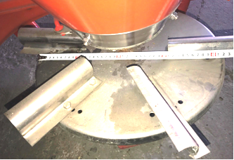

Figure 1. A centrifugal fertilizer spreader, having a flat

disc with straight radial vanes.

Obviously, an adequate control of a fertilizer particle moving in the second spreading phase (traveling along the disk vane) should provide the optimal particle velocity vector at the leaving point from the vane. This vector represents the important input data for ballistic models and influences the free flight of the particle through the air and the fertilizer spreading pattern. This velocity can be either predicted using the suitable mechanical model, or measured by the appropriate experimental set-up.

This paper presents a possible approach among many other less or more similar or quite different methods for analysis and predicting the fertilizer spreading process by centrifugal (spinning) disc spreaders with radial vanes. Modeling of this kind has been intensified since the middle of the 20th century. For example, Cunningham (1962), Cunningham and Chao (1967), Dobler and Flatow (1968) have researched the particle motion along the vane. Among others, Mennel and Reece (1962), Griffis et al. (1983) have analyzed the ballistic flight of the fertilizer particle through the air.

Selecting and integrating previously published partial models, Olieslagers et al. (1996) made a more generalized model, which provided the increased prediction accuracy of the solid fertilizer particle spreading. The model was verified experimentally, applying the traditional simple test method, namely the “collection tray method”. According to this method, while the machine passes the rows of collection trays (placed perpendicular to the travel direction) at a constant travel speed, the fertilizer particles are collected at different transverse positions. After weighing the amount of fertilizer in each tray of each row, the spatial distribution pattern over the experimental plot surface can be composed.

Further improvement of the fertilizer spreading models has been continued in the 21st century: Aphale et al. (2003), Dintwa et al. (2004), Villette et al. (2005), Cool et al. (2014), Cool et al. (2016), etc. However, these models have been based on the assumption that particles do not interact mutually, which may cause prediction errors. In order to improve the predicting accuracy, an alternative approach has been introduced. Methods of this kind include the particle interactions in a modeling algorithm using the numerical mathematics – primarily discrete element methods: Tijskens et al. (2005), Van Liedekerke et al*.* (2009), etc. Unfortunately, quantitative simulations based on this method need physical fertilizer characteristics as input data, which are at present difficult to measure (Villette et al., 2008).

This work presents an analytical solution of the dynamic model that describes the motion of a fertilizer particle along the radial vane of the centrifugal spreader disc. This motion was analyzed in the non-inertial reference system fixed to the spinning disc (Figure 3). Therefore, the carrying motion was accounted by introducing the appropriate inertial forces. To facilitate the problem related to the mathematical apparatus needed, a number of assumptions have been introduced in the mechanical model of particle motion. Consequently, the resulting equations and their solutions represent an appropriate approximation of the real motion, which enables the analysis of working parameters that govern the fertilizer spreading process.

**Materials and Methods**

Dynamics of a single fertilizer particle movement along a straight radial vane attached to the horizontal flat spinning disc of a centrifugal spreader was analyzed in this paper. Thus, only the first phase of a fertilizer spreading process was comprehended, i.e. the model considered the motion of the particle along the vane, until it dropped out. A particle motion model is based on the assumption of continuous motion of a single particle along the vane, and laws of theoretical mechanics (Beer et al., 2010; Hibbeler, 2010).

The focus of interest of this manuscript is the dynamic equation of the fertilizer particle motion. In this particular case, the non-homogeneous second-order differential equation of motion was solved analytically following methods of mathematical analysis (Soare et al*.*, 2007). The solution was applied on specific data, processed using MS Excel.

The last phase of a spreading process, the ballistic flight of the fertilizer particle through the atmospheric air until its lending, has not been analyzed. However, this model provides an additional insight in the fertilizer particle moving over the spinning disc and its velocity vector at the leaving point from the vane. The information on this velocity vector is important, because it influences the flight of the particle through the air and the fertilizer spreading pattern.

**Results and Discussion**

The analytical model of the fertilizer particle motion is based on various assumptions.

An individual fertilizer particle moves along the vane, mounted radially on the horizontal flat disk. Thus, particle interactions were neglected and achieved results approximated the real spreading process (Villette et al*.*, 2008).

The spreading disc is rotating at a constant angular velocity *ωD* [*s*-1].

Fertilizer particles are ideally spherical homogeneous particles, having constant density.

Dynamics of the spherical particle on the spreading disc is based on the approximation of pure sliding against the vane.

According to Olieslagers et al. (1996), Aphale et al. (2003), Dintwa et al. (2004), particles bouncing over the disc are negligible: tight continual contact between the observed particle and the vane is established along the whole particle travel over the disc.

The particle motion follows the well-known Newton’s second law:

$m∙\vec{a^{a}}= \frac{d\vec{v^{a}}}{dt}= \frac{d^{2}\vec{r^{a}}}{{dt}^{2}}={\ddot{\vec{ r }}}^{a}=\sum_{i=1}^{n}{{\vec{F }}_{i } ,}$ (1)

where $m [kg]$ is the particle mass, ${\vec{F}}_{i} \left[N\right]$ (*i*=1,2,...,*n*) are forces acting on it and $\vec{a^{a}} \left[m{∙s}^{-2}\right]$ is the absolute linear acceleration (i.e. the first derivative of the absolute velocity vector $\vec{v^{a}}$) and the second derivative of the position vector $\vec{r^{a}}$ of the particle in the inertial reference coordinate system *Oxyz* (Figure 2).

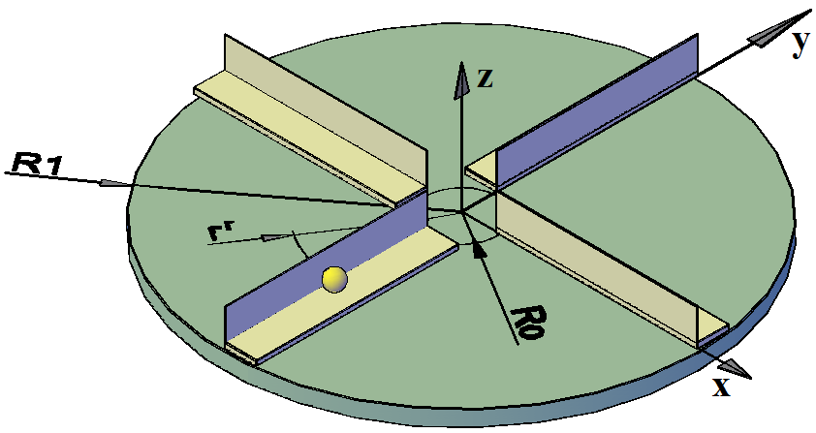

Figure 2. Inertial coordinate system.

Nomenclature:

*R*0, *R*1 the entrance radius of the particle and the external radius of the rotating disc [*m*];

$r^{r}$ the radial distance from the disc center in the rotating (relative) system O*ξηζ* [*m*];

*x*,*y*,*z* the coordinates of a fertilizer particle in the inertial coordinate system [*m*].

Nomenclature:

${\vec{ F }}_{FD}, {\vec{ F }}_{FV}$ the friction forces between the particle and the disc and the vane, [*N*];

${\vec{ F }}_{CF}$ the centrifugal force exerted on the fertilizer particle [*N*];

${\vec{ F }}_{COR}$ the Coriollis force exerted on the fertilizer particle [*N*];

$\vec{ G }, \vec{ g }$ the gravitational force [*N*] and acceleration [*m ∙ s*-2] of the particle;

*m*the mass of fertilizer particle [*kg*];

${\vec{ N }}_{D}$, ${\vec{ N }}_{V}$ the orthogonal forces of the disc and the vane exerted on the particle [*N*];

*ξ*, *η*, *ζ* the coordinates in the non-inertial relative system fixed to the disk [*m*];

*ω*D the angular velocity of the rotating disc [*s*-1].

However, the traveling of the particle is considered in the relative reference system *Oξηζ* (Figure 3), fixed to the center of a spreading disc and rotating together with the vane along which the observed fertilizer particle moves. Therefore, the coordinate system *Oξηζ* is a non-inertial reference system. This means that Newton’s second law can be applied only by introducing the additional imaginary “inertial” forces: the centrifugal ${\vec{ F }}_{CF} [N]$ and Coriollis forces ${\vec{ F }}_{COR} [N]$, (Figure 3). The following real forces also act on the particle: the friction forces exerted by the rotating disc ${\vec{ F }}_{FD}$ [*N*] and the vane ${\vec{ F }}_{FV}$ [*N*], particle weight $\vec{ G }$ [*N*], orthogonal reactions of the disc ${\vec{ N }}_{D}$ [*N*] and the vane ${\vec{ N }}_{V} [N]$.

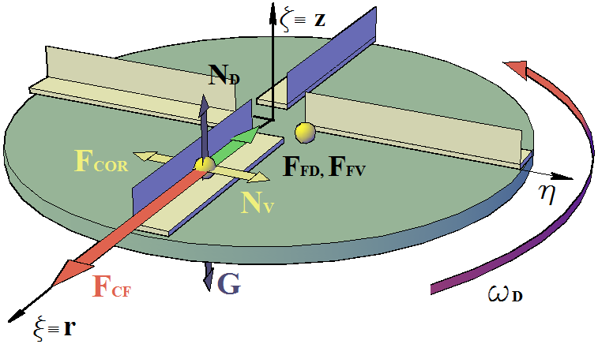

Figure 3.Forces exerted on the particle in the relative reference system.

Thus, the motion of a fertilizer particle can be described by the vector differential equation:

$m∙\frac{d^{2}\vec{r^{r}}}{{dt}^{2}} = {\vec{ F }}_{FD}+{\vec{ F }}_{FV}+{\vec{ F }}_{CF}+\vec{ G }+{\vec{ N }}_{D}+{\vec{ N }}_{V}+{\vec{ F }}_{COR}$, (2)

and represented in the relative coordinate system O*ξηζ* by three scalar equations:

***ξ* ≡ *rr***: (3)

***η***: $0=N_{V}-F_{COR}$ ⟹ $N_{V}=F_{COR}$; (4)

***ζ* ≡ *z***: $0=N_{D}-G$ ⟹ $N_{D}=G$. (5)

Equations (3), (4) and (5) govern the relative motion of the particle. To be solved, it is necessary to previously evaluate unknown intensities of forces exerting on the particle.

Particle weight is the multiple of the mass *m* [N] and the gravitational acceleration  
*g* [*m ∙ s*-2]. It is vertically aligned, but oriented downward, opposite to the axis O***ζ***:

$\vec{ G }=m ∙\vec{ g }= -m∙g∙\vec{ζ_{0}}$; (6)

The Coriollis force originates from the combined particle motion in the rotating coordinate system. It depends on the carrying angular velocity $\vec{ω^{c }}$, which is the disk angular velocity $\vec{ω_{D}}$, and the relative linear velocity $\vec{v^{r}}$ of the particle along the vane (Figure 2):

${\vec{ F}}_{COR}=-2∙m∙\left({\vec{ω}}_{D}×\vec{v^{r}}\right)=-2∙m∙v^{r}∙ω_{D}∙\vec{η_{0}}$, (7)

where $\vec{η_{0}}$ is the unity ort-vector defining the direction of the axis O***η***.

The orthogonal vane reactive force on the particle ${\vec{N}}_{V}$ is the reaction on the influence of the Coriollis force ${\vec{ F}}_{COR}$ of the particle against the vane. Hence, these two forces are collinear but of opposite direction. It follows from equations (4) and (7) that this force (Figure 2) is:

$\vec{N_{V}}=-{\vec{ F}}_{COR}=-\left(-2∙m∙v^{r}∙ω_{D}∙\vec{η_{0}}\right)= 2∙m∙v^{r}∙ω_{D}∙\vec{η_{0}}$ (8)

Similarly, the vector $\vec{N_{D}}$ is the orthogonal reaction of a spreading disc on the fertilizer particle, caused by the particle weight $\vec{ G }$ (active force). Therefore, these two forces are collinear but take opposite directions. Regarding equations (5) and (6), it follows that the vector of this force (Figure 2a) is:

$\vec{N_{D}}= -\vec{ G }=m∙g∙\vec{k}= m∙g∙\vec{ζ_{0}}$. (9)

The centrifugal force

${\vec{ F }}_{CF}=m ∙ ω_{D}^{2} ∙r^{r}∙\vec{ξ_{0}}$, (10)

depends on the particle mass *m* [*kg*], its current radius $r^{r}$ [*m*] along the vane (the distance from the axis of disc rotation $Oζ≡Oz$), and the disc angular velocity $ω_{D }\left[s^{-1}\right]$.

The friction forces $F_{FD}$ and $F_{FV}$ are caused by simultaneous sliding of the particle over the spreading disc and vane. They are functions of the dynamic friction coefficients $μ_{D} [-]$, ${ μ}_{V} [-]$, and normal reactions $N_{D} [N]$, $N_{V} [N]$:

$F_{FD}=μ_{D}∙m ∙g$, (11)

$F_{FV}={2∙μ}_{V}∙m∙ω_{D}∙v^{r}$. (12)

Including equations (10), (11) and (12) in the equation (3) gives the second-order linear inhomogeneous ordinary differential equation with constant coefficients, which describes the relative particle motion:

$\frac{d^{2}r^{r}}{dt^{2}}+2∙μ_{V}∙ω_{D} ∙\frac{dr^{r}}{dt}-ω_{D}^{2}∙r^{r}=-μ_{D}∙g$. (13)

A general solution of the inhomogeneous differential equation can be found as the sum of the solution of the homogeneous equation $r_{h}^{r}$ and a particular solution of the inhomogeneous equation $r_{p}^{r}$

$r^{r}=r_{h}^{r}+r_{p}^{r}$. (14)

The homogeneous part of this ordinary differential equation is

$\frac{d^{2}r^{r}}{dt^{2}}+2∙μ_{V}∙ω_{D} ∙\frac{dr^{r}}{dt}-ω_{D}^{2}∙r^{r}=0$, (15)

having the solution:

$r_{h}^{r}=C_{1}∙y_{1}\left(t\right)+C_{2}∙y_{2}\left(t\right)=C_{1}\left(t\right)∙e^{ω_{D}(-μ_{V}+\sqrt{1+μ_{V}^{2}} )∙t}+C_{2}\left(t\right)∙e^{ω_{D}(-μ_{V}-\sqrt{1+μ_{V}^{2}} ) ∙t}$, (16)

where $C_{1}$ and $C_{2}$ are the unknown integration constants.

A particular solution of the inhomogeneous differential equation (13) can be found by the method of an undetermined constant:

$r_{p}^{r}=C$. (17)

After differentiation of the equation (17) and inclusion in the equation (13), the particular solution of the inhomogeneous differential equation arose

$r_{p}^{r}=\frac{μ_{D}∙g}{ω_{D}^{2}}$, (18)

giving the general solution of the differential equation (13), which describes the *relative* radial position of the fertilizer particle:

$r^{r}\left(t\right)=C_{1}∙e^{ω_{D}∙ \left(-μ_{V}+\sqrt{1+μ_{V}^{2}}\right)∙ t}+C_{2}∙e^{ω_{D}∙ \left(-μ_{V}-\sqrt{1+μ_{V}^{2}}\right)∙ t}+\frac{μ_{D} ∙ g }{ω_{D}^{2}} .$ (19)

The derivation of this equation gave the relative radial velocity of the particle:

$\begin{matrix}{\dot{r}}^{r}\left(t\right)=v^{r}\left(t\right)=ω_{D}∙\left(-μ_{V}+\sqrt{ 1+μ_{V}^{2}}\right)∙C_{1}{∙e}^{ω_{D}∙\left(-μ_{V}+\sqrt{1+μ_{V}^{2}}\right) ∙ t}+ \\ + ω_{D}∙\left(-μ_{V}-\sqrt{ 1+μ_{V}^{2}}\right)∙C_{2}∙e^{ω_{D}∙\left(-μ_{V}-\sqrt{1+μ_{V}^{2}}\right) ∙ t}\end{matrix}$ (20)

The integration constants $C_{1}$ and $C_{2}$ were determined from the initial conditions, which arose from the design and operational conditions of the analyzed fertilizer disc spreader:

$t_{0}=0 ⟹ r^{r}\left(t_{0}=0\right)=r^{r}\left(0\right)=R_{0}$, (21)

$t_{0}=0 ⟹ {\dot{r}}^{r}\left(t_{0}=0\right)={\dot{r}}^{r}\left(0\right)= {\dot{r_{0}}}^{r}={v_{0}}^{r}=0$. (22)

Namely, each fertilizer particle starts the relative motion along the vane from its inner edge and accelerates starting from the zero radial velocity. Combining the formulas (19), (20), (21) and (22) gave the constants $C_{1}$ and $C_{2}$. Their introducing in equations (19) and (20) provided the final expressions defining the relative position and velocity of the particle along the vane:

$r^{r}\left(t\right)= \frac{\left(R_{0} – \frac{μ_{D}∙g}{ω_{D}^{2}}\right)}{2∙ \sqrt{ 1+μ_{V}^{2}}} ∙⟦\left(- μ_{V}+\sqrt{ 1+μ_{V}^{2}}\right) ∙ e^{ω_{D} ∙ \left(-μ_{V }– \sqrt{ 1 +{ μ}_{V}^{2}}\right) ∙ t}-$

$- \left(-μ_{V} – \sqrt{ 1 + μ_{V}^{2}}\right) ∙ e^{ω_{D} ∙ \left( -μ_{V} + \sqrt{ 1+μ_{V}^{2}}\right) ∙ t}⟧+ \frac{μ_{D}∙g}{{ω_{D}}^{2}}$, (23)

${\dot{r}}^{r}\left(t\right)=v^{r}\left(t\right)=\frac{{- ω}_{D}}{2∙ \sqrt{1+μ_{V}^{2}}}∙\left(R_{0}-\frac{μ_{D}∙g}{ω_{D}^{2}}\right)∙\left[e^{{-ω}_{D}∙\left(μ_{V}+\sqrt{1+μ_{V}^{2}}\right)∙t}-e^{{-ω}_{D} ∙ \left(μ_{V}-\sqrt{1+μ_{V}^{2}}\right)∙t}\right].$ (24)

The fertilizer particle ejection (launching) time $t_{K}$ represents the traveling time of a fertilizer particle along the whole length of a centrifugal disk spreader vane, $r^{r}\left(t_{K}\right)=R_{1}$:

$$r^{r}\left(t_{K}\right)=R_{1}= \frac{\left(R_{0} – \frac{μ_{D}∙g}{ω_{D}^{2}}\right)}{2∙ \sqrt{ 1+μ_{V}^{2}}}∙⟦\left(- μ_{V}+\sqrt{ 1+μ_{V}^{2}}\right)∙e^{ω_{D} ∙ \left(-μ_{V}–\sqrt{1+μ_{V}^{2}}\right)∙t_{K}}-$$

$- \left(-μ_{V} –\sqrt{1+μ_{V}^{2}}\right)∙e^{ω_{D} ∙ \left(-μ_{V} + \sqrt{ 1+μ_{V}^{2}}\right) ∙ t_{K}}⟧+\frac{μ_{D}∙g}{{ω_{D}}^{2}}$. (25)

The absolute velocity vector $\vec{{ v}^{a}}$ of the particle is a vector sum of the carrying velocity $\vec{v^{c}}$, induced by vane and disc spinning, and the relative velocity along the vane $\vec{{ v}^{r}}$ (Figure 4):

$\vec{{ v}^{a}}(t)= \vec{{ v}^{c}}(t)+ \vec{{ v}^{r}} (t)$. (26)

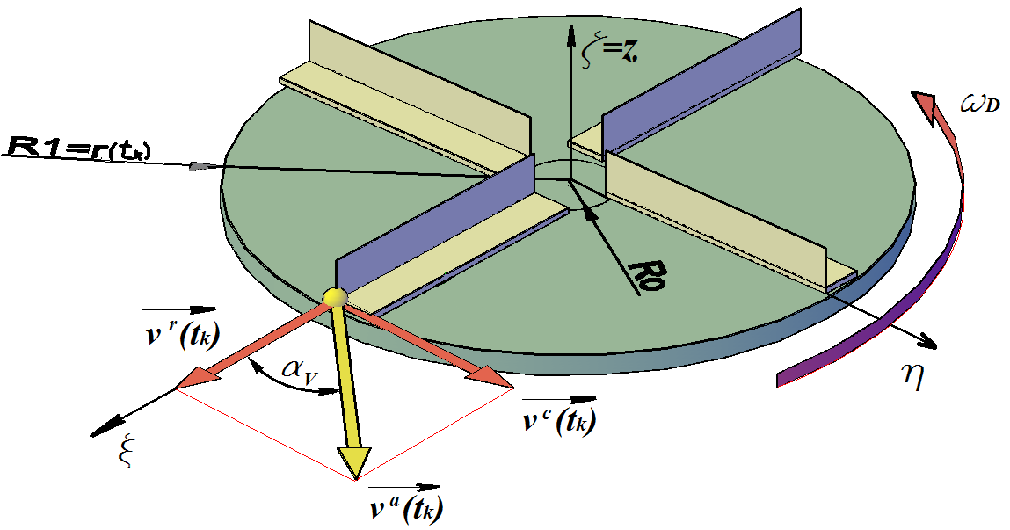

Figure 4. Components of the absolute velocity vector of the fertilizer particle.

The relative velocity vector is aligned with the positive direction of the *Oξ* axis and the carrying velocity is aligned with the positive orientation of the axis *Oη*. The magnitude of the relative velocity, as a function of time, is defined by the formula (24). Thus, its magnitude at the particle ejection point can be calculated by substituting $t=t_{K}$ in the equation (24):

$v^{r}\left(t_{K}\right)=\frac{{- ω}_{D}}{2∙ \sqrt{1+μ_{V}^{2}}}∙\left(R_{0}-\frac{μ_{D}∙g}{ω_{D}^{2}}\right)∙\left[e^{{-ω}_{D}∙\left(μ_{V}+\sqrt{1+μ_{V}^{2}}\right)∙t_{K}}-e^{{-ω}_{D} ∙ \left(μ_{V}-\sqrt{1+μ_{V}^{2}}\right)∙t_{K}}\right]$, (27)

where the ejection time $t_{K}$ is defined by the formula (25).

The magnitude $v^{c}$ of the carrying velocity $\vec{{ v}^{c}}$ vector is the multiple of the particle radius $r^{r}$ and the angular velocity $ω_{D}=const.$ of a carrying motion (spreading disc rotation):

${ v}^{c}\left(t\right)= r^{r}\left(t\right) ∙ ω_{D}$. (28)

At the ejection point, a fertilizer particle reaches the outer disc radius $r^{r}\left(t_{K}\right)=R_{1}$. Therefore, at the ejection point, the magnitude $v^{c}$ of the carrying velocity has the value:

${ v}^{c}\left(t_{k}\right)= R_{1} ∙ω_{D}$. (29)

Therefore, the magnitude of the absolute velocity vector (Figure 4) was evaluated using the well-known Pythagoras theorem:

$v^{a}\left(t\right)=\sqrt{{\left[v^{c}\left(t\right)\right]}^{2}+{\left[v^{r}\left(t\right)\right]}^{2}}$ ⟹ $v^{a}\left(t_{k}\right)=\sqrt{{\left[v^{c}\left(t_{k}\right)\right]}^{2}+{\left[v^{r}\left(t_{k}\right)\right]}^{2}}$. (30), (31)

Its orientation is defined by the polar angle (Figure 4):

$tan\left\{α_{v}\left(t\right)\right\}=\frac{{ v}^{c}\left(t\right)}{{ v}^{r}\left(t\right)}$ ⟹ $tan\left\{α_{v}\left(t_{k}\right)\right\}=\frac{{ v}^{c}\left(t_{k}\right)}{{ v}^{r}\left(t_{k}\right)}$; (32), (33)

$α_{v}\left(t\right)=arctan\left\{\frac{{ v}^{c}\left(t\right)}{{ v}^{r}\left(t\right)}\right\}\left[rad\right]= \frac{360}{2 ∙ π} ∙arctan\left\{\frac{{ v}^{c}\left(t\right)}{{ v}^{r}\left(t\right)}\right\}[^{∘}]$; (34)

$α_{v}\left(t_{k}\right)=arctan\left\{\frac{{ v}^{c}\left(t_{k}\right)}{{ v}^{r}\left(t_{k}\right)}\right\}\left[rad\right]= \frac{360}{2 ∙ π} ∙arctan\left\{\frac{{ v}^{c}\left(t_{k}\right)}{{ v}^{r}\left(t_{k}\right)}\right\}[^{∘}]$. (35)

Numerical results

All calculations, based on the presented analytical model, were performed using MS EXCEL and the input data given in Table 1.

Table 1. Input data for the analytical model.

|  |  |  |  |  |  |
| --- | --- | --- | --- | --- | --- |
| ***n* [min-1]** | **R0 [m]** | **R1 [m]** | ***D* [-]** | ***V* [-]** | ***g* [m·s-2]** |
| 300 | 0.045 | 0.21 | 0.3 | 0.4 | 9.81 |

The radial position of the sliding fertilizer particle $r^{r}=r^{r}\left(t\right)$ was calculated using the expression (23), as it is illustrated in Figure 5a. The total particle traveling time $t_{K}$, along the vane, is defined by the formula (25) that cannot be solved analytically. Therefore, its solution was found numerically, using MS EXCEL and the “sweeping method” applied to the equation (25) and the border condition $r^{r}\left(t_{K}\right)=R_{1}$: $t_{k}=0,0927 [s]$.

**(a)****(a)**

**(b)** **(b)**

Figure 5. Kinematic parameters of the fertilizer particle motion along the vane, with respect to traveling time: (a) radial position $r^{r}\left(t\right)$; (b)−−−relative $v^{r}\left(t\right)$,∙∙∙∙∙∙carrying $v^{c}\left(t\right)$ and −−− absolute velocity $v^{a}\left(t\right)$.

Numerical values defining the fertilizer particle velocity vector, including their values at the launching point, were found using expressions (24), (27), (28), (29), (30), (31), (34) and (35), and presented in Figures 5b and 6.



Figure 6. The radial velocity of the fertilizer particle along the radial vane,

with respect to its distance from the spinning axis.

As it can be seen from the charts presented in Figures 5 and 6, the launching value of the absolute velocity vector magnitude (at the ejecting point) is

$v^{a}\left(t_{k}\right)=7,93 \left[\frac{m}{s}\right]$,

and its angle toward the radial vane (for an illustration, see Figure 4) is:

$α_{v}\left(t_{k}\right)=56,35 \left[°\right]$.

**Conclusion**

The dynamic model for evaluation of the ejection velocity vector of the fertilizer particle from the spinning disc of a centrifugal spreader, having the flat disk with straight radial vanes, is presented in the paper. This work will be continued in order to develop a ballistic model of the fertilizer particle flight, which is expected to enable the prediction of the landing distance and the fertilizer spreading pattern.

The influence of the inclination vane angle toward the spinning disc (inclined forward, inclined backward or orthogonal to a disk) has not been completely resolved yet, especially when combined with the influence of a friction coefficient. This phenomenon should be also included in the more advanced future models of solid fertilizer spreading by disk spreaders.

**Acknowledgements**

This work is supported by the Serbian Ministry of Science and Technological Development, under the project “Improvement of biotechnological procedures as a function of rational utilization of energy, agricultural products productivity and quality increase” (Project No. TR 31051).

**References**

Aphale, A., Bolander, N., Park, J., Shaw, L., Svec, J., & Wassgren, C. (2003). Granular fertiliser particle dynamics on and off a spinner spreader. *Biosyst. Eng*., *85,* 319-329.

Beer, P.F., Johnston, E.R., Jr., Mazurek, F.D., Cornwell, J.P., & Elliot, E.R. (2010). Vector *mechanics for engineers – Statics and dynamics,* 9-th ed. The McGraw-Hill Companies, Inc., New York, USA.

Cool, S., Pieters, J., Mertens, C.K., Hijazi, B., & Vangeyte, J. (2014). A simulation of the influence of spinning on the ballistic flight of spherical fertilizer grains. *Computers and Electronics in Agriculture,* *105,* 121-131.

Cool, R.S., Pieters, G.J., Acker V.J., Van Den, Bulcke, J., Mertens, C.K., Nuyttens, R.E.D., Van De Gucht, C.T., & Vangeyte, J. (2016). Determining the effect of wind on the ballistic flight of fertilizer particles. *Biosystems Engineering, 151,* 425-434.

Cunningham, F.M. (1962). Performance characteristics of bulk fertilizer spreaders for granular fertilizer. *Trans. ASAE*, *6 (2),* 108-114.

Cunningham, F.M., & Chao, Y.S. (1967). Design relationships for centrifugal fertilizer distributors. *Trans. ASAE,* *10 (1)*, 91-95.

Dawson, C.J., & Hilton, J. (2011). Fertilizer availability in a resource-limited world: production and recycling of nitrogen and phosphorus. *Food Policy,* *36*, S14-S22.

Dintwa, E., Tijskens, E., Olieslagers, R., De Baerdemaeker, J., & Ramon, H. (2004). Calibration of a spinning disc spreader simulation model for accurate site specific fertilizer application. *Biosyst. Eng*., *88*, 49-62.

Dobler, K., & Flatow, J. (1968). Berechnung der wurfgange beim schleuderdungerstreuern. [Calculation of particle trajectories, forced by a centrifugal spreader]. *Grundlagen der Landtechnik*, *18(4)*, 129-164.

Gavrilović, V.M. (2016). Influence of physical properties of mineral fertilizers on the centrifugal spreaders working quality and energy balance of the plant production. *Ph.D. Thesis, University of Belgrade*, Faculty of Agriculture, Belgrade-Zemun (In Serbian).

Griffis, C.L., Ritter, D.W., Matthews, & E.J. (1983). *Simulation of rotary spreader distribution patterns*. Transactions of the ASAE 1983, *26 (1),* 33-37.

Hibbeler, C.R. (2010). *Engineering mechanics–Dynamics,* 12-th. ed. Prentice Hall, New Jersey, USA.

Hatem, Ali Esmail Morsy (2013). Simulation of rotary spreader. *Mansoura University, Ph.D. Thesis*, Faculty of Agriculture. Agric. Eng. Dept., Mansoura, Egypt. Retrieved on 14. September 2017, from: <https://www.researchgate.net/publication/236898645>.

Hofstee, J.W. (1995). Handling and spreading of fertilizers: Part 5, The spinning disc type fertilizer spreader. *Journal ofAgricultural Engineering Research*, *62,* 142-162.

Mennel, F.I., & Reece, A.R. (1962). The theory of the centrifugal distributor: II. Motion on the disc, off–center feed. *J*. *Agric. Eng. Res*., *7 (4),* 345-353.

Olieslagers, R., Ramon, H., & De Baerdemaeker, J. (1996). Calculation of fertilizer distribution patterns from a spinning discspreader by means of a simulation model. *J. Agric. Eng. Res*., *63,* 137-152.

Soare, V.M., Teodorescu, P., & Toma, I. (2007). *Ordinary differential equations with applications to mechanics*. Springer, A A Dordrecht. The Netherlands.

Sogaard, H.T., & Kierkegaard, P. (1994). Yield reduction resulting from uneven fertilizer distribution. *Transactions of the ASAE*, *37 (6),* 1749-1752.

Tijskens, E., Van Liederkerke, P., & Ramon, H. (2005). Modelling to aid assessment of fertiliser handling and spreading characteristics. *The International Fertiliser Society, Proceeding,* 553.

Van Liedekerke, P., Tijskens, E., & Ramon, H. (2009). Discrete element simulations of the influence of fertilizer physical properties on the spread pattern from spinning disc spreaders. *Biosystems Engineering,* *102,* (2009), 392-405.

Villette, S., Cointault, F., Piron, E., Chopinet, B., & Paindavoine, M.(2008). Simple imaging system to measure velocity and improve the quality of fertilizer spreading in agriculture. *Journal of Electronic imaging, 17 (3),* 031109.

Zentner, R.P., Basnyat, P., Brandt, S.A., Thomas, A.G., Ulrich, D.J., Campbell, C.A., Nagy, C.N., Frick, B.L., Lemke, R.L., Malhi, S.S., Olfert, O.O., & Fernandez, M.R. (2011). Effects of input management and crop diversity on economic returns and riskiness of cropping systems in the semi-arid Canadian Prairie. *Renewable Agriculture and Food Systems*, *26 (3),* 208-223.

Received: December 18, 2017

Accepted: February 7, 2018

KRETANJE ČESTICE ĐUBRIVA duž lopaticE centrifugalnog rasipača SA DISKOM pretpostavljajući

Čisto klizanje ČESTICE

**Vera B. Cerović1[2]*, Dragan V. Petrović2, Rade L. Radojević2,**

**Saša R. Barać3 i Aleksandar Vuković3**

1Univerzitet u Beogradu, Mašinski fakultet,

Kraljice Marije 16, 11080 Beograd, Srbija

2Univerzitet u Beogradu, Poljoprivredni fakultet,

Nemanjina 6, 11080 Beograd-Zemun, Srbija

3Univerzitet u Prištini, Poljoprivedni fakultet, 38219 Lešak, Srbija

R e z i m e

U Evropi se za rasipanje granularnog mineralnog đubriva najčešće koriste centrifugalni rasipači sa lopaticama. U ovom radu je analizirano kretanje idealne, loptaste, homogene granule đubriva duž lopatica postavljenih po rotirajućem disku. Analiza je izvedena primenom neinercijalnog referentnog koordinatnog sistema. Uvođenjem određenih pretpostavki i primenom zakona teorijske mehanike za opisivanje kretanja čestice, formirana je nehomogena diferencijalna jednačina drugog reda sa konstantnim koeficijentima. Njeno rešenje aproksimira realno relativno kretanje čestice đubriva duž ravnih radijalnih lopatica pričvršćenih za horizontalni disk, koji se obrće konstantnom ugaonom brzinom. Dobijeno rešenje se svakako može koristiti za optimizaciju radnih parametara centrifugalnog rasipača sa diskom.

**Ključne reči**: granula đubriva, centrifugalni rasipač sa diskom, radijalne lopatice, diferencijalna jednačina.

Primljeno: 18. decembra 2017.

Odobreno: 7. februara 2018.

1. Corresponding author: e-mail: verica.cerovic@gmail.com
2. *Autor za kontakt: e-mail: verica.cerovic@gmail.com