WEED BIOMASS AND PRODUCTIVITY OF OKRA (ABELMOSCHUS ESCULENTUS (L) MOENCH) AS INFLUENCED BY SPACING AND PENDIMETHALIN-BASED WEED MANAGEMENT

Emmanuel O. Imoloame* and Muinat Usman

Department of Crop Production, College of Agriculture, Kwara State University, Malete, Ilorin, Kwara State, Nigeria

Abstract: Field trials were conducted at the Teaching and Research Farm of the Kwara State University, Malete, Nigeria, to determine the effect of plant spacing and weed control methods on weed infestation, growth and yield of okra during the 2016 and 2017 cropping seasons. The experiment consisted of twelve treatments comprising six weed control methods and two plant spacings. The method of weed control consisted of pre-emergence application of pendimethalin at 1.0 kg a.i. ha⁻¹, pendimethalin at 2.0 kg a.i. ha⁻¹, pendimathalin at 1.0 kg a.i. ha⁻¹ + one supplementary hoe weeding (SHW) at 6 weeks after sowing (WAS), two hoe weedings at 3 and 6 weeks after sowing (WAS), weeding at 4 and 8 weeks after sowing (WAS) and a weedy check. The plant spacings were 60cm x 30cm and 60cm x 50cm. These treatments were laid out in a randomized complete block design (RCBD) with split plot arrangements and three replications. Weed control and plant spacing treatments were allocated to the main plot and subplots respectively. Results showed that a plant spacing of 60cm x 30cm minimized weed infestation and resulted in a higher total number of pods/plot and okra fresh weight, while pendimethalin at 1.0 kg a.i. ha⁻¹ + one supplementary hoe weeding at 6 WAS minimized weed infestation in the plots, and led to the highest total number of pods and yield of okra. This combination also promoted higher economic returns.
Key words: weed control method, okra productivity, southern Guinea savanna, Nigeria.

Introduction

Okra (Abelmoschus esculentus (L.) Moench) is an important vegetable crop grown in the wet season and to a little extent in the dry season (Alegbajo and Ogunlana, 2006).
The world’s greatest producer of okra is India, producing 70% of the total world’s production estimated to be 6 million tons per year (FAOSTAT, 2012), followed by Nigeria and Sudan (Varmudy, 2011). In Nigeria, okra ranks third in terms of consumption and production area following tomato and pepper (Odeleye et al., 2005).
Adeyemi et al. (2008) have reported that in Nigeria, the limiting factors in okra production, among others, are sub-optimal planting density, weed management, tillage practices and low yielding varieties. Yield loss as a result of uncontrolled weeds in okra fields was reported to be up to 91% in the northern Guinea savanna of Nigeria (Adejonwo et al., 1989). Similarly, Olabode et al. (2006) reported 85% fruit yield loss in okra when comparing the performance of okra in uncontrolled weed plots and mulched plots in the southern Guinea savanna of Nigeria.
Hoe weeding is the most common weed control practice in okra cultivation in Africa, but this method has been reported to be cumbersome, time-consuming and expensive. Apart from high cost of hoe weeding, scarcity of labor is a common problem usually experienced during the peak period of farming operations and can sometimes result in abandonment of field crops (Adigun et al., 2005; Osupitan, 2017).
Although efforts are being intensified to promote the use of chemical weed control among farmers in developed agriculture, the sustained use of herbicides has caused shifts in weed flora of arable fields or in increasing environmental concerns over their use (Racjan et al., 2001; Hyvonen et al., 2002). Furthermore, some workers have reported that the use of herbicides alone for weed control in okra can hardly give season-long weed control (Olabode et al., 2006), especially in the southern Guinea savanna where higher rainfall and relative humidity favor rapid and prolonged weed growth. Consequently, integrated approach to weed management remains very important (Gianessi and Williams, 2001).
A lot of research has been done on the effect of spacing on the productivity of okra. However, different spacings have been recommended for higher okra yield in different agro-ecological conditions (Vikash et al., 2016; Paththinige et al., 2008). Therefore, the need to determine the correct spacing for higher production of okra variety NHAe47-4 in Malete, Kwara State, Nigeria is imperative.
Work done on the use of integrated weed management for effective weed control and for increasing the pod yield of okra includes that of Smith et al. (2009) who have reported that the use of pendimethalin-based integrated weed management system (IWMS) will enhance production of okra and farmers’ livelihood in polyculture-based small farms. Similarly, pendimethalin either alone or in mixtures with broadleaf herbicides and supplemented with other control methods, especially hand weeding, has given effective control of weeds (Dhann Appal and Gowda, 1996; Imoloame, 2017).
Pendimethalin is one of the herbicides commonly used for weed control in okra cultivation in Malete, Kwara State, Nigeria. This could be a result of its low price and availability in agro-chemical stores all the time. However, because most farmers in the area are illiterate and lack the knowledge of using herbicides, these agrochemicals are indiscriminately applied with attendant consequences of low and high costs of weed control, environmental pollution, high crop mortality, poor crop yields, low incomes and standard of living. There is, therefore, the need to determine the correct dose of pendimethalin herbicide and better weed control options that will provide season-long weed control, higher okra pod yield, and increase cash returns to farmers.
The hypothesis of this study is that a single method of weed control will not provide season-long weed control, maximum okra yield and economic returns in Malete, Kwara State. Therefore, IWM involving a lower dose of pendimethalin integrated with a supplementary hoe weeding at 6WAS and narrower spacing of okra will not only give season-long weed control in okra, but it will also increase okra yield and cash returns to the farmers. The objectives of the study are to determine the correct spacing and better pendimethalin weed management option that will be more effective in controlling weeds and increasing yield and cash income in the production of okra.

Materials and Methods

Site description

The experiment was conducted during the 2016 and 2017 cropping seasons at the Kwara State University Teaching and Research (T&R) Farm, Malete (Lat.08º 71^{l}N; Long.04º 44ºE), Kwara State, in a southern Guinea savanna ecological zone of Nigeria. The experimental site was characterized by two peaks of rainfall in June and September and the soil was sandy loam with a low water retaining capacity.

Treatment and experimental design

The experiment consisted of twelve treatments comprising six weed control methods and two plant spacings. The methods of weed control were: application of pendimethalin at 1.0 kg a.i. ha⁻¹, pendimethalin at 2.0 kg a.i. ha⁻¹, pendimathalin at 1.0 kg a.i. ha⁻¹ + 1 supplementary hoe weeding (SHW) at 6 WAS, weeding at 3 and 6 weeks after sowing (WAS), weeding at 4 and 8 weeks after sowing (WAS) and weedy check. Weeding at 3 and 6 WAS served as the control plot. The weed-free treatment was not, therefore, necessary since the critical period of weed competition in okra occurred between 3 and 7 WAS (William and Warren, 1975). In addition, okra plots weeded twice have been reported to give maximum pod yield which was comparable to the weed-free plots ( Olabode et al., 2010). The plant spacings were 60cm x 30cm and 60cm x 50cm giving plant populations of 55,556 and 33,333 plants ha⁻¹ respectively. These treatments were laid out in a randomized complete block design (RCBD) fitted into split plot arrangements and replicated three times.
The land used for the experiment was first mechanically plowed and harrowed, then it was leveled and marked out into plots measuring 3m x 3m each. A space of 0.5m was left between plots, while 1m was left between replicates. There were a total of 36 plots.
In order to provide nutrient supply, the NPK 15:15:15 was applied to each plot at the recommended rate of 300 kg ha⁻¹. The mineral fertilizer was applied in two split doses ‒ the first dose applied to each plot before planting and the remaining dose applied at 6 WAS.
Sowing was done on the 18th and 14th of July, in 2016 and 2017 respectively, using treated seeds of okra variety NHAe47-4 obtained from the National Horticultural Research Institute (NIHORT), Ibadan, Nigeria. Three seeds were planted per hole and the resultant seedlings were thinned to one plant per strand at 3WAS at spacing of 60cm x 30cm and 60cm x 50cm.
Herbicide (pendimethalin) was applied as pre-emergence a day after sowing using a CP 15 knapsack sprayer and a green nozzle calibrated to deliver 208l ha⁻¹ of the herbicide spray volume. Karate insecticide (lambdacyhalothrin) at the rate of 30ml /10 liters of water was used to control insects, especially leaf eater beetles.
Harvesting of okra seed was done periodically in both September and October in the two years of the experiment.

The following parameters were measured:

Weed dry matter (kg ha⁻¹)

Weed dry matter was determined by harvested weeds from one square meter quadrat, randomly placed in three locations within each plot. The weeds were put in well labeled envelopes which were later oven-dried at a temperature of 80ºC for 2 days to a constant weight before the final weights were taken. The weed dry matter was taken at 6 and 9 WAS.

Weed cover score

Weed cover score was determined at 3 and 6 WAS by visual observation using a scale of 0‒9, where 0 means weed-free plots and 9 complete weed cover of plots.

Weed density (kg ha⁻¹)

Weed density was determined at 6 and 9 WAS by counting the number of weed species within a 50cmx50cm quadrat, randomly placed in three locations within each plot and the total number of weed species per unit area was recorded.
Number of leaves/plant

The number of leaves per plant was determined at 6 and 9 WAS. Five plants from each plot were selected at random and the number of leaves on them was counted. The average of the total number of leaves was recorded as the number of leaves per plant.

Leaf area (cm)

Leaf area of okra was determined at 6 and 9 WAS by using the expression: Leaf area (LA) = Length (L) x breadth (B) x 0.62. The leaf area was obtained by measuring the length and breadth of leaves from five randomly selected plants from each plot and the average of these measurements was multiplied by a factor of 0.62 to give the leaf area per plant.

Number of pods/plot

The number of pods per plot was determined by counting the total number of harvested pods from each net plot.

Fresh weight (kg ha⁻¹)

Fresh weight was determined by weighing the pods harvested from each net plot and the weight was converted to kilogram per hectare using the equation below:
Fresh weight = Pod yield per net plot x 10000m² Eq 1
Net plot size (m²)

Effect of plant spacing and different methods of weed control on the economics of producing okra

The effect of plant spacing and methods of weed control on the economics of producing okra was determined by calculating the total cost of production, gross revenue, net revenue (Eni et al., 2013) for each treatment as follows:
Production cost (PC): This was computed by adding the cost of inputs and those of all farm operations. These included cost of okra seeds, pendimethalin herbicide at different rates, insecticide, fertilizers, land preparation, planting, herbicide application, one and two hoe weeding(s), fertilizer application, harvesting and bagging. This is represented by the following equation: PC = (PC1+PC2+PC3+……..PCn) (Eni et al., 2013);
Gross revenue (R): This was obtained by multiplying the okra fresh weight in kg/ha by the farm gate price as follows: Gross revenue = Crop yield (Y) x Farm gate price (P) (Eni et al., 2013).
Net revenue (NR): This was calculated by subtracting the total production cost from the gross revenue as follows: NR= GR-PC.
Cost: benefit ratio = Total cost of production / Total revenue (Joshua and Gworgwor, 2001).

Data analysis

All the data collected were subjected to analysis of variance (ANOVA) using SAS 9.0 package and the means were separated using the least significant difference (LSD) at the 5% level of probability. The yield data in the economic analysis was separated using Duncan’s Multiple Range Test (DMRT) at the 5% level of probability.

Results and Discussion

Rainfall

The total rainfall recorded in 2016 and 2017 amounted to 1414mm and 1015.7mm respectively. The highest rainfall was recorded in the months of September and August in both years, respectively (Figures 1 and 2).

Month
Rainfall (mm)
Figure 1. Rainfalls in 2016 Total – 1, 398.5.
Source: Lower Niger River Basin and Rural Development Authority, Hydrology Station.
Month
Rainfall (mm)
Figure 2. Rainfalls in 2017 Total = 1017MM.
Source: Lower Niger River Basin and Rural Development Authority Hydrology Station.

Effect of spacing and pendimethalin-based weed management options on weed biomass and weed density

Wider spacing promoted a higher amount of weed biomass and weed density in both years and average of the two years compared to narrower spacing. The difference was statistically significant only in 2016 (Figures 3, 4, 5, 9, 10 and 11). Pendimethalin at 1.0 kg a.i. ha⁻¹ plus one SHW and two hoe weedings at 3 and 6, and 4 and 8 WAS significantly reduced weed biomass and weed density and provided season-long effective weed control throughout the life of the crop. Generally, higher values of weed biomass and weed density were recorded in 2016 than in 2017 (Figures 6, 7, 8, 12, 13 and 14). The significant reduction in weed biomass and weed density by the narrower spacing in 2016 could have been a result of the higher rainfall recorded in that year which could have promoted better growth and early canopy closure of okra required for smoother weeds. The broadcast method of producing sesame was found to suppress weeds better than the drilling method as a result of quick and early canopy closure and reduction in light penetration (Dalley et al., 2004; Imoloame, 2007). Similarly, one SHW at 6 WAS integrated with pendimethalin at 1.0 kg a.i. ha⁻¹ increased the efficacy of the herbicide to provide season-long weed control. This method of weed control can serve as an alternative to two hoe weedings at 3 and 6 or 4 and 8 WAS, which is considered to be laborious and associated with drudgery. The higher rainfall recorded could have promoted higher weed biomass in 2016 compared to 2017. There was no significant interaction between spacing and the weed control method.

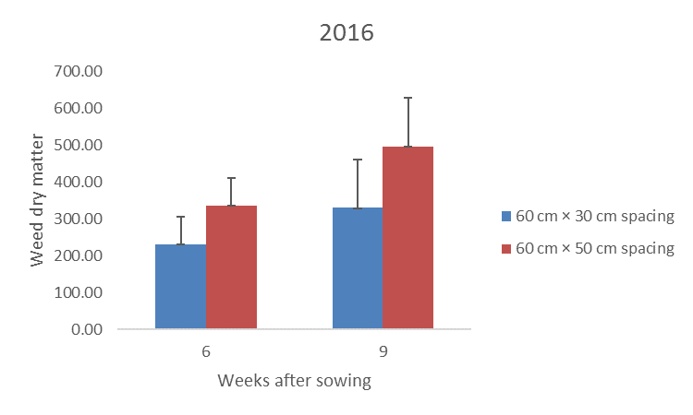
Figure 3. The effect of spacing on weed dry matter (2016).
LSD (0.05) at 6 WAS = 73.59; LSD (0.05) at 9 WAS = 131.76.

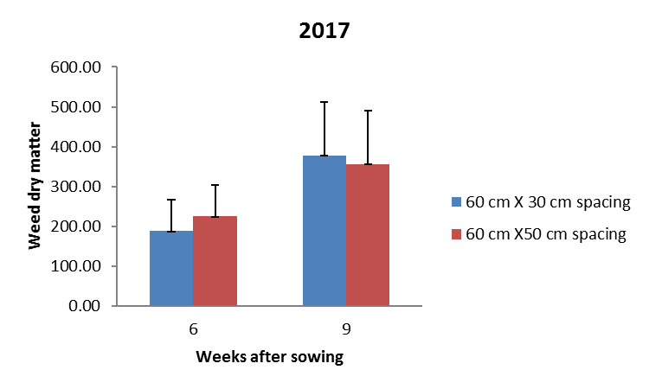
Figure 4. The effect of spacing on weed dry matter (2017).
LSD (0.05) at 6 WAS = 79.70; LSD (0.05) at 9 WAS = 134.00.

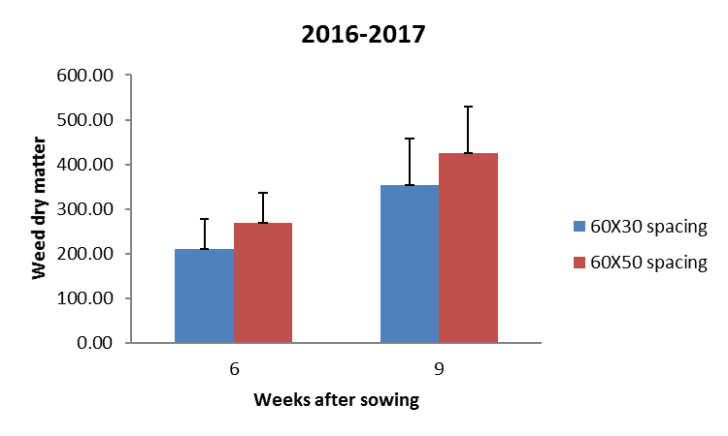
Figure 5. The Effect of spacing on averaged weed dry matter.
LSD (0.05) at 6WAS = 66.76; LSD (0.05) at 9WAS = 103.02.

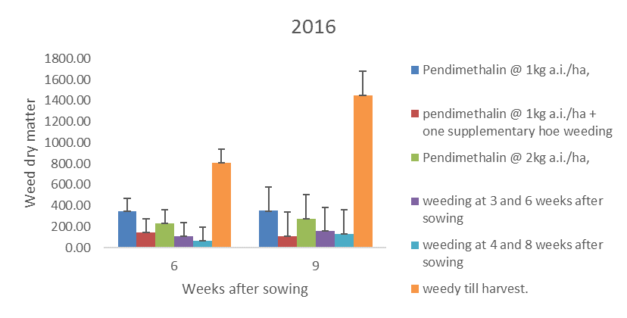
Figure 6. The effect of weed control on weed dry matter (2016).
LSD (0.05) at 6 WAS = 127.45; LSD (0.05) at 9 WAS = 228.07.

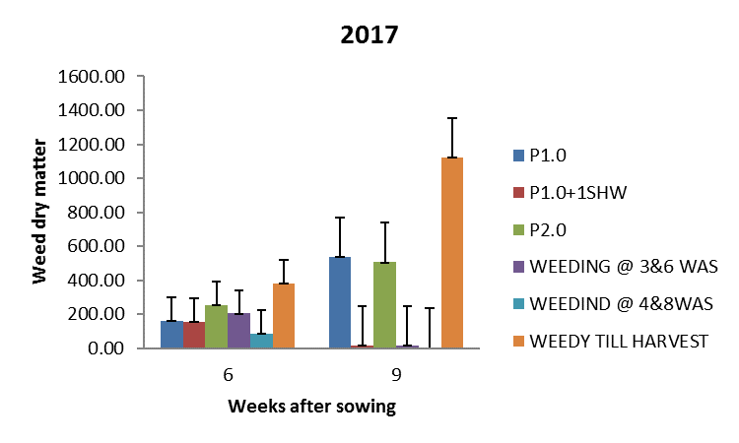
Figure 7. The effect of weed control on weed dry matter (2017).
LSD (0.05) at 6 WAS = 138.04; LSD (0.05) at 9 WAS = 232.09.

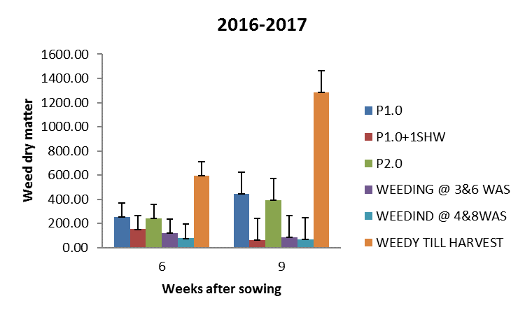
Figure 8. The effect of weed control on weed dry matter at the mean.
LSD (0.05) at 6 WAS = 175.62; LSD (0.05) at 9 WAS = 178.44.

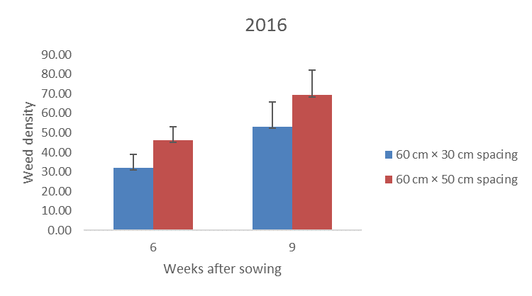
Figure 9. The effect of spacing on weed density (2016).
LSD (0.05) at 6 WAS = 0.85; LSD (0.05) at 9 WAS = 12.74.

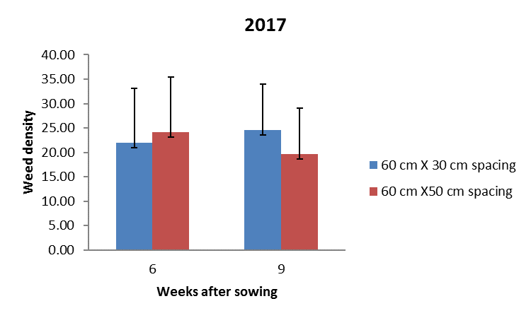
Figure 10. The effect of spacing on weed density (2017).
LSD (0.05) at 6 WAS = 11.22, LSD (0.05) at 9 WAS = 9.42

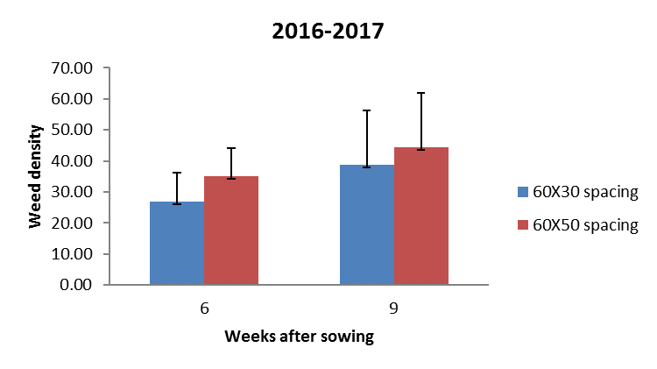
Figure 11. The effect of spacing on weed density at the mean.
LSD (0.05) at 6 WAS = 9.05; LSD (0.05) at 9 WAS = 17.41.

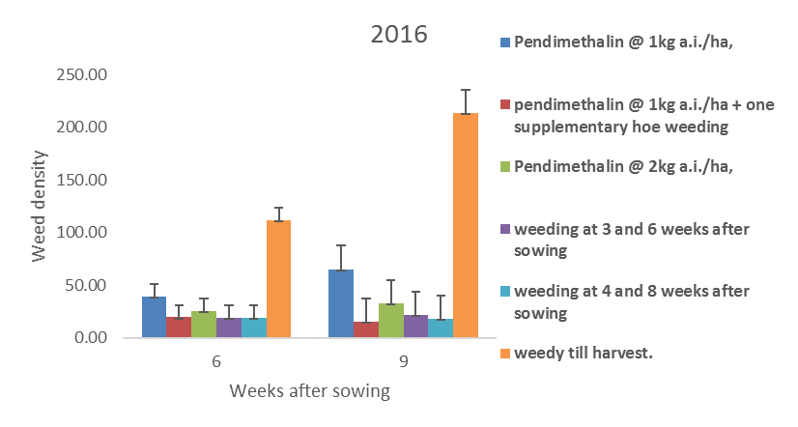
Figure 12. The effect of weed control on weed density (2016).
LSD (0.05) at 6 WAS = 11.86; LSD (0.05) at 9 WAS = 22.06.

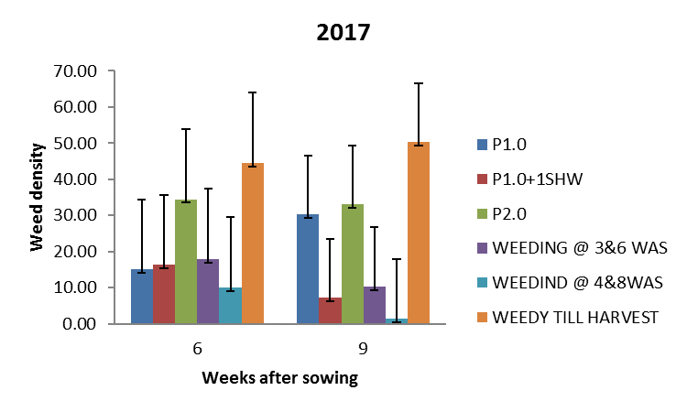
Figure 13. The effect of weed control on weed density (2017).
LSD (0.05) at 6 WAS = 19.44; LSD (0.05) at 9 WAS = 16.32.

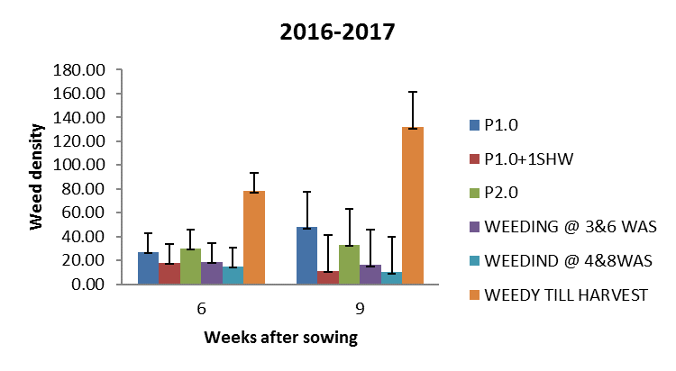
Figure 14. The effect of weed control on weed density at the mean.
LSD (0.05) at 6 WAS = 15.68, LSD (0.05) at 9 WAS = 29.98.
Effect of spacing and pendimethalin-based weed management options on leaf area and number of leaves/plant

There was no significant difference in the leaf area of okra spaced at 60cm x 30cm and 60cm x 50 cm in the two years of the study and the mean (Table 1). However, pendimethalin at 1.0 kg a.i. ha⁻¹ plus one SHW gave rise to crops with leaf areas significantly larger than those from other treatments, but was comparable with two hoe weedings at 3 and 6 and 4 and 8 WAS (Table 2).

Table 1. The effect of spacing and weed control method on leaf area of okra (cm).

 | Leaf area/Plant
Treatment |  | 6WAS |  |  | 9WAS
 |  | 2016 | 2017 | Mean | 2016 | 2017 | Mean
Plant spacing (S)
60cm x 30cm |  | 69.7 | 54.3 | 62.0 | 87.1 | 76.9 | 81.9
60cm x 50cm |  | 74.2 | 56.3 | 65.2 | 88.4 | 72.3 | 80.4
LSD (0.05) |  | 11.99 | 7.57 | 9.07 | 14.12 | 9.86 | 10.10
Method of weed control (WC)
Pendimethalin at 1.0kg a.i.ha⁻¹ |  | 72.2 | 50.9 | 61.8 | 86.4 | 70.9 | 78.6
Pendimethalin at 1.0kg a.i./ha⁻¹ + one SHW at 6WAS |  | 109.7 | 49.5 | 79.6 | 129.4 | 79.6 | 104.5
Pendimethalin at 2.0kg a.i./ha⁻¹ |  | 65.7 | 55.5 | 60.6 | 85.6 | 73.3 | 79.5
Hoe weeding at 3 and 6WAS |  | 81.6 | 64.9 | 73.3 | 108.9 | 80.4 | 94.7
Hoe weeding at 4 and 8WAS |  | 78.9 | 65.2 | 72.1 | 90.8 | 89.2 | 90.0
Weedy Check |  | 22.9 | 45.9 | 34.4 | 25.3 | 54.3 | 39.8
LSD (0.05) |  | 20.90 | 13.10 | 15.72 | 24.45 | 17.08 | 17.49
Interaction S X WC |  | NS | NS | NS | NS | NS | NS
SHW = Supplementary hoe weeding; WAS = Weeks after sowing.

Similarly, okra crops spaced at 60 x 50cm produced a significantly higher number of leaves than narrower spaced crops at 9 WAS in 2016 and in the average for two years (Table 2). In addition, a pre-emergence application of pendimethalin at 1.0 kg a.i.ha⁻¹ plus one SHW resulted in crops with a higher number of okra leaves, which was significantly different from crops in other treatments except for two hoe weedings at 3 and 6 and 4 and 8 WAS at 9 WAS in 2017. There was no significant interactive effect between spacing and weed control methods on the number of leaves/plant (Table 2). The higher rainfall coupled with wider spacing of okra enhanced the uptake of growth factors which could have been responsible for the production of a significantly higher number of leaves in 2016. The effectiveness of weed control methods, namely, pendimethalin at 1.0 kg a.i./ha⁻¹ plus one SHW at 6 WAS and two hoe weedings minimized weed infestation significantly. This freed enough growth resources of moisture, light and soil nutrients for better performance of the crop. This agrees with the report of Jalendhar et al. (2012) that integrated weed management is more effective in controlling weeds.

Table 2. The effect of spacing and method of weed control on the number of leaves/plant.

 | Number of Leaves/Plant
Treatment |  | 6WAS |  |  | 9WAS
 |  | 2016 | 2017 | Mean | 2016 | 2017 | Mean
Plant spacing (S)
60cm x 30cm |  | 6.08 | 6.5 | 6.3 | 7.5 | 8.9 | 8.2
60cm x 50cm |  | 5.9 | 6.9 | 6.4 | 9.3 | 8.9 | 9.1
LSD (0.05) |  | 0.23 | 0.48 | 0.31 | 1.02 | 1.06 | 0.82
Method of weed control (WC)
Pendimethalin at 1.0g a.i.ha⁻¹ |  | 5.8 | 6.7 | 6.2 | 7.4 | 9.1 | 8.2
Pendimethalin at 1.0kg a.i./ha⁻¹ + one SHW at 6WAS |  | 7.2 | 6.8 | 7.0 | 11.8 | 10.2 | 11.0
Pendimethalin at 2.0kg a.i./ha⁻¹ |  | 6.3 | 6.3 | 6.3 | 8.6 | 8.2 | 8.4
Hoe weeding at 3 and 6WAS |  | 6.1 | 7.6 | 6.9 | 10.7 | 10.5 | 10.6
Hoe weeding at 4 and 8WAS |  | 5.9 | 6.8 | 6.3 | 8.1 | 10.2 | 9.1
Weedy check |  | 4.8 | 5.9 | 5.4 | 3.9 | 5.5c | 4.7
LSD (0.05) |  | 0.39 | 0.84 | 0.53 | 1.77 | 1.84 | 1.43
Interaction S X WC |  | NS | NS | NS | NS | NS | NS
SHW = Supplementary hoe weeds; WAS = Weeks after sowing.

Effect of spacing and weed control methods on yield components and yield of okra

Spacing had a significant influence on the total number of pods and fresh pod yield of okra in 2016 and the mean of two years (Table 3). Okra crops spaced at 60cm x 30cm recorded a significantly higher total number of pods and fresh pod weight than those spaced at wider spacing. The utilization of adequate growth resources resulting from better weed control and the higher population of okra plants in plots treated with narrower spacing could have accounted for a higher number of okra pods and better performances. This agrees with the findings of Paththinige (2008) and Okunowo (2012) that narrow plant spacing produced higher yield and fresh weight of okra. The higher rainfall recorded in 2016 compared to 2017 could have caused the significant difference in yield of okra between the two spacings of 60cm x 30cm and 60cm x 50cm. Plots treated with pendimethalin at 1.0 kg a.i.ha⁻¹ plus one SHW produced significantly higher fresh okra pod weight than those from the other treatments in both years and their means. This has further proved the efficacy of this method of weed control which was able to minimize weed infestation and enhance the utilization of growth resources and assimilate for the production of a higher number of pods and fresh pod weight of okra. This is in line with the report of Jalendar et al. (2012), that integrated weed management produced the highest total number of pods and fresh weight of okra.

Table 3. The effect of spacing and method of weed control on total number of pods and fresh okra pod yield.

Treatment | Total number of pods/plot |  |  | Fresh pod weight
 | 2016 | 2017 | Mean | 2016 | 2017 | Mean
Plant spacing (S)
60cm x 30cm | 91.8 | 95.0 | 93.4 | 904.5 | 1104.7 | 1004.6
60cm x 50cm | 68.2 | 86.1 | 77.1 | 665.4 | 967.5 | 816.5
LSD (0.05) | 18.76 | 16.95 | 15.07 | 200.34 | 256.97 | 181.99
Method of weed control (WC)
Pendimethalin at 1.0kg a.i.ha⁻¹ | 74.0 | 72.0 | 73.0 | 705.5 | 776.1 | 740.8
Pendimethalin at 1.0kg a.i. ha⁻¹ + one SHW at 6WAS | 149.3 | 122.0 | 135.7 | 1519.4 | 1445.6 | 1482.5
Pendimethalin at 2.0kg a.i. ha⁻¹ | 61.5 | 54.0 | 57.9 | 574.2 | 605.2 | 589.7
Hoe weeding at 3 and 6WAS | 112.3 | 128.8 | 120.6 | 1109.3 | 1608.35 | 1358.8
Hoe weeding at 4 and 8WAS | 66.5 | 144.0 | 105.3 | 648.1 | 1618.9 | 1133.5
Weedy check | 16.3 | 22.0 | 19.2 | 153.3 | 162.42 | 157.9
LSD (0.05) | 32.50 | 29.36 | 26.10 | 347.01 | 445.08 | 315.21
Interaction S X WC | NS | NS | NS | NS | NS | NS
SHW = Supplementary hoe weeds; WAS = Weeks After Sowing.

Economic performance of the interaction of spacing and methods of weed control

In both years and their mean, plots treated with pendimethalin at 1.0 kg a.i. ha¹ plus one SHW with the crop spacing of 30cm x 60cm had yields significantly greater than the other treatments. However, this was comparable to two hoe weedings at 3 and 6 WAS in 2017 and the mean (Table 4). The highest cost of production (N116, 000.00) was incurred in plots treated with two hoe weedings at 3 and 6 and 4 and 8 WAS followed by those treated with a combination of pendimethalin at 1.0 kg a.i.ha⁻¹ plus one SHW at 6 WAS. On the other hand, the cost of weed control in plots treated with only pendimethalin and weedy check were lower. Manual weed control has been reported to be an expensive weed control method (Imoloame, 2013, 2014, 2017). The additional cost of one SHW at 6 WAS increased the cost of weed control in plots applied with pendimethalin at 1.0 kg a.i. ha⁻¹ plus one SHW (Table 4). The pre-emergence application of pendimethalin at 1.0 kg a.i. ha⁻¹ plus one SHW together with the crop spacing of 60cm x 30cm generated the highest revenue (N239, 708.00 ha⁻¹) followed by two hoe weedings at 3 and 6 WAS with the crop spacing of 60 cm x 30cm. Revenues from plots that received only herbicide treatments and weedy check generated the lowest revenue. A similar trend was recorded with regards to gross margin as pendimethalin at 1.0 kg a.i. ha¹ plus one SHW and two hoe weedings with the spacing of 60cm x 30cm resulted in the highest gross margins, (N124, 542.00 and N76, 374.00 ha⁻¹ respectively. This is a demonstration of the ability of integrated weed management to increase okra yield and enhance revenue and profitability. This result is similar to the findings of Imoloame (2013) in which the application of herbicide mixture plus one SHW at 6 WAS resulted in higher yield and profitability from the production of soybean.
The lowest cost: benefit ratio was recorded under a treatment combination of the pre-emergence application of pendimethalin at 1.0 kg a.i.ha⁻¹ plus one SHW and with the spacing of 60 x 30cm. The significant increase in okra yield caused by this method of weed control could have been responsible for this.

Table 4. The effect of spacing and method of weed control on the economics of production of okra.

Treatment | Yield Kg/ha |  | Mean | Average cost (N) | Average  revenue(N) | Gross margin (N) | Cost: benefit ratio
 | 2016 | 2017
P1.0kga.i,/ha⁻¹ x 60x30cm | 780.2a¹ | 1001.2bc | 890.7bcd | 106,500.00 | 124,698.00 | 18,198.00 | 1:0.854
P1.0kga.i. ha⁻¹ x60x50cm | 630.8def | 551.3cd | 590.9cdef | 106,500.00 | 82,600.00 | -23,900.00 | 1:1.289
P1.0 kg a.i..+One SHWx60x30cm | 1837.9a | 1586.5ab | 1712.2a | 115,160.00 | 239,708.00 | 124.542.00 | 1:0.480
P1.0kg+One SHWx60x50cm | 1200.9bc | 1304.7ab | 1252.9ab | 115,166.00 | 175,406.00 | 60,240.00 | 1:0.657
P 2.0 kg a.i.ha⁻¹ x 60x30cm | 685.2cde | 614.3cd | 649.6cde | 111,555.00 | 90,944.00 | -20,611.00 | 1:1.227
P2.0 kg a.i.ha⁻¹ x 60x50cm | 463.2def | 596.3cd | 529.8def | 111,555.00 | 74,172.00 | -37,383.00 | 1:1.504
Weedy at 3&6 WAS x60x30cm | 1320.4b | 1427.9ab | 1374.1ab | 116,000.00 | 192,374.00 | 76,371.00 | 1:0.603
Weedy at 3&6 WAS x60x50cm | 898.2bcd | 1788.8a | 1343.6ab | 116,000.00 | 188,104.00 | 72,104.00 | 1:0.617
Weedy at 4&8 WAS (60x30cm) | 619.3def | 1812.5a | 1215.9b | 116,000.00 | 170.226.00 | 54,226.00 | 1:0.681
Weedy at 4&8 WAS x60x50cm | 677.3cde | 1425.4ab | 1051.9bc | 116,000.00 | 147.266.00 | 31,266.00 | 1:0.788
Weedy check x 60x30cm | 184.0ef | 185.9d | 184.9ef | 98,000.00 | 25,886.00 | -72,114.00 | 1:3.786
SHW = Supplementary hoe weeds; Market price of okra in 2016/2017 = N140.00/kg P = Pendimethalin.
Conclusion

The treatment combination of pendimethalin at 1.0 kg a.i.ha⁻¹ integrated with one SHW at 6 WAS together with the spacing of 60cm x 30cm caused a significant reduction in weed infestation and enhanced the pod yield of okra. This combination was also found to be more cost-effective and increase cash returns compared to other treatments. Therefore, this method of weed control together with the above-mentioned spacing can be recommended to farmers in the southern Guinea savanna of Nigeria.

References

Adejonwo, K.O., Ahmed, M.K., Lagoke, S.T.O., & Karikari, S.K. (1989). Effect of Variety, Nitrogen and Period of Weed Interference on Growth and Yield of Okra (Abelmoschus esculentus (L.) Moench). Nigeria Journal of Weed Science, 21, 21-28.
Adeyeymi, O.R., Smith, M.A.K., & Ojeniyi, S.O. (2008). Effect of land Preperation Techniques on Weed Control Effectiveness in Okra (Abelmoshus esculentus (L) Moench). Nigeria Journal of Weed Science, 21, 72-83.
Adigun, J.A. (2005). Critical Period of Weed Interference in Rainfed and Irrigated Tomatoes in the Nigerian Savanna. Agriculture Tropica et Sub-tropica, 38 (2), 73-80.
Alegbejo, M.D., & Ogulana, M.O. (2006). Survey for Incidence of Okra Mosaic Virus (OKMV) at Samaru and its Evironment in Gombe State University, Gombe, Nigeria. Journal of Agricultural Research, 6 (3), 408-411.
Dally, C.B., Kells, I.J., & Runner, K.A. ( 2004). Effect of glyphosate application, timing and row spacing on weed growth in corn (Zea mays) and soybean (Glicine max). Weed Technology, 18, 177-182
Dhanna Pal, G.N., & Gowda, A.B. (1996). Effects of Herbicide Residues on Cucumber. Mysore, Journal of Agricultural. Science, 30, 27-31.
Eni, E., Lakoke, S.T.O., Adigun, J.A., & Phillip, B.B. (2012). Effects of Weed Control and Cropping Parttern on the Productivity of Maize-Groundnut intercrop. Nigeria Journal of Weed Science, 25, 49-59.
FAOSTAT (2012). Food and Agriculture Organization of the United Nations. On Line and Multilingual Database http//faostat.fao.org.
Gianessi, L., & Williams, A. (2011). Overlooking the Obvious: The Opportunity for Herbicides in Africa. Outlooks on Pest Management (pp. 211-215).
Hyvonen, T., & Salonen, J. (2002). Weed Species Diversity and Community Composition on Cropping Practices at Two Intensity Levels a Six Year Experiment. Plant ecology, 159, 73-81.
Imoloame, E.O. (2007). Effects of seed rate and sowing method on weed infestation, growth and yield of sesame (Sesame indicum L.) in the semi arid zone of Nigeria M.Sc. Dissertation, University of Maiduguri, Maiduguri.
Imoloame, E.O. (2013). Herbicide Utilization by Farmers in Moro Local Government Area of Kwara State. International Journal of Agricultural Science, 3 (7), 571-578.
Imoloame, E.O. (2014). Evaluation of methods of weed control in soybeans (Glycine max (L.). Merril) production in the southern Guinea savanna of Nigeria. Nigerian Journal of Experimental and Applied Biology, 15, 81-85.
Imoloame (2017). Evaluation of Herbicide Mixtures and Manual Weed Control Method in Maize (Zea Mays L.) Production in the Southern Guinea Savanna of Nigeria. Cogent Food and Agriculture, 3, 1-17.
Jalendhar, G., Chandra, S., Reddy, K., Srinivas, A., & Manohar, Rao, A. (2016). Effect of Integrated Weed Management Practices on Growth, Yield and Attributes in Okra (Abelmoschus esculentus (L.) Moench). International Journal of Science and Nature, 7 (1), 165-167.
Odeleye, F.O., Adeleye, O.M.O, Dada, O.A., & Olaleye, O.A. (2005). The Response of Okra to Varying Levels of Poultry Manure and Plant Population Density Under Sole Cropping. Journal of Food, Agriculture and Environment, 3 (4), 68-74.
Okunowo, O.B. (2012). Effect of Spacing on Growth and Yield of NHae 47-7 Okra Variety University of Agriculture Abeokuta.
Olabode, O.S., Ogunyemi, S., & Awodoyin, R.O. (2006). Response of Okra (Abelmoschus esculentus (L.) Moench) to weed control by mulching. Ghana Journal of Agric Science, 39, 35-40.
Olabode, O.S., Adesina, G.O., & Ajibola, A.T. (2010). Seasonal effect of on the critical period of weed interference and okra performance on Tithonia divesifolia (Helms) A. Gray infested field. Annals. Biological Research, 1 (4), 62-67.
Ospitan, O.A. (2017). Weed Interference and Control in Cowpea Production. A Review. Journal of Agricultural Science, 9 (12), 11-20.
Paththinige, S.S., Upashanthal, P.S.G., Ranaweera, Banda, R.M., & Fonseka, R.M. (2008). Effect of Plant Spacing on Yield and Fruit characteristic of Okra (Abelmoschus esculentus). Tropical Agricultural Research, 20, 336-342.
Racjan, I., & Swanton, C.T. (2001). Understanding Maize – Weed Competition, Resource Competition Light Quality and the Whole Plant. Field Crops Research, 71, 135-150.
Smith, M.A.K., Oloyede, K.O., & Adedeji, A.B. (2009). Preliminary Evaluation of Weed Management Method x Crop Variety Interaction on Weed Control and Okra Yield. Journal of Applied Bio Sciences, 22, 1283-1288.
Varmudy, V. (2011). Marketing Survey Needed to Boost Okra Exports. Department of Economics, Virekananda College, Puttur, Kamatato, India.
Vikash, Dhankhar, S.K., Chandanshive, A.V., & Neha, Y. (2016). Effects of Spacing on growth and yield of two varieties of Okra (Abelmoschus esculentus (L.) Moench). International Journal of Farm Sciences, 6 (1), 163-168.
Williams, R., & Warren, G.F. (1975). Competition between purple nut-sedge and vegetables. Weed Science, 23, 317-323.

Received: July 9, 2018
Accepted: September 18, 2018

BIOMASA KOROVA I PRODUKTIVNOST BAMIJE (ABELMOSCHUS ESCULENTUS (L) MOENCH) USLOVLJENE RASTOJANJEM I ZAŠTITOM OD KOROVA ZASNOVANOJ NA PENDIMETALINU

Emmanuel, O. Imoloame* i Muinat Usman

Odsek za ratarsku proizvodnju, Poljoprivredni koledž, Državni univerzitet u Kvari, Malete, Ilorin, Država Kvara, Nigerija

R e z i m e

Poljski ogledi su sprovedeni na Nastavno-istraživačkom gazdinstvu/dobru Državnog univerziteta u Kvari, Malete, Nigerija, kako bi se odredilo uticaj rastojanja između biljaka i metoda kontrole korova na zakorovljenost, rast i prinos bamije tokom 2016. i 2017. proizvodne sezone. Ogled se sastojao od dvanaest tretmana koji su obuhvatali šest metoda kontrole korova i dva rastojanja između biljaka. Metoda kontrole korova sastojala se od primene pendimetalina pre nicanja korišćenjem doze 1,0 kg a.i. ha⁻¹, pendimetalina doze 2,0 kg a.i. ha⁻¹, pendimatalina doze 1,0 kg a.i. ha⁻¹ + jednog dodatnog plevljenja motikom (engl. supplementary hoe weeding ‒ SHW) 6 nedelje posle setve (engl. weeks after sowing ‒ WAS), dva plevljenja motikom 3 i 6 nedelje posle setve, plevljenja 4 i 8 nedelje posle setve i zakorovljene provere/kontrole. Rastojanja između biljaka bila su 60cm x 30cm i 60cm x 50cm. Ovi tretmani su postavljeni po potpuno slučajnom blok sistemu (engl. randomized complete block design ‒ RCBD) sa podeljenim parcelama u tri ponavljanja. Tretmani kontrola korova i rastojanja između biljaka bili su raspoređeni u glavnoj parceli odnosno potparcelama. Rezultati su pokazali da je rastojanje između biljaka od 60cm x 30cm smanjilo zakorovljenost i dovelo do većeg ukupnog broja mahuna po parceli i sveže mase bamije, dok se u parcelama tretiranim pendimetalinom doze 1,0 kg a.i. ha⁻¹ + jednim dodatnim plevljenjem motikom 6 nedelje posle setve smanjila zakorovljnost, i one su imale najveći ukupan broj mahuna i prinos bamije. Ova kombinacija takođe je dovela do boljih ekonomskih rezultata.
Ključne reči: metoda kontrole korova, produktivnost bamije, južnogvinejska savana, Nigerija.

Primljeno: 9. jula 2018.
Odobreno: 18. septembra 2018.

*Corresponding author: e-mail: oyaimoloame@yahoo.com
*Autor za kontakt: e-mail: oyaimoloame@yahoo.com

