Evaluation of yield and yield-related traits for waterlogging tolerance in mungbean genotypes
using multivariate techniques

Nazmun Nahar Shibly¹, M. Rafiqul Islam¹, Mehfuz Hasan³,
M. Nasimul Bari¹ and Jalal Uddin Ahmed²

¹Department of Agronomy, Faculty of Agriculture, Bangabandhu Sheikh Mujibur Rahman Agricultural University, Gazipur-1706, Bangladesh
²Department of Crop Botany, Faculty of Agriculture, Bangabandhu Sheikh Mujibur Rahman Agricultural University, Gazipur-1706, Bangladesh
³Department of Genetics and Plant Breeding, Faculty of Agriculture, Bangabandhu Sheikh Mujibur Rahman Agricultural University, Gazipur-1706, Bangladesh

Abstract: Waterlogging is a major constraint of mungbean production in the tropical and subtropical regions of the world and can cause a significant yield loss. The study evaluated 100 mungbean genotypes for tolerance to waterlogging employing rigorous field screening procedures. Three-week-old seedlings of 100 mungbean genotypes were subjected to waterlogging for 3 days maintaining a waterlogging depth of 2.5 cm. Waterlogging tolerance was evaluated during the periods of recovery and final harvest considering relative performance (values of waterlogging relative to non-waterlogging controls) of 18 plant traits. All the genotypes showed a wide range of variation in relative values. Some genotypes subjected to waterlogging produced plenty of adventitious roots that contributed to foliage development and chlorophyll increment, which resulted in better shoot growth, and eventually yield of mungbean increased. Nine plant traits highly associated in waterlogged conditions were used in cluster analysis. The genotypes within cluster 6 and cluster 7 performed better regarding almost all plant traits whereas cluster 4 performed very poorly. Discriminant function analysis showed that function 1 and function 2 explained 54.5 and 32.2%, respectively and altogether 86.7% variation in the genotypes. The harvest index and straw dry matter mostly explained the total variance in function 1. Dry matter of root, shoot and straw explained the maximum variance in function 2. Root dry matter played the most dominant role in explaining the maximum variance in the genotypes. The genotypes IPSA-10 and VC 6379 (23-11) showed a better degree of tolerance to waterlogging concerning yield and associated morpho-physiological traits.
Key words: Genetic variability, waterlogging tolerance, growth, yield, multivariate analysis.
Introduction

Mungbean (Vigna radiata L. Wilczek), a short-duration grain legume commonly produced in many cropping systems of South and Southeast Asia, is cultivated in more than 6 million ha in the world of which 90% is in Asia (Noble et al., 2020; Kaur et al., 2015). The crop is considered highly suitable for its widespread diversification to traditionally rice monoculture or rice-rice cropping systems in smallholder farms (Campbell-Ross et al., 2019; Malik et al., 2013; Graham and Vance, 2003). The inclusion of mungbean after harvesting rainfed aman rice predominantly improves soil fertility and reduces pest and disease incidences (Sravan and Murthy, 2018; Porpavai et al., 2011; Yaqub et al., 2010). Regardless of its various advantages, the South Asian farmers are now reluctant to grow mungbean due to an incessant increase of waterlogging spells caused by intense and unpredictable rainfall under climatic extremes (Nair et al., 2019; Hidangmayum et al., 2018; Hirabayashi et al., 2013). Waterlogging caused by excessive rainfall restricts stand establishment and root and shoot growth which may result in the total loss of crop yield (Islam, 2016; Toker and Mutlu, 2011). Therefore, the sustainability of mungbean production largely depends on the responsiveness of the crop to waterlogging stress and subsequent stress management practices (Witcombe et al., 2008).
Waterlogging is usually caused by heavy rainfall and is overstated due to poor surface drainage in addition to direct flood, particularly in clay soil which is common in many coastal regions where mungbean cultivation is intense (Sarkar et al., 2017). Mungbean cannot withstand waterlogging particularly during the early stages of crop growth (Singh and Singh 2011). As a result, the yield of mungbean may be reduced up to 45% depending on the stages of encountering waterlogging (Normile, 2008). Although there are strong shreds of evidence that mungbean genotypes exhibit a wide range of variation in the waterlogging-induced changes in morpho-physiological traits (Islam et al., 2007), a substantial yield loss was reported in many studies in mungbean (Amin et al., 2016; Kumar et al., 2013; Ahmad et al., 2003) and other legumes (Islam et al., 2009; Solaiman et al., 2007; Pociecha et al., 2008; Celik and Turhan, 2011).
Interestingly, the response of mungbean genotypes to waterlogging varied depending on the sensitivity of the genotypes. The crop can withstand waterlogging for a considerable period by producing numerous adventitious roots (Islam et al., 2010). Waterlogging-tolerant genotypes maintained a higher assimilation rate, leaf chlorophyll content, plant height, greater leaf number and area, faster root growth, and production of numerous root nodules during the waterlogging period. The recovery of the aforementioned traits after the recession of waterlogging is reported to be comparatively faster in mungbean (Kumar et al., 2013; Islam et al., 2010; Islam et al., 2008). Genotypic differences in transient waterlogging of mungbean were observed by Islam et al. (2005). Since climate-induced unfavorable ecosystems caused by heavy rainfall is an enormous threat to mungbean productivity (Ceccarelli et al., 2010), the identification of suitable mungbean genotype(s) tolerant to waterlogging from a large number of genetic resources having diverse growth habits as well as yield and yield-related morpho-physiological traits could be a useful option. Considering the genetic variability of waterlogging tolerance in mungbean, a model screening technique was developed and some waterlogging-tolerant genotypes with related morphological plant traits were identified under the semi-controlled environment (Islam et al., 2007). However, screening of a large number of genotypes against waterlogging under variable and heterogeneous field conditions was not adequately performed hitherto. Therefore, the study aims at evaluating 100 mungbean genotypes following a standard protocol and selecting waterlogging-tolerant mungbean genotypes based on yield and yield-related traits under waterlogged and non-waterlogged conditions through various multivariate techniques.

Materials and Methods

Location and climate

The study was conducted at the field research site of Bangabandhu Sheikh Mujibur Rahman Agricultural University, Gazipur-1706 from March 2016 to June 2016 (Figure 1).
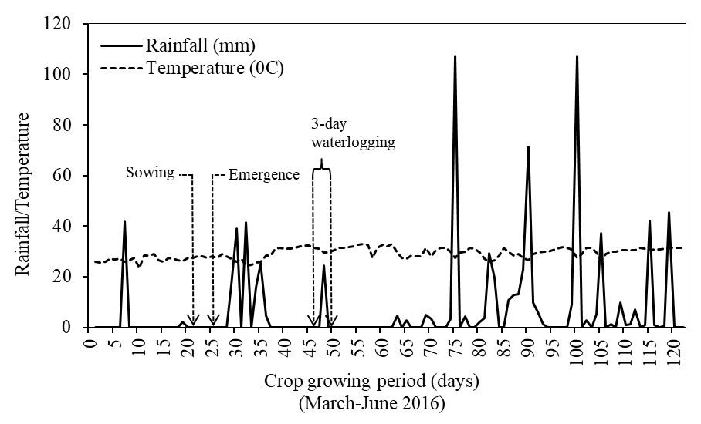
Figure 1. Trends of rainfall and average temperatures during the
mungbean growing period.
The location is between 24°05' N latitude and 90°16' E longitude with an elevation of 8.4 m above the mean sea level. It is characterized by the subtropical climate having intermittent rainfall at the early stage and frequent intense rainfall at the later stages of crop growth. The average temperature ranged between 24.4ºC and 33.0ºC which was highly favorable for mungbean cultivation. Just after the emergence of mungbean seedlings, frequent heavy rainfall occurred for a week which was not unfavorable for seedling establishment. However, the following day of imposition waterlogging treatment, more than 24 mm of rainfall occurred and created transient waterlogging conditions for which the field remained saturation about a week. This created unfavorable soil physical conditions and more adversely affected the waterlogged plants compared to non-waterlogged control plants. Consequently, the recovery of plants from waterlogging damage was delayed.

Planting materials and experimental design

A total of 100 mungbean genotypes available in the Germplasm Unit of Bangabandhu Sheikh Mujibur Rahman Agricultural University, Gazipur-1706 were used in the study. Most of the genotypes were collected from AVRDC, Taiwan (56), followed by various organizations of Bangladesh (23), India (9), Philippines (4), France (2), Pakistan (2) and one each from Hong Kong, Indonesia, and the USA. The genotypes and two waterlogging situations (waterlogging and non-waterlogging) were the treatment variables. For each replication, the field was divided into four small plots by 7.5×2 m². Each plot contained 25 lines and each line represented individual genotypes. To prevent the side leakage of water from the waterlogged plot, the boundaries of the plot were raised and deeply covered with polythene sheets. The experimental design was a two-factorial randomized complete block design (RCBD) with three replications.

Raising of seedlings

Before sowing, seeds were treated with Vitavax-200. Line to line and plant to plant distances were maintained at 30 and 10 cm, respectively. Two to three seeds were sown in every hill at the 2–3-cm depth to maintain a uniform size of the seedling. Recommended fertilizer doses were used at the time of final land preparation and top dressing. Fertilizer urea at 50 kg ha⁻¹, triple superphosphate at 85 kg ha⁻¹ and muriate of potash at 35 kg ha⁻¹ were applied. Half of the urea was applied during final land preparation and the rest of urea was applied at 30 days after emergence (DAE).

Waterlogging treatment imposition

Waterlogging treatment was applied on 3-week-old seedlings and waterlogging depth was maintained at 2.5 cm for 3 days. Thereafter, the excess water was removed from the field. Three days of the water retaining period was considered as the waterlogging period. After the removal of water, the soil remained nearly saturated for 7 days. On the other hand, optimum soil moisture was maintained in non-waterlogged control plants.

Measuring morpho-phenological traits

Plant sample collection and data measurement were done from both waterlogged and non-waterlogged plants during the recovery stage. Five plants of each genotype in the row were selected for data recording. The morphological and growth parameter viz. plant height, the number of leaves, leaf area, branches per plant, root dry matter, total shoot dry matter: root: shoot ratio and nodule dry matter, physiological parameter viz. SPAD value were recorded at 49 DAE. Plant height was measured from the above ground level to the shoot portion of the plant. SPAD value was measured at proper sunlight just before harvesting the plants under field conditions. Different plant components were dried in an oven at 80°C for at least 72 hours and then dry weights were recorded. Phenological data i.e. days to flowering and days to maturity were also recorded. Days to flowering were considered when about 50% of flowers were opened.

Harvesting and recording yield data

Yield and yield components such as the number of pods per plant, seeds per pod, pod length, straw weight and seed yield were recorded at variable dates. The crop was finally harvested when 95% of the pods turned black. Both waterlogged and non-waterlogged plants were uprooted carefully by hand and then bundled and tagged. In each time of picking, pods were threshed carefully in the laboratory and kept under the open sunlight for drying. When the pod walls become brittle, the seeds were separated, cleaned, and then dried under sunlight for a desirable moisture level (12%).

Data analysis

Data on waterlogging induced changes of the genotypes were compared in this study. The ranges and mean values of different plant traits were estimated by Microsoft Office Excel-2013. Analysis of waterlogging tolerance of mungbean genotypes was performed using the program SPSS 16.0 following the procedure described by Rojas et al. (2000) and Islam et al. (2007). However, instead of absolute values, the relative values of plant traits were used and thus the comparison was more meaningful towards identifying genotypes or groups of genotypes tolerant to waterlogging (Islam et al., 2007). Eighteen qualitative variables were considered in the descriptive analysis. Based on higher correlation coefficient values between seed yield and other plant traits, nine plant traits were selected and used in the multivariate analysis and discriminant function analysis (DFA). The non-hierarchical procedure (k-means) of cluster analysis was used for grouping the genotypes according to the relative tolerance of the genotypes to waterlogging (Rojas et al., 2000).

Results and Discussion

Waterlogging tolerance of plant traits

A total of 18 quantitative plant traits were studied at 21 days after the removal of waterlogging stress. The range and mean of all the traits of 100 genotypes under waterlogged and non-waterlogged conditions are illustrated in Table 1. The quantitative traits are presented as absolute as well as relative values (values of waterlogging relative to non-waterlogging controls) to understand the degree of waterlogging tolerance in each plant character of the genotypes. The relative values indicate that plant height, the number of leaves and leaf area showed a wide range of variation in waterlogging tolerance in the genotypes. However, remarkable changes were found in the relative values of root and shoot dry matter where the reduction was comparatively much less in root. This is probably because of the quicker root development of waterlogged plants after the initial damage of roots. The development of adventitious root in waterlogged plants is the most common as observed in Eurasian species (Visser et al., 2015), tomato (Vidoz et al., 2010). In this study, a comparatively wider range with high relative root: shoot ratio up to 1.86 was observed, which indicates that some genotypes produced numerous roots under waterlogged conditions. This is in agreement with an earlier study conducted by Islam et al. (2007) in a semi-controlled environment. The genotypic differences in producing adventitious roots were also evident in tomato (Ezin et al., 2010). The genotypic differences in root nodule production were much more conspicuous where the relative value rose to 6.4, although mean was 1.00. This indicates that some genotypes produced abundant root nodules during the recovery period. The information on the recovery of nodulation from waterlogging damage has not been well documented until now, although the decreases in the number and weight of root nodules following waterlogging are commonly observed in grain legumes (Pampana et al., 2016) and soybean (Saputro et al., 2018).
Table 1. The range and mean for quantitative characteristics of 100 mungbean genotypes subjected to waterlogging.

Plant characters | Control¹ |  | Waterlogging²
 | Range | Mean³ | Range | Mean³
Plant height (cm) | 20.9–51.5 | 37.3±0.62 | 12.5–32.4 (0.34–0.96) | 22.5±0.44 (0.61)
Leaf number (plant⁻¹) | 7.00–24.00 | 13.9±0.33 | 3.2–13.8 (0.29–0.98) | 7.8±0.20 (0.58)
Leaf area (cm²) | 219.9–753.0 | 456.9±12.51 | 88.7–404.7 (0.26–0.98) | 275.5±7.72 (0.63)
Root DM  (g plant⁻¹) | 0.22–0.82 | 0.54±0.01 | 0.15–0.69 (0.33–1.53) | 0.44±0.01 (0.84)
Total shoot DM (g plant⁻¹) | 2.72–8.96 | 4.96±0.13 | 1.36–5.59 (0.25–1.03) | 3.35±0.10 (0.70)
Root: shoot ratio | 0.06–0.20 | 0.11±0.01 | 0.07–0.25 (0.65–1.86) | 0.14±0.01 (1.24)
Nodule DM  (g plant⁻¹) | 0.00–0.21 | 0.08±0.01 | 0.00–0.20 (0.00–6.40) | 0.08±0.01 (1.00)
SPAD value | 39.3–59.5 | 48.9±0.39 | 23.7–55.1 (0.42–1.05) | 42.1±0.56 (0.86)
Days of flowering | 38.0–50.0 | 43.7±0.32 | 35.0–55.0 (0.87–1.23) | 45.5±0.45 (1.04)
Days of maturity | 78.0–92.0 | 83.8±0.35 | 78.00–92.00 (0.91–1.10) | 84.28±0.41 (1.01)
Branches  (no.) plant⁻¹ | 1.00–7.00 | 3.22±0.12 | 0.40–3.20 (0.13–0.98) | 1.83±0.06 (0.61)
Pods per plant | 2.20–42.60 | 20.17±0.84 | 0.70–21.80 (0.21–0.89) | 10.80±0.46 (0.55)
Seeds per pod | 6.45–15.68 | 11.89±0.20 | 4.90–10.40 (0.45–0.89) | 7.20±0.10 (0.62)
Pod length (cm) | 6.33–10.88 | 8.70±0.10 | 5.94–9.90 (0.74–0.99) | 7.62±0.09 (0.88)
1000-Seed weight (g) | 19.18–59.41 | 38.92±0.89 | 11.00–53.00 (0.44–1.30) | 34.75±0.82 (0.91)
Straw weight  (g plant⁻¹) | 2.61–27.39 | 16.93±0.49 | 2.23–21.38 (0.21–0.94) | 8.42±0.36 (0.50)
Seed yield  (g plant⁻¹) | 0.60–9.81 | 5.44±0.20 | 0.21–5.79 (0.15–0.88) | 2.96±0.13 (0.55)
Harvest index | 0.07–0.38 | 0.24±0.01 | 0.05–0.44 (0.48–1.69) | 0.26±0.01 (1.10)
¹plants were allowed to grow at optimum soil moisture throughout the growing period. ²plants were allowed to grow at optimum soil moisture up to 21 DAE and then exposed to waterlogging for 3 days and after the termination of waterlogging, moist soil conditions remained for around 7 days and then again optimum soil moisture was maintained. Data were collected from both control and waterlogged plants at 49 DAE. ³ mean ± standard error. Parentheses expressed the relative values as a ratio of waterlogged to non-waterlogged plants.

Mungbean plants turned into yellow immediately after waterlogging indicating the destruction of leaf chlorophyll content. This is the most common response of waterlogging in many plant species (Bansal et al., 2019; Saputro et al., 2018; Sarkar et al., 2017; Pociecha et al., 2008). However, the average relative SPAD value (0.86) of waterlogged plants indicated better recovery during the post-waterlogging period. The waterlogging delayed flowering and plants took 2 days more to flower but their maturity durations were prompt. The delay of flowering in waterlogged mungbean plants was also reported earlier (Islam et al., 2019; Amin et al., 2016). Among yield contributing traits, the number of pods per plant showed a wide range of variation in relative performance, although it was the worst affected showing a 45% reduction due to waterlogging. The number of seeds per pod, branches per plant and straw weight were also remarkably affected by waterlogging. Such reductions were not much in pod length and seed weight. However, waterlogging-induced average seed yield reduction was 45% in mungbean genotypes. Earlier it was reported that waterlogging reduced seed yield primarily by reducing the number of pods per plant and pod setting (Ahmad et al., 2003). However, there was a wide range of variations in seed yield among the genotypes. Waterlogged plants were capable of recovering depressed growth and yield traits affected by waterlogging and seed production attained 15–88% of the non-waterlogged controls. Ploschuk et al. (2018) explained that plant species used to generate a set of adaptive responses to withstand waterlogging and can produce significant yield at the early stage of waterlogging. In this study, a recovery in root and shoot growth, leaf chlorophyll index, and better translocation of assimilates into seeds as well as better pod settings contributed greatly to seed yield in some genotypes.

Relationship between the root and other plant traits

In our earlier studies, the adverse effect of waterlogging was more pronounced in roots compared to other plant traits at the early stage of waterlogging in mungbean and the recovery rate was faster in the root system of tolerant genotypes due to the development of numerous adventitious roots (Islam et al., 2007, 2010). It is now recognized that the development of adventitious roots on the soil surface or into the soil is a common feature of waterlogged tolerant plants (Pedersen et al., 2020). Therefore, an understanding of the root system development and its relationship with other plant traits as well as their contribution to seed yield is important to identify traits of interest for grouping of a large number of genotypes subjected to waterlogging. Table 2 illustrates the correlation coefficient with the regression equation of root dry matter (DM) with other plant traits. All the morphological plant traits had a significant correlation with root DM in both waterlogged and non-waterlogged control plants except for root: shoot ratio in waterlogged conditions. However, the relationships between morphological traits and root DM were comparatively stronger in waterlogged plants. Waterlogged plants produced numerous adventitious roots which promoted the growth and development of other plant traits faster than non-waterlogged control plants. Such evidence was also reported by Rich et al. (2012). The relationship between root DM and shoot DM was comparatively stronger (r=0.76) in waterlogged plants indicating higher contribution of root to shoot growth, and then foliage development and other morphological traits. The results are also similar to those observed by Islam et al. (2007) who claimed that the above fact is one of the adaptive strategies of mungbean to waterlogging. SPAD chlorophyll index showed a significant relationship with root DM (r=22) in waterlogged plants but the relationship was insignificant in the control plants.

Table 2. The functional equation between root dry matter and other plant characters under waterlogged and non-waterlogged conditions.

Characters | Regression equation and correlation coefficient
 | Control |  | Waterlogging
Morphological:
Plant height | y = 16.06x + 28.62 | r= 0.34** | y = 17.06x + 14.91 | r= 0.46**
Leaf number | y = 6.12x + 10.60 | r= 0.24* | y = 6.71x + 4.81 | r= 0.39**
Leaf area | y = 446.10x + 214.9 | r= 0.48** | y = 413.30x + 92.75 | r= 0.63**
Branches per plant | y = 0.03x + 0.46 | r= 0.24* | y = 1.72x + 1.07 | r= 0.32**
Total shoot DM | y = 5.72x + 1.85 | r= 0.58** | y = 6.15x + 0.63 | r= 0.76**
Root: shoot ratio | y = 0.09x + 0.06 | r= 0.44** | y = 0.04x + 0.12 | r= 0.18
Nodule DM | y = 0.09x + 0.03 | r= 0.20* | y = 0.09x + 0.03 | r= 0.22*
Physiological:
SPAD value | y = 0.99x + 48.30 | r= 0.03 | y = 11.57x + 37.00 | r= 0.24*
Phenological:
Days of flowering | y = -1.20x + 44.38 | r=- 0.05 | y = -5.68x + 47.96 | r= -0.15
Days of maturity | y = 2.61x + 82.36 | r= 0.04 | y = -0.28x + 84.40 | r= 0.01
Yield and yield contributing:
Pods per plant | y = 17.37x + 10.74 | r= 0.23** | y = 17.72x + 2.96 | r= 0.45**
Seeds per pod | y = 3.44x + 10.02 | r= 0.28* | y = 1.10x + 6.71 | r= 0.13
Pod length | y = -0.07x + 8.74 | r= -0.01 | y = 0.01x + 7.61 | r= 0.00
1000-seed weight | y = -1.19x + 39.56 | r= -0.01 | y = 15.04x + 28.09 | r= 0.22*
Straw weight | y = 10.53x + 11.21 | r= 0.28** | y = 15.80x + 1.43 | r= 0.51**
Yield | y = 5.08x + 2.68 | r= 0.33** | y = 5.54x + 0.51 | r= 0.51**
Harvest index | y = 0.04x + 0.22 | r= 0.09 | y = 0.03x + 0.25 | r= 0.03
**Correlation is significant at the 0.01 level (2-tailed); *Correlation is significant at the 0.05 level (2-tailed).

This indicates that the development of the adventitious roots of waterlogged plants stimulates leaf greenness probably via an increase in nutrient uptake and assimilates accumulation in leaf. Among yield and yield contributing traits, pods per plant, straw dry weight and seed yield showed strong relationships with root DM in waterlogged and non-waterlogged plants but the relationship was much stronger under the waterlogged conditions. For instance, the correlation coefficient between seed yield and root DM was 0.51 in waterlogged plants against 0.33 in non-waterlogged plants. Seed weight had a significant positive relationship with root DM under waterlogged conditions indicating the contribution of adventitious roots to increase seed size. All these relationships indicate that the traits having more pronounced responses to waterlogging and wider variations among genotypes were mainly the root and shoot DM, leaf area, leaf chlorophyll index which eventually may contribute to variations in seed yield by increasing the number and size of seeds in waterlogged plants.

Relationship between seed yield and other plant traits

Seed yield had significant positive correlations with all the morphological traits under waterlogged and non-waterlogged control conditions, but correlations were stronger in waterlogged plants (Table 3).

Table 3. The functional equation between yield and other plant characters under waterlogged and non-waterlogged conditions.

Plant characters | Regression equation and correlation coefficient
 | Control |  | Waterlogging
Morphological:
Plant height | y = 1.02x + 31.80 | r = 0.33** | y = 1.61x + 17.69 | r= 0.47**
Leaf number | y = 0.58x + 10.73 | r = 0.36** | y = 0.76x + 5.52 | r= 0.49**
Branches per plant | y = 0.11x + 2.62 | r= 0.19 | y = 0.19x + 1.27 | r= 0.38**
Leaf area | y = 21.62x + 34.20 | r= 0.35** | y = 25.06x + 201.3 | r= 0.42**
Root DM | y = 0.02x + 0.42 | r= 0.33** | y = 0.05x + 0.30 | r= 0.51**
Total shoot DM | y = 0.23x + 3.69 | r= 0.36** | y = 0.34x + 2.34 | r= 0.46**
Root: shoot ratio | y = -0.00x + 0.12 | r= 0.04 | y = -0.00x + 0.14 | r= 0.00
Nodule DM | y = 0.00x + 0.06 | r= 0.07 | y = 0.01x + 0.05 | r= 0.19
Physiological:
SPAD value | y = 0.30x + 47.22 | r= 0.15 | y = 2.17x + 35.69 | r= 0.50**
Phenological:
Days of flowering | y = -0.50x + 46.47 | r= -0.33** | y = -0.67x + 47.45 | r= -0.19
Days of maturity | y = 0.13x + 83.08 | r= 0.07 | y = 0.02x + 84.20 | r= 0.01
Yield and yield contributing:
Pods per plant | y = 3.23x + 2.59 | r= 0.78** | y = 2.94x + 2.10 | r= 0.82**
Seeds per pod | y = 0.28x + 10.34 | r= 0.30** | y = 0.17x + 6.69 | r= 0.22*
Pod length | y = 0.14x + 7.92 | r= 0.30** | y = 0.12x + 7.25 | r= 0.18
1000-seed weight | y = 0.74x + 34.86 | r= 0.17 | y = 2.48x + 27.40 | r= 0.39**
Straw weight | y = 1.43x + 9.14 | r= 0.59** | y = 1.81x + 3.07 | r= 0.64*
Harvest index | y = 0.02x + 0.14 | r= 0.63** | y = 0.03x + 0.17 | r= 0.52**
**Correlation is significant at the 0.01 level (2-tailed); *Correlation is significant at the 0.05 level (2-tailed).

The degree of relationships is useful in selecting traits of interest in any stressful situation. Yield is a multidimensional trait and is affected by the plant characteristics (Filipovic et al., 2014). The closer associations between the plant height, number of leaves, leaf area, root DM, and total shoot DM with seed yield suggest a greater contribution of these traits to increase seed yield of mungbean under waterlogged conditions. Yucel et al. (2006) also determined a positive and significant relationship between seed yield and plant height. A strong significant correlation between SPAD value and grain yield (r=0.50) was observed in waterlogged plants but the relationship was non-significant in control plants. This indicates that waterlogged plants showed a rapid recovery in chlorophyll content that eventually significantly contributed to increasing the yield of mungbean. Phonological traits showed comparatively weaker relationships with seed production. However, the relationship was more negative for days to flowering (r=-0.33) under control conditions compared to waterlogging. This indicates that waterlogged plants took a comparatively longer time to flower. Among yield and yield contributing traits, pods per plant showed the highest correlation coefficient with seed yield in both waterlogged (r=0.82) and control plants (r=0.78). A comparatively higher relationship under waterlogged conditions may be attributed to the rapid recovery of waterlogged plants and pod development. The highest correlations between the number of pods plant⁻¹ and seed yield were reported by Ivanovska et al. (2007) and Ali et al. (2003) in Brassica napus. Among the other yield contributing traits, a significant relationship between seed weight and seed yield (r=0.39) under waterlogging conditions indicating a better assimilate translocation from shoot to grain that possibly contributed to increasing seed yield in waterlogged plants.

Multivariate analysis

Two multivariate methods viz. k-means clustering and discriminant function analysis (DFA) were performed for grouping the genotypes and for identifying the desirable trait(s) of interest related to waterlogging tolerance in 100 mungbean genotypes. The k-means method is widely used among many other techniques for its high-performance quality of clustering with minimum time (Zeebaree et al., 2017; Gayathri et al., 2015). Cluster analysis is the multiple variable method of clustering objects having similar characteristics. The clusters are similar but differences within the clusters are greater (El-Hanjouri and Hamad, 2015). In this study, the traits selected for the multivariate analysis were leaf area, root DM, total shoot DM, SPAD value, branches per plant, pods per plant, straw dry weight, seed yield, and harvest index. These were selected as they were highly correlated with each other and mostly contributed to seed yield. The DFA performs a multivariate test of differences between the groups. It was performed for selecting discriminating variables contributing to the discriminant functions, determining the inter-cluster distance, and graphical illustration of the position of the variable (Verma et al., 2016).
K-means cluster analysis

In k-means clustering, k denotes the number of clusters and the number is usually anonymous but can be chosen by the user (El-Hanjouri and Hamad, 2015). We considered the relative plant traits in the cluster analysis as they exhibited greater variations among genotypes. We arbitrarily grouped the genotypes into seven clusters using k-means non-hierarchical cluster analysis (Table 4). The maximum number of genotypes was included in cluster 7 (35) followed by clusters 5 (18), 1 (12), 3 (11), 6 (11), 2 (10) and 4 (3).

Table 4. The list of 100 mungbean genotypes within 7 clusters classified by k-means cluster analysis based on nine plant characters.

Clustering | No. of genotypes | Genotypes
Cluster 1 | 12 | GK-8, VC-6153 (B-19), IPSA-9, BARI mung 4, VC 6371-94, IPSA-6, Vo-1258 B-G, Vo-1337-A-G, VC 1160 A, VC6163 (B-33), GK-5, Vo1102 A-G
Cluster 2 | 10 | BINA-6, GK-3, BINA-7, VC-6173-B, IPSA-19, VC 6153 (B 20), GK-27, GK-60, Vo 1061 A-G, Vo 1108 B-G
Cluster 3 | 11 | GK-32, IPK-2558-97, VC 6372 (45-8-1), IPSA-24, GK-48, GK-10, VC 6144, IPK 1038-94, GK-23, IPSA-15, ACC 12890054
Cluster 4 | 3 | Vo1353 B-G, VC 1137 A, Vo 1073 A-G
Cluster 5 | 18 | BINA-2, GK-58, VC 6173A, NM 54, Vo1359 B-G, GK-7, VC 6141 (A 90), BUmug 4, IPSA-13, Vo 1396 B-G, BARI mung-2, Vo 1551 B-G, Vo1133 A-G, Vo 1665 A-G, ML-267, ACC12890056, Barisal local, Vo1487 B-G
Cluster 6 | 11 | ACC 12890085, IPSA-10, Vo1472 B-G, GK-3, VC-6173 (B-10), GK-6, BINA-5, IPSA-20, VC 6370-92, GK-65, CO3
Cluster 7 | 35 | VC-3160A-89, IPSA-5, GK-35, GK-1, PDM-11, Vo 1613 A-G, IPSA-10, IPSA-12, GK-50, Vo1183 A-G, Vo 1073 B-G, ACC 12910110, VC-6173 (B-12), Vo1139 B-G, GK-14, BARI mung 6, GK-46, VC 6367 (44-55-2), GK-56, VC 6372 (45-8), GK-21,GK-37, GK-55, BARI mung 5, GK-63, VC 1163, VC 6379 (23-11), Vo1279 A-G, Vo 1319 A-G, GK-16, Vo1368 A-G, GK-29, Vo 1341 B-G, ML 613, Vo 1262 A-G

The mean relative values of nine plant traits of the genotypes within each cluster are presented in Table 5. The genotypes within cluster 1 were characterized by poor relative plant performance regarding leaf area, root and shoot dry matter, SPAD value, branches per plant. The cluster 2 genotypes performed poorly, even much worse in some plant traits including root and shoot dry matter, pods per plant and straw dry weight but showed the highest harvest index. This group of genotypes gave better seed yield compared to that of cluster 1 possibly because of much higher harvest index. The cluster 3 genotypes performed moderately in almost all plant traits. The cluster 4 genotypes showed the lowest relative value of all plant traits except for the leaf area. About 79% of seed yield reduced due to waterlogging in this group of genotypes. The cluster 5 genotypes were categorized also as moderate in terms of morphological traits like leaf area, root and shoot dry matter but yield and yield traits were poor. The cluster 6 genotypes were characterized by the highest relative morphological traits like leaf area, root DM, total shoot DM, SPAD value and yield attributes like pods per plant and straw DM as well as branches per plant. Particularly, the genotypes within this cluster produced the extraordinary amount of adventitious root. The genotypes within cluster 7 also performed better in terms of morphological and yield traits. However, the genotypes within this group produced the highest yield with the relative value of 0.71. A much higher harvest index (1.33) indicates that the highest yield performance of this group of genotypes was attributed to greater biomass partitioning into the grain. The clustering pattern of the genotypes revealed that the relative performance of the genotypes within clusters 6 and 7 in respect of all plant traits was outstanding compared to genotypes clustered into other groups.

Table 5. The comparison profile of the 7 groups of mungbean genotypes classified by k-means clustering.

Variables in terms of relative values* | Cluster
 | 1 | 2 | 3 | 4 | 5 | 6 | 7
Leaf area | 0.46 | 0.39 | 0.74 | 0.40 | 0.60 | 0.83 | 0.70
Root dry matter | 0.62 | 0.60 | 0.90 | 0.43 | 0.86 | 1.07 | 0.91
Total shoot dry matter | 0.52 | 0.44 | 0.73 | 0.42 | 0.72 | 0.89 | 0.77
SPAD value | 0.85 | 0.87 | 0.86 | 0.73 | 0.85 | 0.90 | 0.87
Branches per plant | 0.45 | 0.59 | 0.84 | 0.42 | 0.48 | 0.79 | 0.61
Pods per plant | 0.59 | 0.41 | 0.45 | 0.23 | 0.41 | 0.71 | 0.66
Straw weight | 0.43 | 0.36 | 0.50 | 0.32 | 0.57 | 0.67 | 0.49
Seed yield | 0.39 | 0.58 | 0.44 | 0.21 | 0.42 | 0.64 | 0.71
Harvest index | 0.95 | 1.42 | 0.92 | 0.69 | 0.80 | 0.98 | 1.33
*The relative values are the ratio of the performance of each variable under waterlogging and control conditions.

Discriminant function analysis

The six discriminant functions that differentiated among clusters were obtained by the stepwise procedure. Table 6 summarizes the contribution of each of six canonical discriminant functions for explaining the variance along with their Eigenvalues and canonical correlation coefficient. The larger Eigenvalue (5.0) in function 1 explains that a high variance was noted in the dependent variables. We used functions 1 and 2 having Eigenvalues greater than 1 and reflected 86.7% of the total variation. It gives an idea of the relative performance of the plant traits subjected to waterlogging and indicates that the traits associated with these functions are more useful in differentiating the genotypes. Function 1 alone explained 54.5% of the total variance and function 2 explained 32.2% of the total variance. The high canonical correlation values of functions 1 and 2 also indicate a greater degree of association between the discriminant functions and the dependent variables. The dissimilarities between the clusters were dealt using Wilks’ test. The smallest value of Wilks’ Lambda in function 1 indicates the greater importance of the independent variables to this function. The Chi-square values are high in functions 1 and 2 indicating a high percentage of variance in the dependent variables within these two functions.

Table 6. The summary of canonical discriminant functions.

Eigenvalues |  |  |  |  | Wilks’ Lambda
Function | Eigenvalue | % variance | Cumulative % | Canonical correlations | Wilks’ Lambda | Chi-square | df | Sig.
1 | 5.0a | 54.5 | 54.5 | 0.91 | 0.015 | 384.0 | 42 | 0.000
2 | 3.0a | 32.2 | 86.7 | 0.86 | 0.092 | 219.1 | 30 | 0.000
3 | 0.62a | 6.8 | 93.5 | 0.62 | 0.366 | 92.6 | 20 | 0.000
4 | 0.34a | 3.7 | 97.2 | 0.50 | 0.592 | 48.2 | 12 | 0.000
5 | 0.25a | 2.7 | 99.8 | 0.44 | 0.791 | 21.6 | 6 | 0.001
6 | 0.02a | 0.2 | 100.0 | 0.12 | 0.985 | 1.4 | 2 | 0.509

The variables that mostly contributed to the discriminatory functions along with their coefficients within each function are presented in Table 7. The coefficients of harvest index and straw dry weight were 1.09 and 0.96 respectively in function 1 that indicates these two variables contributed mostly to explain the total variance within function 1.

Table 7. Standardized canonical discriminant function coefficients of the plant characters that mostly contributed in grouping mungbean genotypes.

Discriminating variables  (in relative terms) | Function
 | 1 | 2 | 3 | 4 | 5 | 6
Root DM | 0.46 | 0.43 | 0.24 | 0.05 | -0.11 | 0.23
Total shoot DM | 0.39 | 0.39 | -0.15 | -0.03 | -0.28 | 0.28
Branches per plant | 0.35 | 0.10 | 0.61 | -0.68 | 0.03 | -0.13
Pods per plant | 0.33 | 0.09 | -0.74 | -0.20 | 0.60 | 0.09
Straw weight | 0.96 | 0.40 | 0.82 | 1.93 | 1.55 | 0.01
Seed yield | -0.38 | -0.37 | -0.75 | -1.32 | -1.69 | -0.86
Harvest index | 1.09 | -0.50 | 0.82 | 1.31 | 1.18 | 0.55

The other variables that also contributed are branches per plant and pods per plant. In contrast, root and shoot dry matter, and straw dry weight were mostly responsible for the variation in function 2. However, seed yield showed an equal negative contribution to the variability within functions 1 and 2. From Table 8, it is observed that root DM was placed at the top of the list of discriminatory variables with the correlation coefficient of 0.43 within function 1. It indicates that root DM played the most dominant role out of 9 variables in explaining the maximum variance in 100 genotypes by stepwise DFA. Seed yield and harvest index were the secondary important variables in explaining the variation in function 1. Remarkably, the harvest index played the most negative dominant role in explaining the maximum variation within function 2.

Table 8. The structure matrix representing correlations between 9 discriminating variables and standardized canonical discriminant functions of 100 mungbean genotypes.

Plant characters | Functions
 | 1 | 2 | 3 | 4 | 5 | 6
Root DM | 0.43* | 0.41 | 0.08 | 0.06 | -0.259 | 0.38
Harvest index | 0.48 | -0.79* | 0.03 | 0.02 | -0.139 | 0.35
Pods per plant | 0.38 | -0.01 | -0.72* | -0.25 | 0.5 | -0.07
Branches per plant | 0.20 | 0.12 | 0.51 | -0.65* | 0.33 | -0.34
Shoot DM | 0.38 | 0.41 | -0.11 | -0.03 | -0.45* | 0.34
Leaf areaª | 0.18 | 0.17 | 0.04 | 0.07 | -0.20* | 0.06
Straw weight | 0.16 | 0.39 | -0.02 | 0.31 | 0.06 | -0.85*
Yield | 0.56 | -0.27 | -0.14 | 0.10 | -0.31 | -0.70*
SPADª | 0.12 | -0.18 | -0.01 | -0.03 | -0.15 | -0.20*
Variables ordered by the absolute size of correlations within the function; *the largest absolute correlation between each variable and any discriminant function; ªthe variable not used in the analysis.

The data were analyzed based on pairwise Mahalanobis distance (D²) to measure the genetic variability among the genotypes and the average inter-cluster distances. D² analysis showed that the seven clusters were statistically different from each other at 0.01 levels (Table 9). The highest distance was existed between cluster 7 and cluster 5 followed by clusters 4 and 1 and cluster 6 had a higher distance with clusters 2, 4 and 1. The genotypes within clusters 6 and 7 performed well under waterlogging conditions having less distance from each other. The causes of the highest distance between clusters 5 and 7 as well as clusters 6 and 2 were poor harvest index in cluster 5 but higher harvest index in cluster 2. In contrast, the genotypes were worst affected by waterlogging belonging to clusters 1 and 4. On the other hand, the most similar clusters were clusters 3 and 5 with the lowest distance performed moderately. Figure 2 represents the relative position of the genotypes within the clusters. This is a graphical illustration of how the genotypes are classified into seven clusters according to the first two discriminatory functions i.e. functions 1 and 2. The clustering of the genotypes derived from the K-means cluster analysis is indicated by the closed circles. Function 1 separated clusters 6 and 7 from other clusters. Genotypes situated at the right side of the diagram are characterized by higher harvest index and grain yield under waterlogging conditions. The genotypes that are at the left side produced lower harvest index and seed yield based on X ordinate. On the other hand, the genotypes on the upper side of the diagram produced higher root dry matter and had higher harvest index compared to the genotypes that are scattered at the bottom of the diagram based on Y ordinate.

Table 9. Pairwise Mahalanobis distance (D²) between the final cluster means.

Cluster number | Pairwise group comparisons
 | 1 | 2 | 3 | 4 | 5 | 6 | 7
1 | -
2 | 13.12** | -
3 | 11.94** | 17.21** | -
4 | 7.80** | 16.22** | 15.57** | -
5 | 9.60** | 24.37** | 5.69** | 13.08** | -
6 | 26.52** | 31.18** | 8.53** | 30.64** | 16.94** | -
7 | 26.70** | 17.73** | 15.77** | 28.74** | 32.31** | 12.30** | -
**The distance differing at the probability of 0.01.

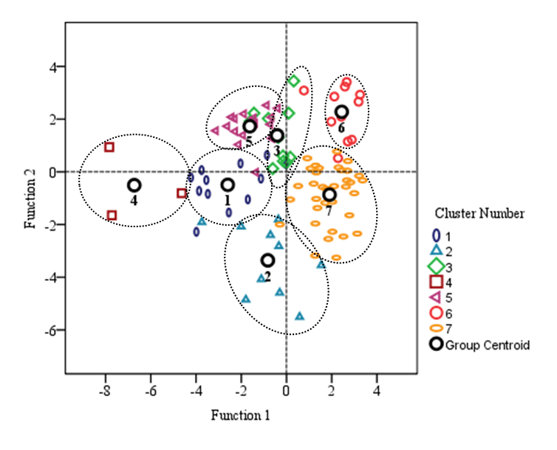
Figure 2. The graphic illustration of the discriminatory analysis of seven
clusters of mungbean genotypes.
Representative genotypes

Figure 3 showed the orientation of genotypes within every 7 clusters individually. The relative position of genotypes indicated the cumulative response of variables representing functions 1 and 2. The group centered represented the optimum value in each cluster that resulted from the cumulative effects of all genotypes oriented within that cluster.

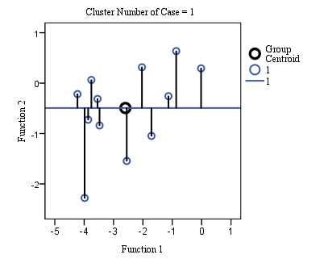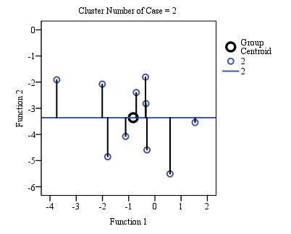
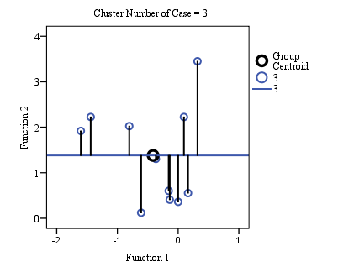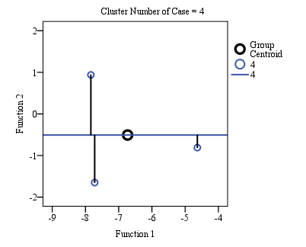
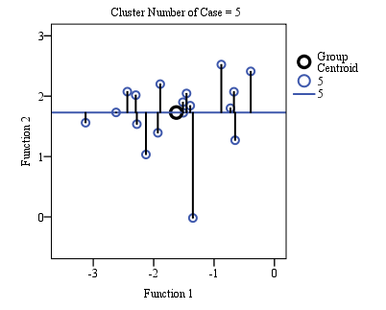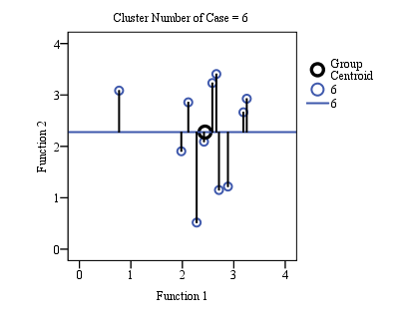
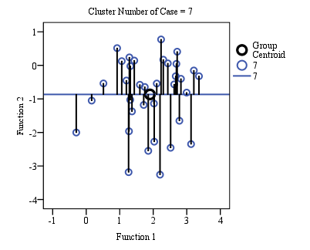

Figure 3. The graphical illustration of genotypes within clusters by
DFA based on nine plant characters.

The deviation of the genotypes in the response to discriminating variables was very close to the group centered and might be considered as the most representative (might not be best) of the group. Accordingly, the genotype Vo 1258 B-G in Cluster 1, GK-27 in cluster 2, IPK-2558-97 in cluster 3, VC 1137 A in cluster 4, BUmug 4 in cluster 5, IPSA-10 in cluster 6 and VC 6379 (23-11) in cluster 7 were most representative in each cluster.

Conclusion

The study reveals that mungbean genotypes showed a wide range of variation in waterlogging tolerance regarding morpho-physiological characters and yield performance under field conditions. The quick development of adventitious roots in waterlogged plants enhanced waterlogging tolerance by recovering other depressed plant characters. The recoveries of plant traits significantly varied depending on the genotypes. The various multivariate techniques were effectively applied to observe the degree of waterlogging tolerance in the tested genotypes. Thus, the genotypes IPSA-10 and VC 6379 (23-11) were obtained as waterlogging-tolerant considering various yield and yield-related traits. However, the genotypes that showed such tolerance need further evaluation for affirmation of their tolerance to waterlogging.

Acknowledgements

The authors wish to thank the Bangladesh Bureau of Educational Information and Statistics (BANBEIS), Ministry of Education, Government of the People’s Republic of Bangladesh for providing the fund under the Higher Educational Research Program.
References

Ahmad, R., Ikraam, M., Ullah, E., & Mahmood, A. (2003). Influence of different fertilizer levels on the growth and productivity of three mungbean (Vigna radiata) cultivars. International Journal of Agriculture & Biology, 5 (3), 335-338.
Ali, N., Javidfar, F., Elmira, J.Y., & Mirza, M.Y. (2003). Relationship among yield components and selection criteria for yield improvement in winter rapeseed (Brassica napus L.). Pakistan Journal of Botany, 35 (2), 167-174.
Amin, M.R., Karim, M.A., Akter, S., & Hossain, M.A. (2016). Effect of waterlogging on growth and yield of mungbean genotypes. Bangladesh Journal of Agricultural Research, 41 (1), 151-162.
Bansal, R., Sharma, S., Tripati, K., Gayacharan, & Kumar, A. (2019). Waterlogging tolerance in black gram [Vigna mungo (L.) Hepper] is associated with chlorophyll content and membrane integrity. Indian Journal of Biochemistry & Biophysics, 56 (1), 81-85.
Campbell-Ross, H.E.G., Yous, S., Martin, R.J., & Tan, D.K.Y. (2019). Mungbean (Vigna radiata (L.) R. Wilczek) varietal evaluation for northwest Cambodian lowland rice systems. Proceedings of the 2019 Agronomy Australia Conference, (pp.??-??). Wagga Wagga, Australia.
Ceccarelli, S., Grando, S., Maatougul, M., Michael, M., Slash, M., Haghparast, R., Rahmanian, M., Taheri, A., Al-Yassin, A., Benberlkacem, A., Labdi, M., Mimoun, H., & Nachit, M. (2010). Plant breeding and climate changes. The Journal of Agricultural Science, 148 (6), 627-637.
Celik, G., & Turhan, E. (2011). Genotypic variation in growth and physiological responses of common bean (Phaseolus vulgaris L.) seedlings to waterlogging. African Journal of Biotechnology, 10 (38), 7372-7380.
El-Hanjouri, M.M.R., & Hamad, B.S. (2015). Using cluster analysis and discriminant analysis methods in classification with application on standard of living family in Palestinian areas. International Journal of Statistics and Applications, 5 (5), 213-222.
Ezin, V., Pena, R.D.L., & Ahanchede, A. (2010). Flooding tolerance of tomato genotypes during vegetative and reproductive stage. Brazilian Journal of Plant Physiology, 22 (2), 131-142.
Filipovic, M., Babic, M., Delic, N., Bekavac, G., & Babic, V. (2014). Determination relevant breeding criteria by the path and factor analysis in maize. Genetika, 46 (1), 49-58.
Gayathri, R., Cauveri, A., Kanagapriya, R., Nivetha, V., Tamizhselvi, P., & Kumar, K.P. (2015). A novel approach for clustering based on Bayesian Network. In Proceedings of the 2015 International Conference on Advanced Research in Computer Science Engineering & Technology, (pp 60-??), ICARCSET, ACM.
Graham, P.H., & Vance, C.P. (2003). Legumes: Importance and constraints to greater use. Plant Physiology, 131, 872-877.
Hidangmayum, A., Singh, A., Kumar, V., & Dwivedi, P. (2018). Abiotic stress responses in cereals and pulses crop and their agronomic practices to enhance tolerance. EurAsian Journal of BioSciences, 12 (2), 487-493.
Hirabayashi, Y., Mahendran, R., Koirala, S., Konoshima, L., Yamazaki, D., & Watanabe, S. (2013). Global flood risk under climate change. Nature Climate Change, 3 (9), 816-821.
Islam, M.R. (2016). Crop Diversification in Sidr Affected Southern Bangladesh: Developing strategies for the improvement and diversification of agricultural production, Scholars' Press, Omni Scriptum GmbH and Co.
Islam, M.R., Hamid, A., Karim, M.A., Haque, M.M, Khaliq, Q.A., & Ahmed, J.U. (2008). Gas exchanges and yield responses of mungbean (Vigna radiata L. Wilczek) genotypes differing in waterlogging tolerance. Acta Physiologiae Plantarum, 30 (5), 697-707.
Islam, M.R., Hamid, A., Khaliq, Q.A, Ahmed, J.U, Haque, M.M, & Karim, M.A. (2007). Genetic variability in waterlogging tolerance of mungbean (Vigna radiata L. Wilczek) genotypes. Euphytica, 156 (1-2), 247-255.
Islam, M.R., Hamid, A., Khaliq, Q.A., Haque, M.M., Ahmed, J.U., Karim, M.A. (2010). Effects of waterlogging on roots, photosynthesis and water relations in mungbean (Vigna radiata (L.) Wilczek). Bangladesh Journal of Botany, 39, 241-243.
Islam, M.R., Hamid A., Khaliq Q.A., Ahmed J.U., & Haque M.M. (2005). Response of mungbean to soil flooding at vegetative stage I. Root and shoot growth. Bangladesh Agronomy Journal, 11, 1-9.
Islam, M.R., Hasan, M., Akter, M., & Shibly, N. (2019). Post-waterlogging rescue nitrogen improves waterlogging tolerance in mungbean (Vigna radiata). The Agriculturists, 17 (1-2), 1-13.
Islam, M.R., Nessa, B., Haque, M.M., & Ahmed, J.U. (2009). Effect of waterlogging stress on morphology and yield of five lentil (Lens culinaris Medic.) genotypes. The IUP Journal of Soil and Water Sciences, 2, 48-57.
Ivanoska, S., Stojkovski, C., Dimov, Z., Marjanovic-Jeromela, A., Jankulovska, M., & Jankuloski, L. (2007). Interrelationship between yield and yield related traits of spring canola (Brassica napus L.) genotypes. Genetika, 39 (3), 325-332.
Kaur, R., Bains, T.S., Bindumadhava, H., & Nayyar, H. (2015). Response of mungbean (Vigna radiata (L.) Wilczek) genotypes to heat stress: Effects on reproductive biology, leaf function and yield traits. Scientia Hortculturae, 197, 527-541.
Kumar, P., Pal, M., Joshi, R., & Sairam, R.K. (2013). Yield, growth and physiological responses of mungbean [Vigna radiata (L.) Wilczek] genotypes to waterlogging at vegetative stage. Physiol and Mol Biol Plants, 19 (2), 209-220.
Malik, J.K., Singh, R., Thenua, O.V.S., & Kumar, A. (2103). Response of pigeonpea (Cajanus sajan)+mungbean (Phaseolus radiates) intercropping system to phosphorus and biofertilizers. Legume Research, 36, 323-330.
Nair, R.M., Pandey, A.K., War, A.R., Hanumantharao, B., Shwe, T., Alam, A., Pratap, A., Malik, S.R., Karimi, R., Mbeyagala, E.K., Douglas, C.A., Rane, J., & Schafleitner, R. (2019). Biotic and Abiotic Constraints in Mungbean Production - Progress in Genetic Improvement. Frontiers in Plant Science, 10, 1340.
Noble, T.J., Williams, B., Hoang, T.M.L., Das Bhowmik, S.S., Tan, G.Z.H., & Mundree, S. (2020). Genomic Approaches to Abiotic Stresses in Mungbean. In: Nair, R., Schafleitner R., Lee, S.H. (eds) The Mungbean Genome. Compendium of Plant Genomes. (pp.??-??). Springer, Cham.
Normile, D. (2008). Reinventing rice to feed the world. Science, 321, 330-333.
Pampana, S., Masoni, A., & Arduini, I. (2016). Response of cool-season grain legumes to waterlogging at flowering. Canadian Journal of Plant Science, 96 (4), 597-603.
Pedersen, O., Sauter, M., Colmer, T.D., & Nakazono, M. (2020). Regulation of root adaptive anatomical and morphological traits during low soil oxygen. New Phytologist. First published: 11 February 2020. doi: 10.1111/nph.16375.
Ploschuk, R.A., Miralles, D.J., Colmer, T.D., Ploschuk, E.L., & Striker, G.G. (2018). Waterlogging of winter crops at early and late stages: impacts on leaf physiology, growth and yield. Frontiers in Plant Science, 9, 1863.
Pociecha, E., Koscielniak, J., & Filek, W. (2008). Effect of root flooding and stage of development on the growth and photosynthesis of field bean (Vicia faba L. minor). Acta Physiolgiae Plantarum, 30 (4), 529-535.
Porpavai, S., Devasenapathy, P., Siddeswaran, K., & Jayaraj, T. (2011). Impact of various rice based cropping systems on soil fertility. Journal of Cereals and Oilseeds, 2, 43-46.
Rich, S., Ludwig, M., & Colmer, T. (2012). Aquatic adventitious root development in partially and completely submerged wetland plants Cotula coronopifolia and Meionectes brownie. Annals of Botany, 110, 405-414.
Rojas, W., Barriga, P., & Figueroa, H. (2000). Multivariate analysis of the genetic diversity of Bolivian quinua germplasm. Plant Genetic Resources Newsletter, 122, 16-23.
Saputro, T.B., Purwani, K.T., Fatimah, V.S., Stevia, E.M., & Jadid, N. (2018). The tolerance improvement of local soybean in waterlogging condition through the combination of irradiation and in vivo selection. IOP Conf. Series: Journal of Physics: Conference Series 1040 (2018) 012001.
Sarkar, M., Datta, S., & Kundagrami, S. (2017). Global Climate Change and Mung Bean Production: A Roadmap towards Future Sustainable Agriculture. In: Pandey D, Sarkar A (eds) Sustaining Future Food Security in Changing Environment, (pp. 99-120). Nova Science Publishers, Inc. New York.
Singh, D.P., & Singh, B.B. (2011). Breeding for tolerance to abiotic stresses in mungbean. Journal of Food Legumes, 24 (2), 83-90.
Solaiman, Z., Colmer, T.D., Loss, S.P., Thomson, B.D., & Siddique, K.H.M. (2007). Growth responses of cool-season grain legumes to transient waterlogging. Australian Journal of Agricultural Research, 58 (5), 406-412.
Sravan, U.S., & Murthy, K.V.R. (2018). Enhancing Productivity in Rice-Based Cropping Systems. In: Daniel Dunea (ed). Plant Competition in Cropping Systems.(pp. 59-75). IntechOpen, London, United Kingdom.
Toker, C., & Mutlu, N. (2011). Breeding for abiotic stress. In: Pratap A, Kumar J (eds) Biology and Breeding of Food Legumes. (pp. 241-260). CAB International, Wallingford, UK.
Verma, U., Thakral, N.K., & Neeru, (2016) Genetic diversity analysis in indian mustard [Brassica Juncea (L) Czern & Coss.]. International Journal of Applied Mathematics and Statistical Sciences, 5 (1), 25-34.
Vidoz, M.L., Loreti, E., Mensuali, A., Alpi, A., & Perata, P. (2010). Hormonal interplay during adventitious root formation in waterlogged tomato plants. The Plant Journal, 63 (4), 551-562.
Visser, E.J.W., Zhang, Q., De Gruyter, F., Martens, S., & Huber, H. (2015). Shade affects responses to drought and waterlogging-acclimation to multiple stresses in bittersweet (Solanum dulcamara L.). Plant Biology, 18 (Suppl.1), 112-119.
Witcombe, J.R., Hollington, P.A., Howarth, C.J., Reader, S., & Steele, K.A. (2008). Breeding for abiotic stresses for sustainable agriculture. Philos Trans R Soc Lond B Biol Sci, 363, 703-716.
Yaqub, M., Mahmood, M., Akhtar, M., Iqbal, M.M., & Ali, S. (2010). Induction of mungbean [Vigna radiata (L) Wilczek] as a grain legume in the annual rice-wheat double cropping system. Pakistan Journal of Botany, 42 (5), 3125-3135.
Yucel, D.O., Anlarsal, A.E., & Yucel, C. (2006). Genetic variability, correlation and path analysis of yield, and yield components in chickpea (Cicer arietinum L.). Turkish Journal of Agriculture and Forestry, 30 (3), 183-188.
Zeebaree, D.Q., Haron, H., Abdulazeez, A.M., & Zeebaree, S.R.M. (2017). Combination of K-means clustering with Genetic Algorithm: A review. International Journal of Applied Engineering Research, 12 (24), 14238-14245.

Received: December 30, 2018
Accepted: May 23, 2020

R e z i m e

Primljeno: 30. decembra 2018.
Odobreno: 23. maja 2020.

*Crossponding author: e mail: rafiarib@yahoo.com

