GENETIC CHARACTERIZATION OF FARMED AND WILD POPULATIONS OF AFRICAN CATFISH (CLARIAS GARIEPINUS BURCHELL, 1822) USING THE RANDOM AMPLIFIED POLYMORPHIC MARKER

Sa'adu B. Suleiman, Mohammed Y. Diyaware,
Mohammed Aliyu and Zanna B. Mohammed

Department of Fisheries, University of Maiduguri, Faculty of Agriculture, Nigeria

Abstract: The genetic characterization of Clarias gariepinus was conducted in this study. Thirty (30) C. gariepinus specimens were collected, fifteen (15) each from the wild and farms in northeastern Nigeria for their genetic relatedness and diversity using the RAPD markers. DNA extraction from the blood sample was performed using the Gene Jet Genomic DNA Purification Kit. Five primers were used in employing PCR and amplified 402 RAPD bands from the four strains of Clarias gariepinus. Three hundred and six (76.12%) bands were polymorphic while 86 (21.39%) were monomorphic. The percentage of polymorphism obtained from farmed and wild populations ranged from 58 (47.3%) to 69 (75.9%), respectively. The polymorphic bands per loci within the populations ranged from 67.9% to 82.0%. The mean numbers of inbreeding coefficient (FIS) were 0.083 and 0.053 in the farmed and wild populations. Gene diversity values within farmed and wild populations (Ht) were 0.4522 and 0.4018. The mean genetic differentiation (FST) ranged between (0.203) in the farmed and 0.129 in the wild populations. The analysis of molecular variance revealed that there was 96% of genetic variance within the population and 4% among the population. The genetic identity and distance of four populations were 0.9490 and 0.1038, respectively. The phylogenetic measure has shown that the four strains were divided into two clusters at approximately 0.089 similarity levels. The result indicated a significant level of genetic variation and minimal dendrogram separation in Clarias gariepinus in northeastern Nigeria. Conclusively, this information will be a useful tool for the genetic and breeding program of Clarias gariepinus.
Key words: RAPD, genetic variation, Clarias gariepinus, polymorphism, Nigeria, markers.

Introduction

Clarias gariepinus is the most important and suitable catfish species for tropical aquaculture in Africa (Barasa et al., 2017). The C. gariepinus production in Nigeria exceeded that of Nile tilapia (Oreochromis niloticus), due to its high fecundity and fast growth, which contributes for about 70–80% of the total freshwater fish production (Ikpeme et al., 2015). It is found all over the country because it is the major culturable fish species in Nigeria. Clarias gariepinus has been introduced into most African countries, as well as several countries in Europe, Asia and South America (FAO, 2013). It is also generally considered to be one of the economically important freshwater fish species for rearing, whose aquaculture potential has been documented (Dada and Wanah, 2003). Species identification and its genetic structure are a crucial issue for the economic importance of C. gariepinus. The traditional method of the characterization of Clarias gariepinus has been used to evaluate this species, and it has not been found to be a reliable method for species identification (Asagbra et al., 2014). Molecular markers such as Random Amplified Polymorphic DNA are used for the genetic identification of fish species.
The Random Amplified Polymorphic DNA (RAPD) PCR method is a technique for the assessment of genetic markers that are capable of differentiating between species and subspecies of organisms. Soufy et al. (2009) reported that the identification of species was possible using the Random Amplified Polymorphic DNA (RAPD) method as a molecular marker. Various authors have seen RAPD analysis as the basis for determining polymorphisms based on allele frequency and amplification of DNA segments with a single primer of the arbitrary nucleotide sequence. The levels of DNA polymorphisms can be detected using this method by the presence or absence of amplification products when two strains or individuals are compared (Williams et al., 1990; Ali et al., 2004; Soufy et al., 2009; Asagbra et al., 2014).
Several studies have been carried out to determine the genetic diversities and characterization of fish species using RAPD such as Clarias gariepinus (Saad et al., 2009; Popoola et al., 2014); Ompok bimaculatus (Rashid et al., 2012); Tilapia species (Ahmed et al., 2004; Soufy et al., 2009; Usman et al.,2013; Asagbra et al., 2014). Other molecular markers used for the genetic evaluation of fish species are microsatellite markers (Galbusera et al., 1996; Agnèse et al., 1997; Agbebi et al., 2013; Barasa et al., 2017); restriction fragment length polymorphism (RFLP) (Hallerman and Beckmann, 1988); Mitochondrial DNA markers (Barasa et al., 2017). Genetic characterization is required for species improvement, viability and fishery management for the conservation of genetic resources.
Therefore, the main objective of this study was to analyze the genetic characterization among and between the farmed and wild populations of Clarias gariepinus through the Random Amplified Polymorphic DNA (RAPD) PCR method.

Materials and Methods

Samples collection and DNA extraction

Thirty (30) brood fish of C. gariepinus (15 each from the wild and farmed populations) were used for the study. Wild fish were obtained from Lake Alau, Borno State (Wild Maiduguri Strain) which is located between latitudes 11⁰39''. 84'N and 11⁰ 40''. 02'N, and longitudes 13⁰39''. 92'E and 13⁰ 40''.12'E (Figure 1), and Gubi, dam Bauchi State (Wild Bauchi Strain) located between latitudes 10⁰ 19' 3. 31''N and longitudes 9⁰ 48' 25.99''E (Figure 2). Farmed fish were procured from the Garbati fish farm (Farmed Maiduguri Strain) in Borno State and the Nafisat fish farm (Farmed Bauchi Strain) in Bauchi State. Blood samples were collected through the caudal vein of the fish using a 5-ml syringe fitted with 23G needles and immediately emptied into an EDTA bottle containing anticoagulants and stored at -80⁰C for the subsequent DNA extraction and amplification. Genomic DNA was extracted from blood samples using Gene Jet Genomic DNA Purification Kit protocols (Thermo Scientific, USA) following the manufacturer protocol with some minor modifications. The purity and concentration of genomic DNA were determined by recording the ratio of the optical density measured at 260/280 nm by using a UV spectrophotometer.

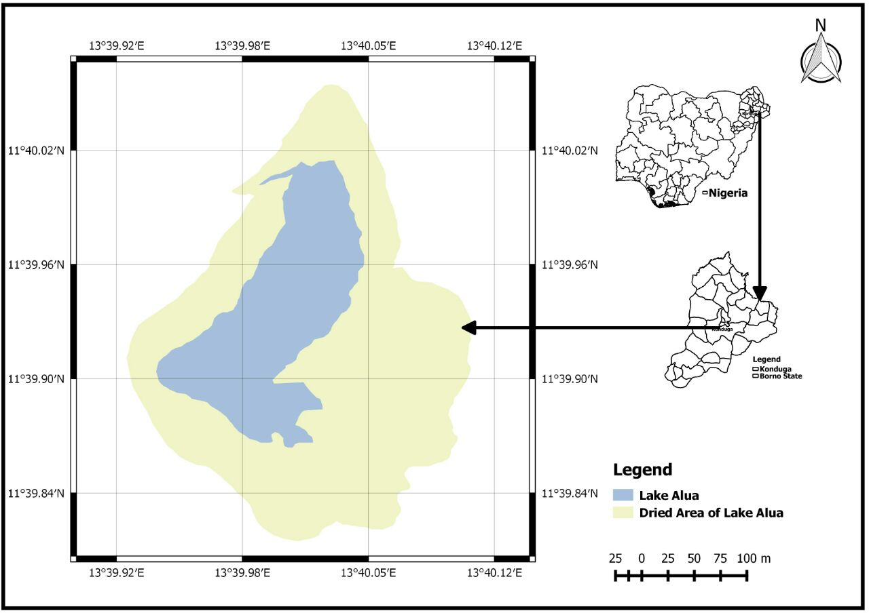

Figure 1. The map of Lake Alau showing the sampling site.
Source: GEONETcast software.
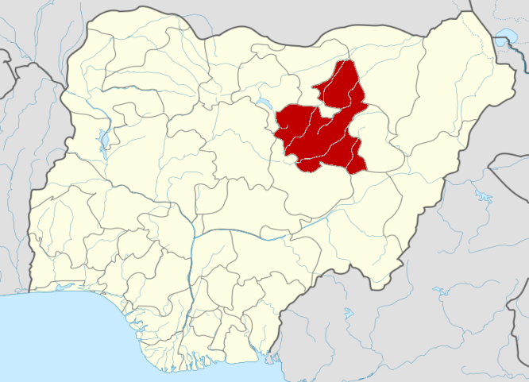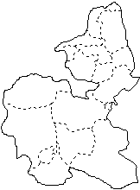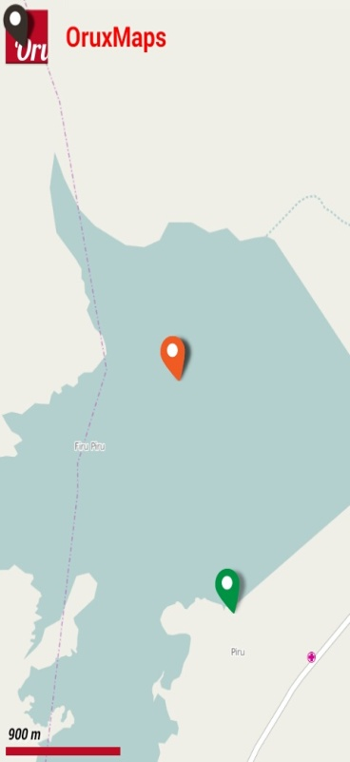

Figure 2. The map of Gubi Dam showing the sampling site.
Source: OruxMaps software.

Polymerase chain reaction (PCR) conditions and electrophoresis

The reaction mix was carried out in the 20-μl final volume containing 60ng–80ng genomic DNA, 0.1 μM of the primers, 2 mM of MgCl₂, and 125 μM of each dNTP and 1unit of Taq DNA polymerase. The initial denaturation temperature was set for 3 mins at 94⁰C, followed by 45 cycles of denaturation temperature at 94⁰C for 20 seconds, the annealing temperature of 37⁰C for 40 seconds and the primer extension temperature of 72⁰C for 40 seconds, then the final extension temperature at 72⁰C for 5 mins was added. Polymerase chain reaction products were separated on 1.4% agarose gel and scored by comparison to a 100 bp standard DNA ladder digest (Thermo scientific, USA) and the molecular weight corresponding to the expected band size was estimated using the Pyelp software version 1.3.

Molecular analysis

The RAPD fragments (bands) generated from the five primers were scored as binary data; 1 = presence and 0 = absence from the bottom to the top of the gels. The total number of alleles, monomorphic alleles and polymorphic alleles were determined using the Pyelp software version 1.3. The percentage of polymorphic loci, polymorphic information content, gene diversity, total number of segregating fragments (alleles), mean number of fragments per individual, inbreeding coefficient (FIS) and the total gene diversity among the populations (HT) were estimated using the GenAlex software version 6.1 (Peakall and Smouse, 2006). The mean Nei’s gene diversity within the populations (HW), genetic differentiation among the population (HB) and the proportion of the total gene diversity that occur among the population (F_{ST}) were also evaluated using the GenAlex software version 6.1. Pairwise indices of genetic distance and identity were computed between the populations based on Nei’s identity (1972) using the FSTAT version 2.9.3.2. The unweighted pair-group method, with the average (UPGMA) dendrogram, was constructed based on Nei’s identity (1972), using the tool for the population genetic analysis (TFPGA) software version 1.3 (Miller, 1997; MEGA 5.0 Tamura et al., 2007).
The analysis of molecular variance (AMOVA) was used to partition the genetic variance into components due to differences between populations, among populations and within populations of each strain using the GenAlex software version 6.1 (Peakall and Smouse, 2006).

Results and Discussion

Five (5) RAPD primers (OPB-10, OPB-12, OPB-20, OPE-08 and OPE-18) synthesized from Operon Technology (Operon Technology Inc. Alamed, USA) were obtained and used in this study as presented in Table 1. The mean numbers of estimated polymorphic loci and genetic variation are shown in Table 2. The number of fragment bands observed per primer ranged from 4 to 11. This range of fragment bands per primer (4–11) recorded in this study was close to 6–12, as observed by Saad et al. (2009) in the African catfish Clarias gariepinus in Egypt. However, it is lower (8–28) than reported in the same species by Asagbra et al. (2014). The differences in the numbers of fragment bands might be attributed to the numbers and sources of species. In the present study, high-quality fragment bands with good reproducibility were obtained in the size range from 150 to 4100 base pairs. This range of fragment bands is comparable from 150 to 5500 bp reported by Popoola et al. (2014) in Nigeria, and 183-1627 bp in Butter catfish (Ompok bimaculatus) as reported by Rashid et al. (2012). Gyan-chandra et al. (2010) used five RAPD primers and obtained a range of bands of 250–2,000 bp of amplicons in Eutropiichthys vacha. Also, Abdelkader et al. (2013) employed 15 random primers, and 215 loci were amplified, ranging from 118 to 2,556 bp among three species of Tilapia in Egypt. The large number of fragment bands recorded in this study might be attributed to the use of more numbers of primers or the presence of more priming sites at the template DNA with the particular series of primers used. Gyan-chandra et al. (2010) reported that the use of more numbers of random primers from different Operon series in more numbers of samples could lead to more reliable results in the genetic studies. In this study, 402 fragment bands were generated (Table 2). This result was found to be similar to that observed in Clarias gariepinus – 425 generated bands, as noted by Popoola et al. (2014). However, it is higher than 215 amplified fragments among three species of Tilapia in Egypt, as reported by Abdelkader et al. (2013), using RAPD analysis. These variations in the number of amplified fragments may be due to the differences in species.

Table 1. Primer codes, sequences and GC percentage used for the genetic characterization of Clarias gariepinus.

S/NO | Primer code | Sequences | GC%
1 | OPB-10 | CTGCTGGGAC | 70
2 | OPB-12 | CCTTGACGCA | 60
3 | OPB-20 | GGACCCTTAC | 60
4 | OPE-08 | TCACCACGGT | 60
5 | OPE-18 | GGACTGCAGA | 60

The percentage of polymorphic loci for each primer ranged from 67.9% to 82.0% (Table 2). The range of percentage polymorphic loci recorded in this study varied between 25% and 35.5% in three populations of Clarias batrachus as reported by Khedkar et al. (2010) in India. The variation in these values of polymorphic loci might be due to the differences in species. Three hundred and six (76.12%) fragment bands were polymorphic while the remaining 96 (21.39%) were found to be monomorphic (Table 2). The percentage of polymorphic loci in the two populations coincided with 70.59% reported in O. bimaculatus by Rashid et al. (2012) and also similar to the result (69.5%) obtained in the African catfish Clarias gariepinus by Saad et al. (2009). However, in the present study, the percentage of polymorphic loci recorded was higher than of those observed in catfish (C. gariepinus) (22%) by Asagbra et al. (2014) and in two populations of Heteropneustes fossilis (18.75%) reported by Garg et al. (2009). The high level of polymorphism recorded in this study is an indication of a relatively higher level of genetic variation.
The polymorphic information content (PIC) per primer ranged from 0.548±0.018 to 0.572±0.016 (Table 2). The result of this study is within the threshold of 0.5 that is considered the value for genetic markers to be informative (Botstein et al., 1980). These results are similar to the findings of Laloei et al. (2013), who reported a PIC of 0.53, but slightly lower than those reported in the Clarias macrocephalus – 0.765 (Nazia et al., 2014) and 0.785, as reported by Wang et al. (2009) in Pelteobagrus fulvidraco, using microsatellite markers. The differences might be due to the difference in molecular markers used. Gene diversity per primer was between 0.93 and 0.95 (Table 2). In the present study, the gene diversity among the two populations was higher than 0.21–0.30 as obtained by Abdelkader et al. (2013). This is an indication of high proportions of heterozygous genotypes.

Table 2. The estimates of polymorphic loci and genetic variation.

Primer code | Total number of loci | Monomorphic loci | Polymorphic loci | Polymorphic loci (%) | Polymorphic information content (±PIC) | Gene  diversity
OPB-10 | 80 | 18 | 62 | 77.5 | 0.548±0.018 | 0.942
OPB-12 | 68 | 17 | 51 | 75.0 | 0.564±0.018 | 0.952
OPB-20 | 87 | 19 | 68 | 78.16 | 0.561±0.017 | 0.940
OPE-08 | 88 | 16 | 72 | 82.0 | 0.570±0.020 | 0.946
OPE-18 | 79 | 26 | 53 | 67.9 | 0.572±0.016 | 0.930
Total | 402 | 96 | 306

Genetic variability

In the present study, the percentage of polymorphisms obtained by each population was 58 (47.3%) for the farmed and 69 (75.9%) for the wild populations (Table 3). This result showed that the wild population had a higher level of heterozygosity than the farmed population, which was found to be consistent with the result of Rahid et al. (2012) in O. bimaculatus. The relatively low percentage of polymorphic loci (47.3%) recorded in a farmed population of C. gariepinus showed the level of inbreeding in the hatchery population. The lowest percentage of polymorphic loci (64.52%) was also reported in the hatchery population of Heteropneustes fossilis (Sultana et al., 2010) through RAPD marker techniques. Simonsen et al. (2005) have reported that inbreeding is a common scenario in fish hatcheries and the offspring produced are genetically inferior. Popoola et al. (2014) reported polymorphisms of 89.9% for the wild and 74.7% for the farmed populations in Clarias gariepinus. However, the result for the wild population (75.9%) in this study was higher than (55.56%) – the result obtained by Gyan-chandra et al. (2010) in two populations of Eutropiichthys vacha in India. The mean number of segregating fragments per individual within the population was 41.6 for the farmed and 38.7 for the wild populations (Table 3).
The inbreeding coefficient (FIS), total gene diversity among the populations (HT), mean Nei’s gene diversity within the populations (HW), the proportion of the total gene diversity that occur among the population (HB) and genetic differentiation among the population (FST) are presented in Table 3. The mean numbers of the inbreeding coefficient (FIS) found (0.083) in the farmed population were much higher than 0.053, as observed in the wild population. Barasa et al. (2017) also obtained a high range (0.069–0.250) of the mean value of the inbreeding coefficient (FIS) in the farmed population of C. gariepinus. Abdul-Muneer et al. (2009) found a high inbreeding coefficient (0.211) in Horabagrus brachysoma. Barasa et al. (2017) posited that a high value of the inbreeding coefficient could be obtained in fish farms due to the loss of heterozygosity. The average number of total gene diversity among the populations (HT) recorded (0.452) in the farmed population was higher than the one (0.402) observed in the wild population. Closer to the present study, Ikpeme et al. (2015) also found high gene diversity (0.385 and 0.365) in two fish farms of Clarias gariepinus in southwestern Nigeria. However, Popoola et al. (2014) obtained a relatively lower (0.30) gene diversity in the cultured population of C. gariepinus. Gene diversity is a parameter used to determine the expected heterozygosity in a given population of plants and animals. The proportion of the total gene diversity that occurs among the population (HB) is significantly higher (0.075) in the farmed population compared to 0.042 obtained in the wild population (p≤0.05). Gyan-chandra et al. (2010) reported high (0.197) gene diversity among the population of Eutropiichthys vacha in India. The mean genetic differentiation (FST) values in the farmed population were relatively higher (0.203) than 0.129 in the wild population when compared in the present study. Wachirachaikarn et al. (2009) reported a similar average value of (0.250) within populations of four hatchery strains of Clarias gariepinus in Thailand. However, Barasa et al. (2017) reported a much higher value of FST: 0.290 among the four farmed populations of Clarias gariepinus in Kenya. Meanwhile, Na-Nakorn et al. (2004) obtained the lower genetic differentiation (FST = 0.099) in walking catfish Clarias batrachus. This result of the present study shows little genetic differentiation among the population, which is an indication of the small gene flow. It could also be due to the small number of samples. A high value of FST is evidence of little gene exchange in each generation of the populations (Abdul-Muneer et al., 2009; Gyan-chandra et al., 2010).

Table 3. The estimation of genetic variation in wild and cultured populations of the sample.

Populations | Total no. of segregating alleles | Mean no. of  alleles per individual | F_{IS} | H_{T} | H_{W} | H_{B} | F_{ST}
farmed | 58 (47.3%) | 41.6 | 0.083 | 0.452 | 0.434 | 0.075 | 0.203
wild | 69 (75.9%) | 38.7 | 0.053 | 0.402 | 0.312 | 0.042 | 0.129
H_{T} = (Total gene diversity among the populations), H_{W} = (Mean Nei’s gene diversity within the populations), H_{B} = (The proportion of the total gene diversity occurring among populations),
F_{ST} = (Genetic differentiation among population), F_{IS =} (Inbreeding coefficient).

The analysis of molecular variance (AMOVA) is presented in Table 4. AMOVA revealed that there was 4% of genetic variability among the population, which is an indication of 96% of the genetic molecular variance within the population. This result was similar to the study reported by Barroso et al. (2005), who observed 4.32% of the variance among the populations and 95.68% within the population in Brycon opalim. Li et al. (2007) have suggested that the stability of the habitat has a significant influence on the level of either low or high genetic variation.
Table 4. The analysis of molecular variance (AMOVA) of wild and cultured Clarias gariepinus populations from the study areas.

Source of variation | DF | SS | MS | Est. Var | %
among populations | 3 | 11.285 | 3.706 | 0.013 | 4%
within populations | 27 | 69.537 | 3.624 | 3.624 | 96%
Total | 30 | 80.822 |  | 3.637 | 100%

Pairwise indices of genetic distance and identity

The genetic identity of the four populations of C. gariepinus is shown in Table 5. The highest level of genetic identity (0.9490) was found between the farmed Bauchi strain and the wild Bauchi strain of C. gariepinus, which shows that they are genetically related compared to the other strains. This could be attributed to the source of brood fish in the study areas. This result is higher than the one (0.939) recorded between two wild populations of Heteropneustes fossilis reported by Sultana et al. (2010). The lowest (0.9014) value of genetic identity was obtained between the farmed Bauchi strain and the farmed Maiduguri strain. The highest (0.1038) and lowest (0.0524) measurements of genetic distance among the four populations of C. gariepinus were recorded between the farmed Maiduguri strain and the farmed Bauchi strain and between the wild Bauchi strain and the farmed Bauchi strain, respectively (Table 5). The results of this study indicate that the farmed Maiduguri strain and the farmed Bauchi strain are more genetically similar than the wild population from Bauchi and Maiduguri, respectively. A similar result (0.157) was obtained by Rashid et al. (2012) for wild and cultured O. bimaculatus. There was no significant correlation between genetic identity and geographical distance in the present study.

Table 5. The genetic distance (below) and identity (above diagonal) between farmed and wild populations of Clarias gariepinus of the RAPD profile.

Populations | FBS | WBS | FMS | WMS
FBS | - | 0.9490 | 0.9014 | 0.9055
WBS | 0.0524 | - | 0.9168 | 0.9284
FMS | 0.1038 | 0.0869 | - | 0.9416
WMS | 0.0992 | 0.0743 | 0.0601 | -
FBS = Farmed Bauchi strain, WBS = Wild Bauchi strain, FMS = Farmed Maiduguri strain, WMS = Wild Maiduguri strain.

The unweighted pair-group method with average (UPGMA) dendrogram shows the segregation of the four Clarias gariepinus populations sampled into two clusters (Figure 3). The phylogenetic dendrogram indicates that cultured Bauchi strain (CBS) and wild Bauchi strain (WBS) are in cluster-1 while cluster-2 contained cultured Maiduguri strain (CMS) and wild Maiduguri strain (WMS). The dendrogram revealed that CBS and WBS were genetically close to a similarity value of 0.0525. The dendrogram of cluster-2 clearly shows that CMS and WMS were closely related to a similarity value of 0.0601. This result demonstrates a separation of the hatchery strains from the wild strains, which agrees with the geographical distance. The genetic variation observed in the study could be as a result of hybridization among and between species in the wild. Similar results were obtained by Saad et al. (2009), who studied the phylogenetic relation of the same species India through RAPD-PCR analysis.

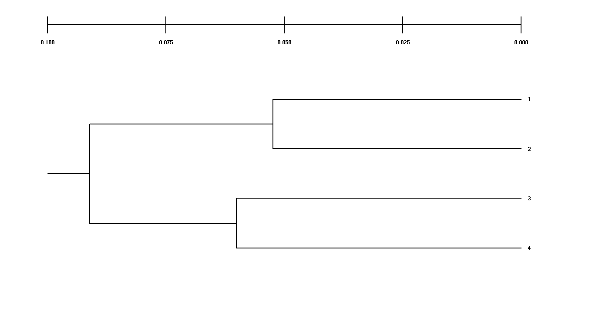
Figure 3. Clustering of four strains of Clarias gariepinus populations plotted using the unweighted pair-group method with average (UPGMA) dendrogram method based on Nei’s genetic distance value (Nei’s 1972) from RAPD-PCR analysis. Keys: (1 = Cultured Bauchi strain (CBS), 2 = Wild Bauchi strain (WBS), 3 = Cultured Maiduguri strain (CMS) and 4 = Wild Maiduguri strain (WMS)).

The relationship among the individual genotypes revealed by the UPGMA dendrogram based on Nei’s D value is shown in Figure 4. The phylogenetic dendrogram trees separated the individual genotypes of four populations of Clarias gariepinus into nine major clusters at the co-efficient of 0.05, 0.15 and 0.10 percent of similarity to each other. The nine major clusters consist of minor sub-clusters at various degrees of genetic similarity. A similar observation was reported by Usman et al. (2013) in two Cichlid populations of Tilapia guineensis and Sarotherodon melantheron. This result can explain the possibility of hybridization between the closely related species to improve the genetic characters.
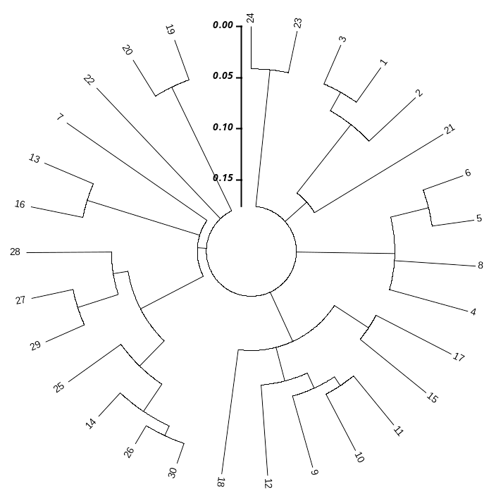

Figure 4. The individual unweighted pair-group method with average (UPGMA) dendrogram based on Nei’s D value (Nei, 1972), original measures of genetic distance, summarizing the data on the differentiation between the four strains of Clarias gariepinus.

Conclusion

In conclusion, the study was aimed to characterize the four populations of Clarias gariepinus through RAPD techniques in northeastern Nigeria. This study revealed a relatively high level of genetic variation within and between the wild and cultured populations of C. gariepinus based on the phylogenetic dendrogram drawn from Nei’s genetic distance. Studying genetic diversity is a prerequisite in understanding how populations of C. gariepinus will adapt to environmental changes. However, we suggest that a further study should be carried out with a larger number of RAPD primers and populations.
References

Abdelkader, A.M.H., Abdelhamid, Z.G., & Mahrous, F.K. (2013). Genetic diversity among three species of Tilapia in Egypt Detected by Ramdom Amplified Polymorphic DNA Marker. Journal of Applied Biological Science, 7 (2), 57-64.
Abdul-Muneer, P.M., Gopalakrishnan, A., Musammilu, K.K., Mohindra, V., Lal, K.K., Basheer, V.S., & Lakra, W.S. (2009). Genetic variation and population structure of endemic yellow catfish, Horabagrus brachysoma (Bagridae) among three populations of Western Ghat region using RAPD and microsatellite markers, Molecular Biology Reports, 36, 1779-1791.
Agbebi, O.T., Ilaboya, D.E., & Adebambo, A.O. (2013). Preliminary characterization of genetic strain in Clariid species, Clarias gariepinus and Heterobranchus bidorsalis using microsatellite markers. African journal of Biotechnology, 12 (4), 364-369.
Agnèse, J.F., Teugels, G.G., Galbusera, P., Guyomard, R., & Volckaert, F. (1997). Morphometric and genetic characterization of sympatric populations of Clarias gariepinus and C. anguillaris Senegal. Journal of Fish Biology, 50, 1143-1157.
Ahmed, M.M.M., Ali, B.A., & El-Zaeem, S.Y. (2004). Application of RAPD markers in fish: part 1-some genera (Tilapia, Sarotherodon and Oreochromis) and species (Oreochromis aurues and Oreochromis niloticus) of Tilapia. International Journal of Biotechnology, 6, 86-93.
Ali, B.A. Ahmed, M.M., & Elzeem, S.Y. (2004). Technical note: application of RAPD markers in fish: part ii- Among and within families; Cichlidae (fresh water), Mugilidae (Catadromous), Sparidae and Serranidae (Marine). Internatinal Journal Biotechnology, 6 (4), 393-401.
Asagbra, M.C., Adebayo, A.S., Ugwumba, O.A., Ugwumba, A.A.A., & Anumudu, C.I. (2014). Genetic characterization of fin fish species from the Warin River at Ubeji, Niger Delta, Nigeria. African Journal Biotechnology, 13 (27), 2689-2695.
Barasa, J.E., Mdyogolo, S., Abila, R., Grobler, J.P., Skilo, R.A., Bindeman, H., Ndotono, N.M., Chemoiwa, E.J., Dangasuk, O.G., Kaunda-Arara, B., & Verheyen, E. (2017). Genetic diversity and population structure of the African catfish, Clarias gariepinus (Burchell, 1822) in Kenya: implication for conservation and aquaculture. Belgian Journal of Zoology, 147 (2), 105-127.
Barroso, R.M., Hilsdorf, A.W.S., Moreira, H.L.M., Cabello, P.H., & Traub-Cseko,Y.M. (2005). Genetic diversity of wild and cultured population of Brycon opalinus (Cuvier, 1819) (Characiforme, Characidae, Bryconiae) using microsatellites. Aquaculture, 247, 51-65.
Botstein, D., White, R.L., Skolnick, M., & Davis, R.W. (1980). Construction of genetic linkagemap in man using restriction fragment length polymorphisms. American Journal of Human Genetics, 32, 314-331.
Dada, A.A., & Wonah, C. (2003). Production of exotic Clarias gariepinus at varying stocking density in outdoor ponds. Journal of aquatic science. 18 (1), 21-24.
FAO (2013). State of the world fisheries and Aquaculture. FAO report available online at http://www.fao.org/3/a-i3720e.pdf. Retrived12/4/2017.
Galbusera, P., Volckaert, F.A., Hellemans, B., & Ollevier, F. (1996). Isolation and Characterization of microsatellite markers in the African catfish Clarias gariepinus (Burchell, 1822). Molecular Ecology, 5, 703-705.
Garg, R. K., Sairkar, P., Silawat, N., Vijay, N., Batav, N., & Mehrotra, N.N. (2009). Genetic diversity between two populations of Heteropneustes fossilis (Bloch) using RAPD profile. International Journal of Zoological Research, 5, 171-177.
Gyan chandra, G., Saxene, A., & Barat, A. (2010). Genetic diversity of two Riverine populations of Eutropiichthys vacha (Hamilton, 1822) using RAPD markers and implications for its conservation. Journal of cell and Molecular Biology, 8 (2), 77-85.
Hallerman, E.M., & Beckmann, J.S. (1988). DNA level polymorphism as tool in fishes science. Canadian Journal of Fisheries and Aquatic Sciences, 45, 1075-1087.
Ikpeme, E.V., Udensi, O.U., Ekaluo, U.B., Ekooffreh, M.E., Okolo, C.M., Ekpo, P.B., & Ogbonna, N.C. (2015). Unveiling the Genetic Diversity in Clarias gariepinus (Burchell, 1822) Using Random Amplified Polymorphic DNA (RAPD) Fingerling Technique. Asian Journal of Animal Science, 9 (5), 187-197.
Khedkar, G.D., Reddy, A.C.S., Persis, M., Ravinder, K., & Muzumdar, K. (2010). Clarias batrachus (Linneus, 1758) population is lacking genetic diversity in India. Molecular Biology Reports, 37, 1355-1362.
Laloei, F., Gilkolaei, S.R., & Taghavi, M.J. (2013). Genetic diversity and differentiation of common carp (Cyprinus carpio) in the southern part of Caspian Sea by using microsatellite marker. Asian Fisheries science, 26, 115-127.
Li, D., Kang, D., Yin, Q., & Sun, X. (2007). Microsatellite DNA marker analysis of genetic diversity in wild common carp (Cyprinus carpio L.) populations. Journal of Genetics and Genmics, 34, 984-993.
Miller, M.P. (1997). Tools for population genetic analyses. A Windows program for the analysis of allozyme and molecular population genetic data (Version 1.3., Feb 2000). Department of Biological Sciences, Northern Arizona University, Flagstaff, AZ, USA.
Na-Nakorn, U., Kamurat, W., & Ngmsiri, T. (2004). Genetic diversity of Walking Catfish, Clarias macrocephalus, in Thailand and Evidence of Genetic Introgression from Introduced Farmed Clarias gariepinus. Aquaculture, 240, 145-163.
Nei, M. (1972). Genetic distance between populations. American Naturalist, 106, 283-293.
Nazia, A.K., Sitti, A., & Zizah, M.N. (2014). Isolation of microsatellites in the bighead catfish, Clarias macrocephalus and cross amplification in selected Clarias species. Molecular Biology Research, 41 (3), 1207-1213.
Peakall, R., & Smouse, P.E. (2006). GENALEX 6: Genetic analysis in Excel, Population genetic software for teaching and research. Molecular Ecology Notes, 6, 288-295.
Popoola,O.M., Emmanuel, A.F., & Awopetu, J.I. (2014). Genetic variability in cultured and wild populations of Clarias gariepinus (Osteichtlys: Clariidae) using Ramdom Amplified Polymorphic DNA (RAPD) marker. Croation Journal of Fisheries, 72, 5-11.
Rashid, J., Faozia, M.T., Mostafa A.H., Md., & Samsul, A. (2012). Genetic variation in endangered butter catfish, Ompok bimaculatus (bloch) populations revealed by random amplified polymorphic DNA (RAPD) fingerprinting. International Journal of Biosciences, 2 (9), 85-93.
Saad, Y.M., Ali, S.F., Hanafi, M.S., Ezza, M.A., & Guerges, A.A. (2009). Genetic Signature of Some Egyptian Clarias gariepinus Populations. Global Veterinaria, 3 (6), 503-508.
Simonsen, V., Hansen, M.M., Mensberg, K.L.D., Alam, M.D., & Sarder, M.D. (2005). Widespread hybridization among species of Indian major carps in hatcheries, but not in the wild. Journal of Fish Biology, 67, 794-808.
Soufy, H., Laila, A.M., & Iman, M.K.A. (2009). RAPD-PCR for DNA-Fingerprinting of Egyptian Tilapia. New York Science Journal, 2, 1554-0200.
Sultana, S., Akter, S., Hossain, M.A.R., & Alam, M.S. (2010). DNA fingerprinting of the Asian stinging catfish (Heteropneustes fossilis, Bloch) by Random Amplified Polymorphic DNA markers. International Journal of Biotechnology Applications, 2 (2), 5-10.
Tamura, K.J., Dudley, M.E., & Kumar, S. (2007). Mega4: Molecular evolutionary genetics analysis (MEGA) software version 4.0. Molecular Biology and Evolution, 24, 1596-1599.
Usman, B.A., Agbebi, O.T., Bankole, M.O., Oguntade, O.R., & Popoola, M.O. (2013). Molecular characterization of two cichlids populations (Tilapia guineensis and Sarotherodon melantheron) from different water bodies in Lagos State, Nigeria. International Journal for Biotechnology and Molecular Biology Research, 4 (5), 71-77.
Wachirachairan, A., Rungsin, W., Srisapoome, P., & Na-Nakorn, U. (2009). Crossing of African Catfish, Clarias gariepinus (Burchell, 1822), Strains Based on strain selection using genetic diversity data. Aquaculture, 290 (1-2), 53-60.
Wang, M.L., Barkley, N.A., & Jenkins, T.M. (2009). Microsatellite marker in plants and insects. Part1: Application of Biotecnology. Genes, Genomes and Genomics, 3 (1), 54-67.
Williams, J.G.K., Kubelik, A.R., Livak, K.J., Rafalski, J.A., & Tingey, S.V. (1990). DNA polymorphisms amplified by arbitrary primers are useful as genetic markers. Nucleic Acids Research, 18 (22), 6531-6535.

Received: March 5, 2019
Accepted: August 20, 2020

GENETIČKA KARAKTERIZACIJA GAJENIH I DIVLJIH POPULACIJA AFRIČKOG SOMA (CLARIAS GARIEPINUS BURCHELL, 1822)
PRIMENOM RAPD METODA

Sa'adu B. Suleiman*, Mohammed Y. Diyaware,
Mohammed Aliyu i Zanna B. Mohammed

Odsek za ribarstvo, Univerziet u Maiduguriju, Poljoprivredni fakultet, Nigerija

R e z i m e

U ovom istraživanju sprovedena je genetička karakterizacija afričkog soma Clarias gariepinus. Prikupljeno je trideset (30) uzoraka afričkog soma C. gariepinus, po petnaest (15) iz divljine i sa ribnjaka u severnoistočnoj Nigeriji zbog njihove genetičke srodnosti i divergentnosti uz pomoć markera RAPD metode. Ekstrakcija DNK iz uzorka krvi izvršena je pomoću kompleta hemikalija Gene Jet Genomic DNA Purification Kit. Pet prajmera je korišćeno za PCR reakciju i amplifikovane su 402 RAPD trake poreklom iz četiri soja Clarias gariepinus. Trista šest (76,12%) traka bilo je polimorfno, dok je 86 (21,39%) bilo monomorfno. Procenat polimorfizma dobijen kod uzgajanih, odnosno divljih populacija, kretao se od 58 (47,3%) do 69 (75,9%). Polimorfne trake po lokusima unutar populacija kretale su se od 67,9% do 82,0%. Prosečne vrednosti koeficijenta inbridinga (FIS) iznosili su 0,083 kod uzgajane odnosno 0,053 kod divlje populacije. Vrednosti divergentnosti gena unutar uzgajanih i divljih populacija (Ht) bile su 0,4522 odnosno 0,4018. Srednja genetička diferencijacija (FST) kretala se između (0,203) kod uzgajanih i 0,129 kod divljih populacija. Analiza molekularne varijanse pokazala je da je unutar populacije bilo 96% genetičke varijanse, a među populacijom 4%. Genetički identitet i genetička distanca četiri populacije iznosili su 0,9490 odnosno 0,1038. Filogenetska mera pokazala je da su četiri soja podeljena u dva klastera na nivou sličnosti od približno 0,089. Rezultati su ukazali na značajan nivo genetičkih varijacija i minimalno odvajanje dendrograma kod Clarias gariepinus na severoistoku Nigerije. U zaključku, ove informacije će biti korisno sredstvo za program selekcije afričkog soma Clarias gariepinus.
Ključne reči: RAPD, genetička varijacija, Clarias gariepinus, polimorfizam, Nigerija, marker.

Primljeno: 5. marta 2019.
Odobreno: 20. avgusta 2020.

*Corresponding author: e-mail: saadbala@unimaid.edu.ng
*Autor za kontakt: e-mail: saadbala@unimaid.edu.ng

