HISTOPATHOLOGY OF COLLETOTRICHUM SP. IN INFECTED MANGO (MAGNIFERA INDICA L.) FRUITS

Oluwole O. Oladele

Department of Biology, Federal University of Technology,
PMB 704, Akure, Nigeria

Abstract: Postharvest losses as a result of anthracnose infection remain a serious threat to mango producers. Hence, histopathology of mango fruits after being artificially infected with spores of Colletotrichum sp. was investigated. Fruits at the physiologically mature stage were wounded (cut) in the peels and inoculated with a spore suspension of Colletotrichum sp. (8.04 × 10³ conidia m1⁻¹) and incubated at 28±2ºC for five days to allow pathogen establishment. The infected peel was then carefully cut with a razor blade and dehydrated in series in different grades (50, 70, 80, 90 and 100%) of ethyl alcohol for 1½ hours each. Histopathological studies were carried out on the infected peel tissue excised from inoculated fruits using standard procedures while unwounded peels of fruits that were not artificially inoculated served as control. Sections were examined by light microscopy to observe histopathological differences between the infected and non-infected fruits. Results from this study revealed that only the wounded peel showed symptoms of anthracnose infection as a result of the artificial inoculation, but the unwounded peel showed no disease symptoms. This showed that the fungus infected the mango fruits through the peel wounds. Besides, the disorganization of the cells and the rupture of the cell walls were observed microscopically, thus indicating disease establishment in the infected fruits. Therefore, mango producers should avoid mechanical damage to fruits during harvesting since this work confirms that the fungus infects mango fruits through wounds.
Key words: infection process, mango anthracnose, wounds, microscopy, inoculation.

Introduction

Mango (Mangifera indica L.) is a member of the family Anacardiaceae and one of the most important and widely cultivated fruits of the tropical world. It is a dominant species of fruit produced worldwide, followed by pineapples, papaya and avocado (FAO, 2013). Mangoes are cultivated mostly for their edible fruit (Singh and Saini, 2017), rich in vitamins A and C, and they have a very good food value (Lauricella et al., 2017). The fruit is a large, fleshy drupe, containing an edible mesocarp which is resinous and an outer thin leathery part is the epicarp which is thick yellowish to reddish in color. The endocarp, the innermost, is hard and stony. In fact, the mesocarp together with the epicarp forms the pericarp or peel of the fruit (Tharanathan et al., 2006).
The two major fungal diseases of mango fruits are anthracnose caused by Collectotrichum gloesporioides or C. acutatum, characterized by the appearance of sunken black spots on the surface of the fruit during ripening (Afanador-Kafuri et al., 2003) and powdery mildew caused by Oidium mangiferae, evident by the formation of whitish, superficial, powdery fungal growth mainly on leaves, the stalk of panicles, flowers and fruits (Diedhlou et al., 2007). However, anthracnose is the most serious, causing considerable losses for the mango industry and is widely distributed all over mango growing regions in the world (Angasu et al., 2014). Namely, postharvest losses due to C. gloeosporioides (Penz and Sacc.) remains one of the biggest concerns for mango producers (Fivaz, 2009). Unfortunately, not much had been done on anthracnose disease of mango in the area of research in Nigeria. Besides, there is little or no information on the histopathology and pathogen infection of C. gloeosporioides in mango fruits. Thus, this work was conducted to study the histopathology of mango fruits after artificial inoculation with Colletotrichum sp. spores.

Materials and Methods

Isolations from infected fruits

Isolations were made from anthracnose lesions characterized by the appearance of black spots on the symptomatic mango fruits. The symptomatic rind was cut without surface sterilization, cultured on plates of solidified malt extract agar (MEA, oxoid) and then incubated at 28±2ºC for 10 days. Pure cultures of the obtained fungus were used to prepare the spore suspension.

Preparation of spore suspension

A ten-day-old agar slant culture of Colletotrichum sp. (the test isolate) on MEA was used to prepare the spore suspension. Sterile water was poured into the slant and shaken vigorously to dislodge the spores from the vegetative hyphae. The wash water was collected in a sterilized beaker, serially diluted to ×10³ and 1ml of the spore suspension was placed on the calibrated hemocytometer (Model 1280) slide and viewed under ×40 objective light binocular microscope (model Olympus CX40). The spore count was measured under four different fields and calculated as follows:
Cells/ml = (n) × 10³,

where n = average cell count per square of the four corner squares counted using in vitro inoculation and pathogenicity assay.

The spore suspension of Colletotrichum sp. (8.04 × 10³ conidia m1⁻¹) was used to inoculate fresh mango fruits, cut 1mm at the equator and incubated at 28±2ºC and 75±5% of relative humidity (RH) inside sterilized desiccators. The infected fruits, observed after 5 days of incubation for anthracnose infection, were then used for histopathological studies. Fruits that were not inoculated served as control. Also, after 5 days of incubation, the pathogen was re-isolated, and its identity was confirmed.

Histopathology

Histopathological studies were carried out on the peel tissue excised from inoculated fruits. The peel was carefully cut from the diseased portion of inoculated fruit with a new razor blade and dehydrated in series in different grades of ethyl alcohol for 1½ hours each (Lamb, 1981) and was later cleared with 100% xylene before being impregnated in molten paraffin wax overnight. The embedded tissues were sectioned to form ribbons (sections) using an HM 325 microtome. The ribbons were made to float on warm water (45ºC) and mounted on a slide and dried in an oven at 40ºC for 2 hours.
Before staining, the section was cleared in 100% xylene by dipping the section in different percentages of alcohol (50, 70, 80, 90 and 100%) to remove the wax, and finally washed in running tap water (hydration) to remove the alcohol. The hydrated sections were stained first with haematoxylin for 4 minutes, and the stained section differentiated in 1% acid alcohol and washed again in running tap water before counterstaining in eosin for 2 minutes. The counterstained section was washed in running tap water and dehydrated in different percentages of alcohol and then cleared in 100% xylene before adding Canada balsam. The preparation was left in the oven at 40ºC for 1 hour and then observed under the microscope (model Olympus CX40) fitted with a digital camera and photographs were taken. The procedure was also repeated on non-inoculated fruits.

Results and Discussion

The examination of several cross-sections of the peel tissue of the mango fruits using a light microscope revealed histopathological differences between the healthy (uninfected) and the diseased mango fruits. Microscopic observation showed that the tissues of the healthy fruit had closely adhered cells. The cells were in perfect cohesion, and the cell walls were also intact (Figure 1). However, the Colletotrichum sp. colonized the tissues of the inoculated mango fruits, and showed long, thickening fungal hyphae in some tissues of the infected fruits and the cells had become disrupted (Figure 2) while in other tissues, many conidia were observed in the cells of the infected fruits (Figure 3). Meanwhile, the fungal hyphae appeared in the form of spherical vesicles in some cells (Figure 4).

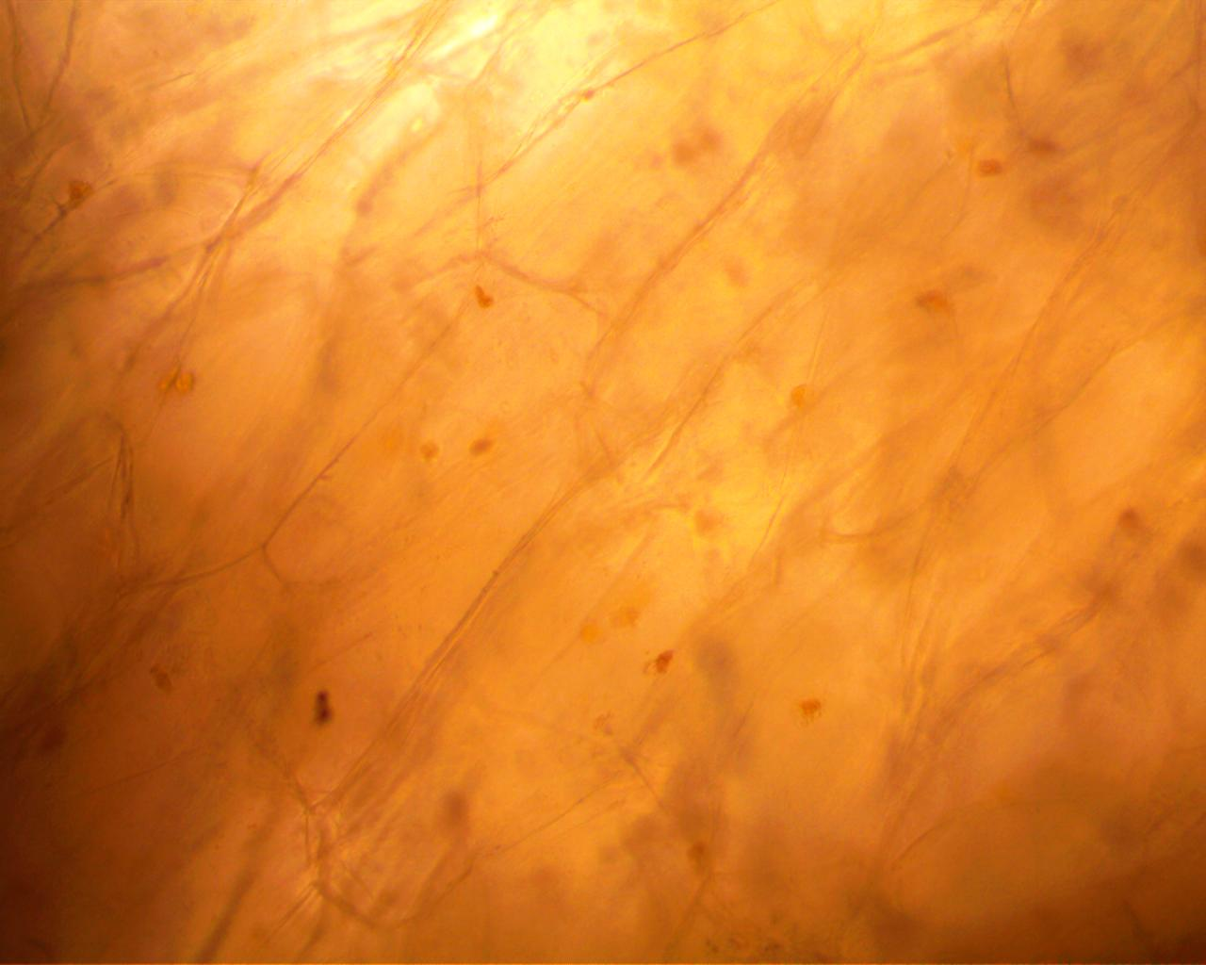 X400

Figure 1. The photomicrograph of a cross-section of the uninoculated and healthy mango fruit showing intact cell walls.

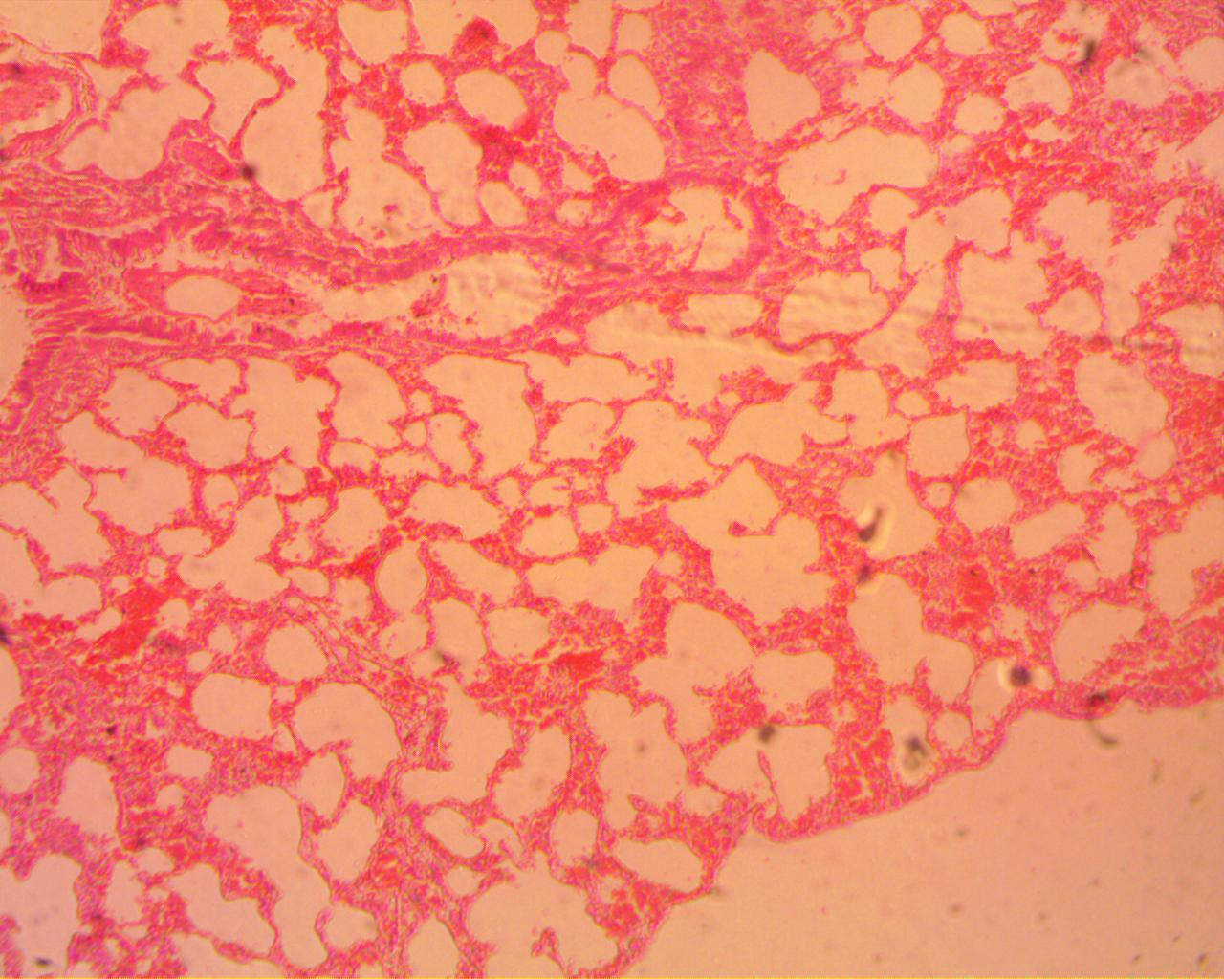 X400
Fungal hyphae

Figure 2. The photomicrograph of a cross-section of the inoculated mango fruit with Collectotrichum sp. showing the fungal hyphae in distorted cells.

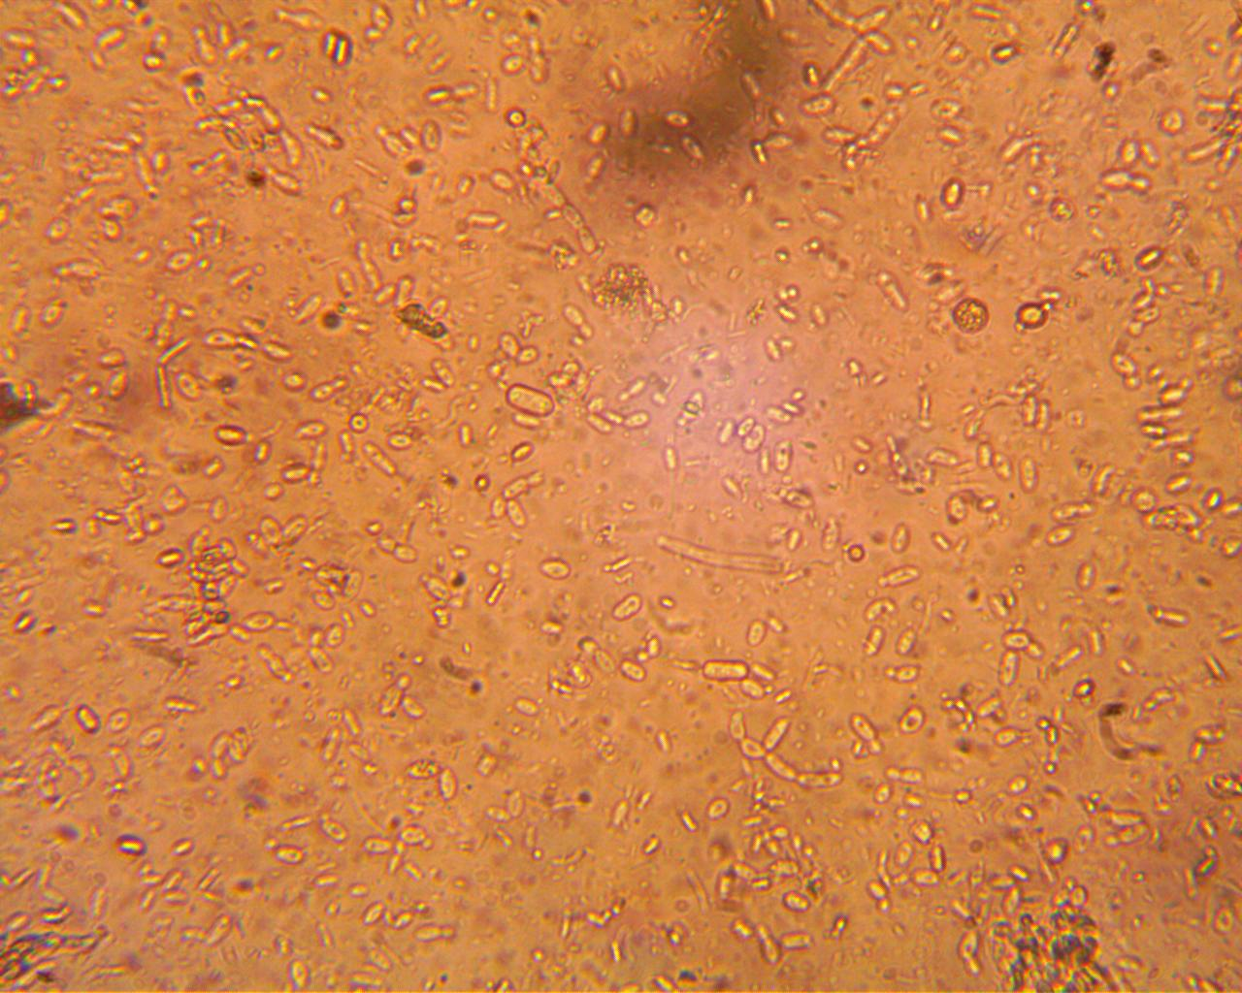
X400
c
c
c
c
c
c
c

c
c
c
c
c

Figure 3. The photomicrograph of a cross-section of the infected mango fruit with Collectotrichum sp. showing the fungal conidia (c) in ruptured cells.

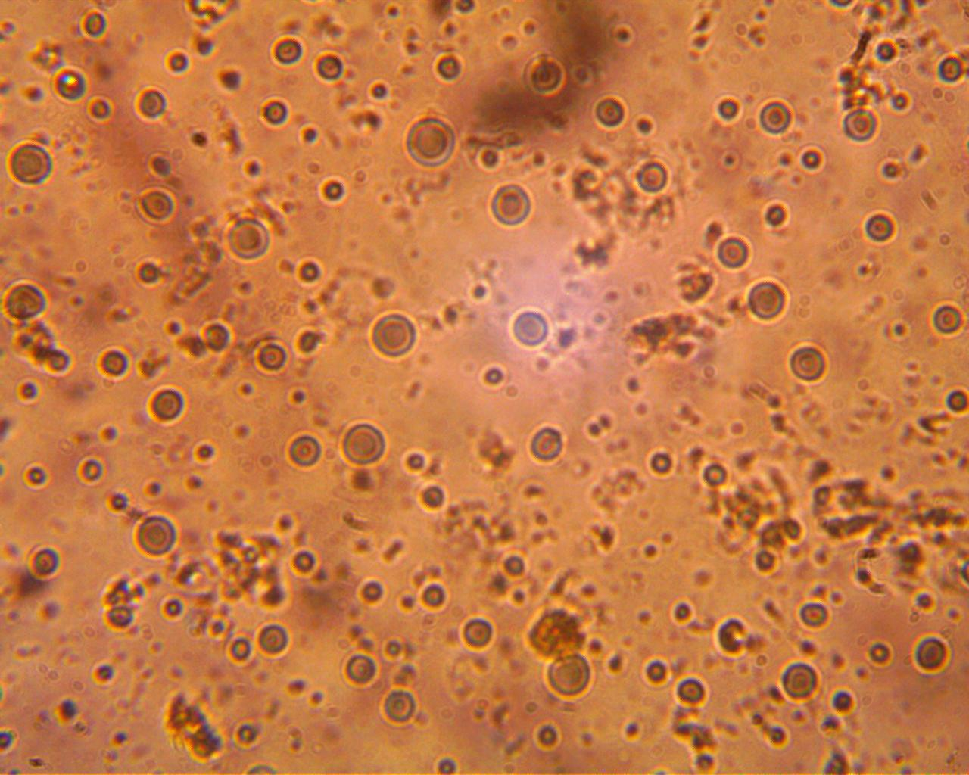
c
X400
Fungal hyphae as vesicles
Figure 4. The photomicrograph of a cross-section of the infected mango fruit with Collectotrichum sp. showing fungal hyphae as spherical vesicles in disrupted cells.

Results from this study revealed that only the wounded peel showed symptoms of anthracnose infection, but the unwounded peel showed no disease symptoms. This showed that Colletotrichum sp. infected the mango fruits through cuts and by using its conidia. This was in conformity with the report of Jeffries et al. (1990) that Colletotrichum species penetrate host plant through wounds, natural openings or directly via appressorium. Arauz (2000), in his own work, has further reported and confirmed that C. gloeosporioides mainly infect through conidia that get easily dispersed by rain. Similar observations were made by Ferreira et al. (2005) but related to C. fimbriata. They also found aleurioconidia in Eucalyptus plants.
In fact, observation from this work also revealed the presence of hyphae and conidia in the infected cells distorting the cell structure. Hyphae were seen growing within and between the cells. This could not but be connected with the ability of the pathogenic fungi to invade the infected tissues causing changes in the cell structure and plasmolysis and dissolution of the infected cells (Pandey et al., 2012). O’Connell et al. (2000) have also reported that dissolution of the cell wall could be connected with hyphae penetration, after which the pathogen grows beneath the cuticle and inside the periclinal and anticlinal wall of the epidermal cells, causing dissolution of the cell wall.
Similarly, microscopic observation from this study also showed the fungal hyphae in the form of spherical vesicles. This was equally the observations of several authors who reported the occurrence of empty fungal hyphae of pathogens surrounded by amorphous material in the cells of many plant species (Bélanger et al., 2003; Rodrigues et al., 2003). After penetration, they form a spherical infection vesicle. Hyphae grow from this vesicle and subsequently colonize other host cells (O’Connell et al., 1985; Mould et al., 1991).

Conclusion

Mango producers should avoid mechanical damage to fruits during harvesting since this work has shown that the fungus infects mango fruits through wounds. Similarly, harvested fruits can be stored in plastics or bowls instead of inside woven baskets to protect the fruits against being wounded. Besides, knowledge of specialized infection structures such as hyphae and infection vesicles of Colletotrichum sp. as observed in this study may be an excellent tool for studying the infection processes of other post-harvest pathogens.

Acknowledgements

The author is very grateful to Prince Adesida of the Department of Animal Production and Health, Federal University of Technology, Akure for providing technical assistance.

References

Afanador-Kafuri, L., Minz, D., Maymon, M., & Freeman, S. (2003). Characterization of Colletotrichum isolates from tamarillo, passiflora, and mango in Colombia and identification of a unique species from the genus. Phytopatholgy, 93, 579-587.
Angasu, O.N., Dessalgne, O.G., & Tadesse, T.N. (2014). Effect of hot water treatment on quality and incidence of postharvest disease of mango (Mangifera indica L.) fruits. Journal of Plant Science, 13 (2), 87-92.
Arauz, L.F. (2000). Mango anthracnose: Economic impact and current options for integrated management. Plant Disease, 84, 600-611.
Bélanger, R.R., Benhamou, N., & Menzies, J.G. (2003). Cytological evidence of an active role of silicon in wheat resistance to powdery mildew (Blumeria graminis sp. tritici). Phytopathology 93, 402-412.
Diedhlou, P.M., Mbaye, N., Drame, A., & Samb, P.I. (2007). Alteration of postharvest diseases of mango (Mangifera indica) through production practices and climatic factors. African Journal of Biotechnology, 6 (9), 1087-1094.
FAO (2013). Medium-term prospects for agricultural Commdities. In: Food and Agriculture Organization of the United Nations. http://www.fao.org/docrep/006/y5143e/y5143e1a.htm.
Ferreira, F.A., Maffia, L.A., & Ferreira, E.A. (2005). Detecçãorápida de Ceratocystis Fimbriata emlenhoinfetado de eucalipto, mangueira e outros hospedeiroslenhosos. Fitopatologia Brasileira, 30, 543-545.
Fivaz, J. (2009). Mango production in South Africa as compared to the rest of the world. Acta Horticulturae, 820, 29-46.
Jeffries, P., Dodd, J.C., Jeger, M.J., & Plumbley, R.A. (1990). The biology and control of Colletotrichum species on tropical fruit crops. Plant Pathology, 39, 343-366.
Lamb, G.M. (1981). Manual of Veterinary Laboratory Techniques. Kenya: CIBA-GEIGY Publisher.
Lauricella, M., Emanuele, S., Calvaruso, G., Giuliano, M., & D’Anneo, A. (2017). Multifaceted health benefits of Mangifera indica L. (Mango): The inestimable of orchards recently planted in Sicilian Rural Areas. Nutrients, 9, 525. Doi: 10.3390/nu9050525.
Mould, M.J.R., Boland, G.J., & Robb, J. (1991). Ultrastrucuture of the Colletotrichum trifolli Medicago sativa pathosystem and pre-penetration events. Physiological and Molecular Plant Pathology, 38, 179-194.
O’Connell, R.J., Perfect, S., Hughes, B., Carzaniga, R., Bailey, J., & Green, J. (2000). Dissecting the cell biology of Colletotrichum infection processes. In: Prusky, D., Freeman, S., Dickman, M.B. (Ed.). Colletotrichum: host specificity, pathology and host-pathogen interaction. Minnessota: APS Press Company.
O’Connell, R.J., Bailey, J.A., & Richmond, D.V. (1985). Cytology and physiology of infection of Phaseolus vulgaris by Colletotrichum lindemuthianum. Physiological Plant Pathology, 27, 75-98.
Pandey, A., Pandey, B.K., Muthukumar, M., Yadava, L.P., & Chauhan, U.K. (2012). Histopathological Study of Infection Process of Colletotrichum gloeosporioides Penz and Sacc. on Mangifera indica L. Plant Pathology Journal, 11, 18-24.
Rodrigues, F.A., Benhamou, N., Datnoff, L.E., Jones, J.B., & Bélanger, R.R. (2003). Ultrastructural and cytochemical aspects of silicon-mediated rice blast resistance. Phytopathology, 93, 535-46.
Singh, S.P., & Saini, M.K. (2017). Postharvest vapour heat treatment as a phytosanitary measure influences the aroma volatiles profile of mango fruits. Food chemistry, 164, 387-395.
Tharanathan, R.N., Yashoda, H.M., & Prabha, T.N. (2006). Mango (Mangifera indica L.), “The King of Fruits” - An overview. Food Reviews International, 22, 95-123.

Received: June 12, 2019
Accepted: October 25, 2020

HISTOPATOLOGIJA PLODA MANGA (MAGNIFERA INDICA L.) ZARAŽENOG GLJIVOM COLLETOTRICHUM SP.

Oluwole O. Oladele*

Odsek za biologiju, Federalni tehnološki univerzitet,
PMB 704, Akure, Nigerija

R e z i m e

Gubici koji se javljaju nakon berbe, kao rezultat antraknoze, predstavljaju ozbiljnu pretnju za proizvođače manga. Stoga je istražena histopatologija plodova manga posle veštačke infekcije sporama Colletotrichum sp. Kore plodova u fiziološki zreloj fazi su povređene, inokulisane suspenzijom spora Colletotrichum sp. (8,04 × 10³ konidija m1⁻¹) i plodovi su inkubirani na 28±2ºC tokom pet dana kako bi se razvila infekcija. Zaražena kora je zatim pažljivo isečena oštricom žileta i dehidrirana u nizu rastvora različitih koncentracija (50, 70, 80, 90 i 100%) etil alkohola u trajanju od 1,5 časa. Histopatološka ispitivanja zaraženog tkiva kore inokulisanih plodova izvršena su pomoću standardnih postupaka, dok je kora nepovređenih plodova, koji nisu veštački inokulisani, služila kao kontrola. Isečci su pregledani svetlosnim mikroskopom, kako bi se uočile histopatološke razlike između zaraženih i nezaraženih plodova. Rezultati ove studije pokazali su da se antraknoza javila samo na povređenoj kori nakon veštačke inokulacije, dok se simptomi bolesti nisu javili na nepovređenoj kori. Rezultati pokazuju da je gljiva zarazila plodove manga kroz povrede/rane na kori. Pored toga, dezorganizacija ćelija i razgradnja ćelijskih zidova uočeni su mikroskopskim pregledom tkiva, što ukazuje na razvoj bolesti u zaraženim plodovima. Stoga proizvođači manga treba da izbegavaju mehanička oštećenja plodova tokom berbe, jer ovaj rad potvrđuje da gljiva zaražava plodove manga preko povreda/rana.
Ključne reči: proces zaražavanja, antraknoza manga, povrede/rane, mikroskopija, inokulacija.

Primljeno: 12. juna 2019.
Odobreno: 25. oktobra 2020.

*Corresponding author: e-mail: prophetoladele2014@gmail.com
*Autor za kontakt: e-mail: prophetoladele2014@gmail.com

