SEED PERFORMANCE OF COMMON BEAN AND COWPEA BY PRIMING AND PLANTING DATE

Mohammad Hasanzadeh¹, Ibrahim Demir², Nahid Hazrati³,
Mehmet Burak Taşkın⁴ and Özge Şahin⁴

¹Department of Plant Production, Faculty of Agriculture and Natural
Resources-Moghan, University of Mohaghegh Ardabili, Ardabil, Iran
²Department of Horticulture, Faculty of Agriculture,
Ankara University, 06110, Dışkapı, Ankara, Turkey
³Department of Field Crops, Faculty of Agriculture,
Ankara University, 06110, Dışkapı, Ankara, Turkey
⁴Department of Soil Science and Plant Nutrition, Faculty of Agriculture,
Ankara University, 06110, Dışkapı, Ankara, Turkey

Abstract: A 2-year farm trial by employing the nutrient priming technique on common bean (Sarıkız) and cowpea (Şimal) seeds was performed to assess seed yield and protein content. Priming: (p1) control, (p2) KH₂PO₄, (p3) ZnSO₄ and (p4) KH₂PO₄+ZnSO₄, planting date: (d1) 20 May, (d2) 15 June 2015, (d1) 7 May, (d2) 7 June 2016 were used to study the yield (kg ha⁻¹) and crude protein (%) of the mentioned crops in Ankara, Turkey. In 2015, application of p3 and p4 (868.8, 834.8), d2 (962.3) and p4d2, p2d2 and p3d2 (1061, 1052, 1028) increased seed yield of Sarıkız, and p2 and p1 (899.5, 835.9) and d2 (955.9) increased the yield of Şimal. Treatments of p4 and p3 (18.7, 18.5), d2 (19.2), and p4d2 (21.3) increased the protein of Sarıkız and d2 (19.4) increased the protein of Şimal. In 2016, p3 (2506), d2 (2516) and p3d2 (3650) increased the yield, and p4 (26.1), d2 (26.8) and p4d2 (28.3) increased the protein of Sarıkız. Treatments of p3 (1979.1), d2 (2664.3) and p3d2 (3310.6) increased the yield, and d1 (24.1) and p3d1 (25.7) increased the protein of Şimal. Application of Zn and P by seed priming seems to effectively increase the yield and protein content of these crops.
Key words: common bean, cowpea, crude protein, planting date, priming, yield.

Introduction

The most effective way to alleviate phosphorus (P) deficiency in crops is to add large quantities of phosphate fertilizers to the P-deficient soils, either as P solutions or soil applications. However, amelioration of P deficiency with large amounts of fertilizers is not a viable option for many farmers. Other methods for providing seeds with nutrients have shown serious limitations. Making high concentrations of P in seeds by increasing soil fertilization would increase the cost of seed production, as a result of partial fixation of this nutrient in the soil. Another way of providing seeds with P is coating them with this element which can stimulate early plant growth, but is less effective in increasing grain yield of plants, such as wheat in the field (Peltonen-Sainio et al., 2006). However, seed dressing of some nutrients has been advised as a low-cost and highly effective approach, but priming the seeds with small amounts of nutrients before planting has been shown to partially increase nutrient use efficiency and it has been found to be effective for legumes yield, so that a considerable increase in their yield has been observed (Musa et al., 2001; Rashid et al., 2004; Harris et al., 2004). Seed P content, although constitutes a small proportion of total plant demand, may be effective for optimum plant establishment and growth. Generally, seed priming with P and zinc (Zn) nutrients around or within the seed may be an attractive solution to overcome P and Zn deficiencies and it has been found that on-farm seed priming with solutions of KH₂PO₄ increased the yield of different crops grown on P-deficient soils (Ali et al., 2008). Some investigations have been performed using primed seeds of chickpea and wheat (Harris et al., 2004) and maize (Harris et al., 2007) with Zn solutions leading to high seed yields.
In terms of protein content of seed legumes, there are few studies on seed priming with Zn and P elements in spite of findings on the impacts of these on the improvement of the protein content of the cowpea (Chavan et al., 2012,) common bean (Poshtmasari, 2008) and green gram seeds (Muhammad et al., 2014). Also, reports on the combined application of foliar spraying along with seed priming with Zn containing solutions in crops such as black gram which has increased protein content are found in the literature (Kshama, 2013).
Planting date as a climatic factor plays an important role in the final yield of legumes by affecting the vegetative and reproductive stages and their ratio (Lopez-Bellido et al., 2008). Suitable planting date causes the flowering stage not to coincide with high temperatures, leading to the highest pod production. Also, suitable planting date prolongs the duration of the vegetative stage to transport more assimilates to the sinks while the late planting date results in the early flowering leading to a dry matter reduction, a decline in the produced pods and finally yield loss (Mozumber et al., 2003). It has been suggested that early cultivation of warm-season plants may negatively affect preliminary seedling establishment due to the lower rates of air temperatures (onset of spring). Also, when planting is performed at the beginning of the season which is earlier than optimum date, seed yield loss in such plants is expected because of encountering the stages of flowering, anthesis and early seed filling with high temperatures of July and August. On the other hand, late planting may prolong the seed filling period due to the lower air temperatures of the end of summer and early autumn (Khajehpour, 2000). In this regard, it has been shown that in the semi-arid conditions of Northern Iran, high yields of cowpea have been obtained in June cultivation (Farahmand-Rad, 1999).
The objective of this work was to assess the quality and quantity responses of common bean and cowpea plants to phosphorus and zinc seed treatments grown at different planting dates.

Materials and Methods

The field trial was run at the research farm of the Faculty of Agriculture, Ankara University, Ankara, Turkey during 2015 and 2016 growing years for the planting of the primed seeds to measure the seed yield of the common bean (Phaseolus vulgaris, Sarıkız), and cowpea (Vigna unguiculata, Şimal) crops. The priming section of the present work was carried out in the Laboratory of Seed Sciences, Faculty of Agriculture, Ankara University, Ankara, Turkey. For measuring the crude protein content of the crop, harvested seeds were analyzed in the Laboratory of the Soil and Plant Nutrition, Faculty of Agriculture, Ankara University. This work was carried out as a factorial experiment based on a randomized complete block design (RCBD) with three replicates. Factors included different seed priming including (p1) control (untreated), (p2) KH₂PO₄ 10 g L⁻¹, (p3) ZnSO₄ 4 g L⁻¹ and (p4) KH₂PO₄ 5 g L⁻¹+ZnSO₄ 2 g L⁻¹ and planting dates: (d1) 20 May and (d2) 15 June for the year of 2015, and (d1) 7 May and (d2) 7 June for the year of 2016. In both years, before planting, seed priming was performed for 7 hours by immersion of seeds inside the mentioned salt solutions followed by drying of the seeds for 36 hours at 25°C and thereafter, the seeds were subjected to planting. Each plot comprised 5 rows three meters long and 50 cm apart, seeds were planted manually in the rows with a distance of 10 cm between the two plants.
For weed controlling in the first year, hand hoeing was employed for three times over the season. In the second year, Treflan® (Trifluralin) herbicide was applied on the soil surface and soil incorporated at least one week before planting.
Irrigation was done after planting and continued in 7–10-day intervals depending on the rainfall of the season and climatic conditions. At the end of the growing period of each planting date, while the pods turned yellow-gray in color, seeds were harvested from the two middle rows of each plot manually.
Table 1. Different dates of planting, flowering and harvesting of the Sarıkız and Şimal crops in 2015 and 2016.

2015 – the first date
 | Planting | Flowering | Harvesting
Sarıkız | 20/05/2015 | 28/06/2015 | 08/08/2015
Şimal | 20/05/2015 | 15/07/2015 | 15/08/2015
2015 – the second date
Sarıkız | 15/06/2015 | 22/07/2015 | 05/09/2015
Şimal | 15/06/2015 | 02/08/2015 | 05/09/2015
2016 – the first date
Sarıkız | 07/05/2016 | 22/06/2016 | 01/08/2016
Şimal | 07/05/2016 | 14/07/2016 | 10/08/2016
2016 – the second date
Sarıkız | 07/06/2016 | 14/07/2016 | 22/09/2016
Şimal | 07/06/2016 | 30/07/2016 | 13/09/2016

Seed yield

Sampling for measuring the seed yield was performed for all plants of the two middle rows of each plot by clipping them at the ground level including the whole pods. Since some of the pods were not absolutely dry while being at the maturity, they were left for air drying in plots for two days. Nearly at 13% relative humidity of the harvested seeds, pods were threshed to obtain the seeds and weighed as the yield per plot and then calculated as kg ha⁻¹.

Seed crude protein content

Seed crude protein content was measured for the harvested seeds. The amount of 0.5g of each seed set concerning the relevant priming treatment was taken. Samples were ground to fine flour for about 30 seconds and from which 0.252 g was stored at -20 °C until the protein extraction. Flour samples were subjected to determine nitrogen content by the micro Kjeldahl (AOAC, 2000) method and crude protein content was calculated by multiplying nitrogen % values by a conversion factor of 6.25.
Also, monthly average temperatures and monthly maximum temperatures over the growing seasons of the years of 2015 and 2016 in the experimental site (Ankara, Turkey) have been demonstrated in Table 2.

Statistical analysis

Data were subjected to analysis by MSTAT-C program, mean comparisons were performed by Duncan’s multiple range test at P <0.05, and graphs were drawn by Excel software.
Table 2. Monthly temperatures and monthly maximum temperatures (°C) of the years of 2015 and 2016 in Ankara, Turkey.

Months | May | Jun | Jul | Aug | Sep
2015
Monthly average temperature (˚C) | 16.6 | 20.2 | 25.9 | 26.0 | 19.4
Monthly maximum temperature (˚C) | 28.9 | 34.1 | 36.5 | 38.1 | 34.9
2016
Monthly average temperature (˚C) | 17.2 | 18.4 | 24.9 | 24.7 | 23.4
Monthly maximum temperature (˚C) | 32.1 | 28.1 | 38.0 | 34.7 | 34.6

Results and discussion

Data of the analysis of variance of the seed yield and crude protein influenced by the priming and planting date of the years of 2015 and 2016 has been shown in Table 3.
According to the results of the analysis of variance for both years and crops, effects of priming, planting date and interaction of priming and planting date (except for the interaction observed for Şimal in 2015) were significant (Table 3).

Table 3. Analysis of variance for the mean of squares (MS) values of studied traits: seed yield and seed crude protein content as affected by priming and planting date factors on Sarıkız and Şimal crops for 2015 and 2016 growing years.

Source | df | MS (2015) |  | MS (2016)
Source | df | Yield | Crude protein | Yield | Crude protein
(Sarikiz)
Replicaton | 2 | 73.9 | 0.230 | 119918.1 | 6.246
Priming | 3 | 74979.2* | 2.726* | 606898.4* | 3.932*
Plant date | 1 | 905088.5* | 37.951* | 4731797.0* | 70.384*
Priming x Planting date | 3 | 47770.9* | 8.166* | 1894849.6* | 6.417*
(Şigmal)
Replicaton | 2 | 41877.4 | 4.451 | 60332.7 | 3.631
Priming | 3 | 118372.4* | 0.629^{ns} | 724647.3* | 1.004^{ns}
Plant date | 1 | 983947.5* | 140.796* | 23660608.6* | 37.026*
Priming x Planting date | 3 | 40811.0^{ns} | 2.610^{ns} | 534176.8* | 3.264*
*Significant at P < 0.05; ns Not significant.

Planting date resulted in the significant difference between the yields of the two planting dates so that the second one caused 962.3 kg ha⁻¹ of yield (Figure 1e). The rate of the seed yield at the first planting date reached 573.9 kg ha⁻¹, which demonstrates a nearly1.5-fold decrease compared to the second planting date. Also, p4d2, p2d2 and p3d2 interactions (1061, 1052 and 1028 kg ha⁻¹, respectively) jointly resulted in the highest seed yields (Figure 1f).
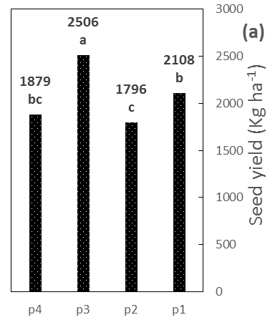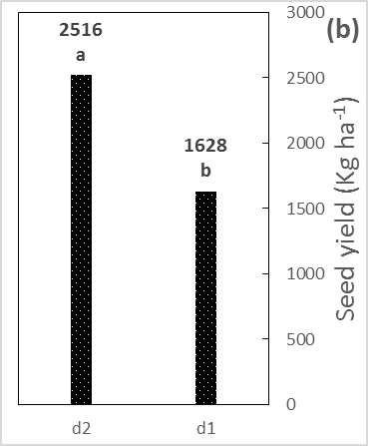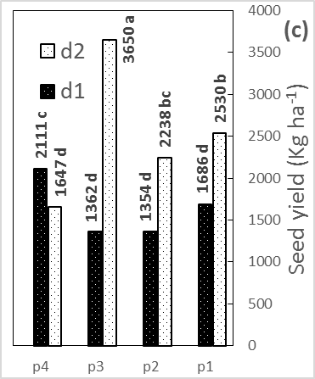
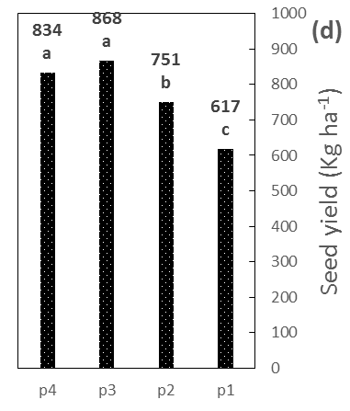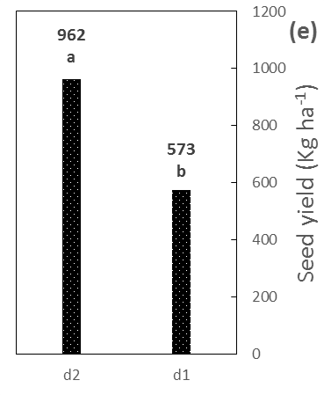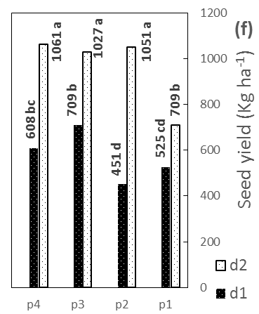

Figure 1. The impact of different priming solutions (p1, p2, p3, p4) and planting dates (d1, d2) on the yield of Phaseolus vulgaris, Sarıkız, including priming (a), planting date (b) and interaction of priming × planting date (c) for the year of 2016, and priming (d), planting date (e) and priming × planting date (f) for the year of 2015, in the order of the highest rates. Data with the same letters have no significant differences to each other at P < 0.05.

Similar to the year of 2015, the second planting date caused the highest yield (2516 kg ha⁻¹) (Figure 1b). Furthermore, the interaction of planting date and priming (p3d2) was significantly effective on the yield (3650 kg ha⁻¹) (Figure 1c). For Şimal, the same to Sarıkız, the p3 treatment and the second planting date were significantly effective on the yield (1979.1 and 2664.3 kg ha⁻¹, respectively) (Figures 2a and 2b). As shown in Sarıkız, the interaction of priming and planting date resulted in the highest seed yield (p3d2 with 3310.6 kg ha⁻¹) as well (Figure 2c). Similar to Sarıkız, the planting date showed a significant difference in terms of seed yield of Şimal and the highest rates obtained at the second planting date (955.9 kg ha⁻¹) (Figure 2e).

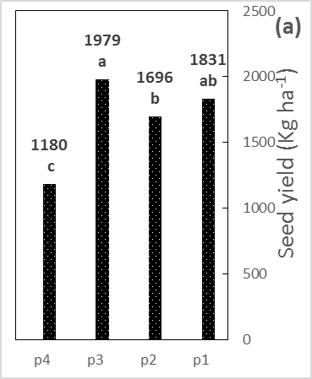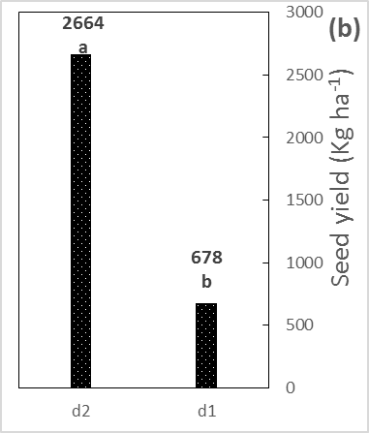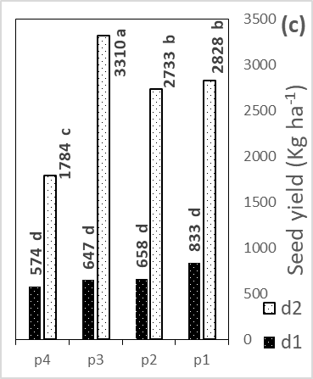
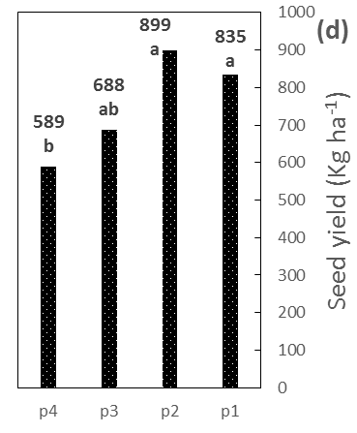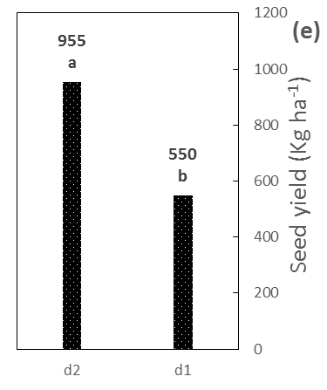

Figure 2. The impact of different priming solutions (p1, p2, p3, p4) and planting dates (d1, d2) on the yield of Vigna unguiculata, Şimal, including priming (a), planting date (b) and interaction of priming × planting date (c) for the year of 2016, and priming (d) and planting date (e) for the year of 2015, in the order of the highest rates. Data with the same letters have no significant differences to each other at P < 0.05.

At the second planting date of the first year (2015), in relation to the first planting date, the growth period of Sarıkız from the flowering to the harvest time lasted 4 days more (45 compared to 41 days for the first date). In the same way, the growth period of Şimal from flowering to the harvest time lasted 34 days, which is 3 days more than that of the first date. For the second year (2016), these rates for the first and second planting dates of Sarıkız were 40 days versus 70 (30 days more than the fırst date) and these of Şimal were 27 and 45 days (18 days more than the first date). As we can see, in both years, the second planting dates showed the longer time to the harvest, leading to higher yields than those of the first dates most likely due to the more time to produce higher dry matter as affected by the climatic conditions, and especially air temperatures (Table 2) and this is the main reason for remarkably higher yields of the year of 2016 for both crops.
Optimum temperatures for bean crop vary between 21 and 25 °C depending on the growth phase (Ferreira et al., 1997) and despite being warm-season crops, both Sarıkız and Şimal were negatively affected by high temperatures, especially over the reproductive stage. Considering Table 2, it is clear that July and August were the warmest months across the growing seasons of both years and it should be noted that the planted crops at the first date suffered from the high temperatures over July. For example, the first planting date of the second year with longer exposure to the high temperatures resulted in the lowest amounts of the pods/plant for both crops, as a yield component (data not shown), which is in accordance with the findings of Adam et al. (2013). This decrease in pod number may be attributed to the failure of pollination which has been shown in kidney bean (Prasad et al., 2002). In addition, it has been reported that rising air temperature from 29 to 34 °C during the seed filling stage significantly decreases soybean seed yield (Dornbos and Mullen, 1991; Adam et al., 2013). Furthermore, it has been demonstrated that temperatures above 30/25 °C (day/night) during the flowering and pod development reduce seed weight, regardless of temperatures during the seed filling period (Egli and Wardlaw, 1980). As being the yield components, the number of seeds per pod is negatively affected by high temperatures as well (Baker et al., 1989). All of these features indicate the negative impact of high temperatures, which mostly coincides with the flowering stage, on the crop yield. In this regard, other researchers (Mani and Abas, 2014) have reported a decrease in the yield of the cowpea planted at the early season of the warm regions of Iran, which confirms our results on the yield loss resulted from the first planting date.
In the year of 2015, p3 and p4 treatments jointly increased the seed yield of Sarıkız at rates of 868.8 and 834.8 kg ha⁻¹ compared to the control and p2 treatments (Figure 1d). Contrary to the Sarıkız, p3 and p4 treatments did not affect the seed yield in Şimal. In the recent crop, p2 and p1 increased the yields at rates of 899.5 and 835.9 kg ha⁻¹, respectively (Figure 2d). Hence, seed priming with KH₂PO₄ was less effective on the yield of Şimal, the same way it was demonstrated in Sarıkız. Furthermore, another anomaly, compared to Sarıkız, is the remarkable impact of the non-primed seeds of Şimal on the yield increment.
In the year of 2016, p3 priming of Sarıkız resulted in the highest seed yield of 2506 kg ha⁻¹ (Figure 1a). Treatments of p4 and p1 were classified in the same group.
We found that providing the seed with P can be as important as planting date for improving the seed yield. There are some findings indicating the role of seed content of P in increasing grain yield of lupins (Bolland et al., 1989), pasture legumes (Bolland and Paynter, 1990), wheat (Burnett et al., 1997) and maize (Miraj et al., 2013) enriched with P (not merely by the priming procedure) under the field conditions. Although seed soaking in P solutions may delay seed germination of common bean (Teixeira et al., 1999), several reports indicate the benefits of P supplied by the priming on the seed yield of bean (Setareh et al., 2013; Sixbert and George, 2012; Adelson et al., 2000) and cowpea (Ntare and Bationo, 1992; Nkaa et al., 2014). Also, soaking seeds of barley (Zhang et al., 1998) and mung bean (Adnan et al., 2011) in P solutions has improved their yield that is in accordance with our results on Şimal and Sarıkız in the first year. Like P, seed treatment with Zn shows beneficial aspects in primed seeds. This element (Zn) is required for plant growth and is directly involved in the biosynthesis of growth regulators needed for the production of cells and biomass that will be stored in the plant organs, especially in seeds (Marschner, 1995). It has been shown that seed priming of rice with Zn resulted in higher uptake of this element by the seedling (Nathan et al., 2001), which may cause the yield improvement. Also, an increase in Zn content and final yield of chickpea primed with ZnSO_{4,} has been observed (Harris et al., 2008). In addition, it has been reported that seed priming with Zn solutions significantly improved yield and related traits in common bean (Kaya et al., 2007) and chickpea (Mahnaz et al., 2015). These findings are in accordance with our results.
According to the results of both years for Sarıkız and Şimal (Table 3), priming, planting date and their interactions were significantly effective on the seed protein content except for priming in the second year for both crops.
In the year of 2015, the application of p4 and p3 on Sarıkız jointly increased the seed protein content compared to the control and p2 treatments, at rates of 18.7 and 18.5%, respectively (Figure 3d).
Also, the second planting date remarkably increased the seed protein content of 19.2% (Figure 3e), and p4d2 interaction significantly increased the seed protein content (21.3%) (Figure 3f). Contrary to Sarıkız, the application of different seed priming treatments did not lead to any crude protein improvement and only planting date was effective on the seed protein content (19.4%) (Figure 4c).

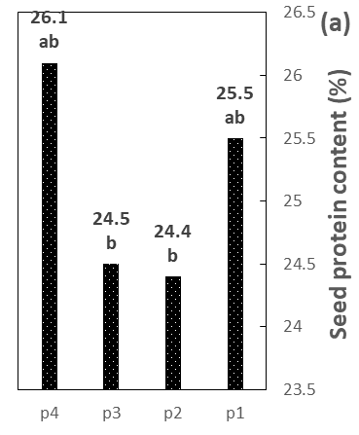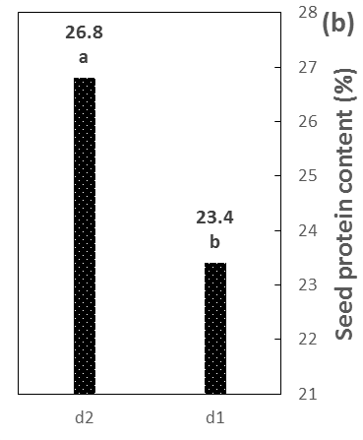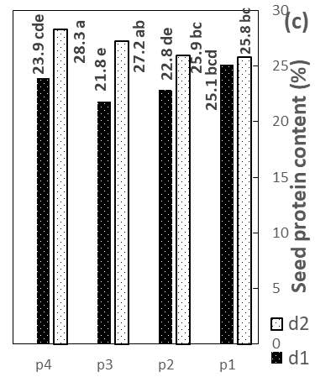
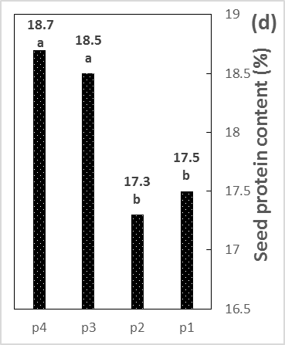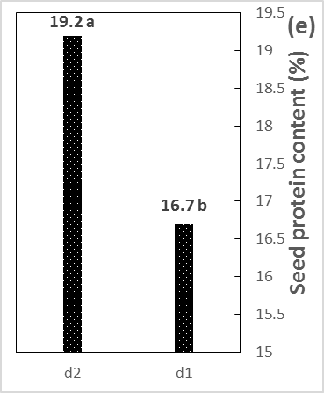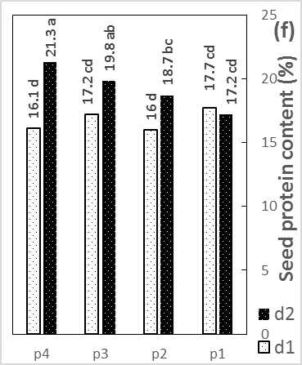

Figure 3. The impact of different priming solutions (p1, p2, p3, p4) and planting dates (d1, d2) on the crude protein content of Phaseolus vulgaris, Sarıkız, including priming (a), planting date (b) and interaction of priming × planting date (c) for the year of 2016, and priming (d), planting date (e) and priming × planting date (f) for the year of 2015, in the order of the highest rates. Data with the same letters have no significant differences to each other at P < 0.05.

In the year of 2016, the same to the results of Sarıkız for the year of 2015, crude protein content of Sarıkız was significantly increased using p4 treatment (26.1%), but the effect of p3 was not significant on this trait (Figure 3a). Also, the second planting date was significantly effective on the crude protein content of Sarıkız in both years and the highest amount (26.8%) (Figure 3b) was achieved in the second year (7% more protein content). In addition, p4d2 interaction significantly yielded the highest protein content of 28.3% (Figure 3c) in 2016 and 21.3% in 2015 applied on Sarıkız. Considering the effect of planting date on Şimal, it is observed that contrary to the year of 2015, the first planting date of 2016 significantly improved the crude protein content (24.1%) (Figure 4a). Finally, the interaction of p3d1 increasingly raised the crude protein content compared to the other combinations (25.7%) (Figure 4b). With regard to the findings of both years, it is clear that the year of 2016 had the relatively higher values both in terms of seed yield and seed crude protein content and this difference in the measured traits was higher, especially in values of the year of 2016.

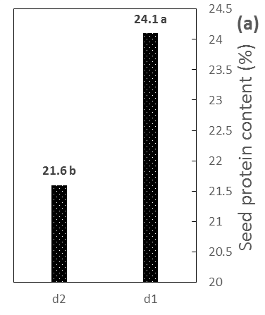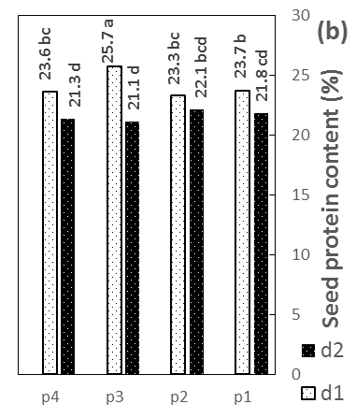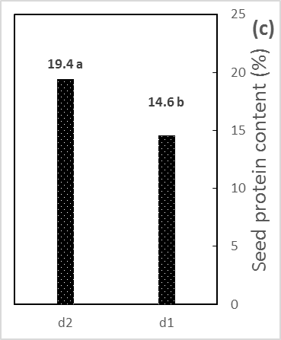
Figure 4. The impact of different priming solutions (p1, p2, p3, p4) and planting dates (d1, d2) on the crude protein content of Vigna unguiculata, Şimal, including planting date (a) and interaction of priming × planting date (b) for the year of 2016, and planting date (c) for the year of 2015, in the order of the highest rates. Data with the same letters have no significant differences to each other at P < 0.05.

There are few studies on supplying Zn for increasing the protein content of legumes by seed priming while the relationship between seed Zn content and protein concentration in cereal and legume seeds has been found (Levent et al., 2006; Cakmak et al., 2004). Priming is considered as one of the ways to enhance seed content of Zn. In this regard, Johnson et al. (2005) found that Zn content of chickpea and lentil seeds after priming with ZnSO₄ solution increased about 10-fold than the initial Zn content. These rates may also be provided by the other fertilization methods but without any benefits of the priming. Zn actively affects nitrogen metabolism that may result in protein synthesis (Fageria et al., 2003). In other words, protein synthesis is negatively affected by Zn deficiency, and an increase in the seed protein content makes a sink for Zn, and there is a close positive correlation between the seed protein content and Zn concentration (Cakmak et al., 2010). It has been found that in case of higher rates of Zn concentration in shoot meristematic tissues of rice than in mature leaves, a high rate of protein synthesis is observable (Kitagishi and Obata, 1986), while in leaves of bean under conditions of Zn deficiency, the concentration of soluble proteins is decreased (Cakmak, 1989). Also, a significant positive effect of zinc treatment on crude protein content in the seeds of mung bean has been found (Krishna, 1995). Various enzymes are responsible for the carbohydrate metabolism and protein biosynthesis and activation and kinetics of these enzymes intrinsically depend on Zn content (Fageria et al., 2003; Broadley et al., 2007). Similar to the seed priming, other methods of Zn application like foliar spraying increase the seed protein content of crops such as cowpea (Hemn, 2013). In addition to the Zn, some studies have shown that P nutrient has led to the increase in the seed protein content of soybean (Dalshad et al., 2013; Soares et al., 2014), rice bean (Asghar Malik et al., 2002) and moth bean (Nishi et al., 2007). This may be due to the improved uptake of elements like N in plants subjected to the seed priming with KH₂PO₄. In such cases, an increase in the protein content of 21-day-old mung bean plants has been observed (Adnan et al., 2013). Also, the seed treatment of mung bean with KH₂PO₄ enhances nitrogen fixation (Adnan et al., 2011). High seed P concentration produces plants less dependent on soil P supply and can enhance nitrogen fixation in common bean which leads to the higher protein content of the seeds (Teixeira et al., 1999). In addition, P is necessary for seed formation and is a fundamental element for nodule metabolism in legumes (Gutierrez-Rodriguez et al., 2006) and it is required to regulate the activity of several proteins through phosphorylation reactions (Martinez-Ballesta et al., 2010).

Conclusion

Planting date significantly influenced seed protein content in Sarıkız in 2015 and 2016 and this result was obtained in Şimal at least in 2015. In terms of seed yield, the same trend was observed in Sarıkız and Şimal in the second planting date of 2015 and 2016 indicating that the planting date of these plants should be arranged so that the flowering stage does not coincide with the warmest temperatures of the summer which may be achieved by few days of delay in the early spring. Also, considering the findings of this work on the impact of P and Zn priming on an increase in the seed yield and protein content, we suggest that by increasing P, as an element consumed in legumes in large amounts, and Zn content of the seeds of Sarıkız and Şimal, high rates of yield and protein content may be achievable while cellular mechanisms and changes in the plant metabolism linked to the priming remain unknown to some extent, and we propose further studies in this regard.

Acknowledgements

We acknowledge the kind assistance of Prof. Dr. Aydın Güneş, Department of Soil Science and Plant Nutrition, Ankara University. Also, we would like to thank Prof. Dr. Ensar Başpınar, Ankara University, for his statistical pieces of advice. We also greatly appreciate technical efforts of Uğur Yenipınar for preparation of the experimental site.

References

Adam, B.P., Myint, T., Mohd, M.A.M., Nur, A.P.B.A., & Mohd, R.A.H. (2013). Soybean [Glycine max (L.) Merrill] seed yield response to high temperature stress during reproductive growth stages. Australian Journal of Crop Science, 7 (10), 1472-1479.
Adelson, P.A., Marcelo, G.T., & Dejair, L.D.A. (2000). Growth and yield of common bean cultivars at two soil phosphorus levels under biological nitrogen fixation. Pesquisa Agropecuária Brasileira, 35 (4), 809-817.
Adnan, U., Safdar, A., Muhammad, S., Kashif, B., Muhammad, J.T., & Muhammad, A.M. (2013). Assessment of some priming techniques in mung bean (Vigna radiata): a greenhouse study. Pakistan Journal of Agricultural Research, 26 (4), 265-274.
Adnan, U., Safdar, A., Rifat, H., Muhammad, A., & Muhammad, J.T. (2011). Evaluation of seed priming in mung bean (Vigna radiata) for yield, nodulation and biological nitrogen fixation under rainfed conditions. African Journal of Biotechnology, 10 (79), 18122-18129.
Ali, S., Khan, A.R., Mairaj, G., Arif, M., Fida, M., & Bibi, S. (2008). Assessment of different crop nutrient management practices for yield improvement. Australian Journal of Crop Science, 2 (3), 150-157.
AOAC (2000). Official methods of analysis of AOAC international (17th ed.), MD, USA, Gaithersburg.
Asghar Malik, M., Shah, S.H., Farrukh Saleem, M., & Sajid Jami, M. (2002). Determining suitable stand density and phosphorus level for improving productivity of rice bean (Vigna umbellata). International Journal of Agriculture and Biology, 4 (1), 120-122.
Baker, J.T., Allen, L.H., & Boote, K.J. (1989). Response of soybean to air temperature and carbon dioxide concentration. Crop Science, 29, 98-105.
Bolland, M.D.A., & Paynter, B.H. (1990). Increasing phosphorus concentration in seed of annual pasture legume species increases herbage and seed yields. Plant Soil, 125, 197-205.
Bolland, M.D.A., Paynter, B.H., & Baker, M.J. (1989). Increasing phosphorus concentration in lupin seed increases grain yields on phosphorus deficient soil. Australian Journal of Experimental Agriculture, 29, 797-801.
Broadley, M.R., White, P.J., Hammond, J.P., Zelko, I., & Lux, A. (2007). Zinc in plants. New Phytologist, 173 (4), 677-702.
Burnett, V.F., Coventry, D.R., & Newton, P.J. (1997). Effect of seed source and seed phosphorus content on the growth and yield of wheat in Northeastern Victoria. Australian Journal of Experimental Agriculture, 37, 191-198.
Cakmak, I., Pfeiffer, W.H., & McClafferty, B. (2010). Biofortification of durum wheat with zinc and iron. Cereal Chemistry, 87, 10-20.
Cakmak, I., Torun, A., Millet, E., Feldman, M., Fahima, T., Korol, A., Nevo, E., Braun, H.J., & Ozkan, H. (2004). Triticum dicoccoides: an important genetic resource for increasing zinc and iron concentration in modern cultivated wheat. Soil Science and Plant Nutrition, 50, 1047-1054.
Cakmak, I., Marschner, H., & Bangerth, F. (1989). Effect of Zinc nutritional status on growth, protein metabolism and levels of Indole-3-acetic acid and other phytohormones in bean (Phaseolus vulgaris L.). Journal of Experimental Botany, 40 (3), 405-412.
Chavan, A.S., Khafi, M.R., Raj, A.D., & Parmar, R.M. (2012). Effect of potassium and zinc on yield, protein content and uptake of micronutrients on cowpea (Vigna unguiculata (L.) Walp). Agricultural Science Digest, 32, 175-177.
Dalshad, A.D., Pakhshan, M.M., & Shireen, A.A. (2013). Effect of phosphorus fertilizers on growth and physiological phosphorus use efficiency of three soybean cultivars. IOSR Journal of Agriculture and Veterinary Science, 3 (6), 32-36.
Dornbos, D.L., & Mullen, R.E. (1991). Influence of stress during soybean seed fill on seed weight, germination, and seedling growth rate. Journal of Plant Sciences, 71, 373-383.
Egli, D.B., & Wardlaw, I.F. (1980). Temperature response of seed growth characteristics of soybeans. Agronomy Journal, 72, 560-564.
Fageria, N.K., Slaton, N.A., & Baligar, V.C. (2003). Nutrient management for improved lowland rice productivity and sustainability. Advances in Agronomy, 80, 63-152.
Farahmand-Rad, S., Mazaheri, D., & Banaei, T. (1999). Effect of planting date and plant density on yield and growth trends of cowpea line 29005. Seed and Plant Journal (In Persian, abstract in English), 15, 84-98.
Ferreira, M.E., e Abreu, J.P. deM., Bianco, V.V., & Monteiro, A. (1997). Predicting phasic development of green beans for processing using a model with high temperature reduction of thermal time accumulation. Scientia Horticulturae, 69, 123-133.
Gutierrez-Rodriguez, M., Escalante-Estrada, J.A., Gonzalez, M.T.R., & Reynolds, M.P. (2006). Canopy reflectance indices and its relationship with yield in common bean plants (Phaseolus vulgaris L.) with phosphorous supply. International Journal of Agriculture and Biology, 8, 203-207.
Harris, D., Joshi, A., Khan, P.A., Gothkar, P., & Sodhi, P.S. (2004). On-farm seed priming in semi-arid agriculture: development and evolution in maize, rice and chickpea in India using participatory methods. Experimental Agriculture, 35, 15-29.
Harris, D., Rashid, A., Arif, M., & Yunas, M. (2004). Alleviating micronutrient deficiencies in alkaline soils of the North West frontier province of Pakistan: on-farm seed priming with zinc in wheat and chickpea. Micronutrients in South and South East Asia: Proceedings of an International Workshop (pp.??-??). Kathmandu, Nepal.
Harris, D., Rashid, A., Miraj, G., Arif, M., & Shah, H. (2007). On-farm seed priming with zinc sulphate solution-A cost-effective way to increase the maize yields of resource-poor farmers. Field Crops Research, 102 (2), 119-127.
Harris, D., Abdul, R., Ghzal, M., Mohammed, A., & Mohammed, Y. (2008). On-farm seed priming with zinc in chickpea and wheat in Pakistan. Plant and Soil Journal, 306 (1), 3-10.
Hemn O.S. (2013). Effect of foliar fertilization of Fe, B and Zn on nutrient concentration and seed protein of cowpea (Vigna unguiculata). IOSR Journal of Agriculture and Veterinary Science, 6 (3), 42-46.
Johnson, S.E., Lauren, J.G., Welch, R.M., & Duxbury, J.M. (2005). A comparison of the effects of micronutrient seed priming and soil fertilization on the mineral nutrition of chickpea (Cicer arietinum), lentil (Lens culinaris), rice (Oryza sativa) and wheat (Triticum aestivum) in Nepal. Experimental Agriculture, 41, 427-488.
Kaya, M., Atak, M., Khawar, K.M., Ciftci, C.Y., & Ozcan, S. (2007). Effect of pre-sowing seed treatment with zinc and foliar spray of humic acids on yield of common bean (Phaseolus vulgaris L.). International Journal of Agriculture and Biology, 7, 875-878.
Khajehpour, M.R. (2000). Principles of agronomy. Isfahan, Iran: Isfahan University of Technology Press.
Kitagishi, K., & Obata, H. (1986). Effects of zinc deficiency on the nitrogen metabolism of meristematic tissues of rice plants with reference to protein synthesis. Soil Science and Plant Nutrition, 32, 397-405.
Krishna, S. (1995). Effect of sulphur and zinc application on yield, S and Zn uptake and protein content of mung (green gram). Legume Research, 18, 89-92.
Kshama, S. (2013). Evaluation of zinc application methods to enhance yield and quality of black gram. Global Journal of Current Research, 1 (2), 50-56.
Levent, O., Mustafa, A.Y., Cemal, Y., Ayfer, T., Cemal, C., Ahmet, B., Hakan, O., Hans-Joachim, B., Zehra, S., & Ismail, C. (2006). Concentration and localization of zinc during seed development and germination in wheat. Physiologia Plantarum, 128, 144-152.
Lopez-Bellido, F.J., Lopez-Bellido, R.J., Kasem, K.S., & Lopez-Bellido, L. (2008). Effect of planting date on winter Kabuli chickpea growth and yield under rainfed Mediterranean conditions. Agronomy Journal, 100 (4), 957-964.
Mahnaz, V., Khosro, M., Mohammad., & Tahsin, K.N. (2015). Effect of priming and foliar application of nanoparticles on agronomic traits of chickpea. Biological Forum – An International Journal, 7 (2), 599-602.
Mani, M., & Abas, N. (2014). The effect of sowing date and plant density on yield and yield components of cowpea. Indian Journal of Fundamental and Applied Life Sciences, 4 (3), 461-467.
Marschner, H. (1995). Mineral nutrition of higher plants. 2nd Edition, London, UK: Academic Press.
Martinez-Ballesta, M.C., Dominguez-Perles, R., Moreno, D.A., Muries, B., Alcaraz-Lopez, C., Bastias, E., Garcia-Viguera, C., & Carvajal, M. (2010). Minerals in plant food: effect of agricultural practices and role in human health. Agronomy for sustainable agriculture, 30, 295-309.
Miraj, G., Shah, H.U., & Arif, M. (2013). Priming maize (Zea mays) seed with phosphate solutions improves seedling growth and yield. The Journal of Animal and Plant Sciences, 23 (3), 893-899.
Mozumber, S.N., Moniruzzaman, M., Islam, M.R., & Alam, S.N. (2003). Effect of planting time and spacing on the yield performance of bush bean (Phaseolus vulgaris L.) in the eastern hilly area of Bangladesh. Legume Research, 26 (4), 242-247.
Muhammad, U., Muhammad, T., & Atif, M. (2014). Effect of zinc sulphate as soil application and seed treatment on green gram (Vigna radiata L.). Pakistan Journal of Life and Social Sciences, 12 (2), 87-91.
Musa, A.M., Harris, D., Johansen, C., & Kumar, J. (2001). Short duration chickpea to replace fellow after AMAN rice: The role of on-farm seed priming in the high barind tract of Bangladesh. Experimental Agriculture, 37, 509-521.
Nathan, A. S., Charles, E. W., Sixte, N., Richard, J. N., & Danny, L. B. (2001). Evaluation of zinc seed treatments for rice. Agronomy Journal. 96, 152-157.
Nishi, M., Joginder, S., Sachendra, B., Avinash, B., & Anil, V. (2007). Effect of phosphorus application and time of harvest on yield and quality of moth bean [Vigna aconitifolia (Jecq.) Marechal]. Journal of Plant Sciences, 2 (2), 247-250.
Nkaa, F.A., Nwokeocha, O.W., & Ihuoma, O. (2014). Effect of phosphorus fertilizer on growth and yield of cowpea (Vigna unguiculata). IOSR Journal of Pharmacy and Biological Sciences, 9 (5), 74-82.
Ntare, B.R., & Bationo, A. (1992). Effects of phosphorus on yield of cowpea cultivars intercropped with pearl millet on Psammentic paleustalf in Niger. Fertilizer Reasearch, 32, 143-147.
Peltonen-Sainio, P., Kontturi, M., & Peltonen, J. (2006). Phosphorus seed coating enhancement on early growth and yield components in oat. Agronomy Journal, 98, 206-211.
Poshtmasari, H.K., Bahmanyar, M.A., Pirdashti, H., & Shad, M.A. (2008). Effects of Zn rates and application forms on protein and some micronutrients accumulation in common bean (Phaseolus vulgaris L.). Pakistan Journal of Biological Sciences, 11 (7), 1042-1046.
Prasad, P.V.V., Boote, K., Allen, L.H., & Jean, M.G. (2002). Effects of elevated temperature and carbon dioxide on seed-set and yield of kidney bean. Global Change Biology, 8, 710-721.
Rashid, A., Harris, D., Hollington, P., & Ali, S. (2004). On-farm seed priming reduces yield losses of mung bean (Vigna indiata) associated with mung bean yellow mosaic virus in NWFP of Pakistan. Crop Protection, 23, 1119-1124.
Setareh, R., Hamid, M., & Shahram, S.H. (2013). Effect of seed priming on red bean (Phaseolus calcaratus) growth and yield. Annals of Biological Research, 4 (2), 292-296.
Sixbert, K.M., & George, M.T. (2012). Evaluation of common bean (Phaseolus vulgaris L.) genotypes for adaptation to low phosphorus. International Scholarly Research Network, 1, 1-9.
Soares, M.M., Silva, L.J., Oliveira, G.L., Sekita, M.C., & Dias, D.C.F.S. (2014). Endogenous level of phosphorous in soya bean seeds and the relationship with physiological quality, oil and protein content. Seed Science and Technology, 42 (3), 433-443.
Teixeira, M.G., Guerra, J.G.M., Almeida, D.L., Araújo, A.P., & Franco, A.A. (1999). Effect of seed phosphorus concentration on nodulation and growth of three common bean cultivars. Journal of Plant Nutrition, 22, 1599-1611.
Zhang, M., Nyborg, M., & McGill, W.B. (1998). Phosphorus imbibed by barley seeds: location within the seed and assimilation by seedlings. Seed Science and Technology, 26, 325-32.

Received: June 15, 2019
Accepted: November 29, 2019

UČINAK OBIČNOG PASULJA I VIGNE POTAPANJEM I
PREMA DATUMU SETVE

Mohammad Hasanzadeh¹*, Ibrahim Demir², Nahid Hazrati³,
Mehmet Burak Taşkın⁴ i Özge Şahin⁴

¹Odsek za biljnu proizvodnju, Fakultet za poljoprivredu i prirodne resurse-Moghan, Univerzitet Mohaghegh Ardabili, Ardabil, Iran
²Odsek za hortikulturu, Poljoprivredni fakultet, Univerzitet u Ankari,
06110, Diskapi, Ankara, Turska
³Odsek za ratarstvo, Poljoprivredni fakultet, Univerzitet u Ankari,
06110, Diskapi, Ankara, Turska
⁴Odsek za nauku o zemljištu i ishranu biljaka, Poljoprivredni fakultet,
Univerzitet u Ankari, 06110, Diskapi, Ankara, Turska

R e z i m e

Na semenima običnog pasulja (Sarıkız) i vigne (Şimal) sproveden je dvogodišnji poljoprivredni ogled korišćenjem tehnike potapanja hranljivih materija kako bi se ispitao prinos semena i sadržaj proteina. Potapanje: (p1) kontrola, (p2) KH₂PO₄, (p3) ZnSO₄ and (p4) KH₂PO₄+ZnSO₄, i datumi setve: (d1) 20. maj, (d2) 15. jun 2015, (d1) 7. maj, (d2) 7. jun 2016. godine korišćeni su da bi se proučio prinos (kg ha⁻¹) i sirovi protein (%) pomenutih useva u Ankari, Turska. U 2015. godini, primenom p3 i p4 (868,8, 834,8), d2 (962,3) i p4d2, p2d2 i p3d2 (1061, 1052, 1028) povećan je prinos semena useva Sarıkız, a p2 i p1 (899,5, 835,9) i d2 (955,9) povećali su prinos useva Şimal. Tretmani p4 i p3 (18,7, 18,5), d2 (19,2), i p4d2 (21,3) povećali su sadržaj proteina u usevu Sarıkız i d2 (19,4) povećao je sadržaj proteina kod useva Şimal. U 2016. godini, p3 (2506), d2 (2516) i p3d2 (3650) povećali su prinos, i p4 (26,1), d2 (26,8) i p4d2 (28,3) povećali su sadržaj proteina kod useva Sarıkız. Tretmani koji su uključivali p3 (1979,1), d2 (2664,3) i p3d2 (3310,6) povećali su prinos, i d1 (24,1) i p3d1 (25,7) povećali su sadržaj proteina u usevu Şimal. Izgleda da primena Zn i P potapanjem efikasno povećava prinos i sadržaj proteina ovih useva.
Ključne reči: obični pasulj, vigna, sirovi protein, datum setve, potapanje, prinos.

Primljeno: 15. juna 2019.
Odobreno: 29. novembra 2019.

Corresponding author: e-mail: hassanzadeh123@gmail.com
*Autor za kontakt: e-mail: hassanzadeh123@gmail.com

