**Experimental study of the Cu-Al-Sn phase equilibria, close to the copper zone**

List of figures:

|  |
| --- |
|  |
| a) |
|  |
| b) |

Figure 1– Thermal analysis curves (DTA), on the second heating cycle at 10 °C/min in argon atmosphere, for samples with increasing Sn content, a) and alloy transition temperatures evolution with increasing Sn content (wt%), for a constant Al alloy content b).

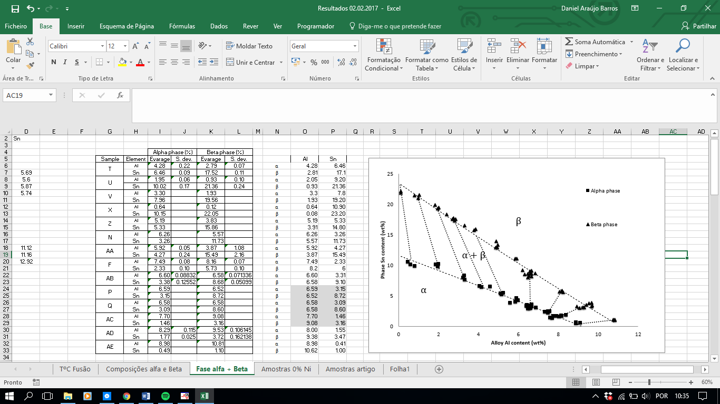

Figure 2 – Proposed conjugated lines, inside the (α + β) phase field, at 800 ºC.

|  |  |  |
| --- | --- | --- |
| **Sample 2** | **Sample 7** | **Sample 11** |
| **α**  **α**  **β**  **α**  **β**  **β** | | |

Figure 3 – Microstructure, obtained by SEM, of samples with different volume fractions of α + β phases.