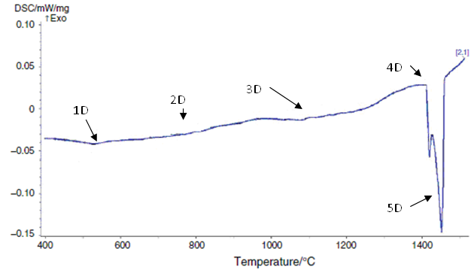Figure 1. Duplex stainless steel-SAF 2205; 5 K/min

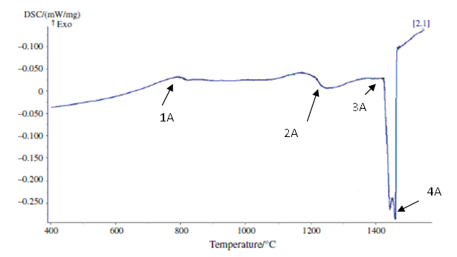Figure 2. DSC heating curve: austenitic stainless steel-AISI 304LN; 10 K/min

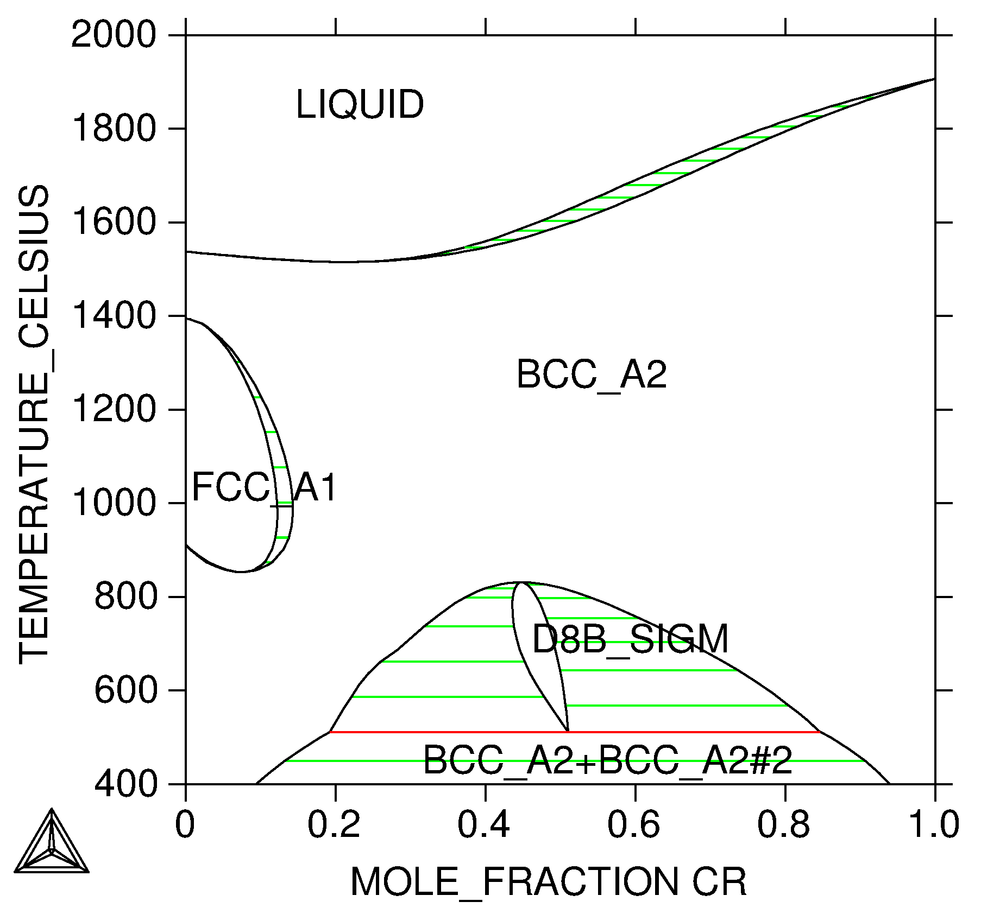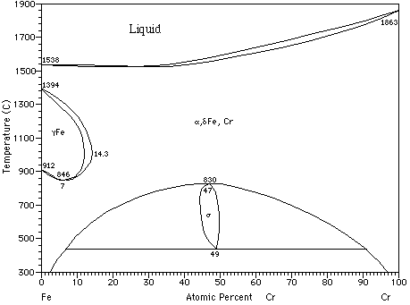
(a) (b)
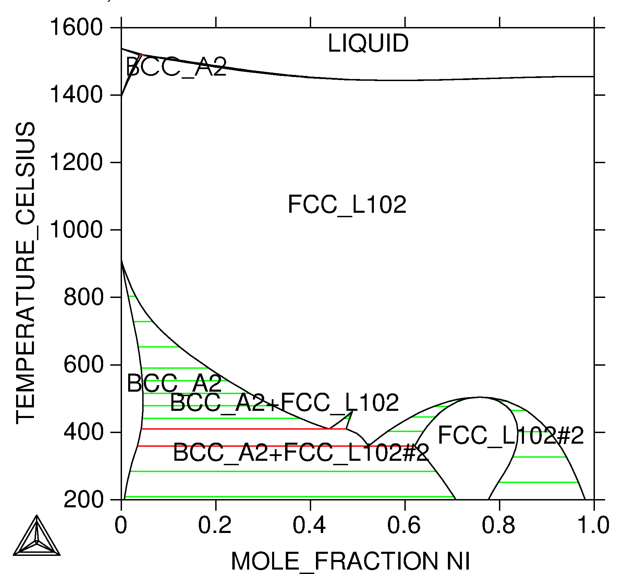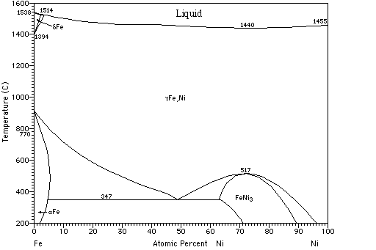
(c) (d)
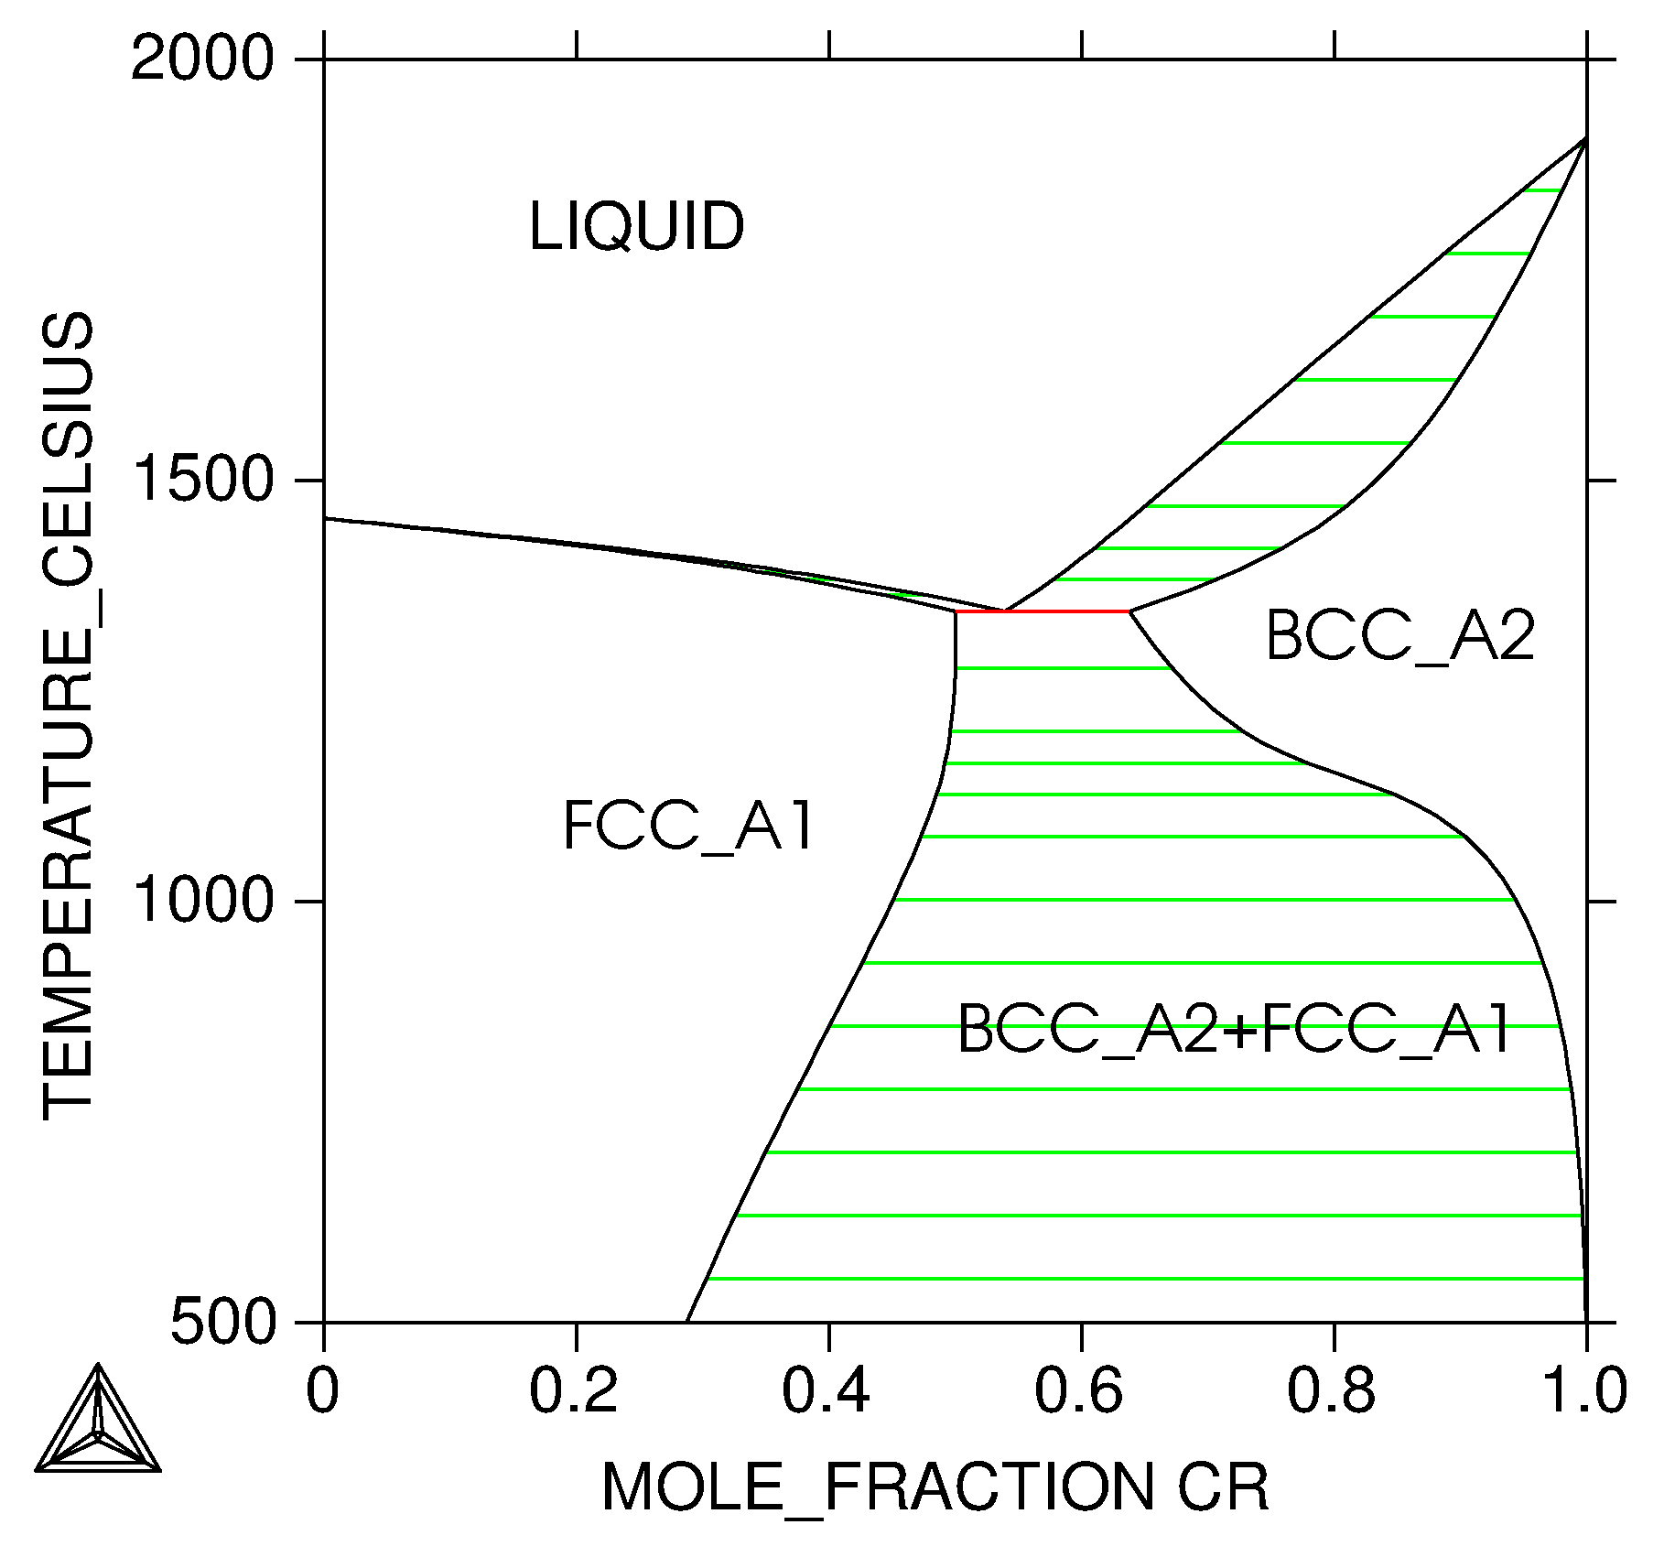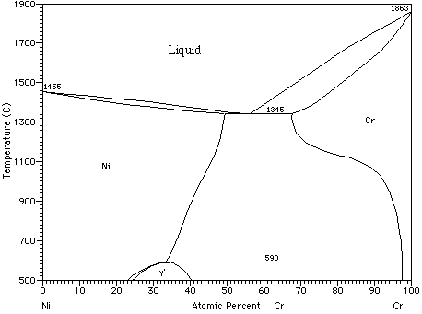
(e) (f)
Figure 3. (a, b) Cr-Fe, (c, d) Fe-Ni and (e, f) Ni-Cr system [20]
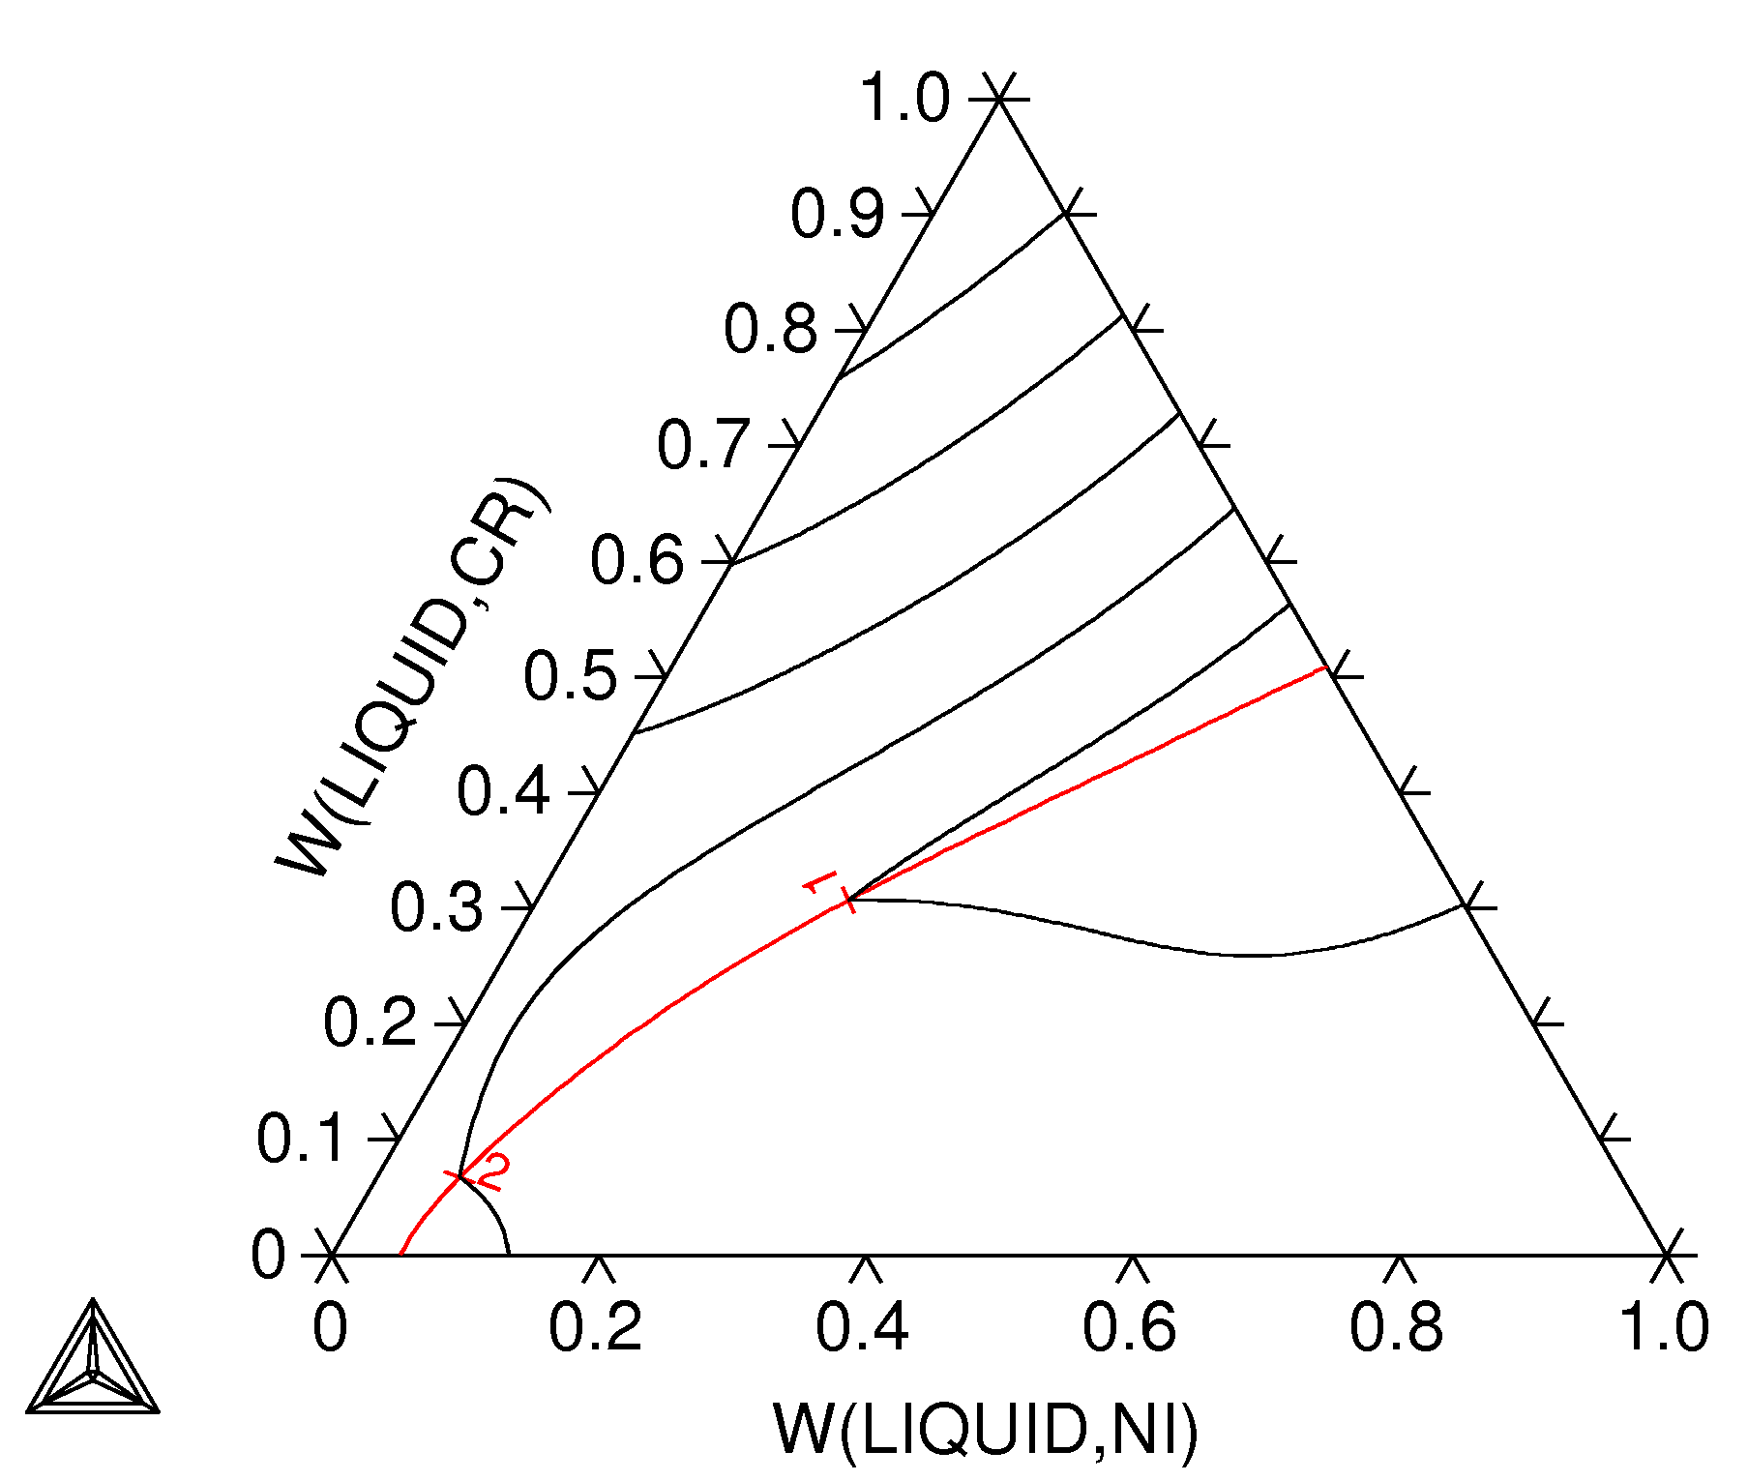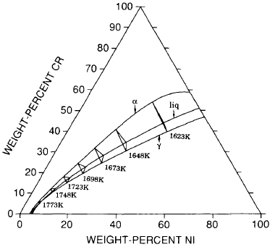
(a) (b)
Figure 4. The ternary phase diagram Fe-Ni-Cr: (a) Calculated using internal thermodynamic database of TCFE7 and (b) calculated three-phase equilibrium L + α + γ reported by Hillert and Qiu [2] All data for the calculations are referred to Standard Element Reference (SER).

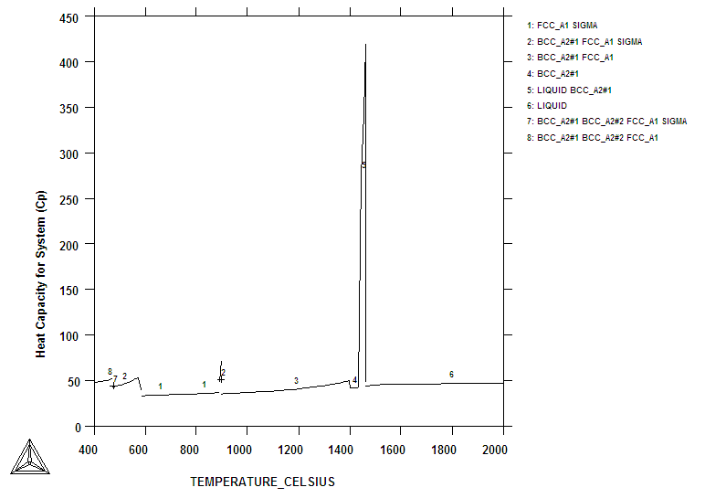
(a)
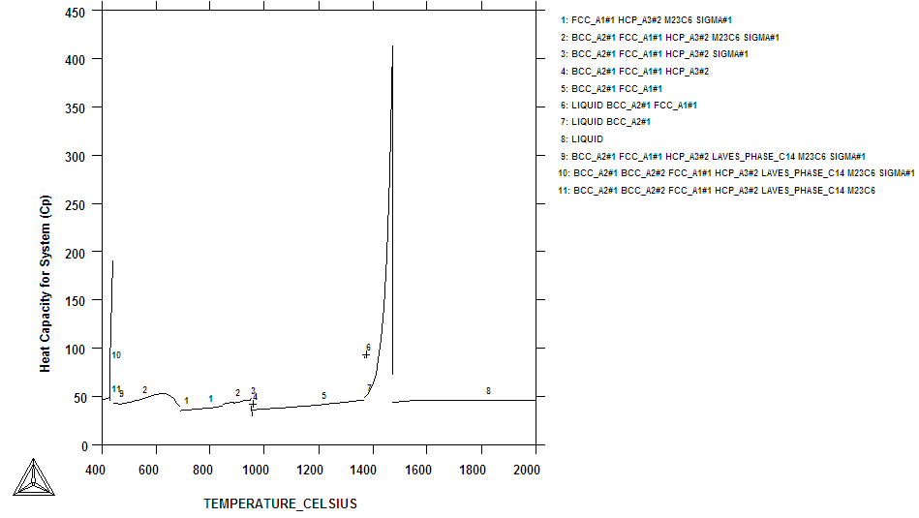
(b)
Figure 5. Specific heat (Lever) for duplex– SAF 2205 in Joule per mol-K; gas suspended: (a) calculation is based on nickel and chromium equivalent and (b) calculation using complete chemical composition.

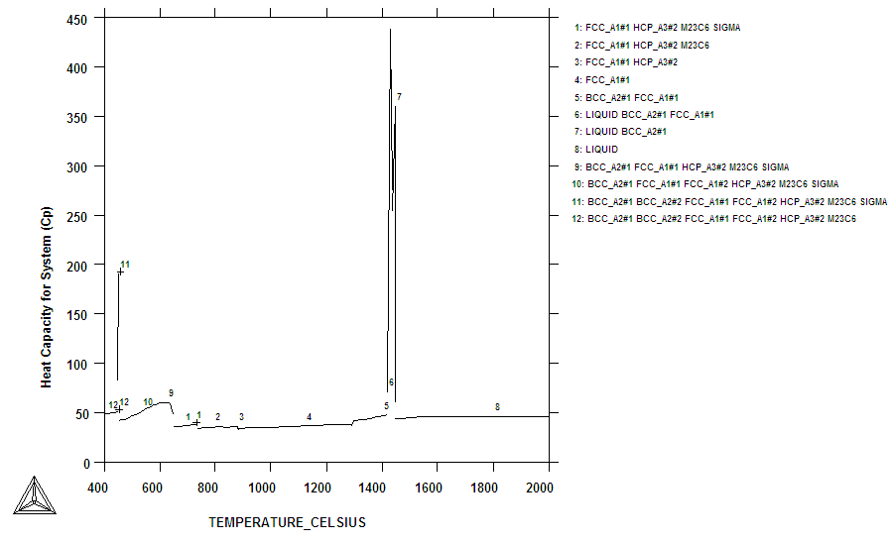Figure 6. Specific heat (Lever) for austenitic stainless steel - AISI304LN Joule per mol-K.

Table 1. Chemical composition of steels / wt.%
Type | C | Si | Mn |  | Cr | Ni | Mo | N |  | Fe
Duplex SAF 2205 | 0.024 | 0.49 | 1.4 |  | 22.41 | 5.31 | 3.13 | 0.165 |  | Balance
Austenitic AISI304LN | C | Cr | Ni |  | Mn | Cu | Si | N |  | Mo
Austenitic AISI304LN | 0.021 | 18.32 | 8.29 |  | 1.31 | 0.56 | 0.3 | 0.1 |  | 0.31
Austenitic AISI304LN | Co | Fe
Austenitic AISI304LN | 0.218 | Balance

List of captions
Table 1. Chemical composition of steels / wt.%
Figure 1. Duplex stainless steel-SAF 2205; 5 K/min
Figure 2. DSC heating curve: austenitic stainless steel-AISI 304LN; 10 K/min
Figure 3. (a, b) Cr-Fe, (c, d) Fe-Ni and (e, f) Ni-Cr system [20]
Figure 4. The ternary phase diagram Fe-Ni-Cr: (a) Calculated using internal thermodynamic database of TCFE7 and (b) calculated three-phase equilibrium L + α + γ reported by Hillert and Qiu [2] All data for the calculations are referred to Standard Element Reference (SER).
Figure 5. Specific heat (Lever) for duplex– SAF 2205 in Joule per mol-K; gas suspended: (a) calculation is based on nickel and chromium equivalent and (b) calculation using complete chemical composition.
Figure 6. Specific heat (Lever) for austenitic stainless steel - AISI304LN Joule per mol-K.
Table 1. Chemical composition of steels / wt.%

