Figure 1

Figure 2

Figure 3

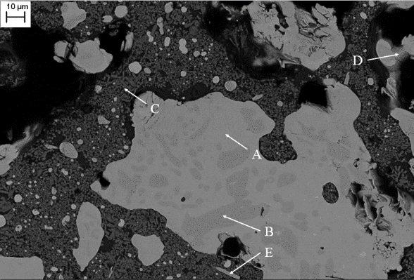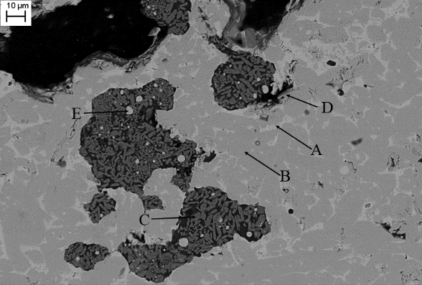
a 1573K b 1673K
Figure 4

Figure 5

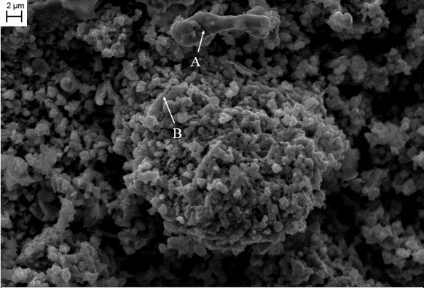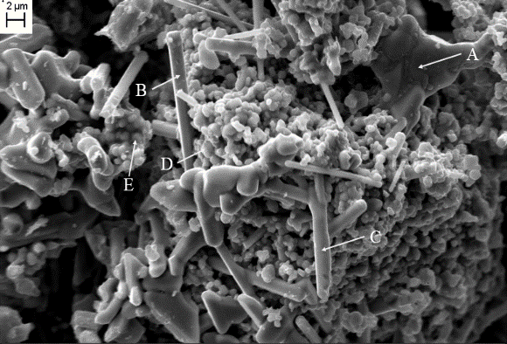
- 5min b. 15min
Figure 6

Figure 7
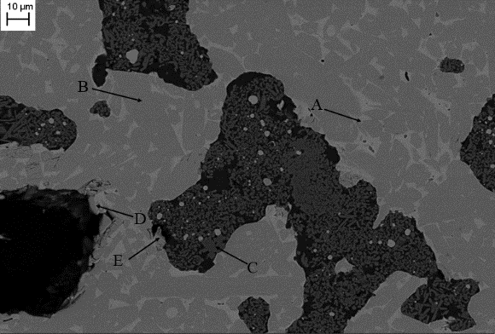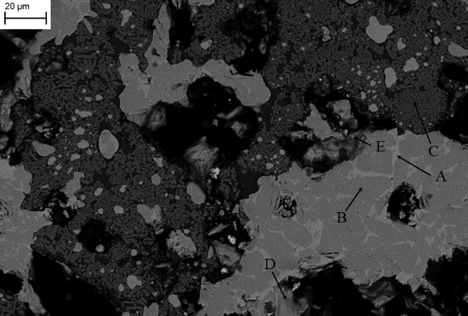
a with 10% excess carbon b with 20% excess carbon
Figure 8

a early stage
b later stage
Figure 9

