Investigation on the Thermodynamic analysis, preparation and characterization of LaNi₅ Alloy by Magnesiothermic Reduction Diffusion process

G. Giresanª, S. Raman Sankaranarayananª, L. John Berchmans^{b,*}

ªDepartment of Metallurgical and Materials Engineering, National Institute of Technology, Tiruchirappalli, Tamilnadu-620015, India.
^{b}Electropyrometallurgy Division, CSIR-Central Electrochemical Research Institute, Karaikudi, Tamilnadu-630 006, India.
*corresponding author: ljberchmans@gmail.com

Abstract
The present investigation focuses on the preparation of LaNi₅ intermetallic compound by “Metallothermic reduction diffusion process”. Experiments were carried out using oxides and chlorides of La and Ni metal powders as the raw materials. Granular Mg powder was used as the reductant. The thermal reduction process was carried out at 900ºC for 9 hrs in Ar atmosphere. After the completion of reaction, the contents were purified by treating with dilute acetic acid followed by de-ionized water. Thermodynamic feasibility studies were carried out to determine the probabilistic nature of formation of the desired compound. Thermal analysis was carried out to find the dissociation and decomposition temperature of the reactants. The phase purity and the elemental composition of the alloy were assessed by XRD and EDAX analyses. The morphological features of the prepared powders were examined by SEM. From this study, it has been concluded that LaNi₅ alloy can be prepared with an appreciable purity by the Metallothermic reduction diffusion process.
Key words: Metallothermic reduction, Intermetallic compound, Thermal analysis, XRD, EDAX, SEM.
INTRODUCTION
A demand for more competent power sources has augmented the interest in diverse fields of technology, such as fuel cells by means of hydrogen or hydrocarbon as fuel and water electrolysis [1, 2, 3]. Hydrogen storage alloys (HSAs), the main materials in the negative electrodes of nickel/metal hydride (Ni–MH) secondary batteries, have been widely premeditated for many years because of their principal role in the battery applications [4]. Rare-Earth AB₅ type LaNi₅-based and Zr–Ti–V-based laves phase (AB₂) HSAs have been extensively used as negative electrode materials for the commercial production of Ni–MH batteries [5, 6]. Structure dependence of the host metal, hydrogen atoms take up the tetrahedral or octahedral interstices of the metallic sub lattice. AB₅’s have a hexagonal crystal structure represents the most commercial family on the market. The AB₂’s seem to be more sensitive to gaseous impurities than the AB₅’s [7] hence the advantage of LaNi₅ intermetallic compound is that they exhibit low hysteresis, are moderate to gaseous impurities and are effortlessly hydrogenated in the initial cycle after manufacture [8].Conventionally, the metal hydride materials have been prepared by arc melting [9-11] , induction melting [12], mechanical alloying [8, 13-15] electro chemical synthesis [16, 17], solid state reduction method [18]. Rare Earth metals and alloys production from its ores has not yet full-fledged in India .Therefore the production processes of Rare Earth based functional materials are found to be considered as a insightful area of research. The Reduction-Diffusion (R-D) process involves reduction of cheaper raw materials such as lanthanum oxide (La₂O₃) by calcium and simultaneous diffusion in nickel [19-21] forming the intermetallic compound. The process is based on the relative thermodynamic stability of oxides. From the thermodynamic calculations of reactants, the free energy of formation of CaO at 1200K is 245 Kcal/gfw, which is lower than that of La₂O₃, 205 Kcal/gfw [22], hence we can say that the so-called calciothermic reduction process is possible to reduce lanthanum oxide by calcium metal to prepare single phase LaNi₅ [19]. Although many methods have been attempted for the preparation of LaNi₅, to our knowledge no one has attempted to prepare this alloy by reduction-diffusion technique using magnesium (Mg) as the reductant. Hence, we have made an attempt to prepare this alloy by reduction- diffusion technique using magnesium as the reductant. The results of the above investigation have been presented in this paper.
Thermodynamic Analysis
Thermodynamic models have been elaborately studied for La-Ce, La-Nd, La-Nd alloys [23]. Mixing enthalpies of liquid Co-Ce, Co-La alloys has been calculated [24] and the thermodynamic models have been proposed. Thermodynamic properties of Dy-Ni intermetallic compound has been studied [25]. The mechanism of formation of LaNi₅ [26], DyFe₂ [27], TbFe₂ [28] by R-D process has been presented. Based on the above model theories and taking account of the previous work done in R-D process, a thermodynamic feasibility study has been carried out and discussed briefly in the following section. Thermodynamic analysis has been carried out for the preparation of LaNi₅ using oxides and chlorides of La and Ni metal powders with granular Mg powder at 900⁰C. Raoult’s law approximation has been put forth and ∆G^{mix} corresponds to negative value favoring the A-B type bonding rather A-A and B-B type bonding [31]. Unreacted core model [27, 28] and standard thermodynamic properties [29, 30] have been taken into account for carrying out this feasibility analysis.

La₂O₃ + 10Ni + 3Mg 2LaNi₅ + 3MgO ( 1 )
2LaCl₃ + 10 Ni + 3Mg 2LaNi₅ + 3MgCl₂ ( 2 )
Equations 1and 2 exhibit the fundamental reactions describing the preparation of LaNi₅ alloy. Gibbs free energy of formation (∆G) and Equilibrium constant (K) of the above equations explore the possibilities and the nature of the chemical reactions taking place in the process.
La + 5 Ni LaNi ₅ ( 3 )
La₂O₃ + 3Mg 2La + 3Mgo ( 4 )
2LaCl₃ + 3Mg 2La + 3MgCl₂ ( 5 )
Mg (l) Mg (g) ( 6 )
Equations 1, 2 can be analyzed by splitting into elemental equations 3, 4 and 5. Based on the above equations, Mg has been considered as the reductant to form rare earth alloys, which has been illustrated in the theory of unreacted core model [27, 28]. Specific heat capacity (C_{p}) values are assumed to follow standard quadratic equation [29, 30] and the ∆G values can be determined using elemental equations [31]. Table.1 represents ∆G for equations 1 and 2, signifying the non spontaneity [31] of the reaction. Hence, the reaction has to be carried out at 900⁰C for a longer time (say 9h.) [32, 33, 34] to allow the precursors to reduce and diffuse among themselves simultaneously to form the respective alloy. The characteristic features of the process appear to be dawdling in reality. Hence the idealistic approximation is reasonable form of approach to understand the thermodynamic behavior of the process [26, 27, 28].
Equation  no. | Free energy of formation  ∆G (J/mol-K)
1 | -4220.582
2 | -3049.204

Table.I. Values of Free energy of formation for equations 1 and 2

Experimental
Preparation of (LaNi₅) intermetallic compound by Reduction- Diffusion (R-D) Technique
For the preparation of LaNi₅ alloy, La₂O₃, LaCl₃.6H₂0, NiCl₂ and NiO powder (99% purity, Merck, India) were used as the raw materials. Fine granular magnesium (Mg) powder was used as the reductant. The above reactants were mixed using a pestle and mortar. The mixed salts were placed in a high density alumina crucible. The layers of reactants were sandwiched with granular magnesium powder. The crucible was then placed in an inconel reactor which had provisions for the purging of argon gas and for the release of exhaust gases. The whole assembly was positioned in an electrical resistance furnace. The thermal reduction was performed at 900⁰C which is above the melting point of Mg metal for about 9 hrs. During the process, the inconel reactor was flushed with high purity argon gas. During the course of reaction, Mg burnt and instantaneously gave high energy, which was utilized for the formation of LaNi₅ intermetallic compound. After the thermal reduction, the residuals in the alumina crucible was removed and treated with 5% acetic acid and followed by deionised water. Dull gray powder was obtained which was further cleaned with acetone. The puriﬁed powders were calcinated at 450⁰C for 2 h to get the fine crystallineLaNi₅ powders.
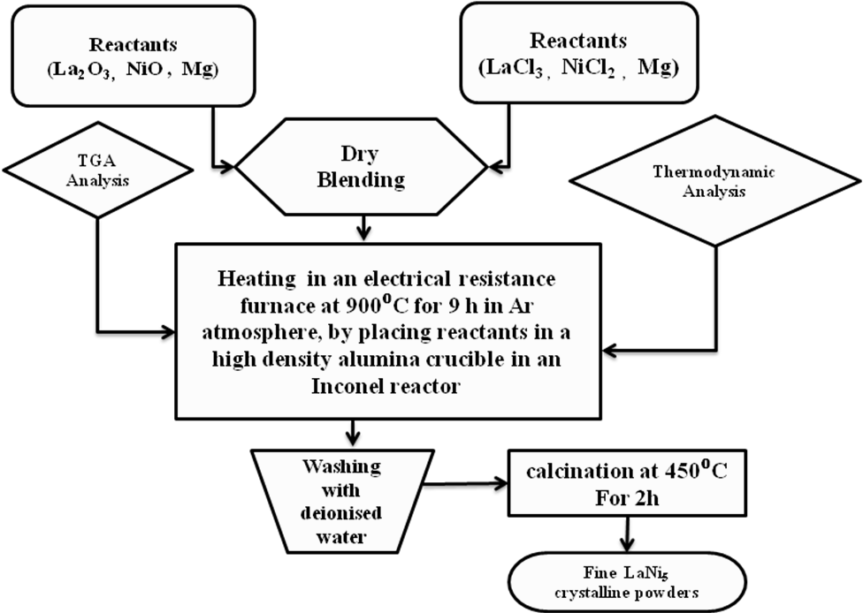

Fig. 1 Experimental procedure for the preparation of LaNi₅ intermetallic compound
Characterization of LaNi₅ intermetallic compound
Before the thermal reduction, the decomposition and the thermal dissociation reactions of the reactants have been determined Thermo Gravimetric Analysis (TGA) using a thermal analyzer (instrument model SDT Q600500 PL, Thermal Sciences, version V4.30 analyzer). The TGA curves were recorded from room temperature to 900⁰C in N₂ atmosphere at a heating rate of 10⁰C min⁻¹. The phase purity of the product was assessed using a Philips 8030 X-ray Diffractometer. The unit cell lattice parameters were obtained by least square ﬁtting method of the d spacing and the hkl values. The morphological features of the prepared powders were scrutinized by SEM (JEOL JLA-3.5 CF-Japan).

Results and Discussion
Thermal Analysis
TGA Analysis for oxide and chloride systems
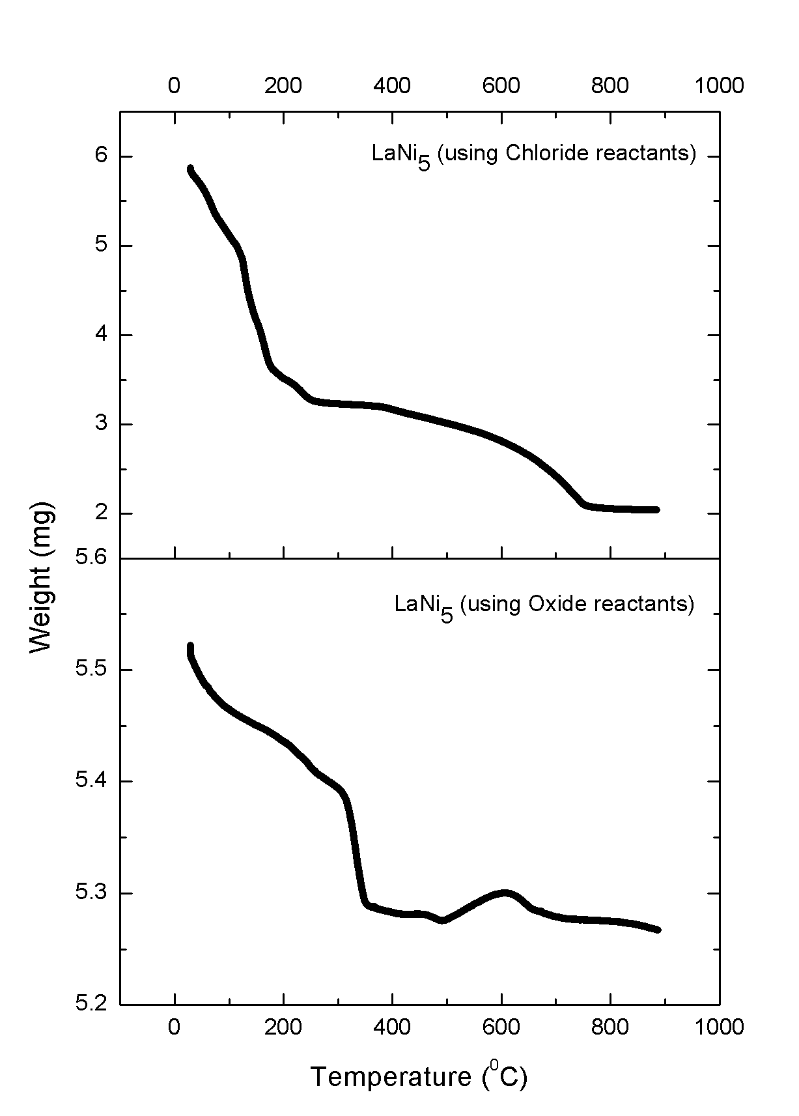
The first weight loss accounts to 3.34% occurs between 58.19ºC to 351.92 ºC is ascribed for the dehydration of water molecules in oxide system and a weight loss of 36.50% amid 93.94 ºC and 151.65 ºC has been concerned for chloride system respectively . The loss in weight between 305.19 ºC to 606.55 ºC which may be due to the transformation of reactants into the desired product LaNi₅ compound in oxide system and subsequent to 249.87 ºC, there is a spiky variation in TGA curve may be endorsed to the renovation of reactants and crystallization of the product LaNi₅ in chloride system respectively. Beyond 809.68 ºC, the TGA curve does not show any prominent exothermic reaction, with a declining curve indicating the progressive transformation of reactants into a single phase LaNi₅ from their compounds as far as oxide precursors are concerned and an trivial weight loss of 0.27% has been noticed between 675.21 ºC and 900 ºC can be attributed to the evaporation of the melt at high temperature region of the oxide precursors.

Fig.2 TGA curves for LaNi₅ through oxide and chloride reactants
X-ray Diffraction (XRD) studies
Figure 3 shows the XRD pattern of prepared LaNi₅ alloy by reduction diffusion technique using magnesium as the reductant for both oxide and chloride precursors. XRD spectrum indicates the well defined peaks match well with the standard HCP LaNi₅ alloy (space group p6/mmm and a = 5.0160 Å, C = 3.9820 Å). The calculated values of a = 4.992 Å, and C = 3.978 Å, which are in good agreement with the standard data and reported values [11,17,18]. From the XRD data, we have calculated the average crystalline size via line broadening analysis and by using Scherer’s formula. The calculated average crystalline size of the prepared powders is lying between 1.8 µm to 2.2µm. The appearance of weak diffraction peaks appeared in the spectrum indicates that the presence of minor amounts of impurities such as magnesium oxide, lanthanum oxide and nickel oxide in the product.

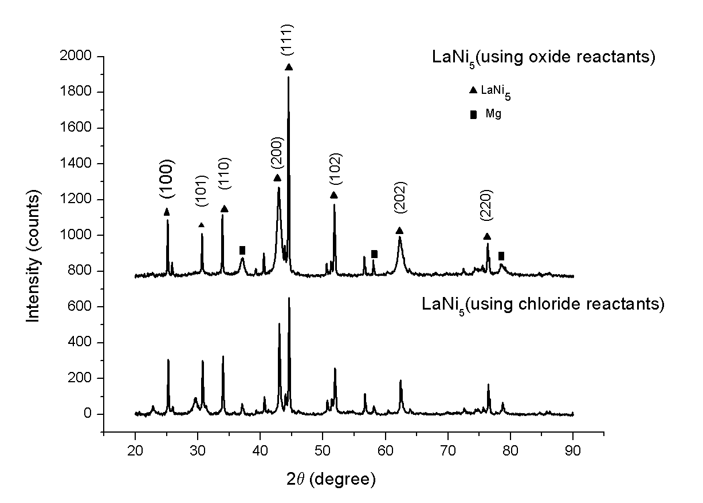

Fig.3 XRD analyses of LaNi₅ intermetallic compound
ENERGY DISPERSIVE SPECTROSCOPY ANALYSIS USING X-RAYS (EDAX)
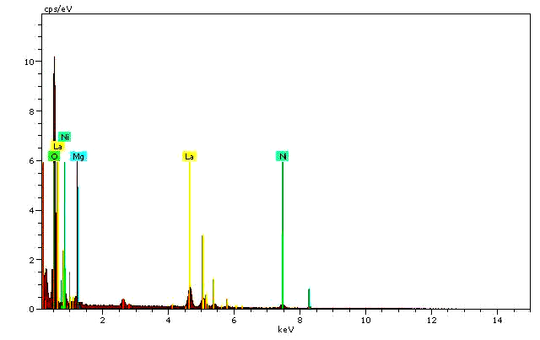
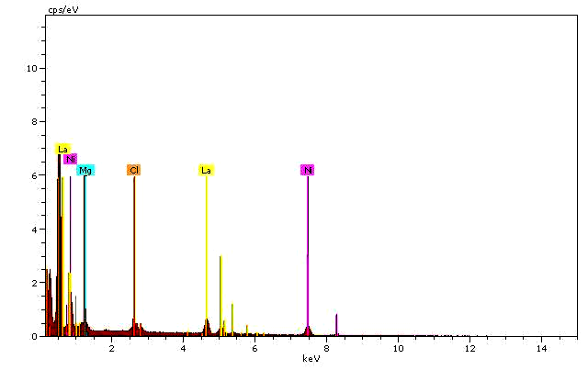
Fig.4 (a, b) shows the EDAX profile of the prepared LaNi₅ powders by oxide and chloride routes. The spectra ascertain the presence of La, Ni elements in appropriate concentrations in the prepared alloy.

Fig.4 (a) EDAX Spectra of LaNi₅ powders by oxide system Fig.4 (b) EDAX Spectra of LaNi₅ powders by chloride system
MORPHOLOGICAL ANALYSIS
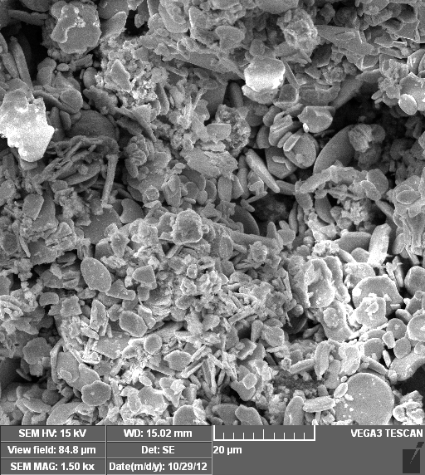
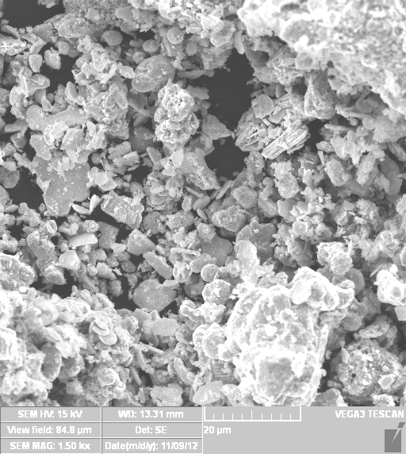
Fig. 5(a, b) shows the scanning electron micrographs (SEM) of the prepared LaNi₅ powders through oxide and chloride routes. The SEM images reveal that the particles are uniformly distributed with regular size and shape. The average particle size of the powders is found to be in the range of 1.8µ - 2µ for both oxides and chloride routes.

Fig. 5(a) SEM images of LaNi₅ powders by oxide reactants Fig. 5(b) SEM images of LaNi₅ powders by chloride reactants
Conclusions
It has been accomplished that the preparation of LaNi₅ alloy powders can be possible by R-D process using Mg as the reductant. The process is sluggish due to low kinetics in thermal reduction process. The XRD data confirms the presence of hexagonal crystals of LaNi₅ with minor impurity phases. SEM micrographs reveal that the powders are in irregular morphology with aborted size and shape. EDAX profile ascertains the presence of lanthanum and nickel ions are in appropriate proportions. Attention is needed in several investigations involving concepts of diffusion and rate kinetics, structure-property relationship pertaining to the reaction proceedings are unsettled, which are to be addressed in our upcoming work.
References

[1] G. Sandrock, K.J. Gross, G. Thomas, J. Alloys Compd. 339 (2002) 299 - 308.
[2] B. Bogdanovic, R.A. Brand, A. Marjanovic, M. Schwickardi, J. Tolle, J. Alloys Compd. 302 (2000) 36 - 58.
[3] Elena David, Journal of Materials Processing Technology 162–163 (2005) 169 –177.
[4] Kuriyama N, Sakai T, Miyamura H, Tanaka H, Ishikawa H, Uehara I., Vacuum 47(6-8) (1996) 889 – 892.
[5] Cui N, He P, Luo JL, Acta Mater 47 (14) (1999) 3737– 3743.
[6] Xiangyu Zhao, Liqun Ma Intl. Jour. of Hydrogen Energy 34 (2009) 4788–4796.
[7] P. Dantzer, Materials Science and Engineering A 329–331 (2002) 313–320.
[8] A. Szajek, A. Jezierski, M. Nowak and M. Jurczyk, ACTA PHYSICA POLONICA A 115 (2009) 247-250.
[9] P. Termsuksawad, S. Niyomsoan, B. Mishra, D.L. Olson, Z. Gavra, V.I. Kaydanov, Mat.Sci.and Engg. B 117 (2005) 45–51.
[10] L.T. Tai, B.T. Hang, N.P. Thuy, T.D. Hien, Jour. of Mag. and Mag. Mat. 262 (2003) 485–489.
[11] Dong Guixia, Wu Borong, Du Jun, Zhu Lei, Jour. of Asian Elect. Vehicles 3 2 (2005) 789-791.
[12] G.M.R. van Druten , E. Labbe´, V. Paul-Boncour, J. Pe´richon,A. Percheron-Gue´gan, Jour. of Electroanal. Chem. 487 (2000) 31–36.
[13] M. JURCZYK, M. NOWAK, I. OKONSKA, L. LAARDZ, A. SZAJEK,Mater. Sci. Forum Vol. 610-613 (2009) 472-479.
[14] J. Kusinski, K. Kowalski, S. Kac, P. Matteazzi, M. Krebs, J. Morgiel, S. Cochet, Solid state Phenomena Vol. 186 (2012) 124-129.
[15] M.V Blanco , E. Zelaya, M.R Esquivel, Procedia Materials Science 1 ( 2012 ) 564 – 571.
[16] Yun Gao, HuixiaoZhao, Zheng Zhou, Lei Mao, Manhua Peng , Adv. Mater. Res. Vols. 189-193 (2011) 575-579.
[17] Xue Kang, Qian Xu, Sujuan MA, Lina Zhao, Qiushi SONG, Communication 8 (2009) 663-666.
[18] Yong Xiao, Yingliang Liu , Dingsheng Yuan, Jingxian Zhang, Yuanzhu Mi, Materials Letters 60 (2006) 2558–2560.
[19] M. Ohtsuka, D.-Y. Kim, K. Itagaki, Jour. of Alloys and Compounds 230 (1995) 46-52.
[20] Teruo Tanabe, Keiji Takahashi, Hideki Yoshinda, Zenjiro Asaki, Mat. Trans., JIM, 35 8 (1994) 516-521.
[21] T. TANABE, Z. ASAKI, Met.and Mat. Trans. B, 29B, (1998), 331- 338.
[22] Thomas B. Reed, Free Energy of Formation of Binary Compounds, MIT Press, Cambridge, MA, 1971.
[23] Masashi Sato, R.V. Denys, A.B. Riabov, V.A. Yartys, J. Alloys Compd. 397, 1–2 (2005) 99-103.
[24] N.I. Usenko, M.I. Ivanov, V.V. Berezutski, J. Alloys Compd. 346 1–2 (2002) 7- 10.
[25] H Konishi, T Nishikiori, T Nohira, Y Ito, Electrochim. Acta, 48 10 (2003) 1403-1408.
[26] T. TANABE, Z. ASAKI, Metall. and Mater. Trans. B, 29B, (1998), 331- 338.
[27] Guangsi GUO, Guangqiang LI, Zhenqi HUANG, Zhitong SUI, Liang LIU, J. Mater. Sci. Technol. 16 (2000) 181-182.
[28] Guangsi GUO, Guangtai WANG and Zhitong SUI, J. Mater. Sci. Technol., 20 1 (2004) 68-70.
[29] Thomas B. Reed, Free Energy of Formation of Binary Compounds, MIT Press, Cambridge, MA, 1971.
[30] D. R. Stull and H. Prophet, JANAF Thermochemical Tables, NSRDS-NBS 37, U.S. Dept of Commerce, National
Bureau of Standards, 1971.
[31] C N R Rao, University General Chemistry: An Introduction to Chemical Science, first ed., Macmillan India Limited, 2000.
[32] C W Km, Y H Km, H G Cha, Y S Kang, J. Phys. Scr. 129 (2007) 321-325.
[33] X. L. Dong, B. K. Kim, C. J. Choi, K. S. Park and Z. D. Zhang, J. Mater. Res. 16 (2001) 1083-1089.
[34] J. H. Lin, S. F. Liu, Q. M. Cheng, X. L. Qian, L. Q. Yang, M. Z. Su, J. Alloys Compd. 249 (1997) 237 - 241.

Equation Free energy of formation
no. ∆G (J/mol-K)

1 - 4220.582
2 - 3049.204

Table :

Tables & Figures Captions :

- Table.I. Values of Free energy of formation for equations 1 and 2
- Fig. 2 Experimental procedure for the preparation of LaNi₅ intermetallic compound
- Fig.2 TGA curves for LaNi₅ through oxide and chloride reactants
- Fig.3 XRD analyses of LaNi₅ intermetallic compound
- Fig.4 (a) EDAX Spectra of LaNi₅ powders by oxide system
- Fig.4 (b) EDAX Spectra of LaNi₅ powders by chloride system
- Fig. 5(a) SEM images of LaNi₅ powders by oxide reactants
- Fig. 5(b) SEM images of LaNi₅ powders by chloride reactants

References
[1] G. Sandrock, K.J. Gross, G. Thomas, J. Alloys Compd. 339 (2002) 299 - 308.
[2] B. Bogdanovic, R.A. Brand, A. Marjanovic, M. Schwickardi, J. Tolle, J. Alloys Compd. 302 (2000) 36 - 58.
[3] Elena David, Journal of Materials Processing Technology 162–163 (2005) 169 –177.
[4] Kuriyama N, Sakai T, Miyamura H, Tanaka H, Ishikawa H, Uehara I., Vacuum 47(6-8) (1996) 889 – 892.
[5] Cui N, He P, Luo JL, Acta Mater 47 (14) (1999) 3737– 3743.
[6] Xiangyu Zhao, Liqun Ma Intl. Jour. of Hydrogen Energy 34 (2009) 4788–4796.
[7] P. Dantzer, Materials Science and Engineering A 329–331 (2002) 313–320.
[8] A. Szajek, A. Jezierski, M. Nowak and M. Jurczyk, ACTA PHYSICA POLONICA A 115 (2009) 247-250.
[9] P. Termsuksawad, S. Niyomsoan, B. Mishra, D.L. Olson, Z. Gavra, V.I. Kaydanov, Mat.Sci.and Engg. B 117 (2005) 45–51.
[10] L.T. Tai, B.T. Hang, N.P. Thuy, T.D. Hien, Jour. of Mag. and Mag. Mat. 262 (2003) 485–489.
[11] Dong Guixia, Wu Borong, Du Jun, Zhu Lei, Jour. of Asian Elect. Vehicles 3 2 (2005) 789-791.
[12] G.M.R. van Druten , E. Labbe´, V. Paul-Boncour, J. Pe´richon,A. Percheron-Gue´gan, Jour. of Electroanal. Chem. 487 (2000) 31–36.
[13] M. JURCZYK, M. NOWAK, I. OKONSKA, L. LAARDZ, A. SZAJEK,Mater. Sci. Forum Vol. 610-613 (2009) 472-479.
[14] J. Kusinski, K. Kowalski, S. Kac, P. Matteazzi, M. Krebs, J. Morgiel, S. Cochet, Solid state Phenomena Vol. 186 (2012) 124-129.
[15] M.V Blanco , E. Zelaya, M.R Esquivel, Procedia Materials Science 1 ( 2012 ) 564 – 571.
[16] Yun Gao, HuixiaoZhao, Zheng Zhou, Lei Mao, Manhua Peng , Adv. Mater. Res. Vols. 189-193 (2011) 575-579.
[17] Xue Kang, Qian Xu, Sujuan MA, Lina Zhao, Qiushi SONG, Communication 8 (2009) 663-666.
[18] Yong Xiao, Yingliang Liu , Dingsheng Yuan, Jingxian Zhang, Yuanzhu Mi, Materials Letters 60 (2006) 2558–2560.
[19] M. Ohtsuka, D.-Y. Kim, K. Itagaki, Jour. of Alloys and Compounds 230 (1995) 46-52.
[20] Teruo Tanabe, Keiji Takahashi, Hideki Yoshinda, Zenjiro Asaki, Mat. Trans., JIM, 35 8 (1994) 516-521.
[21] T. TANABE, Z. ASAKI, Met.and Mat. Trans. B, 29B, (1998), 331- 338.
[22] Thomas B. Reed, Free Energy of Formation of Binary Compounds, MIT Press, Cambridge, MA, 1971.
[23] Masashi Sato, R.V. Denys, A.B. Riabov, V.A. Yartys, J. Alloys Compd. 397, 1–2 (2005) 99-103.
[24] N.I. Usenko, M.I. Ivanov, V.V. Berezutski, J. Alloys Compd. 346 1–2 (2002) 7- 10.
[25] H Konishi, T Nishikiori, T Nohira, Y Ito, Electrochim. Acta, 48 10 (2003) 1403-1408.
[26] T. TANABE, Z. ASAKI, Metall. and Mater. Trans. B, 29B, (1998), 331- 338.
[27] Guangsi GUO, Guangqiang LI, Zhenqi HUANG, Zhitong SUI, Liang LIU, J. Mater. Sci. Technol. 16 (2000) 181-182.
[28] Guangsi GUO, Guangtai WANG and Zhitong SUI, J. Mater. Sci. Technol., 20 1 (2004) 68-70.
[29] Thomas B. Reed, Free Energy of Formation of Binary Compounds, MIT Press, Cambridge, MA, 1971.
[30] D. R. Stull and H. Prophet, JANAF Thermochemical Tables, NSRDS-NBS 37, U.S. Dept of Commerce, National
Bureau of Standards, 1971.
[31] C N R Rao, University General Chemistry: An Introduction to Chemical Science, first ed., Macmillan India Limited, 2000.
[32] C W Km, Y H Km, H G Cha, Y S Kang, J. Phys. Scr. 129 (2007) 321-325.
[33] X. L. Dong, B. K. Kim, C. J. Choi, K. S. Park and Z. D. Zhang, J. Mater. Res. 16 (2001) 1083-1089.
[34] J. H. Lin, S. F. Liu, Q. M. Cheng, X. L. Qian, L. Q. Yang, M. Z. Su, J. Alloys Compd. 249 (1997) 237 - 241.

