Figure captions
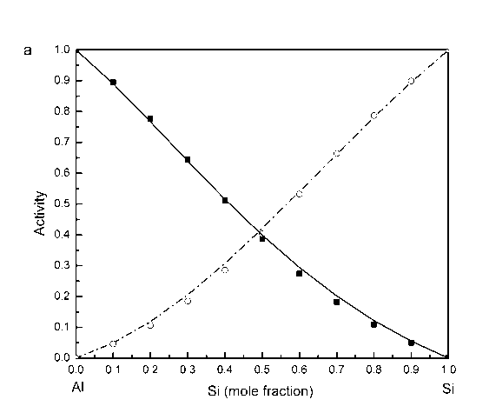
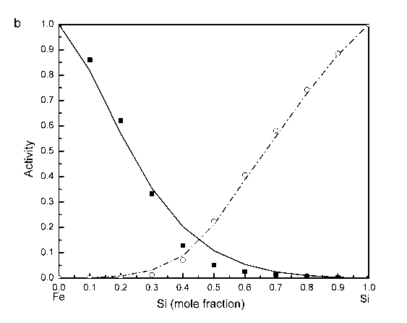
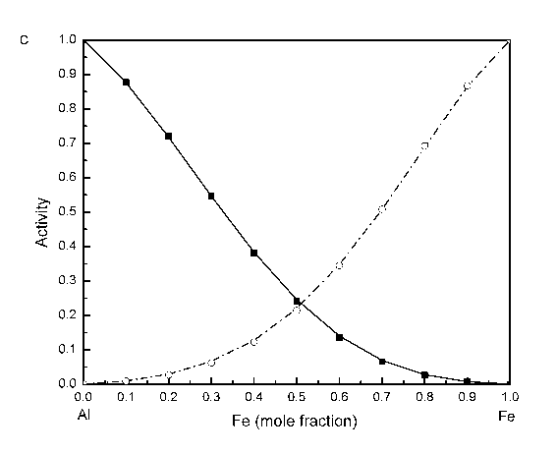
Fig.1 Comparison of the predicted activities of MIVM (lines) with experimental data [14,15] (symbols) of alloy systems (a) Si-Al at 1700 K, (b) Si-Fe at 1873 K, (c) Fe-Al at 1900 K.

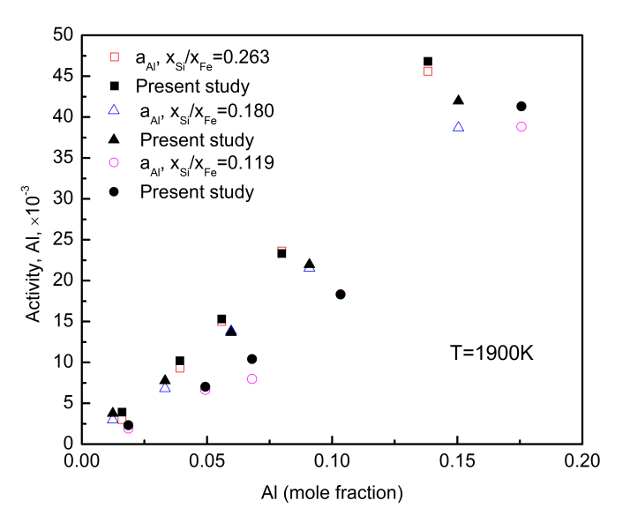
Fig. 2 Al activities at 1900K according to the present model compared with experimental data by Bedon et al. [16].

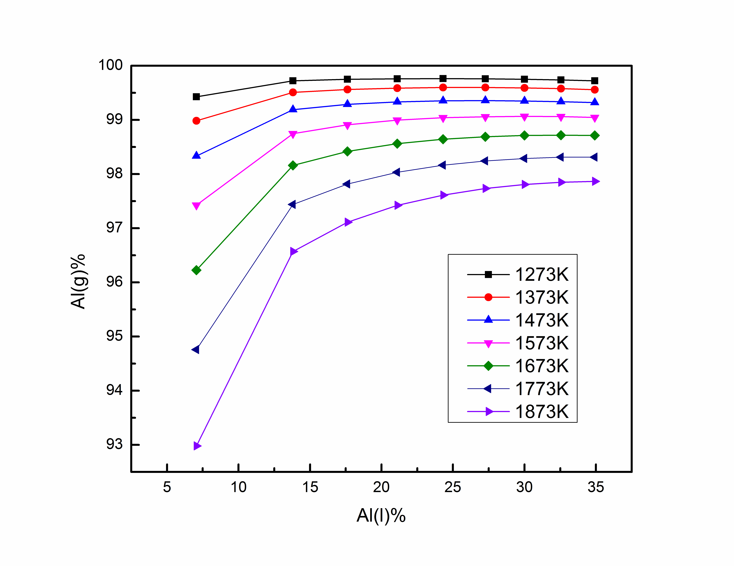
Fig. 3 Vapor–liquid equilibrium composition of Si–Fe–Al ternary system at the different temperatures

