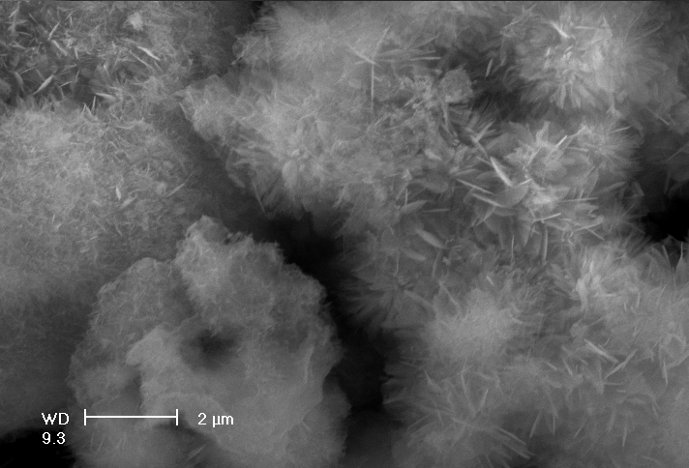 | 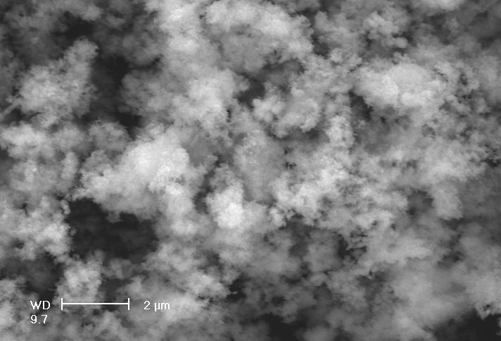
(a)110°C | (b) 120°C
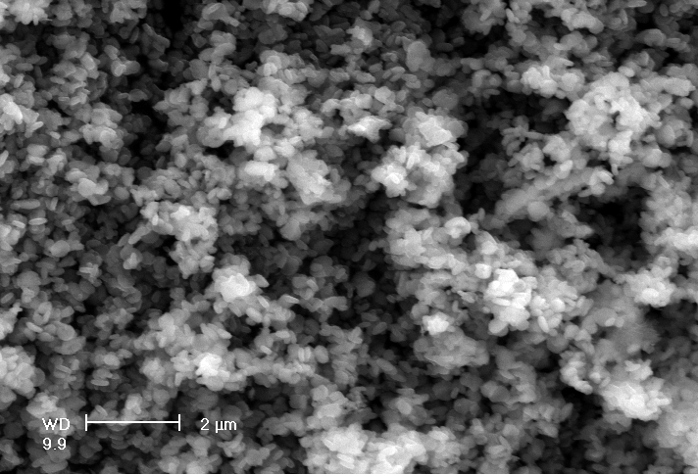 | 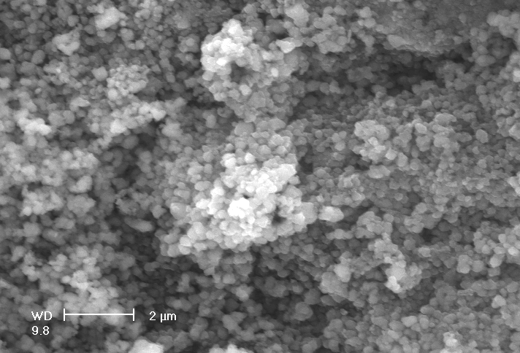
(c) 130°C | (d) 140°C

Figure 8. SEM morphology images of leaching residues formed at specific temperature after leaching for 60 minutes under pO₂= 1.0MPa, A/O = 0.164 and L/S = 10.

