SHORT COMMUNICATION  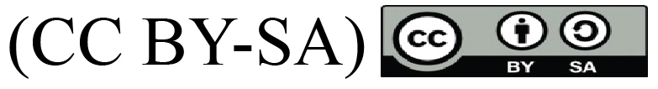 |  | UDC: 612.39:613.292]:616-092.8  https://doi.org/10.2298/VSP180326122V

The effects of fish-based and milk-based diets on liver tissue antioxidant enzymes and lipid peroxidation in female Wistar rats: A pilot study
Efekti hrane obogaćene ribljim brašnom i mlekom u prahu na antioksidativne enzime i lipidnu peroksidaciju u jetri ženki pacova Wistar soja: pilot studija

Nevena Vidović*, Slavica Ranković*, Zorana Oreščanin-Dušić†, Jasmina Debeljak-Martačić*, Tamara Popović*, Mirko Tomić†, Marija Glibetić*

University of Belgrade, Institute for Medical Research *Centre of Research Excellence in Nutrition and Metabolism, Belgrade, Serbia; University of Belgrade, †Institute for Biological Research “Siniša Stanković”, Belgrade, Serbia

Abstract

Background/Aim. Recently, there has been an increased interest in novel dietary antioxidants, including omega-3 fatty acids and bioactive proteins present in milk. The aim of this study was to examine potential antioxidant effects of four-weeks long fish-based and milk-based diets in female Wistar rats. Methods. Four-months old rats were divided into three groups receiving either: control diet, diet enriched with fish meal, or diet enriched with milk. The activities of antioxidant enzymes: glutathione peroxidase (GPx), superoxide dismutase (SOD) and catalase (CAT), and concentration of thiobarbituric acid reactive substances (TBARS) were determined in liver homogenates obtained at the end of the treatment period. Results. Statistically significant higher activities of GPx (3.52 ± 0.73 U/mg) and CAT (147.25 ± 15.93 U/mg) were detected in rats fed with fish-based meal in comparison with both the control (GPx: 1.93 ± 0.11 U/mg; CAT: 99.37 ± 10.03 U/mg) and the group fed with milk-based diet (GPx: 1.72 ± 0.52 U/mg; CAT: 104.18 ± 37.49 U/mg). Despite somewhat lower concentration of TBARS in the milk-treated group (0.88 ± 0.23 nmoL/mg), no significant differences were detected in comparison with other groups (the control group: 1.00 ± 0.08 nmoL/mg; the fish-based diet group: 1.13 ± 0.15 nmoL/mg). Conclusion. Diet enriched with fish could improve one’s oxidative status by enhancing activities of antioxidant enzymes in the liver tissue. On the contrary, we failed to obtain results suggesting that milk could serve as a source of dietary antioxidants.

Key words:
antioxidants; catalase; enzymes; fatty acids, omega-3; fishes; food; lipid peroxidation; milk; rats; superoxide dismutase.
Apstrakt

Uvod/Cilj. U poslednje vreme povećano je interesovanje za istraživanja novih antioksidanasa u ishrani, uključujući omega-3 masne kiseline i bioaktivne proteine prisutne u mleku. Cilj ove studije bio je ispitivanje potencijalnih antioksidativnih efekata hrane obogaćene ribljim brašnom i hrane obogaćene mlekom u prahu kod ženki Wistar pacova, u trajanju od četiri nedelje. Metode. Pacovi, starosti četiri meseca, podeljeni su u tri grupe koje su bile hranjene standardnom hranom (kontrolna grupa), hranom obogaćenom ribljim brašnom i hranom obogaćenom mlekom u prahu. U homogenatima jetre, posle četiri nedelje, određene su aktivnosti antioksidativnih enzima: glutation peroksidaze (GPx), superoksid dismutaze (SOD) i katalaze (CAT), kao i koncentracija reaktivnih supstanci tiobarbiturne kiseline (TBARS). Rezultati. Statistički značajno veće aktivnosti GPx (3,52 ± 0,73 U/mg) i CAT (147,25 ± 15,93 U/mg) nađene su kod pacova koji su dobijali hranu obogaćenu ribljim brašnom u odnosu na kontrolu (GPx: 1,93 ± 0,11 U/mg; CAT: 99,37 ± 10,03 U/mg) i grupu koja je hranjena hranom obogaćenom mlekom u prahu (GPx: 1,72 ± 0,52 U/mg; CAT: 104,18 ± 37,49 U/mg). Uprkos nešto nižoj koncentraciji TBARS u grupi koja je primala hranu obogaćenu mlekom u prahu (0,88 ± 0,23 nmoL/mg), nisu utvrđene statistički značajne razlike u poređenju sa drugim grupama (kontrola: 1,00 ± 0,08 nmoL/mg; grupa na ishrani obogaćenoj ribljim brašnom: 1,13 ± 0,15 nmoL/mg). Zaključak. Ishrana bogata ribom mogla bi delovati povoljno na oksidativni status preko poboljšanja aktivnosti antioksidativnih enzima jetre. Sa druge strane, rezultati ne pokazuju da bi mleko moglo biti dobar izvor dijetarnih antioksidanasa.

Ključne reči:
antioksidansi; katalaza; enzimi; masne kiseline, omega-3; ribe; hrana; lipidi, peroksidacija; mleko; pacovi; peroksid dismutaza.

Introduction
Use of dietary antioxidants is highly recommended in order to maintain overall health and prevent metabolic disorders, cardiovascular diseases, cancer and other pathological conditions. Beneficial effects of plant foods rich in antioxidant vitamins and phytochemicals are well established and confirmed in numerous epidemiological and human and/or animal studies ^{1, 2}. On the contrary, more investigations are needed on novel dietary antioxidants such as omega-3 fatty acids (FA), bioactive proteins and peptides. High intake of fish and fish oil has been associated with lower incidence of cardiovascular, neurological diseases and cancer, well known oxidative stress-related states ^{3, 4}. However, data on antioxidant effects of omega-3 FA are still contradictory and need to be further investigated. Some reports suggest that intake of these highly unsaturated FA contributes to the increase in lipid peroxidation and oxidative damage ^{5, 6}. Other studies indicate potential role of omega-3 FA in stimulation of endogenous antioxidant defence and homeostasis of free radicals. Antioxidant effects of fish oil have been reported in animal models of asthma, diabetes, and nephrotoxicity and in normal rats as well ^{5–8}. Still, firm conclusions can not be drawn, since so far studies have varied in design and duration ranging from 15 days to 13 weeks ^{7–10}. The most recent study, testing the combined effects of fish oil and α-lipoic acid on liver fatty acid oxidation and parameters of oxidative stress, lasted for 21 days ¹¹.
Among other novel functional foods, dairy products and milk-based supplements are indicated as potential antioxidants with beneficial impact on health and healthy ageing ^{12, 13}. Milk and dairy products have a unique protein and FA composition that could beneficially affect one’s oxidative status. Potential antioxidant activity of milk proteins is related to their ability to scavenge radicals, chelate metals, and enhance the endogenous antioxidant defence. In addition, studies have revealed potential impact of milk proteins on oxidative stress-related states, such as insulin resistance and cardiomyopathy ^{14, 15}. In comparison with the fish and omega-3 FA, data on interventions with milk are far scarcer. Available intervention studies on animals are quite different in the tested organ models as well as in the study design and duration ranging from 14 days to eight weeks ^{14–17}. One of the latest studies on the influence of milk-based diets on, among others, liver enzymatic antioxidant defence, reported an experimental period of 30 days ¹⁷.
The aim of our study was to investigate potential antioxidant effects of fish-based and milk-based diets in female Wistar rats. Since lipid peroxidation is commonly used indicator of oxidative status, we measured concentration of thiobarbituric acid (TBA) reactive substances (TBARS). In addition, we determined the activities of antioxidant enzymes: glutathione peroxidase (GPx), superoxide dismutase (SOD), and catalase (CAT). The mentioned parameters were measured in rats’ livers at the end of the 4-weeks long treatment period. This treatment period was chosen based on the available research and it was considered to be long enough for obtaining significant changes in measured parameters.
Methods
Animals and treatments
The experiments were carried out on four-months old female Wistar rats, housed under controlled conditions (room temperature 23°C–25°C, 12 h light-dark cycle, food and drinking liquid ad libitum) and provided by the vivarium of the Institute for Biological Research (University of Belgrade, Serbia). The experimental protocols, as well as the maintenance of animals were in accordance with the Official Institutional Guide for Experimental Work on Animals, adjusted to the European Communities Council Directive (86/609) and the Guide for Care and Use of Laboratory Animals, NIH publication No. 85–23. The approval was obtained from the Ethics Committee for the Use of Laboratory Animals of the Institute for Biological Research (University of Belgrade, Serbia), under the decision No 02-56/12.
The animals were randomly assigned into one of the three treatment groups, and were well matched in terms of body weight (250–300 g). The control group (n = 6) was fed with the standard laboratory chow, while the fish-based group (n = 5) had added fishmeal (based on anchovy) and the milk-based group (n = 8) had dried-milk powder added. The formulation of rat chow was made by the Department of Animal Nutrition and Botany, Faculty of Veterinary Medicine, University of Belgrade, Serbia. A detailed analytical characterisation of food (rat chow), its chemical composition, respectively is given in previously published article ¹⁸.
Preparation of tissue homogenate
At the end of the treatment period, the rats were sacrificed by decapitation, livers were dissected and immediately frozen on dry ice. Further on, the livers were stored at -80ºC until the following procedures were applied: livers were weighed, and homogenates were prepared by homogenization of 1 g of the tissue in 10 mL of buffer containing: 50 mM Tris pH 7.4, 150 mM sodium chloride (NaCl), 2 mM ethylenediaminetetraacetic acid (EDTA) and 1% Igepal® (Sigma Aldrich®, Darmstadt, Germany). Homogenization was performed using a homogenizer Ultra Turex followed by the centrifugation of the tissue at 37 °C for 90 min 500 rpm at 4ºC. The supernatants were further used for the analyses of the antioxidant enzymes’ activities and TBARS concentration. All the results were expressed per mg of proteins.
Determination of TBARS level
The concentration of TBARS, as by-product of lipid peroxidation, was measured with the use of TBARS Assay Kit (Cayman chemical, Ann Arbor, Michigan, USA) based on the reaction with TBA in acidic pH at 90–100°C ¹⁹. After boiling the mixtures for 1 h, they were cooled, centrifuged and the absorbance of resulting pink products measured by plate reader at 540 nm. Malondialdehyde (MDA), 500 µM, was used to prepare standard curve for the calculation of TBARS levels (MDA equivalents) in liver samples.
Determination of SOD
The SOD activity was determined by Ransod kit (Randox, Crumlin, UK) based on the superoxide radical anion production in a xanthine–xanthine oxidase system and its further reaction with 2-(4-iodophenyl)-3-(4-nitrophenol)-phenyltetrazolium chloride, resulting in the formation of red formazan dye. Samples were diluted 150- to 200-fold and the decrease in the absorbance was measured at 505 nm and 37°C for 3 min. The units of SOD activity were calculated from the absorbance changes per minute with the use of the standard curve made with purified enzyme. One unit of SOD was defined as the amount of enzyme resulting in the 50% inhibition of red formazan dye formation.
Determination of GPx
The GPx activity was measured by the Ransel kit (Randox, Crumlin, UK) based on the oxidation of reduced glutathione in the presence of cumene hydroperoxide. The formed glutathione-disulphide was further reduced by glutathione reductase in the presence of NADPH coenzyme. The samples were 100-fold diluted and the activity was determined by monitoring the decrease in absorbance due to the disappearance of the NADPH at 340 nm and 37 °C. One unit of GPx was defined as amount of NADPH (expressed in nmol) oxidized per min, and calculated based on the NADPH molar absorption coefficient.
Determination of CAT
The CAT activity was determined by the slightly modified method described by Aebi ²⁰, based on the degradation of hydrogen peroxide – H₂O₂ (Sigma Aldrich®, Darmstadt, Germany), reaction that can be measured directly by the decrease in absorbance at 240 nm. Liver homogenates were diluted 100- to 150-fold, added to 1 M phosphate buffer (pH 7.0) and reaction was initiated by adding 10 mM H₂O₂ and the decrease in absorbance recorded for 3 min at 25ºC. One unit of CAT activity was defined as the amount of enzyme decomposing 1 μmoL of H₂O₂ per min.
Determination of protein content
Protein content in tissue homogenates was determined by the use of bicinchoninic acid (BCA) Protein Assay Macro Kit (SERVA Electrophoresis, Heidelberg, Germany), according to the given instructions. The method combined Biuret reaction, and colorimetric detection of the cuprous cation (Cu¹⁺) with a BCA containing reagent. The absorbance of the purple-coloured product, formed by chelating two molecules of BCA with one Cu¹⁺ ion, was measured at 562 nm. Bovine serum albumin was used to prepare a standard curve, and the liver homogenates were diluted 50-fold prior the analyses.
Statistical analysis
All variables were tested for normality using the Shapiro-Wilk’s test. For normally distributed variables, comparisons between the groups were performed by one-way analysis of variance (ANOVA) with Tukey post hoc test. Data are shown as mean values ± standard deviation. Due to the absence of normal distribution, SOD values were compared by Kruskal-Wallis nonparametric test and data presented as medians with interquartile ranges (25th and 75th percentiles). Correlations between measured parameters were evaluated by Pearson’s coefficients of correlation. Analyses were performed with SPSS software (Chicago, IL, USA).
Results
Effects on TBARS
Despite the somewhat lower concentration of TBARS in the milk-treated group (0.88 ± 0.23 nmoL/mg), no significant differences were detected in comparison with the other groups (the control group: 1.00 ± 0.08 nmoL/mg; the fish-based diet group: 1.13 ± 0.15 nmoL/mg) (Figure 1).
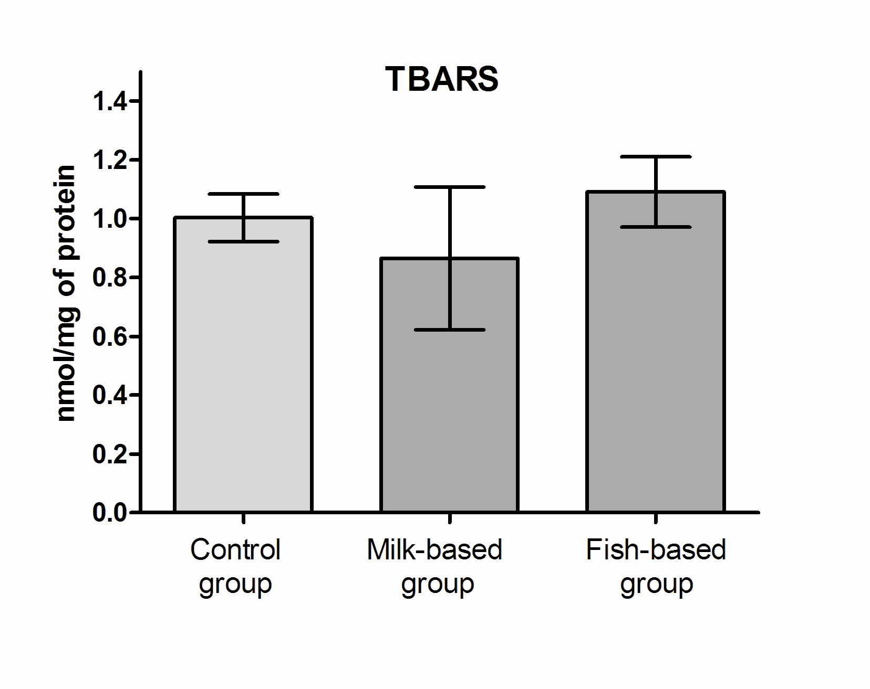
Fig. 1 – Levels of lipid peroxidation – thiobarbituric acid reactive substances (TBARS) at the end of four-weeks long consumption period.
Data are shown as mean values ± standard deviation; Comparisons were performed by one-way analysis of variance (ANOVA) with Tukey post hoc test.
Effects on antioxidant enzymes
Statistically significantly higher activities of GPx (3.52 ± 0.73 U/mg) and CAT (147.25 ± 15.93 U/mg) were detected in rats fed with fish-based meal, in comparison with both the control (GPx: 1.93 ± 0.11 U/mg, p < 0.001; CAT: 99.37 ± 10.03 U/mg, p < 0.05) and the milk-fed rats (GPx: 1.72 ± 0.52 U/mg, p < 0.001; CAT: 104.18 ± 37.49 U/mg, p < 0.05), as presented in Figure 2. There were no significant differences in the activities of SOD among the groups.
Correlation between measured parameters
In the group fed with the milk-based diet, TBARS levels positively correlated with the activities of the measured enzymes (Table 1), although the correlation was not significant for SOD. Furthermore, a significant correlation was found between GPx and CAT activities (p < 0.05, r = 0.795), while SOD positively correlated with both GPx and CAT, but not significantly. In the control group, we observed significant correlation (p < 0.05) between the GPx and CAT activity as well.

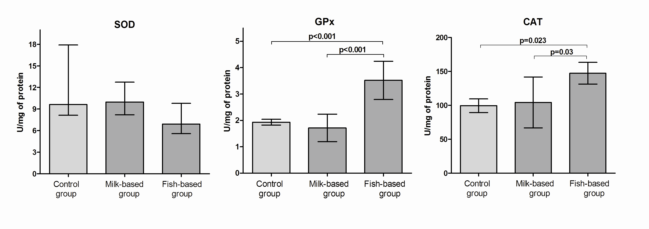
Fig. 2 – Activities of antioxidant enzymes at the end of four-weeks long consumption period.
SOD- superoxide dismutase, GPx- glutathione peroxidase, CAT- catalase; For GPx and CAT, data are shown as mean values ± standard deviation and comparisons were performed by one-way analysis of variance (ANOVA) with Tukey post hoc test; SOD values were compared by Kruskal-Wallis nonparametric test and data are presented as medians with interquartile ranges (25th and 75th percentiles).

Table 1
Correlations between activities of antioxidant enzymes and level of lipid peroxidation
Parameters |  | r |  | p
Milk-based group
TBARS/GPx | 0.811 |  | 0.014
TBARS/CAT | 0.980 |  | < 0.001
TBARS/SOD | 0.681 |  | 0.062
GPx/CAT | 0.795 |  | 0.018
GPx/SOD | 0.668 |  | 0.070
CAT/SOD | 0.670 |  | 0.069
Control group
GPx/CAT | 0.816 |  | 0.047
r – Pearson’s coefficient of correlation;
TBARS – thiobarbituric acid reactive substances, index of lipid peroxidation; GPx – glutathione peroxidase;
CAT – catalase; SOD – superoxide dismutase.
Discussion
In the present study, we found significantly higher activities of GPx and CAT in female Wistar rats treated with fish-based meal for four weeks in comparison with those in both the control and milk-fed animals. In comparison with the control group, the milk-based diet showed no effects, but we observed some significant correlations in this group.
Our results contribute to previous suggestions that omega-3 FA could improve enzymatic antioxidant defense ²¹. A study that investigated effects of 30 days long fish oil supplementation in male Wistar rats revealed significantly higher erythrocytes’ CAT activity in treated animals ⁷. Similarly, supplementation with fish oil enhanced activities of both GPx and SOD in asthmatic rats ¹⁰ and raised CAT activity in animal model of nephrotoxicity ⁹. Furthermore, treatment with omega-3 FA caused an increase in glutathione concentration and GPx activity in streptozotocin-induced diabetic rats ⁸. Although the use of fish and fish-based meals as dietary antioxidants is yet to be established, their ability to scavenge radicals, down-regulate activity of NADPH activity ²², and increase microRNA expression of antioxidant enzymes ²³, have been reported. Besides evaluating activities of antioxidant enzymes, we measured concentration of TBARS, as by-product of lipid peroxidation ²⁴ and found no significant impact of tested diets. Similarly to our results, dietary supplementation with fish oil in duration of 13 weeks caused no significant changes in liver lipid peroxidation in female rats, comparing with the supplementation with soybean and linseed oil. Still, research to date is quite ambiguous particularly on the impact of fish-based meals on lipid peroxidation. Since double bonds are the main targets of free radical attack, long-chain polyunsaturated FA, with numerous double bonds, represent particularly prone FA to the lipid peroxidation. Thus, it could be expected that higher intake of fish and fish based meals could lead to the increase in the lipid peroxidation, as confirmed previously ^{5, 6}. On the contrary, reducing effect of omega-3 FA and fish oil on increased TBARS concentration was reported in diabetic rats, rats with uranyl nitrate-induced nephrotoxicity ^{8, 9}, as well as in healthy rats ⁷. In our previous work, we have investigated the impact of fish and milk-based diets on liver phospholipids' FA composition in rats of both genders. We observed sex-specific changes in FA profile. In case of fish-based diet, there was more pronounced increase in the concentration of omega-3 FA (both total and individual FA) in female comparing with the male rats ¹⁸. Considering this and the fact that polyunsaturated FA could be used as indirect measure of lipid peroxidation (as the most prone FA to lipid peroxidation), we assumed that the changes in lipid peroxidation and other parameters of oxidative stress would be more pronounced in female rats ²⁵. This is why we have included female rats in here presented research.
Although we observed to some extent lower concentration of TBARS in rats fed with milk-based diet in comparison with the control group and the group fed with fish-based diet, these differences were not significant. In addition, we found no significant impact of milk-based diet on activities of antioxidant enzymes in rats' liver. Still, we recorded significant positive correlations between TBARS concentration and both GPX and CAT activities. In other words, lower lipid peroxidation was followed by lower activities of antioxidant enzymes. Indeed, we found significantly lower activities of GPx and CAT in the group fed with milk-based diet in comparison with the fish-based diet. Comparing the levels of TBARS in these two groups, lipid peroxidation was to some extent higher in the group fed with fish-based diet. The higher lipid peroxidation could serve as a trigger for the upregulation of antioxidant defence in the body. The lack of effect on antioxidant enzymes in the group fed with milk-based diet could be derived from the lower concentration of TBARS in this group. In accordance with previous findings, significant correlations were found between the activities of GPx and CAT in both the milk-fed and the control group.
Besides being highly nutritious and tasty, milk and dairy products could serve as food supplements with promising health effects. This is because these products are rich in FA, proteins, amino acids, such as cysteine and glutamic acid, and vitamins, such as A and E ¹³. Novel findings suggest that milk proteins and their break down products could serve as potent dietary antioxidants, based on their radical scavenging and metal chelating activity ^{26, 27}. Antioxidant activity of milk and milk products still needs to be evaluated in vivo in both animals and humans. One of the few animal studies investigated the impact of 2-week feedings with breads enriched with milk powder. The authors revealed higher CAT activity in groups fed with breads containing, among other compounds, milk powder in comparison with the group fed with plainbread ¹⁶. In addition, whey protein-enriched diet significantly increased total antioxidant capacity, SOD activity and glutathione concentration, while it decreased lipid peroxidation in insulin resistant rats ¹⁴. Whey protein also ameliorated effects of iron load on oxidative damage in male rats, demonstrated as an increase in total antioxidant defence and a decrease in lipid peroxidation ¹⁵.
In spite of the promising results, our study has some limitations. Firstly, the duration of the treatment (four weeks) was relatively short. A longer supplementation and possibly an assessment of other parameters, in other tissues as well, would provide broader conclusions and would help identifying mechanisms underlying observed antioxidant activity of fish-based diet. Secondly, final conclusions are limited due to the low number of animals especially in the group fed with fish-based meals. Still, we believe that this study provides valuable and novel findings, bearing in mind scarce and ambiguous literature data, especially on milk as potential functional food.
Conclusion
Based on the results of the current study and on the research available to date, we conclude that the intake of fish and fish-based meals could improve one’s oxidative status by enhancing activities of antioxidant enzymes. On the contrary, we obtained no effects in favour of statements that milk could serve as a good source of novel dietary antioxidants. Overall, possible applications and physiological relevance of our findings should be further tested in long-term animal and human intervention studies.
Acknowledgement
This work was supported by the Project No III41030, financed by the Ministry of Education, Science and Technological Development of the Republic of Serbia.
Author disclosure statement
The authors declare that they do not have any actual or potential financial interests or any conflict of interests in the findings from this manuscript.

REFERENCES

- Del Rio D, Rodriguez-Mateos A, Spencer JP, Tognolini M, Borges G, Crozier A. Dietary (poly)phenolics in human health: structures, bioavailability, and evidence of protective effects against chronic diseases. Antioxid Redox Signal 2013; 18(14): 1818–92.
- Hooper L, Kroon PA, Rimm EB, Cohn JS, Harvey I, Le Cornu KA, et al. Flavonoids, flavonoid-rich foods, and cardiovascular risk: a meta-analysis of randomized controlled trials. Am J Clin Nutr 2008; 88(1): 38–50.
- Calder PC. Functional Roles of Fatty Acids and Their Effects on Human Health. JPEN J Parenter Enteral Nutr 2015; 39(Suppl 1): 18S–32S.
- Mozaffarian D, Wu JH. Omega-3 fatty acids and cardiovascular disease: effects on risk factors, molecular pathways, and clinical events. J Am Coll Cardiol 2011; 58(20): 2047–67.
- Wander RC, Du SH. Oxidation of plasma proteins is not increased after supplementation with eicosapentaenoic and docosahexaenoic acids. Am J Clin Nutr 2000; 72(3): 731–7.
- Tsuduki T, Honma T, Nakagawa K, Ikeda I, Miyazawa T. Long-term intake of fish oil increases oxidative stress and decreases lifespan in senescence-accelerated mice. Nutrition 2011; 27(3): 334–7.
- Iraz M, Erdogan H, Ozyurt B, Ozugurlu F, Ozgocmen S, Fadillioglu E. Brief communication: omega-3 essential fatty acid supplementation and erythrocyte oxidant/antioxidant status in rats. Ann Clin Lab Sci 2005; 35(2): 169–73.
- Arnal E, Miranda M, Johnsen-Soriano S, Alvarez-Nolting R, Diaz-Llopis M, Araiz J, et al. Beneficial effect of docosahexanoic acid and lutein on retinal structural, metabolic, and functional abnormalities in diabetic rats. Curr Eye Res 2009; 34(11): 928–38.
- Priyamvada S, Khan SA, Khan MW, Khan S, Farooq N, Khan F, et al. Studies on the protective effect of dietary fish oil on uranyl-nitrate-induced nephrotoxicity and oxidative damage in rat kidney. Prostaglandins Leukot Essent Fatty Acids 2009; 82(1): 35–44.
- Zanatta AL, Miranda DT, Dias BC, Campos RM, Massaro MC, Michelotto PV Jr, et al. Fish oil supplementation decreases oxidative stress but does not affect platelet-activating factor bioactivity in lungs of asthmatic rats. Lipids 2014; 49(7): 665–75.
- Ide T. Physiological activities of the combination of fish oil and α-lipoic acid affecting hepatic lipogenesis and parameters related to oxidative stress in rats. Eur J Nutr 2018; 57(4): 1545–61.
- Power-Grant O, McCormack WG, Ramia De Cap M, Amigo-Benavent M, Fitzgerald RJ, Jakeman P. Evaluation of the antioxidant capacity of a milk protein matrix in vitro and in vivo in women aged 50-70 years. Int J Food Sci Nutr 2016; 67(3): 325–34.
- Da Silva MS, Rudkowska I. Novel functional foods for optimal oxidative status in healthy ageing. Maturitas 2016; 93: 100–7.
- Tong X, Li W, Xu JY, Han S, Qin LQ. Effects of whey protein and leucine supplementation on insulin resistance in non-obese insulin-resistant model rats. Nutrition 2014; 30(9): 1076–80.
- Kim J, Paik HD, Yoon YC, Park E. Whey protein inhibits iron overload-induced oxidative stress in rats. J Nutr Sci Vitaminol (Tokyo) 2013; 59(3): 198–205.
- Świeca M, Reguła J, Suliburska J, Złotek U, Gawlik-Dziki U. Effects of gluten-free breads, with varying functional supplements, on the biochemical parameters and antioxidant status of rat serum. Food Chem 2015; 182: 268–74.
- Alférez MJ, Rivas E, Díaz-Castro J, Hijano S, Nestares T, Moreno M, et al. Folic acid supplemented goat milk has beneficial effects on hepatic physiology, haematological status and antioxidant defence during chronic Fe repletion. J Dairy Res 2015; 82(1): 86–94.
- Ranković S, Popović T, Debeljak-Martačić J, Petrović S, Tomić M, Ignjatović Đ, et al. Liver phospholipids fatty acids composition in response to different types of diets in rats of both sexes. Lipids Health Dis 2017; 16(1): 94.
- Girotti MJ, Khan N, McLellan BA. Early measurement of systemic lipid peroxidation products in the plasma of major blunt trauma patients. J Trauma 1991; 31(1): 32–5.
- Aebi H. Catalase in vitro. Methods Enzymol 1984; 105: 121–6.
- Bu J, Dou Y, Tian X, Wang Z, Chen G. The Role of Omega-3 Polyunsaturated Fatty Acids in Stroke. Oxid Med Cell Longev 2016; 2016: 6906712.
- An WS, Kim HJ, Cho KH, Vaziri ND. Omega-3 fatty acid supplementation attenuates oxidative stress, inflammation, and tubulointerstitial fibrosis in the remnant kidney. Am J Physiol Renal Physiol 2009; 297(4): F895–903.
- Venkatraman JT, Chandrasekar B, Kim JD, Fernandes G. Effects of n-3 and n-6 fatty acids on the activities and expression on hepatic antioxidant enzymes in autoimmune-prone NZBxNZW F mice. Lipids 1994; 29(8): 561–8.
- Dotan Y, Lichtenberg D, Pinchuk I. Lipid peroxidation cannot be used as a universal criterion of oxidative stress. Prog Lipid Res 2004; 43(3): 200–27.
- Lluís L, Taltavull N, Muñoz-Cortés M, Sánchez-Martos V, Romeu M, Giralt M, et al. Protective effect of the omega-3 polyunsaturated fatty acids: Eicosapentaenoic acid/Docosahexaenoic acid 1:1 ratio on cardiovascular disease risk markers in rats. Lipids Health Dis 2013; 12: 140.
- Hernández-Ledesma B, Dávalos A, Bartolomé B, Amigo L. Preparation of antioxidant enzymatic hydrolysates from alpha-lactalbumin and beta-lactoglobulin. Identification of active peptides by HPLC-MS/MS. J Agric Food Chem 2005; 53(3): 588–93.
- Pan D, Guo Y, Jiang X. Anti-fatigue and antioxidative activities of peptides isolated from milk proteins. J Food Biochem 2011; 35(4): 1130–44.
Received on March 23, 2018.
Revised on April 24, 2018.
Accepted on July 2, 2018.
Online First July, 2018.

