ORIGINAL ARATICLES |  | UDC: 616.56-008.8-089  DOI: 10.2298/VSP120122047M
A single incision transaxillary thoracoscopic sympathectomy
Transaksilarna torakoskopska simpatektomija jednom incizijom

Nebojša Marić*, Vojkan Stanić*†, Aleksandar Ristanović*, Vlado Cvijanović*†,
Slobodan Milisavljević‡
*Clinic for Thoracic Surgery, Military Medical Academy, Belgrade, Serbia; †Faculty of Medicine of the Military Medical Academy, Universiti of Defence, Belgrade, Serbia; ‡Department of General Thoracic Surgery, Clinical Center Kragujevac, Kragujevac, Serbia

Abstract

Background/Aim. Primary hyperhidrosis causes are unknown. The disorder begins in early childhood. It intensifies in puberty and maturity. It is equally present in both sexes. The symptoms exacerbate when the body temperature rises and due to emotional stimuli affecting the sympathetic nerve system. The aim of this study was to demonstrate that video-assisted thoracoscopic surgery (VATS) sympathectomy is a method for primary focal hyperhidrosis permanent treatment. The single incision method in properly selected patients maximizes the intervention effectiveness and minimizes aesthetic side effects. Methods. This prospective study analysed the findings in patients who had been operated on due to primary focal hyperhidrosis (face, palms, and armpits) using a single small transaxilarry incision in the third inter-rib space at the level of the anterior axillary line with two 5 mm flexible ports. All the patients, with T2–T5 thoracoscopic sympathectomy of the sympathetic chain using a single small incision in the third inter-rib space in the anterior axillary line, were analysed in the period from September 2009 to November 2010 regarding the postoperative morbidity and outcomes of the operation (clinical evaluation and visual analogue scale) with a view to assessing the effectiveness of the surgery conducted in this manner. Results. A total of 47 patients (18 men, 29 women), 18 to 48 years old (29 on average) had underwent 94 bilateral video-assisted thoracoscopic sympathectomies. The sympathectomy was indicated in cases of facial blushing and sweating (6.38%), palmary sweating (34.04%), axillary sweating (14.89%) or both palmary and axillary sweating (44.68%). The largest percentage of patients (98.6%) had left the hospital the following day. The postoperative 30 day’s mortality was 0 and the conversion into open surgery was not necessary. As for complications, there had been an occurrence of partial pneumothorax in two patients treated by means of exuflation and chest drain, and one case of unilateral transitory Horner’s syndrome. Quarterly and annual postoperative monitoring showed excellent aesthetic effects of the surgery without any residual pain. The complete withdrawal of hyperhidrosis symptoms was noted in 44 (93.62%) of the patients. The recurrence of symptoms following the initial regression was seen in 3 (6.38%) of the patients 12 months after the surgery, whereas the patients surgically treated as a result of facial hyperhidrosis saw a significantly increased sweating of feet. The quality of life improved in 45 (95.6%) of the patients. Conclusion. Single incision transaxillary thoracoscopic sympathectomy generates excellent aesthetic and functional results in patients with primary focal hyperhidrosis.

Key words:
hyperhidrosis; sympathectomy; treatment outcome.

Apstrakt

Uvod/Cilj. Uzroci primarne hiperhidroze nisu poznati. Ovaj poremećaj javlja se u ranom detinjstvu, a pogoršava se u pubertetu i zrelom dobu. Zastupljen je podjednako kod oba pola. Simptomi se pojačavaju sa porastom temperature, kao i zbog emocionalne napetosti koja deluje na simpatički nervni sistem. Cilj rada bio je prikaz video-assisted thoracoscopic surgery (VATS) simpatektomije kao metode trajnog lečenja problema prekomernog znojenja. Metoda jednom incizijom pruža minimalne estetske defekte, a maksimalan efekat operacije. Metode. Svi bolesnici koji su podvrgnuti torakoskopskoj simpatektomiji od T2–T5 simpatičkog gangliona primenom jedne male incizije u trećem međurebarnom prostoru, u nivou prednje aksilarne linije, analizirani su u vremenskom intervalu od septembra 2009. do novembra 2010. prema postoperativnom morbiditetu i ishodu operacije (klinička evaluacija i vizuelna analogna skala) radi procene efekta operacije izvedene na ovaj način. Rezultati. Analizirani su podaci 47 bolesnika (18 muškaraca, 29 žena), starih od 18 do 48 godina (prosečno 29 godina) kod kojih su urađene 94 bilateralne VATS simpatektomije. Indikacije za simpatektomiju uključivale su znojenje lica (6,38%), znojenje dlanova (34,04%), znojenje pazušnih jama (14,89%) i/ili dlanova i pazušnih jama (44,68%). Najveći procenat (98,6% ) bolesnika napustio je bolnicu sledećeg dana, postopeativni 30-dnevni mortalitet bio je 0 i nije bilo potrebe za konverzijom u otvorenu proceduru. Od komplikacija zabeležena je pojava parcijalnog pneumotoraksa kod dva bolesnika koji su lečeni eksuflacijom i torakalnom drenažom i pojava unilateralnog tranzitornog Hornerovog sindroma kod jednog bolesnika. Tromesečno i jednogodišnje praćenje nakon operacije ukazalo je na odlične funkcionalne i kozmetske efekte operacije bez rezidualnog bola. Kompletno povlačenje simptoma hiperhidroze zabeleženo je kod 44 (93,62%) bolesnika. Ponavljanje simptoma nakon početne regresije zabeleženo je kod tri (6,38%) bolesnika 12 meseci nakon operacije, dok je kod bolesnika koji su operisani zbog hiperhidroze lica značajno povećano znojenje stopala. Poboljšanje kvaliteta života primećeno je kod 45 (95,6%) bolesnika. Zaključak. Transaksilarna torakoskopska simpatektomija jednom incizijom daje odlične kozmetske i funkcionalne rezultate kod bolesnika sa primarnom fokalnom hiperhidrozom.

Ključne reči:
hiperhidroza; simpatektomija; lečenje, ishod.

Introduction
Hyperhidrosis is a phenomenon indicating excessive sweating. In normal circumstances the sweating glands are stimulated by a physical activity, environment factors, as well as emotional factors. In the primary focal hyperhidrosis, sweating is intensified regardless of the climate impact, leading to psycho-social dysfunction.
Primary hyperhidrosis causes are unknown. The disorder begins in early childhood. It intensifies in puberty and maturity. It is equally present in both sexes. The symptoms exacerbate when the body temperature rises and due to emotional stimuli affecting the sympathetic nerve system.
Hans Christian Jacobeus, the Swedish internist, who is called the ‘Father of Thoracoscopy’, performed the first thoracoscopy in 1865 jointly with Francis Richard Cruise, the Irish physicist ¹. The first published surgical sympathectomy was presented by Alexander ² and it was performed at the level of the neck because of epilepsy.
In 1911 in London Meachen ³ described profuse sweating localized in feet, on the face and palms. He used peroral drugs, as well as X-ray to treat the disorder.
In 1927 Kuntz ⁴ described aberrant branching of the sympathetic chain inferior to the stellate ganglion at the level of the first and the second thoracic nerve. Such anatomical variations are responsible for the failure of sympathectomy after the sympathetic trunk is appropriately disrupted.
The most common nonsurgical modern treatments for hyperhidrosis, which fall broadly into the categories of topical treatments are iontophoresis, oral medications, and botulinum toxin (BTX) 5. For those who fail such treatment, are surgery is typically recommended for palmar and axillary hyperhidrosis 6.
These were rare reports in regard to hyperhidrosis-based sympathectomy until the 90s of the last century when video-assisted thoracoscopic surgery (VATS) became more accessible owing to the improved technical scope. The beginnings of the minimally invasive thoracic surgery are associated with the year of 1992 and Chandler ⁷ from Alabama who presented a case study of dorsal sympathectomy which he performed at the T2-T3 level of ganglionectomy due to the post-traumatic pain syndrome. In 1993 the first international symposium on thoracoscopic sympathectomy was held in Boras, Sweden. The procedure immediately saw an increasing popularity, particularly in Sweden ⁸ to become a regular procedure nowadays in all larger thoracic surgery centers worldwide ⁹.
The aim of this study was to assess long-term outcomes and efficiency of bilateral sympathectomy using single incision in the skin with two flexible 5 mm ports inserted for a camera and an electric knife for transection of the sympathetic chain at an appropriate level.
Methods
Between September 2009 and November 2010 all the patients with VATS sympathectomy for primary focal hyperhidrosis (face, palms, armpits) were included in this study. They were carefully selected following a detailed anamnesis and confirmed symptoms leading to a condition which hindered their work and social activities and gave rise to a social phobia. The pre-conducted clinical check-up and lab analyses excluded the possibility of the secondary hyperhidrosis as a result of a possible disorder of the thyroid gland, diabetes or cancer ¹⁰. X-ray of the lungs was being performed preoperatively on a regular basis to exclude possible pleural adhesions which would compromise the intervention or make it impossible.
The surgery was performed during a single lung ventilation by using a double lumen tube. The position of a patient on the operating table was semi-sitting, with arms in abduction under the angle of 90°. After excluding the lung from ventilation, the pleural area was accessed by making an incision of around 15 mm in length in the anterior axillary line behind the course of fibres of the grand thoracic muscle, through which two flexible 5 mm ports are inserted (Figure 1).
After the optical system was distributed, the sympathetic chain could be seen extending usually posterior from the head of the ribs. The first rib was identified through palpation by means of instruments, whereafter the coagulation of an appropriate ganglion was performed by means of low voltage electrocauterization, along with disconnection of the sympathetic chain at the appropriate level. Regarding facial blushing and sweating, the level was directly under the first thoracic vertebra T1, for excessive palmary sweating it was T2, whereas for profuse axillary sweating the levels were T3 and T4. Communicant branches ⁴ at the distance of 3 cm from the point of transection were also coagulated with the maximum protection of intercostal neurovascular structures. The surgery was completed following the haemostasis control tests and a complete video assisted reexpansion of lungs (Figure 2).
The 24 Fr lumen chest drain was inserted through the same incision, and connected to the water container system with the underwater drain. The same procedure was repeated on the other side insofar as the patient remained in the same position on the operating table.
The duration of the surgery, the time spent in hospital, complications and recidives were recorded. The results were evaluated during medical controls a year after the operation, based on received answers to questions on symptoms. The answers were graded in the ten degree visual analogue scale (VAS) where the score 0 was the best, and it implied the absence of symptoms, whereas the score 10 was the worst implying the same or the worse intensity of problems than the intensity found preoperatively. The statistics was erform using the nonparametric test (Wilcoxon). The p-value smaller than 0.05 was considered statistically significant.
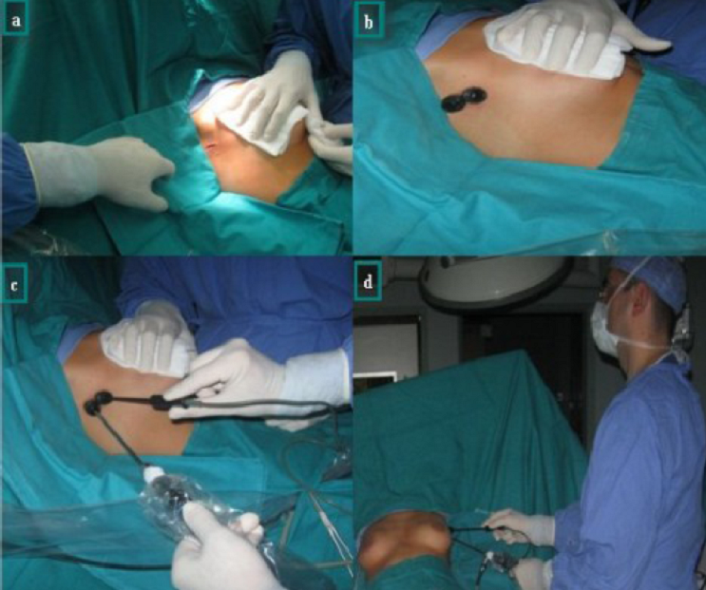
Fig. 1 – a) The incision on the wall of the thorax at the level of the third inter-rib space in the anterior axillary line;
b) The flexible 5 mm ports inserted in the pleural area; c, d) The camera and the employed instrument distributed
through the ports.

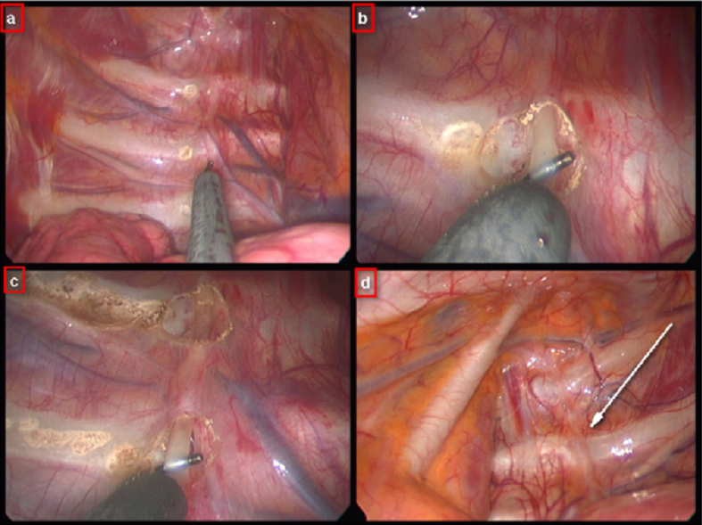
Fig. 2 – Intrapleural video assisted display of the sympathetic chain.
a) The ribs 2, 3 and 4 marked; b) The sympathetic chain at the level of the second rib, lifted by the instrument; c) The sympathetic chain at the level of the second rib cut off, whereas it is lifted by the instrument at the level of the third rib;
d) Intrapleural figure of the sympathetic chain to the left (white arrow).

Results
A total of 47 consecutive patients, 18 men and 29 women, average age 29 years (18–48 years), underwent bilateral transaxillary thoracoscopic sympathectomy at the Military Medical Academy (MMA), Clinic for Thoracic Surgery, between September 2009 and November 2010. Out of the total number, 68% of the patients were on beta-blockers therapy, sedatives or psychotherapy due to intensive hyperhidrosis symptoms, but without any significant subjective improvement. The sympathectomy was indicated in cases of facial blushing and sweating in 3 (6.38%) patients, palmary sweating in 16 (34.04%) patients, axillary sweating in 7 (14.89%) patients or both palmary and axillary sweating in 21 (44.68%) patients. The average duration of the bilateral surgical procedure was 45 minutes. After the surgery, the palms of all the operated patients were warm and dry. Pleural adhesions in one patient were so striking that the operation took 90 minutes, but the conversion into the open surgery was not necessary in any patient. Pleural drains were removed 4 hours after the surgery on average. The sum of 98.6% (44/47) of the patients left the hospital the following day.

Table 1
Symptoms overview in the patients operated on due to excessive facial blushing; prior to the operation and after a 12-month monitoring on the basis of the visual analogue scale (0 means the absence of symptoms and 10 means the worst possible symptom).
Patients with excessive facial blushing | Prior to the surgery | Monitoring after 12 months | p
Facial blushing | 9.0 ± 1.6 | 3.0 ± 2.1 | < 0.0005
Cardiac palpitations | 4.7 ± 1.6 | 1.3 ± 0.9 | < 0.008
Anxiety | 4.3 ± 2.5 | 2.3 ± 1.1 | < 0.004
Compensatory body sweating | 3.0 ± 0.5 | 4.5 ± 1.1 | = 0.3
Compensatory feet sweating | 2.7 ± 0.7 | 6.0 ± 1.3 | < 0.004
Note: results are given as ґ ± SD.
Table 2
Symptoms overview in the patients operated on due to excessive sweating of the palms and axilae, prior to the operation and after monitoring on the basis of the visual analogue scale (0 means the absence of symptoms and 10 means the worst possible symptom).
Hyperhidrosis (axilla, palms) | Prior to the surgery | Monitoring after 12 months | p
Palmar sweating | 8.1 ± 2.5 | 0.3 ± 0.8 | < 0.0001
Axillary sweating | 5.4 ± 2.8 | 3.4 ± 1.4 | < 0.02
Compensatory body sweating | 3.6 ± 1.1 | 5.3 ± 2.2 | < 0.004
Compensatory feet sweating | 3.8 ± 1.5 | 6.0 ± 2.5 | < 0.008
Note: results are given as ґ ± SD.
Complications observed postoperatively were recorded in 3 patients, in two (0.94%) cases partial pneumothorax after the removal of chest drains, and in one (0.47%) case unilateral transitory Horner’s syndrome. One of the patients suffering from partial pneumotorax was released two days after the surgery as the result of exuflation was satisfactory. His control X-ray after two days indicates a complete reexpansion of the lungs, whereas the other patient was drained and remained in hospital for five days in total due to persisting problems. A complete remission was accomplished after 16 weeks in the patient with signs of Horner’s syndrome. Severe complications were not noted.
All the patients (100%) were monitored after a year. Regular healing of wounds was ascertained along with excellent aestetic results. The shoulder area was symmetrical and functional in all the patients without any residual pain syndrome. All the 3 patients operated on for the reasons of facial blushing and sweating were openly satisfied with the effectiveness of the surgery, but intensified sweating of feet was noted.
The reduction in or absence of palmar sweating was noted in all the patients, (100%), who underwent surgery due to hyperhidrosis. The reduction in axillary sweating was found in 18/28 (64.28%) patients. Compensatory sweating of the trunk and lower limbs was stated in 32/44 (72.27%) patients. The improvement of life style and the absence of social phoebia was recorded in 45/47 (95.6%) patients whereas 2 (4.4%) patients were not satisfied with the effectiveness of the procedure due to excessive compensatory sweating in the lower part of the body after the 12 month’s monitoring. All the patients returned to work after a medium period of sick leave of 7 days (ranging from 1 to 15 days). Peroral use of analgetics up to 7 days following the surgical procedure was required in 90% of the patients (Tables 1 and 2).
Discussion
Thoracoscopic sympathectomy is an optimal procedure for surgical treatment of excessive facial, palmar and axillary blushing and sweating. Unlike many non-surgical treatments where results are slow and insufficient, the effect of this procedure is felt by patients immediately after waking up from anaesthesia.
Hyperchidrosis is a chronic disease that can have a significant negative impact on a patient’s quality of life. Primarily involving the axillae, palms, soles, and face, patients who have primary focal hyperhidrosis seek medical advice often long after they have been living with functional and psychosocial disability for some time. For every affected area of hyperhidrosis and at every stage of disease severity, conservative measures should be exhausted before progressing to surgical options. Generally, the most conservative options with the fewest adverse effects are attempted first. These include iontophoresis. A minimally invasive procedure, intradermal botox (BTX) injections have been shown to improve the disease significantly in these patients 5. Serving as an intermediate between conservative therapy and invasive surgery, BTX has revolutionized the treatment of focal hyperhidrosis. Oral medications such as glycopyrrolate can be tried alone at any point in treatment, or as a useful adjunct, but side effects are common and caution should be taken with highrisk patients. For all the forms of hyperhidrosis, the desired outcome for treatment should be qualitative and quantitative and it is critical for physicians to assess the patient’s improvement periodically and adjust therapy, based on these theraupetic landmarks.
Thoracoscopic sympathectomy for the excessive facial blushing and sweating was described for the first time in 1985 ¹¹. Still, the first comprehensive study on excessive facial blushing was published by the Swedish ‘Boras Group’ in 1998 ^{12, 13}. Several papers addressing isolated treatment of excessive facial blushing and sweating by means of thoracoscopic sympathectomy ^{14–22} have been published since then, but the number of papers on this subject is far smaller than the number of those dealing with the primary focal hyperhidrosis (axillae, palms), and because a small number of surgeons perform thoracoscopic sympathectomy in patients with the isolated problem of excessive facial blushing and sweating ²³.
Different surgical techniques are applied depending on the following: the number of incisions in the skin, usually two; the point where the ports are inserted; the manner of accessing the sympathetic chain; whether the chain is transected or the ganglia are electrocoagulated and disconnected at the head of the rib or metal clips are inserted ¹⁰.
This paper contains a series of 47 patients who underwent video-assisted thoracoscopic bilateral sympathectomy in a manner where ports were inserted through a single incision in the skin in the anterior axillary line at the level of the third inter-rib space posteriorly from the course of fibres of the large thoracic muscle. The lumen of the ports is 5 mm, one port serving for the insertion of the camera, the other for distributing instruments. This technique was described for the first time by Lardinois and Ris ²⁴ ten years ago who used the paedriatic cysto-resectoscope to transect the sympathetic chain. Benefits of this mechanism for performing the procedure are primarely reflected in a good aesthetic effect as the incision is small, and transaxillary localized. They are also reflected in the fact that the pain is lesser. In addition, the sympathetic chain can be clearly seen from the point of the first rib. The flexible 5 mm ports inserted through the same incision do not compromise one another, and the tissue is not significantly traumatized. Clinical check-up after 3 months from surgery showed regular healing of wounds and excellent aesthetic and functional results in all the patients. The complications found in 3 (1.4%) of the patients were smaller than normally ²⁵ and the conversion into open surgery was not necessary. Partial pneumothorax after endoscopic or open chest surgery is a known complication, and it is not specific when this intervention is concerned. Horner’s syndrome found in one (0.47%) patient is specific for this procedure, the incidence of which is more rare than the one normally found in the literature (2.7%) ²⁶. Symptomatology withdrew completely in patients after 16 weeks. The complication is most likely the result of the thermic injury of the stellate ganglion during identification of the sympathetic chain between the first rib and the second rib. In order to achieve a maximum reduction of this incidence, i.e. complication, it is necessary to identify precisely the first rib ²⁷.
Optimal understanding of denervation of the sympathetic chain due to excessive sweating is still a subject of a number of controversies, primarely due to a significant anatomic variability of the sympathetic chain. Some authors advocate for a limited sympathetic chain (T2–T3) transection in hyperhidrosis palmaris and additional transection T4 in axillary hyperhidrosis ²⁸. When facial blushing and sweating is concerned, Yilmaz et al. ¹⁸ recommend, as an additional step, excision of the lower third of the stellate ganglion. Most authors perform transection of the chain from T2 to T4 for optimal sympathetic denervation.
Severe side effects, particularly compensatory sweating (in this paper compensatory sweating of the trunk and lower limbs was stated in 32/44 (72.27%) of the patients, develop after multiple ganglionectomy. Some of these patients might be managed with medication. If that fails, then reversal is the only remaining option 29. If an extensive resection of the chain is performed, then a difficult nerve interposition is the only option.
In this paper we used the technique to perform transection of the sympathetic chain at a certain level depending on predominant symptoms and problems, and after precise anatomic identification of the first rib, and the separation of the sympathicus in layers thereafter. In cases of excessive facial blushing, the transection was performed inferior to the first rib T1, in the isolated excessive palmar sweating inferior to the second and the third ribs T2 and T3, in excessive axillary sweating under T4, and from the second through the fifth rib T2–T5, a complete transection was performed in cases of joint medical problems.
After a 12-month monitoring, the recurrence of symptoms following the initial regression was noted in 3 (6.38%) of the patients which is in conformity with the standards referred to in the world books where the recidive rate ranges from 4% to 8% ^{17, 29}.
Conclusion
A single incision transaxillary thoracoscopic sympathectomy offers great aesthetic and functional results. Potential sequellae and painful sensations on the chest wall, which can be a consequence of a surgical technique with 2 to 3 incisions for inserting ports, are avoided by means of this procedure. Sympathetic chain branching and its transection depending on discomfort generate the best results in patients suffering from hyperhidrosis palmaris.

REFERENCES

- Moisiuc FV, Colt HG. Thoracoscopy: origins revisited. Respiration 2007; 74(3): 344−55.
- Alexander W. Treatment of epilepsy. Edinburgh: Y.D. Pentland; 1889.
- Meachen GN. Profuse sweating. Practitioner 1911; 87: 589−92.
- Kuntz A. Distribution of the sympathetic rami to the brachial plexus.Its relation to sympathectomy affecting the upper extremity. Arch Surg 1927; 15: 871−7.
- Reisfeld R, Berliner KI. Evidence-based review of the nonsurgical management of hyperhidrosis. Thorac Surg Clin 2008; 18(2): 157−66.
- Solish N, Bertucci V, Dansereau A, Hong HC, Lynde C, Lupin M, et al. A comprehensive approach to the recognition, diagnosis, and severity-based treatment of focal hyperhidrosis: recommendations of the Canadian Hyperhidrosis Advisory Committee. Dermatol Surg 2007; 33(8): 908−23.
- Chandler KE. Video thoracoscopic dorsal sympathectomy : a new approach. Surg Laparosc Endosc 1993; 3(2): 112−4.
- Samuelsson H, Claes G, Drott C. Endoscopic electrocautery of the upper thoracic sympathetic chain: a safe and simple technique for tretment of sympathetically maintained pain. Eur J Surg Suppl 1994; (572): 55−7.
- Lee LS, Ng SM, Lin CC. Single-lumen endotracheal intubated anaesthesia for thoracoscopic sympathectomy--experience of 719 cases. Eur J Surg Suppl 1994; (572): 27−31.
- Rex LO, Drott C, Claes G, Göthberg G, Dalman P. The Borås experience of endoscopic thoracic sympathicotomy for palmar, axillary, facial hyperhidrosis and facial blushing. Eur J Surg Suppl 1998; (580): 23−6.
- Wittmoser R. Treatment of sweating and blushing by endoscopic surgery. Acta Neurochir (Wien) 1985; 74(3−4): 153−4.
- Rex LO, Drott C, Claes G, Göthberg G, Dalman P. The Borås experience of endoscopic thoracic sympathicotomy for palmar, axillary, facial hyperhidrosis and facial blushing. Eur J Surg Suppl 1998; (580): 23−6.
- Drott C, Claes G, Olsson-Rex L, Dalman P, Fahlén T, Göthberg G. Successful treatment of facial blushing by endoscopic transthoracic sympathicotomy. Br J Dermatol 1998; 138(4): 639−43.
- Lin CC, Telaranta T. Lin-Telaranta classification: the importance of different procedures for different indications in sympathetic surgery. Ann Chir Gynaecol 2001; 90(3): 161−6.
- Reisfeld R, Nguyen R, Pnini A. Endoscopic thoracic sympathectomy for hyperhidrosis: experience with both cauterization and clamping methods. Surg Laparosc Endosc Percutan Tech 2002; 12(4): 255−67.
- Krasna MJ, Jiao X, Sonett J, Gamliel Z, King K. Thoracoscopic sympathectomy. Surg Laparosc Endosc Percutan Tech 2000; 10(5): 314−8.
- Lardinois D, Ris HB. Minimally invasive video-endoscopic sympathectomy by use of a transaxillary single port approach. Eur J Cardiothorac Surg 2002; 21(1): 67−70.
- Yilmaz EN, Dur AH, Cuesta MA, Rauwerda JA. Endoscopic versus transaxillary thoracic sympathectomy for primary axillary and palmar hyperhidrosis and/or facial blushing: 5-year-experience. Eur J Cardiothorac Surg. 1996; 10(3): 168−72.
- Neumayer C, Zacherl J, Holak G, Jakesz R, Bischof G. Experience with limited endoscopic thoracic sympathetic block for hyperhidrosis and facial blushing. Clin Auton Res 2003; 13 Suppl 1: I52−7.
- Rajesh YS, Pratap CP, Woodyer AB. Thoracoscopic sympathectomy for palmar hyperhidrosis and Raynaud's phenomenon of the upper limb and excessive facial blushing: a five year experience. Postgrad Med J 2002; 78(925): 682−4.
- Licht PB, Pilegaard HK, Ladegaard L. Sympathicotomy for isolated facial blushing: a randomized clinical trial. Ann Thorac Surg 2012; 94(2): 401−5.
- Malmivaara A, Kuukasjärvi P, Autti-Ramo I, Kovanen N, Mäkelä M. Effectiveness and safety of endoscopic thoracic sympathectomy for excessive sweating and facial blushing: a systematic review. Int J Technol Assess Health Care 2007; 23(1): 54−62.
- Khan AZ, Morgan SC, Currie IC, Lewis P, Lewis DR. Current practice of transthoracic endoscopic sympathectomy in the south west of England: an e-mail survey. Eur J Vasc Endovasc Surg 2001; 22(4): 373−5.
- Lardinois D, Ris HB. Minimally invasive video-endoscopic sympathectomy by use of a transaxillary single port approach. Eur J Cardiothorac Surg 2002; 21(1): 67−70.
- Herbst F, Plas EG, Függer R, Fritsch A. Endoscopic thoracic sympathectomy for primary hyperhidrosis of the upper limbs. A critical analysis and long-term results of 480 operations. Ann Surg 1994; 220(1): 86−90.
- Wong CW. Transthoracic video endoscopic electrocautery of sympathetic ganglia for hyperhidrosis palmaris: special reference to localization of the first and second ribs. Surg Neurol 1997; 47(3): 224−9; discussion 229−30.
- Bonjer HJ, Hamming JF, du Bois NAJJ, van Urk H. Advantages of limited thoracoscopic sympathectomy. Surg Endosc 1996; 10(7): 721−3.
- Raposio E, Filippi F, Nordström RE, Santi P. Endoscopic transthoracic dorsal sympathectomy for the treatment of upper extremity hyperhidrosis: a new minimally invasive approach. Plast Reconstr Surg 1998; 102(5): 1629−32.
- Licht PB, Clausen A, Ladegaard L. Resympathicotomy. Ann Thorac Surg 2010; 89(4): 1087−90.
Received on January 22, 2012.
Revised on November 16, 2012.
Accepted on January 30, 2013.
OnLine-First October, 2013.

