CASE REPORT |  | UDC: 616.831-001.8-06  DOI: 10.2298/VSP1405515B
Improvement of post-hypoxic action myoclonus with levetiracetam add-on therapy: A case report
Poboljšanje akcionog posthipoksičnog mioklonusa primenom dodatne terapije levetiracetamom

Ksenija Božić, Ksenija Gebauer-Bukurov, Lorand Sakalaš, Ivana Divjak,
Aleksandar Ješić
Clinic for Neurology, Clinical Center of Vojvodina, Novi Sad, Serbia

Abstract

Introduction. Chronic post-anoxic myoclonus, also known as Lance-Adams syndrome, may develop following hypoxic brain injury, and is resistant to pharmacological therapy. Case report. The patient we presented developed post-anoxic action myoclonus with severe, completely incapacitating myoclonic jerks. Myoclonus did not respond to the treatment with commonly used agents, i.e. valproate and clonazepam alone or in combination. Improvement of the action myoclonus was observed only after adding levetiracetam. Conclusion. Although Lance-Adams syndrome may not be fully curable at this point, levetiracetam appears to be a promising agent that can significantly improve functional level and overall quality of life of patients with this disorder.

Key words:
myoclonus; anoxia; syndrome; diagnosis; drug therapy; drug resistance; treatment outcome.
Apstrakt

Uvod. Hronični postanoksični mioklonus, poznat i kao Lance-Adamsov sindrom, može se javiti nakon hipoksične povrede mozga i rezistentan je na farmakološku terapiju. Prikaz bolesnika. Prikazan je bolesnik sa postankosičnim mioklonusom i izraženim miokloničnim trzajevima koji su doveli do njegove potpune onesposobljenosti. Mioklonije nisu reagovale na uobičajene lekove kao što je valproat i klonazepam pojedinačno ili u kombinaciji. Poboljšanje akcionog mioklonusa postignuto je tek nakon uvođenja levetiracetama u dodatnoj terapiji. Zaključak. Iako još nije moguće potpuno izlečenje sindroma Lans-Adams, levetiracetat znatno popravlja funkcionalni i nivo ukupnog kvaliteta života bolesnika sa ovim poremećajem.

Ključne reči:
mioklonus; anoksija; sindrom; dijagnoza; lečenje lekovima; lekovi rezistencija; lečenje, ishod.

Introduction
Post-hypoxic action myoclonus (PAM), first described by Lance and Adams in 1963, is characterized mainly by action myoclonus and associated cerebellar ataxia, mild intellectual deficit and resistance to conventional pharmacological agents ¹. This syndrome is caused by anoxia of the central nervous system, generally in the course of primary respiratory failure. It is a rare condition, with fewer than 150 cases reported in the literature. We presented a male patient who survived hypoxic brain injury, after which he developed severe action-triggered jerks unresponsive to standard anticonvulsants, and had partial improvement only after levetiracetam was added. We discussed clinical and electroencepahalographic features of our patient in the light of the relevant published data.
Case report
According to available medical history data, a 58-year-old male injured in a car-accident (March 2009) experienced anoxia during surgery on his fractured zygomatic bone in a local hospital. For the following five days the patient remained in coma, receiving respiratory support. While in coma, eight hours after the surgery, the patient developed seizure-like generalized tonic-clonic movements. He was treated with phenobarbital and diazepam injections. Electroencephalography (EEG) was not performed at this time, and brain computed tomography (CT) was reported as normal.
After five days, when the patient regained consciousness, he had no hemiparesis or aphasia, but generalized myoclonus was present accompanied by dysmetria, dysarthria and impaired swallowing. Because of myoclonus he was unable to sit from a supine position, stand up after sitting in a wheelchair, walk without aid, or perform simple, coordinated manual tasks. Myoclonic jerks would disappear only during sleep. Repeated brain CT showed abnormal, frontal and temporal lesions corresponding to contusion.
Brain magnetic resonance imaging (MRI) and magnetic resonance angiography (MRA) performed three weeks after the anoxic event demonstrated a few lacunar infarcts in the cerebral white matter without signs of postcontusion lesions, and with insignificant bilateral stenosis of the common and internal carotid arteries (Figure 1).
Despite the treatment with phenobarbital (100 mg/day p.o.), diazepam (20 mg/day i.m.) and carbamazepine (300 mg/day p.o.) the patient continued to have multifocal myoclonus that increased with voluntary movements and nurse’s manipulation. The patient was therefore referred to electrophysiological evaluation at our tertiary clinic. Simple EEG demonstrated paroxismal abnormalities in the form of rapid series of spikes and polyspikes on slow-wave background activity. The EEG spikes were highly frequent, generalized, with an amplitude maximum at the vertex and often followed by slow waves (Figure 2). Myoclonic jerks and paroxismal EEG abnormalities were not strictly related to each other. Somatosensory evoked responses (SSEP) were normal.

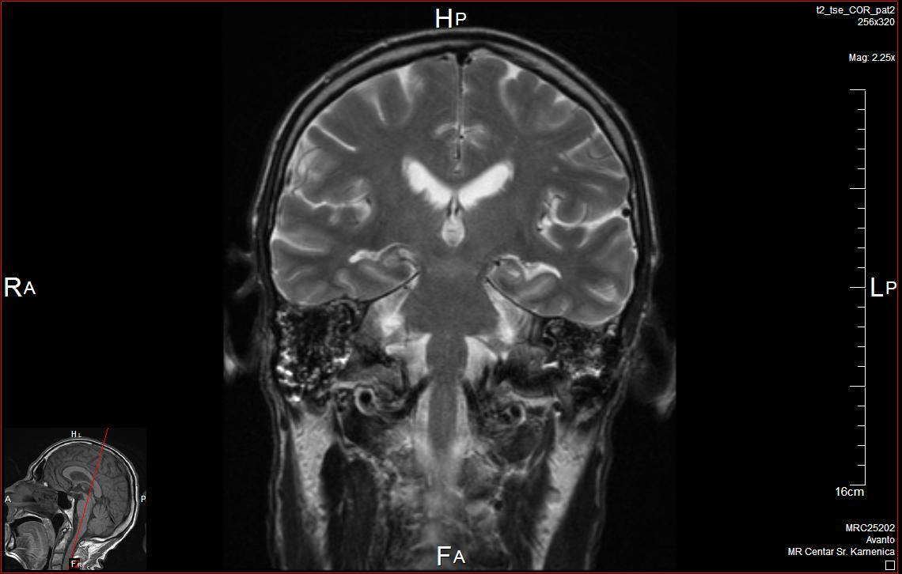 | 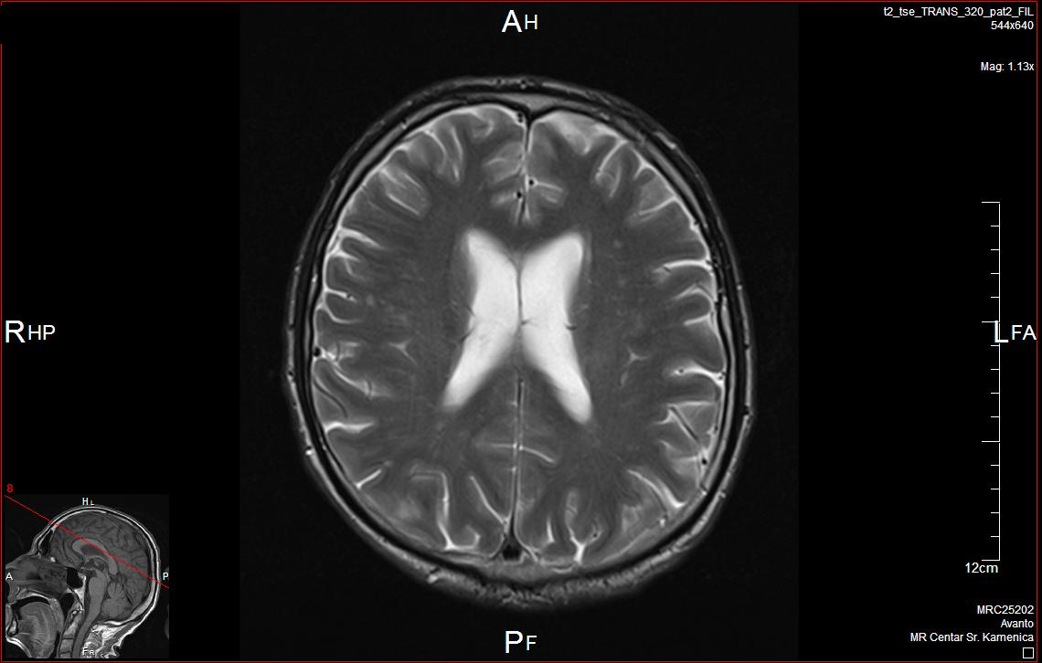
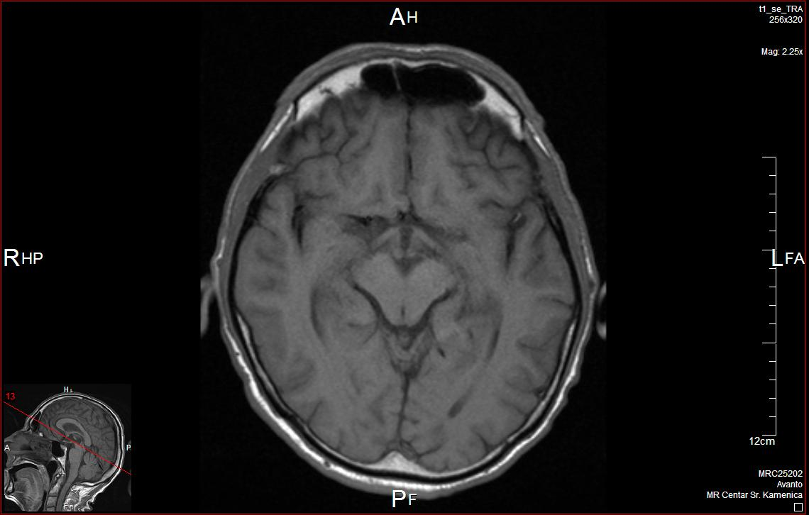 | 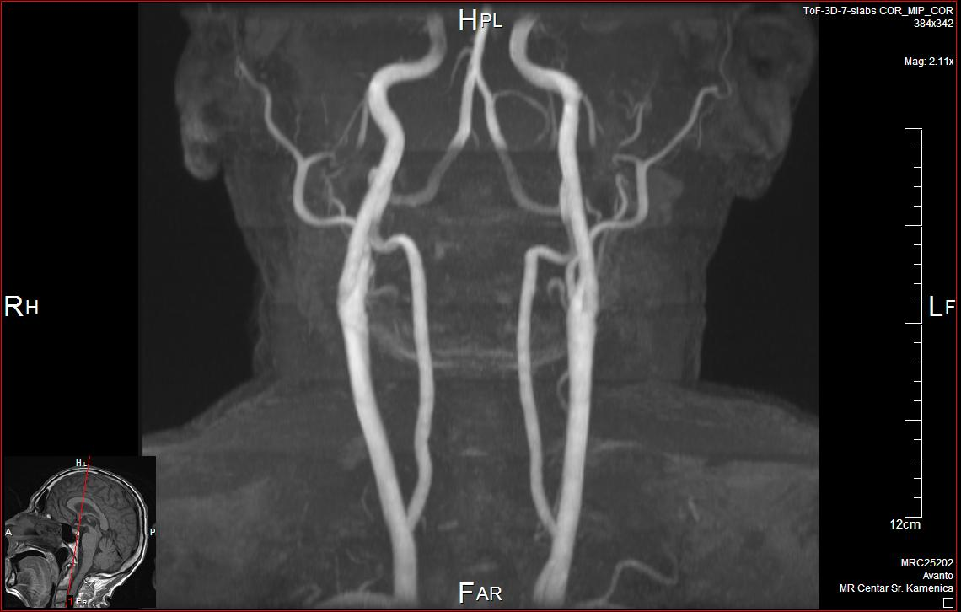
Fig. 1 – Lacunar infarcts in the cerebral white matter demonstrated by brain magnetic resonance imaging (MRI); magnetic resonance angiography (MRA) without significant pathological changes.

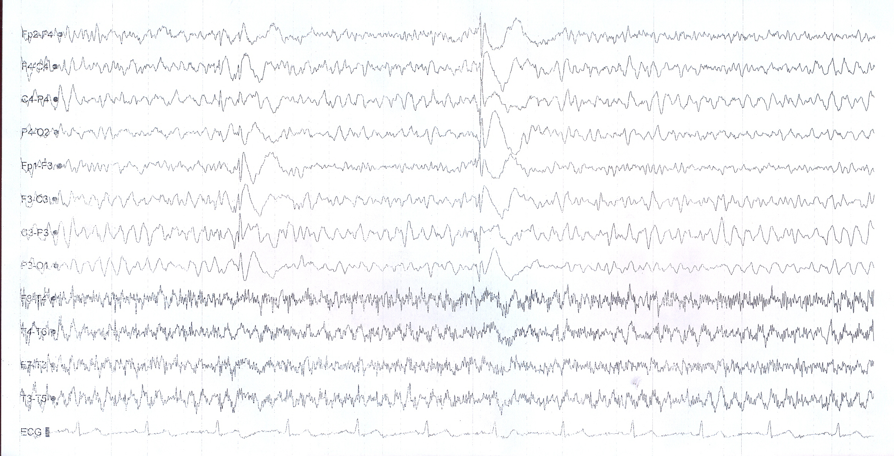
Fig. 2 –Electroencephalography (EEG) before levetiracetam (LEV) was added (longitudinal montage; 30 mm/sec, 7 μV/mm, 70.0 Hz, 1,600 Hz, Notch Off).

The diagnosis of post-hypoxic action myoclonus was established, and discontinuation of phenobarbital and carbamazepine was advised. Drugs known to control myoclonus were administered progressively, first sodium valproate (VPA) (1000 mg/day p.o.) and then clonazepam (CZP) (2 mg/day p.o.), thereafter the frequency and severity of myoclonus slightly decreased. The patient’s speech and swallowing improved, he was able to turn himself in bed, sit up and stand up for a while, but he was unable to walk without aid.
At this point he was discharged from the local hospital and for the following six months he was receiving VPA (1750 mg/day), CZP (6 mg/day), lamotrigine (LTG) (200 mg/day) and sertraline (50 mg/day). However, there was no further improvement, and due to action myoclonus the patient was bed-bound and completely dependent. Levetiracetam (LEV) (250 mg b.d.) was added to the therapy, to which an immediate response was seen. The LEV dose was gradually increased up to 3,000 mg/day and a marked clinical improvement of action myoclonus was achieved. On EEG, central spiking was dramatically reduced, small-amplitude intermediate centro-temporal slow activity over both hemispheres on normal background activity was noted (Figure 3). The patient’s overall quality of life was considerably improved. He could sit and stand up without support and had no significant cognitive impairment. Dysarthria and daily activities, such as eating and dressing, improved as well. However, he was still mildly ataxic, able to walk only about 150 meters independently, prone to sudden falling because of “sudden weakness in his legs” (negative myoclonus), still requiring supervision.
The patient’s condition remained constant on the therapy (VPA 1,500 mg/day + CZP 6 mg/day + LEV 3,000 mg/day) for the past two years.

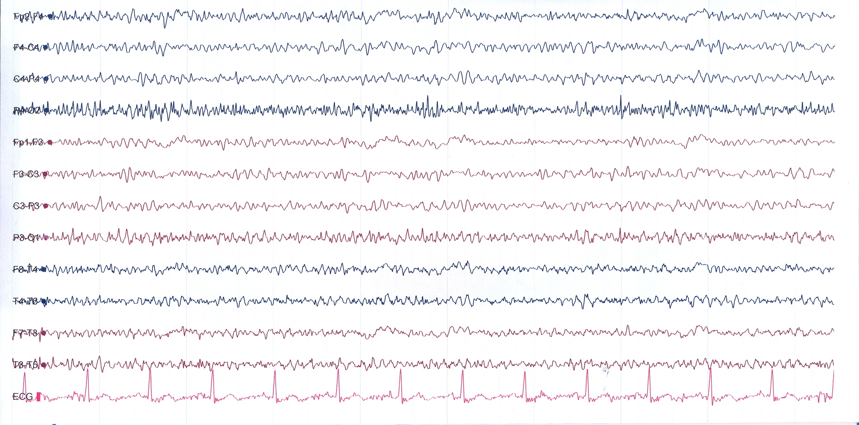
Fig. 3 – Electroencephalography (EEG) after levetiracetam (LEV) was added (longitudinal montage; 30 mm/sec, 7 μV/mm, 70.0 Hz, 1,600 Hz, 50Hz).

Discussion
Post-anoxic action myoclonus is a distinct entity that can develop in survivors of anoxic brain injury. It is a rare but devastating complication of near-fatal cardiopulmonary arrest (e.g., cardiac arrest, anesthesia accident during surgical procedures, asthmatic attacks, airway obstruction and drug intoxication).
Clinical presentation of PAM is quite distinct and in most cases, like in our case, the diagnosis can be established on the clinical ground alone. In chronic PAM, myoclonus is noted within a few days to some months after the acute episode. The myoclonus may be accompanied by dysmetria, dysarthria and ataxia, with relatively preserved higher cognitive functions ^{2, 3}. Several types of myoclonus can be observed in this syndrome: cortical, subcortical, brainstem, reticular myoclonus, and exaggerated startle. Myoclonus may originate from either cortical or subcortical foci, although both forms may coexist ⁴. Myoclonus may be focal, multifocal, segmental or generalized, it may be spontaneous or stimulus-sensitive, but typically is precipitated by movement intention and voluntary action ². Both positive and negative myoclonus may exist, separately or in association. Negative myoclonus may involve the hamstrings and quadriceps muscles, producing a characteristic “bouncing” gait and/or sudden falls ^{5, 6}. Lapses of postural control due to negative myoclonus may play an important role in producing the clinical picture of more obvious muscle jerking ⁷. Clinical course of chronic PAM is variable. Gradually, myoclonus and neurological deficits improve, although the brainstem reticular reflex myoclonus may be associated with a poorer prognosis ^{2, 5}. In our patient, myoclonus was multifocal, action- and stimulus-sensitive, bilateral and generalized. Action jerks were more prominent distally and occurred particularly at the onset of a limb movement. His facial muscles were involved as well, affecting speech and swallowing. He was mildly ataxic without cognitive impairment. As it is typical with negative myoclonus, in our patient lapses in contraction of anti-gravity muscles became more apparent when the patient attempted to walk.
The mechanism underlying this movement disorder remains largely unknown. Alterations in multiple neurochemical systems have been reported in animal and human studies, pointing out that abnormalities within the serotonin system and/or a loss of GABA-ergic inhibition may influence the pathophysiological mechanism of PAM ^{8, 9}. According to recent neuroimaging data, it is likely that subcortical neuronal networks including the ventrolateral thalamus are involved ^{10, 11}.
Imaging findings of brain CT and MRI in patients with PAM are usually unremarkable. MRI may occasionally show loss of grey-white matter distinction and selective neuronal injuries in the grey deep nuclei, but usually it is not specific of PAM ^{2, 5}. In agreement with published data, in our patient brain MRI revealed only a few small lesions in the cerebral white matter consistent with infarction.
In chronic PAM EEG background activity is usually normal, occasionally associated with spikes or spike-waves that are enhanced by movement or other stimuli ^{2, 12}. In some cases, EEG-EMG polygraphy with back-averaging and giant somatosensory evoked potentials are required to confirm the diagnosis (i. e., cortical origin of action myoclonus). In our patient, the standard EEG was initially abnormal. Abnormalities consisted of bilateral spikes, sharp waves or spike/poly-spike slow-wave complexes mainly over the vertex on slow (theta/alpha) background activity. These were only occasionally accompanied by muscle jerks. Cortical somatosensory evoked potentials (SSEPs) were normal. The EEG-EMG polygraphy with back-averaging of the EEG activity preceding jerks were not done.
Therapy of chronic PAM is difficult and empiric. Because of the relative rarity of the syndrome, case-controlled data are lacking. Several treatment options have been previously proposed, however, the results are inconsistent. Drugs that augment GABA-ergic transmission are useful in all types of myoclonus, and CZP and VPA are the first-line treatments ^{13, 14}. Approximately 50% of patients respond to treatment, although often partially ⁵. Standard anticonvulsants, such as phenobarbital, carbamazepine and lamotrigine, were not efficient in our patient, which is in accordance with previous findings ¹⁵. Efficacy of piracetam, as a very potent antimyoclonic agent, was reported many years ago, first in patients with Lance-Adams syndrome ¹⁶. However, very high doses of piracetam (20–45 g/day) needed to reach efficacy is not very practical and can impede compliance ^{17–19}.
Novel anti-epileptic medications such as levetiracetam and zonisamide (ZNS) have recently been described to be useful in the control of myoclonus disorders, including Lance-Adams syndrome ^{20, 21}. A body of evidence suggests that LEV may be effective in both positive and negative myoclonus ^{22, 23} as well as in patients with post-hypoxic and postencephalitic myoclonus ²⁴. The exact mechanism of action of LEV is unknown. It was found to be effective for the treatment of PAM in higher doses (3000–4000 mg/day) than those used for seizures ^{25, 26}, although Krauss et al. ²⁴ achieved a good response with low doses (1000 mg/day). In our patient improvement of action myoclonus ensued in the first day of LEV therapy. We used relatively high doses of LEV add-on therapy (3000 mg/day) and successfully controlled the action myoclonus without any unwanted side effects. Interestingly, LEV was not so effective for negative myoclonus in our case. However, although our patient did not recover completely, the treatment with LEV add-on therapy seems to have significantly improved his quality of life.
Conclusion
Although Lance-Adams syndrome may not be fully curable at this point, levetiracetam appears to be a promising agent that can significantly improve functional level and overall quality of life of patients with this disorder.

REFERENCES

- Lance JW, Adams RD. The syndrome of intention or action myoclonus as a sequel to hypoxic encephalopathy. Brain 1963; 86: 111−36.
- Werhahn KJ, Brown P, Thompson PD, Marsden CD. The clinical features and prognosis of chronic posthypoxic myoclonus. Mov Disord 1997; 12(2): 216−20.
- Borg M. Symptomatic myoclonus. Neurophysiol Clin 2006; 36(5−6): 309−18.
- Frucht S, Fahn S. The clinical spectrum of posthypoxic myoclonus. Mov Disord 2000; 15(Suppl 1): 2−7.
- Hallett M, Chadwick D, Adams J, Marsden CD. Reticular reflex myoclonus: a physiological type of human post-hypoxic myoclonus. J Neurol Neurosurg Psychiatry 1977; 40(3): 253−64.
- Frucht SJ. The clinical challenge of posthypoxic myoclonus. Adv Neurol 2002; 89: 85–8.
- Lance JW, Adams RD. Negative myoclonus in post-hypoxic patients: historical note. Mov Disor 2001; 16(1): 162−3.
- Truong DD, Kirby M, Kanthasamy A, Matsumoto RR. Posthypoxic myoclonus animal models. Adv Neurol 2002; 89: 295−306.
- Matsumoto RR, Truong DD, Nguyen KD, Dang AT, Hoang TT, Vo PQ, et al. Involvement of GABA(A) receptors in myoclonus. Mov Disord 2000; 15 (Suppl 1): 47−52.
- Tai KK, Truong DD. Post-hypoxic myoclonus induces Fos expression in the reticualr thalamic nuclei and neurons in brainstem. Brain Res 2005; 1059(2): 122−8.
- Frucht SJ, Trost M, May Y, Eidelberg D. The metabolic topography of posthypoxic myoclonus. Neurology 2004; 62(10): 1879−81.
- Witte OW, Niedermeyer E, Arendt G, Freund HJ. Post-hypoxic action (intention) myoclonus: a clinico-electroencephalographic study. J Neurol 1988; 235(4): 214−8.
- Rollinson RD, Gilligan BS. Postanoxic action myoclonus (Lance Adams syndrome) responding to valproate. Arch Neurol 1979; 36(1): 44−5.
- Frucht SJ. Myoclonus. Curr Treat Options Neurol 2000; 2(3): 231−42.
- Polesin A, Stern M. Post-anoxic myoclonus: A case presentation and review of management in the rehabilitation setting. Brain Inj 2006; 20(2): 213−7.
- Terwinghe G, Daumerie J, Nicaise C, Rosillon O. Therapeutic effect of piracetam in a case of posthypoxic action myoclonus. Acta Neurol Belg 1978; 8(1): 30−6. (French)
- Obeso JA, Artieda J, Quinn N, Rothwell JC, Luquin MR, Vaamonde J, et al. Piracetam in the treatment of different types of myoclonus. Clin Neuropharmacol 1988; 11(6): 529−36.
- Genton P, Guerrini R, Remy C. Piracetam in the treatment of cortical myoclonus. Pharmacopsychiatry 1999; 32(Suppl 1): 49−53.
- Janszky J, Holló A, Halász P. Treatment and long term follow-up of post-anoxic myoclonus. Orv Hetil 2001; 142(38): 2091−3. (Hungarian)
- Genton P, Gelisse P. Antimyoclonic effect of levetiracetam. Epileptic Disord 2000; 2(4): 209−12.
- Lim LL, Ahmed A. Limited efficacy of levetiracetam on myoclonus of different etiologies. Parkinsonism Relat Disord 2005; 11(2): 135−7.
- Gelisse P, Crespel A, Genton P, Baldy-Moulinier M. Dramatic effect of levetiracetam on epileptic negative myoclonus. Acta Neurol Scand 2003; 107 (4): 302−3.
- Yu HY, Kwan SY, Lirng JF, Liao KK, Chu YK, Liao SQ. Epileptic negative myoclonus: SPECT, PET, and video/EEG studies and the dramatic effects of levetiracetam. Epilepsy Behav 2009; 14(4): 687−90.
- Krauss GL, Bergin A, Kramer RE, Cho YW, Reich SG. Suppression of post-hypoxic and post-encephalitic myoclonus with levetiracetam. Neurology 2001; 56(3): 411−2.
- Genton P, Gelisse P. Suppression of posthypoxic and post-encephalitic myoclonus with levetiracetam. Neurology 2001; 57(6): 1144−5.
- Venot M, Weiss N, Espinoza S, Imbert A, Tadie JM, Fagon JY, et al. Improvement of early diagnosed post-anoxic myoclonus with levetiracetam. Intensive Care 2011; 37(1): 177−9.
Received on January 8, 2012.
Revised on January 22, 2013.
Accepted on January 24, 2013.

