ORIGINAL ARTICLE |  | UDC: 576.3::616.314.18-053.2  DOI: 10.2298/VSP1408735D
Characterization of deciduous teeth stem cells isolated from crown dental pulp
Karakterizacija matičnih ćelija izolovanih iz zubne pulpe mlečnih zuba dece

Jasmina Debeljak Martačić*, Jelena Francuski†, Tijana Lužajić†,
Nemanja Vuković‡, Slavko Mojsilović*, Neda Drndarević‡, Marijana Petakov‡, Marija Glibetić*, Danica Marković†, Anita Radovanović†, Vera Todorović‡, Milica Kovačević Filipović†
*Institute for Medical Research, University of Belgrade, Belgrade, Serbia; †Department of Pathophysiology, Faculty of Veterinary Medicine, University of Belgrade, Belgrade, Serbia; ‡Faculty of Stomatology, University of Business Academy, Pančevo, Serbia

Abstract

Background/Aim. The last decade has been profoundly marked by persistent attempts to use ex vivo expanded and manipulated mesenchymal stem cells (MSCs), as a tool in different types of regenerative therapy. In the present study we described immunophenotype and the proliferative and differentiation potential of cells isolated from pulp remnants of exfoliated deciduous teeth in the final phase of root resorption. Methods. The initial adherent cell population from five donors was obtained by the outgrowth method. Colony forming unit–fibroblast (CFU-F) assay was performed in passage one. Cell expansion was performed until passage three and all tests were done until passage eight. Cells were labeled for early mesenchymal stem cells markers and analysis have been done using flow cytometry. The proliferative potential was assessed by cell counting in defined time points and population doubling time was calculated. Commercial media were used to induce osteoblastic, chondrogenic and adipogenic differentiation. Cytology and histology methods were used for analysis of differentiated cell morphology and extracellular matrix characteristics. Results. According to immunophenotype analyses all undifferentiated cells were positive for the mesenchymal stem cell markers: CD29 and CD73. Some cells expressed CD146 and CD106. The hematopoietic cell marker, CD34, was not detected. In passage one, incidence of CFU-F was 4.7 ± 0.5/100. Population doubling time did not change significantly during cell subcultivation and was in average 25 h. After induction of differentiation, the multicolony derived cell population had a tri-lineage differentiation potential, since mineralized matrix, cartilage-like tissue and adipocytes were successfully formed after three weeks of incubation. Conclusion. Altogether, these data suggest that remnants of deciduous teeth dental pulp contained cell populations with mesenchymal stem cell-like features, with a high proliferation and tri-lineage differentiation potential and that these cultures are suitable for further in vitro evaluation of cell based therapies.

Key words:
dental pulp; stem cells; tooth, deciduous; child, preschool; cell differentation; adipogenesis; chondrogenesis; osteogenesis.

Apstrakt

Uvod/Cilj. Prošla dekada je bila posebno obeležena naporima na polju korišćenja ex vivo razvijenih i usmeravanih mezenhimskih matičnih ćelija (MSCs), kao sredstva za različite tipove regenerativne terapije. Cilj ove studije bio je da se utvrdi imunofenotip i potencijal za proliferaciju i diferencijaciju ćelija izolovanih iz zubne pulpe mlečnih zuba dece eksfoliranih u periodu kada je koren zuba bio u poslednjoj fazi resorpcije. Metode. Primarna adherentna populacija ćelija poreklom od pet donora dobijena je metodom eksplanta. Prisustvo progenitorskih ćelija koje obrazuju kolonije fibroblasta (CFU-F) pokazano je u prvoj pasaži. Do treće pasaže ćelije su ekspandirane, a potom korišćene za analiziranje. Imunofenotip je određen korišćenjem protočne citometrije. Proliferativni potencijal i vreme udvajanja ćelija (PDT) u kulturi je definisano na osnovu apsolutnog broja ćelija na početku i na kraju svake pasaže. Posle tronedeljne kultivacije ćelija u komercijalnim medijumima za stimulaciju osteogeneze, hondrogeneze i adipogeneze, citološkim i histološkim metodama je određena morfologija ćelija i karakteristike vanćelijskog matriksa. Rezultati. Antigeni koji karakterišu mezenhimske matične ćelije CD29 i CD73 su bili eksprimirani na svim nediferenciranim ćelijama, dok su antigeni CD146 i CD106 bili eksprimirani na ograničenom broju ćelija. Antigen CD34 (karakterističan za ćelije hematopoetske loze) nije bio eksprimiran. Incidencija CFU-F bila je 4,7 ± 0,5/100 ćelija. PDT se nije menjao tokom osam pasaža i u proseku je iznosio 25 h. Posle tronedeljne stimulacije diferencijacije u kulturama sa adipogenim medijumom došlo je do stvaranja ćelija sa masnim kapljicama, a u kulturama sa osteogenim medijumom došlo je do formiranja vanćelijskog matriksa sa deponovanim kalcijumovim solima. U kulturama sa hondrogenim medijumom došlo je do stvaranja tkiva sličnog hrskavici i vanćelijskog matriksa sa glikozaminoglikanima i kolagenom II. Zaključak. Zubna pulpa mlečnih zuba dece sadrži ćelijsku populaciju koja odgovara mezenhimskim matičnim ćelijama prema svojim karakteristikama, ima visok proliferativni potencijal i potencijal da se diferencira u tri ćelijske linije što je čini pogodnom za dalje in vitro analize i evaluaciju ćelijske terapije.

Ključne reči:
zub, pulpa; ćelije, matične; denticija, mlečna; deca, predškolska; ćelija, diferencijacija; adipogeneza; hondrogeneza; osteogeneza.

Introduction
The last decade has been profoundly marked by persistent attempts to use ex vivo expanded and manipulated mesenchymal stem cells (MSCs), as a tool in different types of regenerative therapy. Most of them were focused on healing diseases and injuries of the musculoskeletal system ¹, as well as solving problems in dental medicine ².
Research targeting cell therapy and tissue engineering in regeneration of tooth structures, was stimulated after Gronthos and coworkers ³ described dental pulp stem cells (DPSC) isolated from impacted third molars of adult donors. Clinically interesting populations of cells have also been isolated from deciduous teeth. Thus, Miura et al. ⁴ described stem cells from human exfoliated deciduous teeth (SHED) and Kerkis et al. ⁵ obtained immature DPSC (IDPSC) from the same source. Subsequently, several more papers confirmed these findings and enlarged our knowledge about stem cells that could be isolated from deciduous dental pulp ^{6–11}. In the review of Kerkis and Caplan ¹² all isolated cell populations were named deciduous teeth stem cells (DTSC) with the conclusion that they have a higher colony forming cell score and a higher proliferation rate than DPSC, and therefore are more primitive than their counterparts isolated from permanent teeth. The pluripotent nature of DTSC, and the fact that teeth develop from oral ectoderm and neural crest-derived mesenchyme, leaded some investigators to conclude that these cells display developmental potential similar to embryonic stem cells ¹³. In vivo, SHEDs generate a tissue with morphological and functional properties that closely resemble those of human dental pulp ¹⁴ and strongly induce bone formation ⁴. Besides stem cells from dental pulp, periodontal ligament stem cells ¹⁵, dental follicle progenitor cells ¹⁶, stem cells from apical papilla ¹⁷ and even stem cells from periapical lesions have been described ¹⁸. Development in the field of biomaterials and tissue engineering, together with stem cell research, has shown promising results for the development of optimal restorations to replace lost tooth structures.
Special interest in characterization of stem cell populations that can be found in dental pulp of human exfoliated deciduous teeth is underlined by the fact that these cells are easly obtained. Instead of being discarded, they could be cryopreserved, and if necessary, expanded and used for autologeous or allogeneous treatment.
The aim of this study was to test the proliferation and differentiation potential of cells isolated from dental pulp of human exfoliated deciduous teeth in the final phase of root resorption, and to describe their colony forming capacity, population doubling time, immunophenotype in the undifferentiated state and their tri-lineage differentiation capacity. The term DTSC will be used subsequently for the cell population isolated in this work.
Methods
Isolation of the initial cell population
Deciduous incisor teeth from children aged 6 and 7 years (5 patients) were obtained after extraction due to orthodontic reasons, under local anesthetic, with informed consent of their parents and ethical comity approval. Teeth roots were in the final phase of resorption with viable pulp tissue. Only crowns that contained gelatinous pinkish pulp tissue were used. Dental pulp was pulled out with a barbed Nervbroach, washed twice with sterile phosphate buffered saline (PBS) supplemented with antibiotics (100 U/ml penicillin and 100 µg/ml streptomycin) and antimycotic (2.5 µg/ml amphotericin B) – AA solution (antibiotic/antimycotic). Pulp tissue was minced into 1–2 mm fragments, transferred to 35 mm Petri dishes and cultivated using Dulbecco’s modified Eagle’s medium (DMEM) / Ham’s F12 (1:1, Invitrogen, Carlsbad, California, USA) supplemented with 10% FBS MSC qualified (Invitrogen, Carlsbad, California, USA) and AA solution. Cultures were incubated at 37°C in a humified atmosphere with 5% CO₂.
The growing culture of the initial cell population (passage 0) was maintained for 10 to 15 days, dissociated in a 0.05% TrypLE™ Express (Invitrogen, Carlsbad, California, USA), and seeded at 1 × 10⁵ cells per 25 cm² flasks. Cultures initiated as multicolony culture systems were maintained semi-confluent in order to prevent premature senescence. Thus, the cells were passed every 5 days, while the medium was replaced every 2–3 days. Cells were used from passages three to eight.
Colony forming unit fibroblast (CFU-F) assay
After harvesting cells from passage 0, single-cell suspensions (1 × 10⁴ cells) designated passage 1, within DMEM/F12 containing 10% FBS were seeded into T 25 tissue culture flasks (BD Falcon, Becton, Dickinson and Company – BD, NJ, USA). After 10 days, cultures were fixed with 10% methanol, and then stained with Crystal violet solution. Aggregates containing 50 or more cells were counted as CFU-F under the microscope.
For assessment of colony-forming efficiency (CFE), cells in the fourth passage were plated at a density of 500 cells in six-well plates and colony formation was inspected under a microscope after 7 days of culture. The CFE index was calculated by dividing the number of colonies formed by the number of cells plated and multiplying with the factor 100.
Population doubling time
For analysis of population doubling time (PDT), cells were seeded at a density of 1 × 10⁴ cells/well in six-well plates. The cell number was assessed after 4 days, with a hemocytometer, after collecting cells from the wells by trypsinization (3 replicates for each time point). PDT was calculated by the formula: PDT = [ln (Nt / N0) / ln (2)] / t (t = the time period, Nt = number of cells at time t and No = initial number of cells).

Flow cytometry
After harvesting, cells (third to sixth passage) were washed in cold PBS supplemented with 0.5% BSA (Sigma-Aldrich, Saint Louis, MO, USA). Aliquots of 5 × 10⁵ cells were labeled (30 min in the dark at 4ºC) with monoclonal antibodies specific for human markers associated with mesenchymal and hematopoietic lineages. Namely, mouse anti-human antibodies against the following antigens were used: CD34 (PE conjugated), CD29 PECy5 conjugated, CD73 and CD146 (PE conjugated) and CD106 (FITC conjugated), all purchased from BD Biosciences. To determine the level of nonspecific binding, fluorochrome conjugated isotype control antibodies were used. Flow cytometry was performed using a CyFlow CL (Partec, Münster, Germany).

Differentiation
Complete commercial media (StemPro Osteogenesis, Chondrogenesis and Adipogenesis Kits, Gibco-Invitrogen, Carlsbad, CA, USA) were used to induce osteogenesis, chondrogenesis and adipogenesis of DTSCs from the third to sixth passage. Characteristic features of differentiated cells were visualized by cytochemical and/or histochemical methods.
After 3 weeks in complete medium (changed every 2 days) for osteogenesis, calcium depositions were demonstrated in the extracellular matrix. Cell layer was washed twice in PBS and fixed with 10% neutral buffered formalin (NBF) for 1 h at room temperature (RT). Cultures were then stained with 1% Alizarin red S solution (Sigma-Aldrich, Saint Louis, MO, USA), pH 4.2, for 20 min at RT, followed by rinsing three times with deionized water. After 3 weeks in complete medium for adipogenesis (changed every 2 days), cells were fixed in 4% paraformaldehyde for 8 h, rinsed twice with PBS, then treated with 60% isopropanol (until evaporation), stained with a fresh 0.35% Oil Red O solution for 10 min, followed by washing twice with deionized water. The chondrogenic differentiation potential of the expanded cells was investigated by micromass culture. The cell solution of 2 × 10⁵ viable cells was prepared in chondrogenic or control medium. Tubes were centrifuged at 1,000 rpm for 6 min allowing cells to aggregate at the tube bottom. Pellets were formed after 24 h. After 2 and 3 weeks (medium changed every 2 days), pellets were fixed in 4% non-buffered formaldehyde for 24 h, embedded in paraffin and 5 μm thick sections were prepared. Sulfated glycosaminoglycans (GAG) were demonstrated with 0.1% Alcian blue (Sigma-Aldrich, Saint Louis, MO, USA) counterstained with 0.1% Fast nuclear Red (Sigma-Aldrich). The presence of collagen type II was detected immunohistochemically using rabbit polyclonal antibodies to collagen type II (Abcam, Cambridge, MA, USA).
All the quantitative data are presented as mean ± standard deviation. Data were processed in Excel for Windows program.
Results
Our study demonstrated that after adhesion of dental pulp explants to plastic, initial cell migration was obtained in 2 to 3 days, followed by rapid cell proliferation. Initial cell growth was designated passage 0. The number of cells harvested after passage 0 was 0.3 × 10⁵ to 3 × 10⁵. In passage 1, the incidence of CFU-F was 4.7 ± 0.5 per 100 cells (Figure 1).

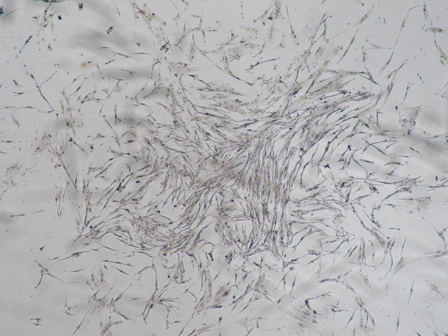
Fig. 1 – Colony forming unit-fibroblast (CFU-F) in low density culture at passage 1 (Crystal violet staining, magnification objective 4 ×).

In our experiment, in all time points, the PDT was approximatly 25 h (Figure 2a). Colony forming efficiency (CFE) in passage four was 80.4 ± 7.5% on average (Figure 2b).
Using flow cytometry, we demonstrated that all cells expressed CD29 and CD73 (Figures 3a and 3b), 88% of cells expressed CD146 (Figure 3c), and 5% of cells expressed CD106 (Figure 3d). We also confirmed that CD34 was not expressed on the cell population examined (Figure 3e). Figure 3f demonstrate mean expression of the analyzed markers from five donors.
The differentiation potential of isolated cells is important when considering their potential to regenerate specified tissues, like bone, cartilage or adipose tissue. After 3 weeks of cultivation in adipogenic medium, the cells became more round and filled with fat droplets (Figure 4a) while cells

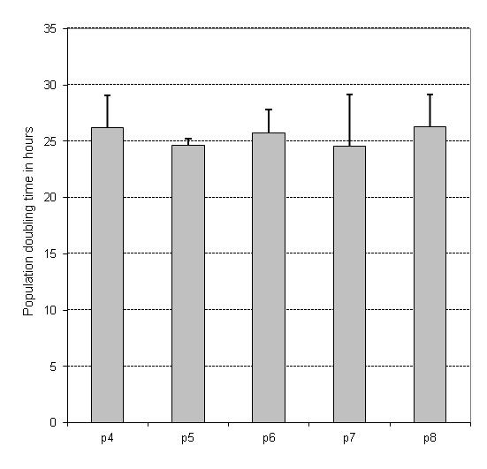 a | 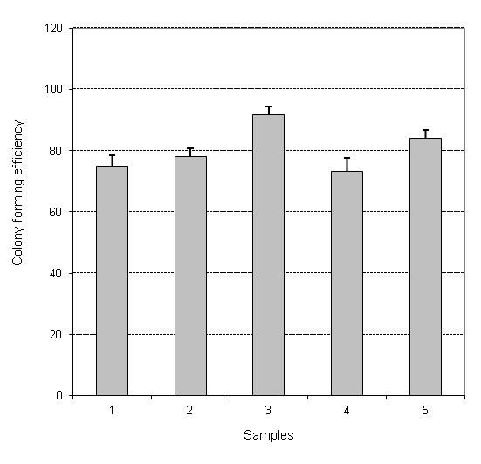 b
Fig. 2 – a) Deciduous teeth stem cells (DTSC) population doubling time from passage four to passage eight did not change significantly (n = 5, mean ± standard deviation); b) Colony forming efficiency was similar between different samples at passage four (values are mean ± standard deviation of experiments done in triplicate).

Fig. 3 – Representative flow cytometry plots (passage four) showing expression of a) CD29; b) CD73; c) CD146; d) CD106; e) CD34 f). The histogram gives the mean (± standard deviation) expression of the analyzed markers from five donors.

in the control media had scarce and small fat droplets (Figure 4b). Highly induced calcium deposition in ECM was demonstrated with Alizarin red staining after 3 weeks of culture (Figure 4c). In control media no Alizarin red staining was noted (Figure 4d). After 2 and 3 weeks in chondrogenic medium, small, compact pellets rich in cells were formed. Cells produced the ECM with postive GAGs (Figure 4e) and collagen type II (Figure 4f) staining. Due to the loose tissue structure, pellets in controle medium were decomposed during paraffin embedding protocols.
Discussion
Staining | Oil Red O Adipogenesis | Alizarin Red Osteogenesis | Alcian Blue Chondrogenesis
 | a | c | e
 | 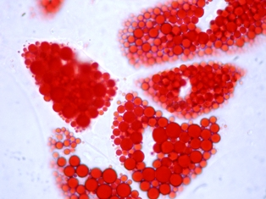 | 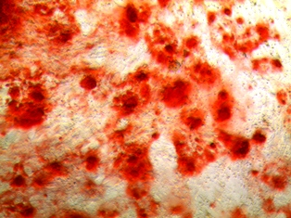 | 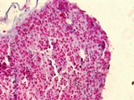
Staining | Oil Red O | Alizarin Red | Collagen II
 | Control | Control | Chondrogenesis
 | b | d | f
 | 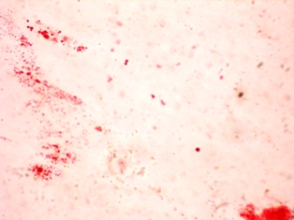 | 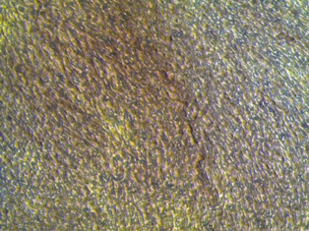 | 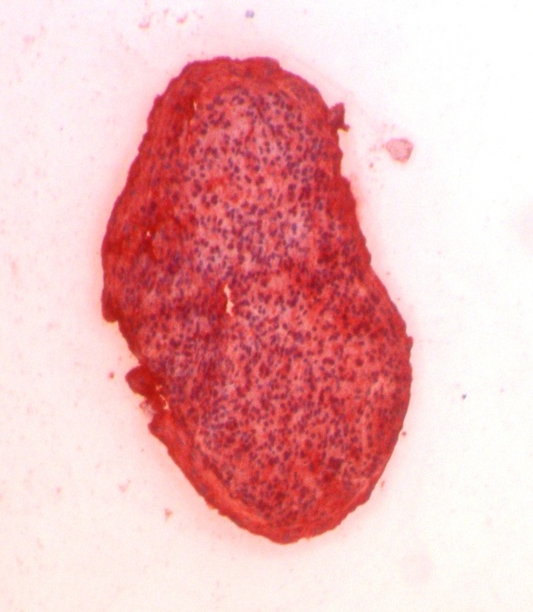
Fig. 4 – Representative images demonstrating: a) Formation of lipid droplets stained with Oil Red O in adipogenesis medium after 3 weeks of cultivation (magnification objective 100 ×); b) Oil Red O staining in a well with cells cultivated in the control media (magnification objective 100 ×); c) Mineralized matrix stained with Alizarin red in osteogenesis medium after 3 weeks of cultivation (inverted microscope, magnification objective 10 ×); d) Alizarin red staining in a well with control media (inverted microscope, magnification objective 10 ×); e) After 2 weeks in chondrogenesis medium, pellets contained sulfated glycosaminoglycans stained light blue with Alcian Blue (magnification objective 20 ×); f) Immunocytochemistry for collagen type II in pellets formed in chondrogenesis medium after 3 weeks of cultivation (magnification objective 10 ×).

Our study demonstrates that remnants of crown dental pulp of exfoliated deciduous teeth contain a population of cells that migrate in vitro, form CFU-F and have high colony forming efficiency. The CFU-F assay is a useful tool to demonstrate, among primary isolated cells, single ones with sufficient proliferative potential to form colonies of several hundred to a thousand cells. In analogy with the hematopoietic system hierarchy, those cells may form a population of progenitor cells with tri-lineage, bi-lineage or uni-lineage potential. The CFU-F frequency could represent the tissue potential for generating enough cells for tissue engineering or cell therapy. In our study the CFU-F frequency was comparable with earlier published data about culture of deciduous teeth pulp cells and those isolated from other tissues connected with tooth development ¹⁹. Calculating on the basis of 10⁵ cells, dental pulp contains at least 10 times more CFU-F than bone marrow (BM), but the total number of CFU-F in one digested remnant of crown dental pulp is about 12 to 20 ⁴, much below the total number of CFU-F that can be obtained after BM aspiration ²⁰. From the clinical point of view, the low initial number of CFU-F is a disadvantage. However, DTSC can exert three times more population doublings than BM MSCs ⁴, so their proliferation potential is higher and they are naturally more primitive. Short PDT reveals a high proliferative activity of cells isolated in our experiment. This is consistent with similar findings of other authors ^{4, 21}, but much shorter than the average PDT reported by Suchaneck et al. ²². This inconsistency could be explained by diverse culture conditions in different laboratory protocols, which could lead to isolation or expansion of different cell populations. The other possibility is that PDT could be influenced by different FBS lots containing different amounts of stimulators or inhibitors of cell proliferation. Besides fundamental stem cell biology, our data concerning the proliferative potential of DTSCs are important for cell therapy protocols. Namely, a small number of cells harvested from a primary source is a limitation for therapeutic use ^{23, 24}. We showed that, although the initial number of 0.3 × 10⁵ to 3 × 10⁵ cells harvested from dental pulp tissue explants was insufficient for clinical use, expansion was fast and the final number of cells after the fourth passage (calculating PDT ~ 25 h) was around 100 × 10⁶. Also, their CFE was high, leading to the conclusion that most cells have the important proliferative potential necessary for tissue engineering strategies.
It is known that remnants of dental pulp contain extracellular matrix, odontoblasts, fibroblasts, endothelial cells, pericytes and MSCs ⁴. Among them, MSCs, endothelial cells and pericytes are migratory cells that at the same time have high proliferative potential. A heterogeneous phenotype for CD146 and CD106 antigens in multicolony culture of MSCs is a common finding ^{4, 5} and not all of the markers are specific for putative mesenchymal stem cells. CD146 is expressed in pericytes and endothelial cells in culture ^{4, 25, 26}. CD106 is a vascular cell adhesion molecule (VCAM) expressed in endothelial cells and also in smooth muscle cells and proliferating pericytes ²⁷. DPSC and SHED were found positive for CD106 but less strongly than BM MSC ^{3, 28, 29}. Since CD146 and CD106 molecules are expressed on endothelial cells and dental pulp stem cells easily differentiate into endothelial cells ^{10, 30}, we cannot exclude that a small portion of cells positive for CD106 in our cultures could be endothelial cells. Based on markers expression, the majority of cultivated cells could be pericytes. Indeed, multiple studies have recognized pericytes as MSCs ^{31, 32}. Therefore, we can conclude that using the outgrowth method to yield cells from remnants of deciduous teeth dental pulp, results in isolation of cells that do not belong to hematopoietic cell lineages but have markers indicative for pericytes that are also indicated as markers for MSCs ³².
The differentiation potential of harvested cells is important when considering their potential to regenerate specified tissues, like bone, cartilage or adipose tissue. We demonstrated that cells isolated in our multicolony culture system are able to differentiate in cells that from large lipid droplets, depose ECM with calcium salts and from cartilage like tissue that contains GAGs and collagen II. It was previously shown that SHED, obtained by enzymatic digestion of dental pulp, underwent adipogenic, osteogenic, dentinogenic and neurogenic differentiation in vitro ⁴, while chondrogenic potential ⁸ and embryonic stem cell markers were demonstrated later ³³. IDPSC obtained by the outgrowth method formed adipocytes, osteoblasts, chondrocytes, skeletal and smooth muscles as well as neurons ⁵. OCT-4 and other embryonic stem cell markers were also detected pointing to the very primitive nature of these cells ⁵. Considering all these findings, it seems that SHED and IDPSC, first claimed to have separate characteristics ⁵, do not differ from each other. The spectrum of the differentiation potential of DTSC was enlarged when these cells were found to differentiate into a pancreatic cell lineage resembling islet-like cell aggregates ³⁴, endothelial ¹⁰ and epithelial-like cell types ⁹.
Previously, important results about the differentiation potential of DTSC multicolony and clonal cell cultures were collected from experiments in vivo, mostly using immunocompromised mice. Thus, one quarter of SHED clones generated dentine-like tissue ¹⁰. Also, multicolony derived cells generated ectopic dentine-like tissue equivalent to that produced by clonal cells ⁴ indicating that multicolony derived cell populations have the same differentiation capacity as clonal cells but are more convenient to use in a clinical setting.
Conclusion
In our experimental conditions, after 10 to 15 days of explant culture, the harvested cell population was able to expand for up to 1 month, when the cultures were stopped. Cells were positive for mesenchymal cell markers typically found on expanded stem cell populations, produced CFU-F and successfully formed a mineralized matrix, cartilage-like tissue and adipocytes, so showing multipotency. Taking together, the approach using dental pulp tissue explants yield high number of cells with MSC properties and is convenient for further investigations in vitro and work on tissue engineering protocols.
Acknowledgment
The research was supported by grant number 175061 from the Ministry of Education, Science and Technology Development, Republic of Serbia.

REFERENCES

- Jorgensen C, Noël D. Mesenchymal stem cells in osteoarticular diseases. Regen Med 2011; 6(6 Suppl): 44−51.
- Casagrande L, Cordeiro MM, Nör SA, Nör JE. Dental pulp stem cells in regenerative dentistry. Odontology 2011; 99(1): 1−7.
- Gronthos S, Mankani M, Brahim J, Robey PG, Shi S. Postnatal human dental pulp stem cells (DPSCs) in vitro and in vivo. Proc Natl Acad Sci USA 2000; 97(25): 13625−30.
- Miura M, Gronthos S, Zhao M, Lu B, Fisher LW, Robey PG, et al. SHED: stem cells from human exfoliated deciduous teeth. Proc Natl Acad Sci USA 2003; 100(10): 5807−12.
- Kerkis I, Kerkis A, Dozortsev D, Stukart-Parsons GC, Gomes MS, Pereira LV, et al.. Isolation and characterization of a population of immature dental pulp stem cells expressing OCT-4 and other embryonic stem cell markers. Cells Tissues Organs 2006; 184(3–4): 105–16. PubMed PMID: 17409736.
doi: 10.1159/000099617
- Angelova A, Takagi Y, Okiji T, Kaneko T, Yamashita Y. Immunocompetent cells in the pulp of human deciduous teeth. Arch Oral Biol 2004; 49(1): 29−36.
- Huang GT, Gronthos S, Shi S. Mesenchymal stem cells derived from dental tissues vs. those from other sources: their biology and role in regenerative medicine. J Dent Res 2009; 88(9): 792−806.
- Koyama N, Okubo Y, Nakao K, Bessho K. Evaluation of pluripotency in human dental pulp cells. J Oral Maxillofac Surg 2009; 67(3): 501−6.
- Nam H, Lee G. Identification of novel epithelial stem cell-like cells in human deciduous dental pulp. Biochem Biophys Res Commun 2009; 386(1): 135−9.
- Sakai VT, Zhang Z, Dong Z, Neiva KG, Machado MAAM, Shi S, Nör JE. SHED differentiate into functional odontoblasts and endothelium. J Dent Res 2010; 89(8): 791−6.
- Wang J, Wei X, Ling J, Huang Y, Huo Y, Zhou Y. The presence of a side population and its marker ABCG2 in human deciduous dental pulp cells. Biochem Biophys Res Commun 2010; 400(3): 334−9.
- Kerkis I, Caplan AI. Stem cells in dental pulp of deciduous teeth. Tissue Eng Part B Rev 2012; 18(2): 129−38.
- le Douarin NM, Creuzet S, Couly G, Dupin E. Neural crest cell plasticity and its limits. Development 2004; 131(19): 4637−50.
- Cordeiro MM, Dong Z, Kaneko T, Zhang Z, Miyazawa M, Shi S, et al. Dental pulp tissue engineering with stem cells from exfoliated deciduous teeth. J Endod 2008; 34(8): 962−9.
- Seo B, Miura M, Gronthos S, Bartold PM, Batouli S, Brahim J, et al. Investigation of multipotent postnatal stem cells from human periodontal ligament. Lancet 2004; 364(9429): 149−55.
- Handa K, Saito M, Tsunoda A, Yamauchi M, Hattori S, Sato S, et al. Progenitor cells from dental follicle are able to form cementum matrix in vivo. Connect Tissue Res 2002; 43(2−3): 406−8.
- Sonoyama W, Liu Y, Yamaza T, Tuan RS, Wang S, Shi S, et al. Characterization of the Apical Papilla and Its Residing Stem Cells from Human Immature Permanent Teeth: A Pilot Study. J Endod 2008; 34(2): 166−71.
- Đokić J, Tomić S, Cerović S, Todorović V, Rudolf R, Čolić M. Characterization and immunosuppressive properties of mesenchymal stem cells from periapical lesions. J Clin Periodontol 2012; 39(9): 807−16.
- Shi S, Bartold PM, Miura M, Seo BM, Robey PG, Gronthos S. The efficacy of mesenchymal stem cells to regenerate and repair dental structures. Orthod Craniofac Res 2005; 8(3): 191−9.
- Kasten P, Beyen I, Egermann M, Suda AJ, Moghaddam AA, Zimmermann G, et al. Instant stem cell therapy: characterization and concentration of human mesenchymal stem cells in vitro. Eur Cell Mater 2008; 16: 47−55.
- Nakamura S, Yamada Y, Katagiri W, Sugito T, Ito K, Ueda M. Stem cell proliferation pathways comparison between human exfoliated deciduous teeth and dental pulp stem cells by gene expression profile from promising dental pulp. J Endod 2009; 35(11): 1536−42.
- Suchánek J, Visek B, Soukup T, El-Din Mohamed SK, Ivancaková R, Mokrỳ J, et al. . Stem cells from human exfoliated deciduous teeth-isolation, long term cultivation and phenotypical analysis. Acta Medica (Hradec Kralove) 2010; 53(2): 93−9.
- Emadedin M, Aghdami N, Taghiyar L, Fazeli R, Moghadasali R, Jahangir S, et al. Intra-articular injection of autologous mesenchymal stem cells in six patients with knee osteoarthritis. Arch Iran Med 2012; 15(7): 422−8.
- Martin I, Baldomero H, Bocelli-Tyndall C, Passweg J, Saris D, Tyndall A. The survey on cellular and engineered tissue therapies in Europe in 2010. Tissue Eng Part A 2012; 18(21−22): 2268−79.
- Shi S, Gronthos S. Perivascular niche of postnatal mesenchymal stem cells in human bone marrow and dental pulp. J Bone Miner Res 2003; 18(4): 696−704.
- Siemerink MJ, Klaassen I, Vogels IM, Griffioen AW, van Noorden CJ, Schlingemann RO. CD34 marks angiogenic tip cells in human vascular endothelial cell cultures. Angiogenesis 2012; 15(1): 151−63.
- Garmy-Susini B, Jin H, Zhu Y, Sung R, Hwang R, Varner J. Integrin alpha4beta1-VCAM-1-mediated adhesion between endothelial and mural cells is required for blood vessel maturation. J Clin Invest 2005; 115(6): 1542−51.
- Nourbakhsh N, Soleimani M, Taghipour Z, Karbalaie K, Mousavi S, Talebi A, et al. Induced in vitro differentiation of neural-like cells from human exfoliated deciduous teeth-derived stem cells. Int J Dev Biol 2011; 55(2): 189−95.
- Tomic S, Djokic J, Vasilijic S, Vucevic D, Todorovic V, Supic G, et al. Immunomodulatory properties of mesenchymal stem cells derived from dental pulp and dental follicle are susceptible to activation by toll-like receptor agonists. Stem Cells Dev 2011; 20(4): 695−708.
- d'Aquino R, Graziano A, Sampaolesi M, Laino G, Pirozzi G, de Rosa A, et al. Human postnatal dental pulp cells co-differentiate into osteoblasts and endotheliocytes: a pivotal synergy leading to adult bone tissue formation. Cell Death Differ 2007; 14(6): 1162−71.
- Covas DT, Panepucci RA, Fontes AM, Silva WA, Orellana MD, Freitas MC, et al. Multipotent mesenchymal stromal cells obtained from diverse human tissues share functional properties and gene-expression profile with CD146+ perivascular cells and fibroblasts. Exp Hematol 2008; 36(5): 642−54.
- Crisan M, Yap S, Casteilla L, Chen C, Corselli M, Park TS, et al. A perivascular origin for mesenchymal stem cells in multiple human organs. Cell Stem Cell 2008; 3(3): 301−13.
- Huang AH, Chen Y, Lin L, Shieh T, Chan AW. Isolation and characterization of dental pulp stem cells from a supernumerary tooth. J Oral Pathol Med 2008; 37(9): 571−4.
- Govindasamy V, Ronald VS, Abdullah AN, Nathan GKR, ab Aziz ZA, Abdullah M, et al. Differentiation of dental pulp stem cells into islet-like aggregates. J Dent Res 2011; 90(5): 646−52.
Received on April 9, 2013.
Accepted on May 9, 2013.

