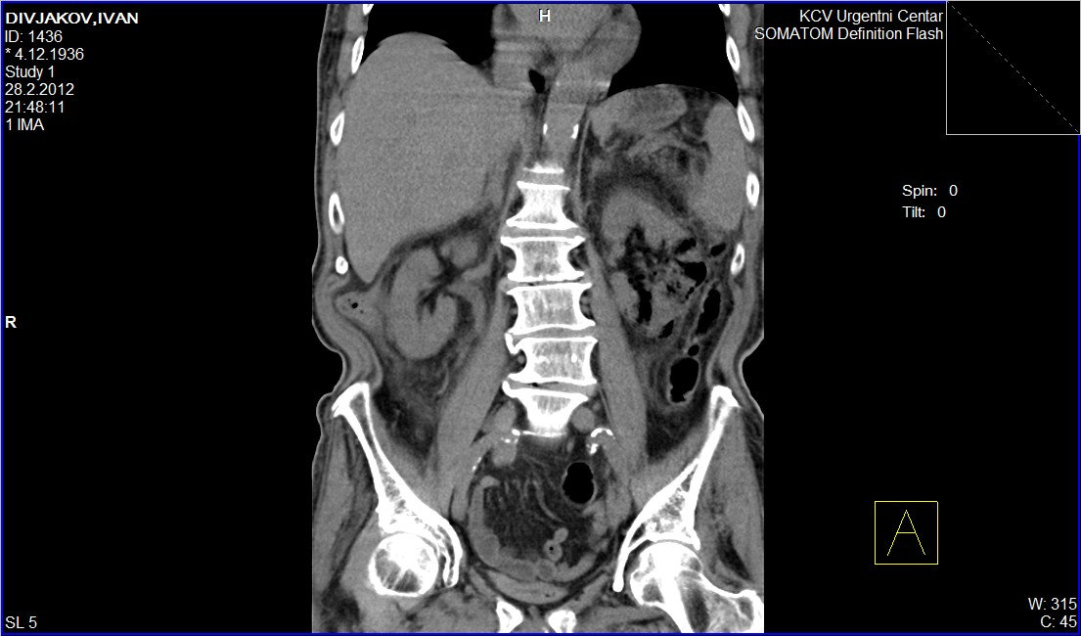

Figure 1. CT scan of abdomen (longitudinal view), showing minimal gas accumulations in the right kidney and extensive gas accumulations in the left kidney, collecting system on the left side and in the left pararenal tissue

