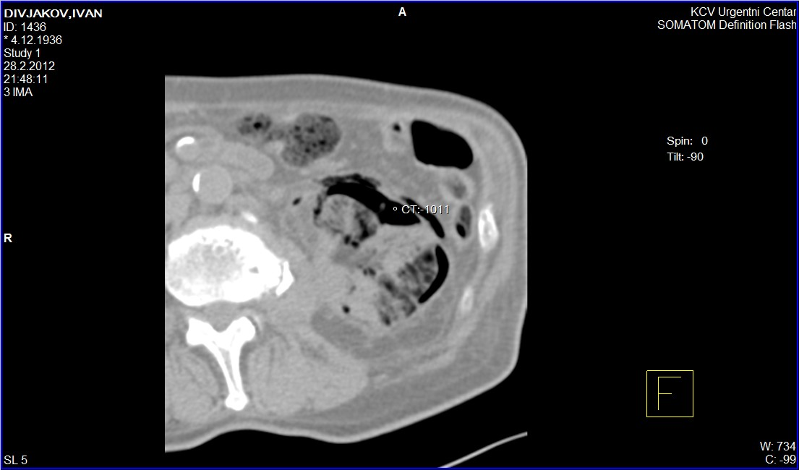
Figure 2. CT scan of abdomen (transversal view), showing extensive gas accumulations in the left kidney, collecting system on the left side and in the left pararenal tissue

